PROJECT PHASE 2
Cloud Dashboard Development
Diet Analysis using Azure Functions, Azure Blob Storage, and Azure Static Web Apps
Team | Anagha Roy, Jasmeen, and Manya Sethi
Member C | Manya Sethi - Integration and Documentation
Course | [Course / Section]
Instructor | [Instructor Name]
Prepared | July 17, 2026

PUBLIC FRONTEND URL
[PASTE AZURE STATIC WEB APP URL AFTER DEPLOYMENT]
GitHub Repository: github.com/anagha-04-roy/diet-analysis-phase2

1. Executive Summary
Phase 2 moves the diet analysis solution from local Azurite and localhost execution to a cloud-native deployment. The final system stores All_Diets.csv in Azure Blob Storage, processes the dataset through three HTTP-triggered Azure Functions, and presents the returned JSON in a public dashboard hosted on Azure Static Web Apps.
Member C completed the frontend-to-backend integration, added filter and refresh behavior, measured function/API response time, prepared CORS and authentication guidance, created the end-to-end test plan, assembled the repository structure, and produced the architecture and submission documentation.
Final result
The dashboard connects to GetNutritionalInsights, GetRecipes, and GetClusters; displays four distinct visualizations; provides diet, cuisine, and search controls; shows execution metadata; and includes deployment-ready static frontend files.

2. Team Work Division
Member | Assigned responsibility | Completed work
Anagha Roy - Member A | Cloud Backend and Storage | Resource group, Storage Account, Function App, live blob dataset, three deployed endpoints, endpoint testing.
Jasmeen - Member B | Frontend Dashboard | Initial dashboard interface and chart components.
Manya Sethi - Member C | Integration and Documentation | API wiring, filters, refresh, timing metadata, CORS/auth handling, end-to-end tests, architecture diagram, documentation, repository assembly, deployment checklist.

3. Solution Architecture
The architecture separates storage, serverless compute, and frontend hosting. The browser never downloads the CSV directly. Instead, each Azure Function retrieves the live blob through the Azure Storage SDK, processes it with Pandas, and returns JSON to the dashboard.
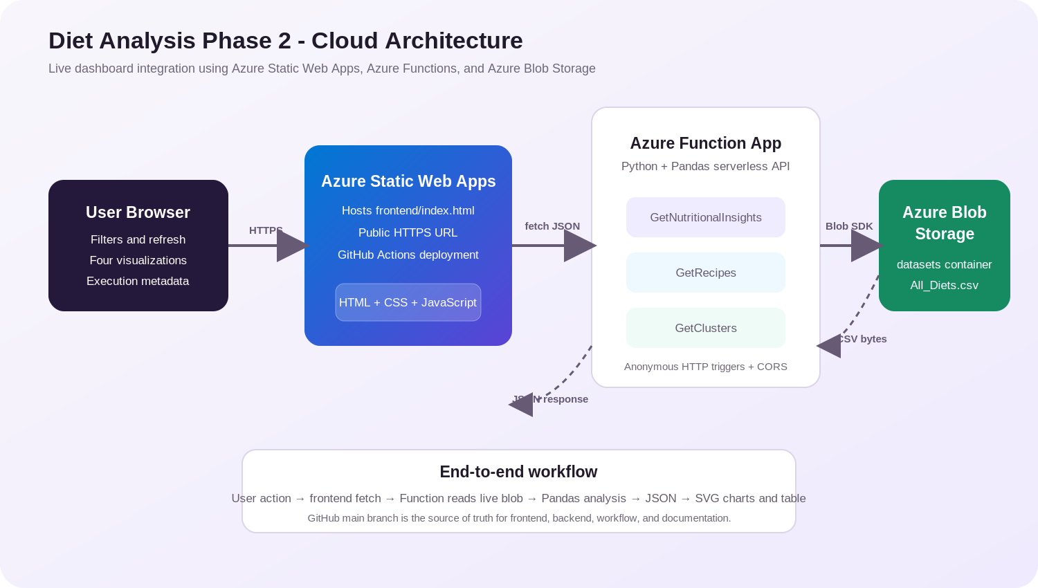
Figure 1. End-to-end Azure cloud architecture.

4. Azure Services and Responsibilities
Service | Role in solution | Cloud-native evidence
Azure Blob Storage | Stores datasets/All_Diets.csv. | Functions read the live cloud blob instead of Azurite.
Azure Function App | Runs Python/Pandas analysis through HTTP endpoints. | Serverless deployment with environment-based AzureWebJobsStorage.
Azure Static Web Apps | Hosts the public dashboard over HTTPS. | GitHub-connected deployment and publicly accessible URL.
GitHub | Stores frontend, backend, tests, workflow, and report. | Main branch becomes the final source of truth.

5. Deployed Backend Endpoints
The three endpoint URLs were verified as publicly reachable on July 17, 2026. The frontend accepts both the current array response format and a future wrapped response containing data and metadata.
Endpoint | Purpose | Dashboard use
GetNutritionalInsights | Average protein, carbohydrates, and fat grouped by diet type. | Grouped bar chart and line chart.
GetRecipes | Recipe rows with optional diet_type query filter. | Scatter plot, recipe table, search, CSV download.
GetClusters | Cuisine-level recipe counts and macro averages. | Cuisine distribution pie chart and cuisine filter.

Endpoint base URL
https://diet-analysis-func01-d7fdd4awc3dacqew.canadacentral-01.azurewebsites.net/api

6. Frontend Integration
The final frontend is a dependency-free static application containing HTML, CSS, JavaScript, and inline SVG chart rendering. This design minimizes Azure Static Web Apps build failures and satisfies the assignment allowance for plain JavaScript and chart-based visualization.
- All three endpoints are requested in parallel during initial load and refresh.
- The diet filter re-calls GetRecipes with a diet_type query parameter.
- Cuisine and text filters update the displayed recipes without a full page reload.
- The dashboard measures each API request with performance.now() and displays milliseconds.
- The code also reads backend execution_time_ms metadata if the Function App later returns it.
- Errors are shown clearly, including a targeted CORS troubleshooting message.
- Demo mode is available with ?demo=1 for classroom presentation or visual testing.

7. Dashboard Visualizations and Interactions
Visualization / control | Data source | Meaning
Grouped bar chart | GetNutritionalInsights | Compares average protein, carbs, and fat by diet.
Line chart | GetNutritionalInsights | Shows macro trends across diet categories.
Pie chart | GetClusters | Shows recipe distribution across cuisines.
Scatter plot | GetRecipes | Plots recipe protein against carbohydrates; point size reflects fat.
Diet filter | GetRecipes query + insights filter | Changes the selected diet and reloads recipe data.
Cuisine/search filters | Client-side filtered recipe data | Narrows chart points and table rows.
Refresh and CSV download | All endpoints / filtered recipes | Refreshes cloud data and exports filtered rows.

8. CORS and Authentication
The deployed functions use anonymous HTTP authorization, so the frontend does not require a function key. Because Azure Static Web Apps and Azure Functions use different origins, the exact frontend origin must be added to the Function App CORS allowed-origins list.
Required CORS value
After deployment, add the exact https://...azurestaticapps.net origin without a trailing slash. Use a specific origin rather than a wildcard in the final configuration.

Azure CLI alternative:
az functionapp cors add --resource-group YOUR_RESOURCE_GROUP --name diet-analysis-func01 --allowed-origins https://YOUR-STATIC-APP.azurestaticapps.net

9. End-to-End Testing
- Open the public Azure Static Web App URL and open browser Developer Tools.
- Select Refresh data and confirm successful requests to all three Function endpoints.
- Verify that all four charts, timing cards, and recipe rows display.
- Change the diet filter and confirm the GetRecipes request includes ?diet_type=.
- Change cuisine and search filters and confirm the scatter plot and table update.
- Use Download CSV and verify the exported file contains only matching recipes.
- Capture Network-tab evidence showing successful frontend-to-backend communication.
- Run tests/integration_check.py as an additional endpoint smoke test.
Test case | Expected result | Evidence
All endpoints | JSON data loads with no browser errors. | Network tab and dashboard status pill.
Diet filter | Recipe endpoint is called with the selected diet. | Network request URL and changed rows.
Cuisine/search | Client-side data and charts update immediately. | Filtered table and scatter plot.
Execution metadata | Timing cards display milliseconds. | Dashboard screenshot.
Responsive layout | Dashboard remains readable on desktop and mobile. | Browser responsive mode screenshot.

10. Challenges and Solutions
Challenge | Solution implemented
Initial UI contained visual elements but incomplete live integration. | Added endpoint fetch logic, loading state, errors, filters, refresh, timing, and table rendering.
The three endpoints return different object shapes. | Created dedicated transformations for insights, recipes, and cuisine clusters.
Function execution metadata was not included in current array responses. | Measured client-side API duration and added support for future backend metadata.
Cross-origin requests may fail after the frontend receives a new domain. | Prepared exact portal and CLI CORS steps and surfaced a clear in-dashboard error message.
Framework build configuration can delay a time-sensitive submission. | Prepared a plain static deployment with no npm build dependency.
Multiple branches require final assembly. | Prepared a manya-integration merge workflow and pull-request checklist.

11. Cloud Practices and Security
- AzureWebJobsStorage is read from environment variables rather than hard-coded in source code.
- local.settings.json and connection strings are excluded from GitHub.
- The frontend calls the Function API and does not expose the Storage Account connection string.
- The final CORS policy should contain the exact Static Web App origin rather than a wildcard.
- Static Web Apps security headers are defined in staticwebapp.config.json.
- Dataset processing occurs in the Function App, not inside the browser.
- Screenshots must hide secrets, access keys, and full connection strings.

12. GitHub Repository Assembly
The final main branch should contain the deployed Function source, the selected frontend folder, documentation files, deployment instructions, tests, and the Azure Static Web Apps workflow generated during deployment.
- Create a manya-integration branch from main.
- Merge origin/anagha-backend and origin/jasmeen-frontend.
- Add the completed Member C frontend, documentation, deployment, and test files.
- Review git status and verify that no local.settings.json or connection string is included.
- Push the integration branch and merge it into main through a pull request.
- Deploy Azure Static Web Apps from the final main branch.

13. Required Screenshot Evidence
Replace the boxes below with the team screenshots before exporting the final submission PDF. The editable DOCX is included so this can be completed quickly.
Figure 2. Azure resources and live Blob dataset
INSERT SCREENSHOT HERE
Show the resource group containing the Function App, Storage Account, and Static Web App. Include a second image or crop showing datasets/All_Diets.csv.
Evidence note: Make sure the resource name, URL, or successful response is visible. Hide connection strings and secrets.
Figure 3. Three live Azure Function endpoints
INSERT SCREENSHOT HERE
Show GetNutritionalInsights, GetRecipes, and GetClusters returning JSON in a browser or Postman.
Evidence note: Make sure the resource name, URL, or successful response is visible. Hide connection strings and secrets.

Figure 4. Function App CORS configuration
INSERT SCREENSHOT HERE
Show the exact Azure Static Web App URL in the Function App Allowed Origins list.
Evidence note: Make sure the resource name, URL, or successful response is visible. Hide connection strings and secrets.
Figure 5. Public dashboard
INSERT SCREENSHOT HERE
Show the deployed Azure Static Web App with timing cards, filters, and all four visualizations populated.
Evidence note: Make sure the resource name, URL, or successful response is visible. Hide connection strings and secrets.

Figure 6. End-to-end browser Network test
INSERT SCREENSHOT HERE
Show successful requests from the Static Web App to all three Function endpoints.
Evidence note: Make sure the resource name, URL, or successful response is visible. Hide connection strings and secrets.
Figure 7. GitHub final main branch
INSERT SCREENSHOT HERE
Show the final repository structure and successful Azure Static Web Apps workflow.
Evidence note: Make sure the resource name, URL, or successful response is visible. Hide connection strings and secrets.

14. Deployment and Submission Checklist
- GitHub collaborator invitation accepted.
- Backend and frontend branches merged into the integration branch.
- Final files merged into main.
- Azure Static Web App deployed from main.
- Exact Static Web App origin added to Function App CORS.
- Public dashboard tested with all three live endpoints.
- Public frontend URL pasted on the cover page and deliverables section.
- All screenshot placeholders replaced.
- DOCX exported to PDF and reviewed for clipping or missing images.
- Submission includes deployed Function URL, frontend URL, GitHub repository, and documentation PDF.

15. Deliverables
Deliverable | Final value / location
Azure Function URL | https://diet-analysis-func01-d7fdd4awc3dacqew.canadacentral-01.azurewebsites.net
Azure Static Web App URL | [PASTE AFTER DEPLOYMENT]
GitHub repository | https://github.com/anagha-04-roy/diet-analysis-phase2
Documentation PDF | docs/Project_Phase2_Cloud_Dashboard_Documentation.pdf
Architecture diagram | docs/architecture-diagram.png
Integration test | tests/integration_check.py

16. Conclusion
The Phase 2 solution demonstrates the complete transition from a local prototype to a cloud-connected application. Azure Blob Storage provides the live dataset, Azure Functions perform reusable serverless analysis, and Azure Static Web Apps delivers an interactive dashboard. The final integration provides meaningful visualizations, user controls, execution metadata, error handling, test evidence, and clear documentation of the architecture and workflow.

References
- Microsoft Learn. Configure function app settings in Azure Functions - CORS.
- Microsoft Learn. Azure CLI: az functionapp cors.
- Microsoft Learn. Quickstart: Build your first static web app.
- GitHub repository: https://github.com/anagha-04-roy/diet-analysis-phase2
- Project brief: Project Phase 2 - Cloud Dashboard Development.

