ANAGHA ACHARYA

1BM19CS224

1A.  Write a recursive program to solve Towers-of-Hanoi problem

#include<stdio.h>

#include<time.h>

void TowerOfHanoi(int n, char frompeg, char auxpeg, char topeg){

if(n==1){

printf("Move disc 1 from %c to %c", frompeg,topeg);

return;

}

TowerOfHanoi(n-1,frompeg,topeg,auxpeg);

printf("\nMove disc %d from %c to %c\n",n,frompeg,topeg);

TowerOfHanoi(n-1,auxpeg,frompeg,topeg);

}

void main(){

int n;

clock_t start,end;

double time;

printf("Enter number of discs\n");

scanf("%d",&n);

start=clock();

TowerOfHanoi(n,'A','B','C');

end=clock();

time=((float)(end-start))/CLOCKS_PER_SEC;

printf("\nTime taken for %d disks is %lf",n,time);

}

OUTPUT:

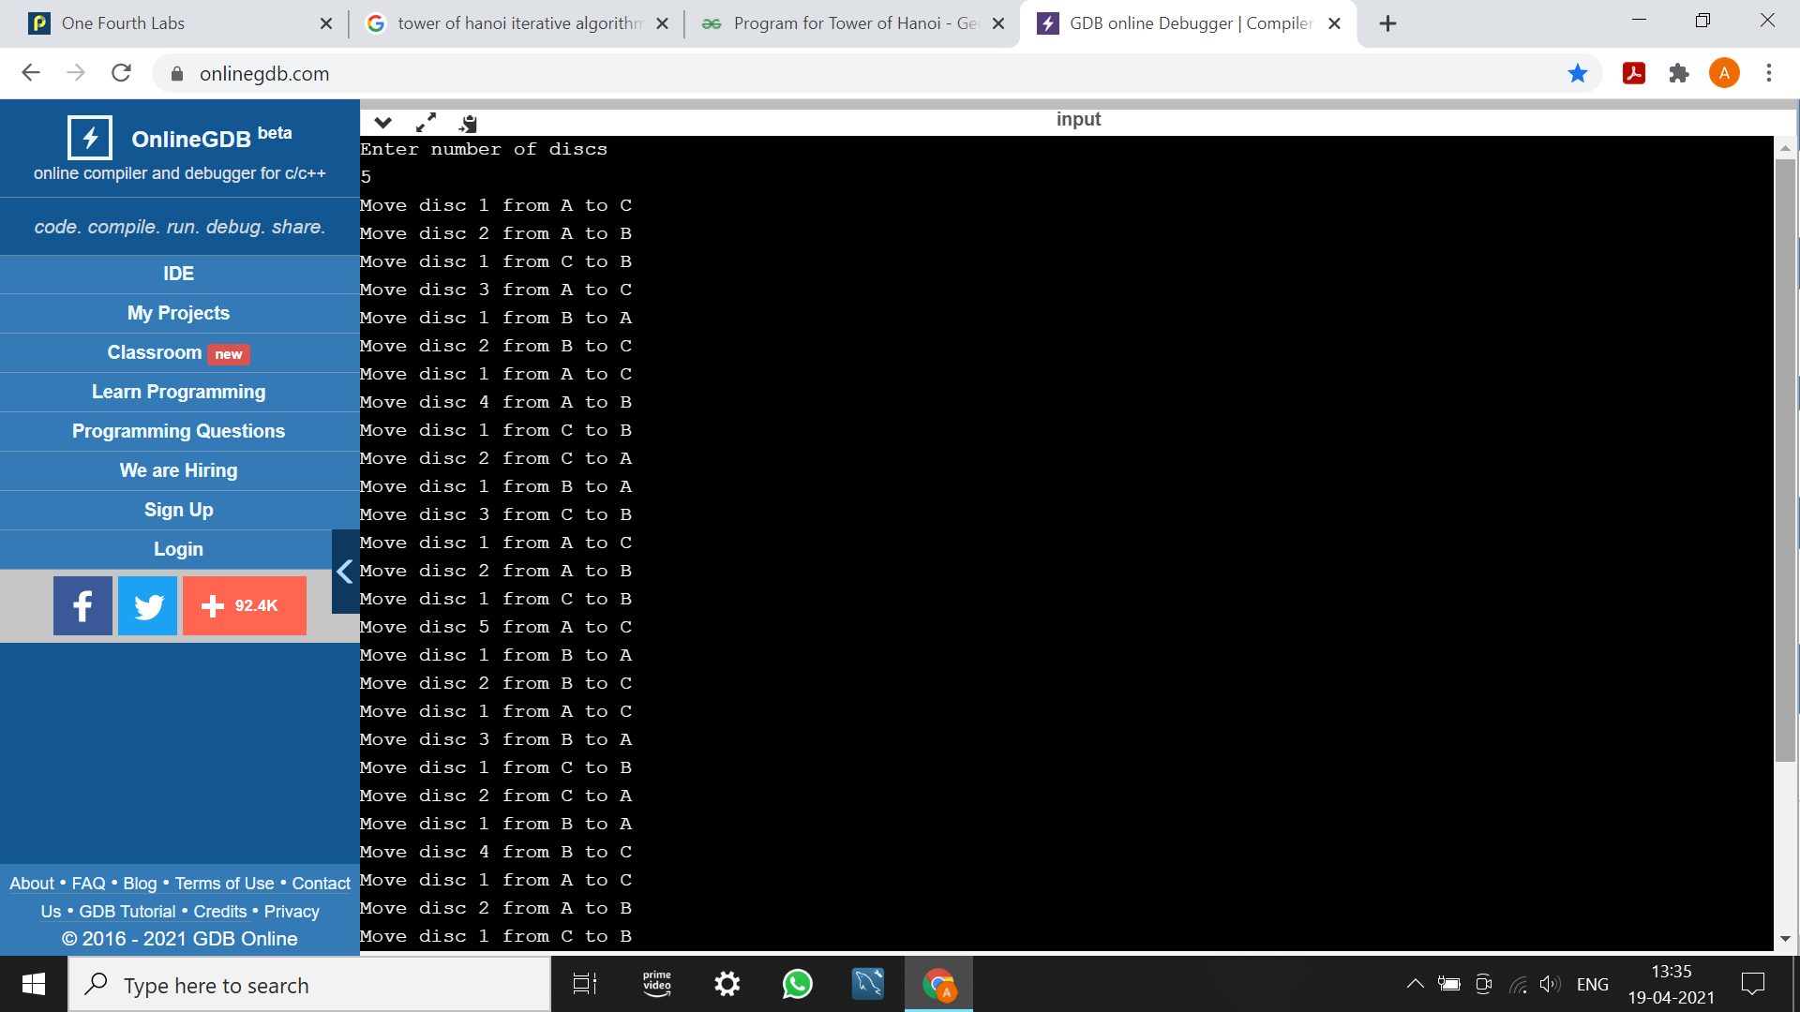

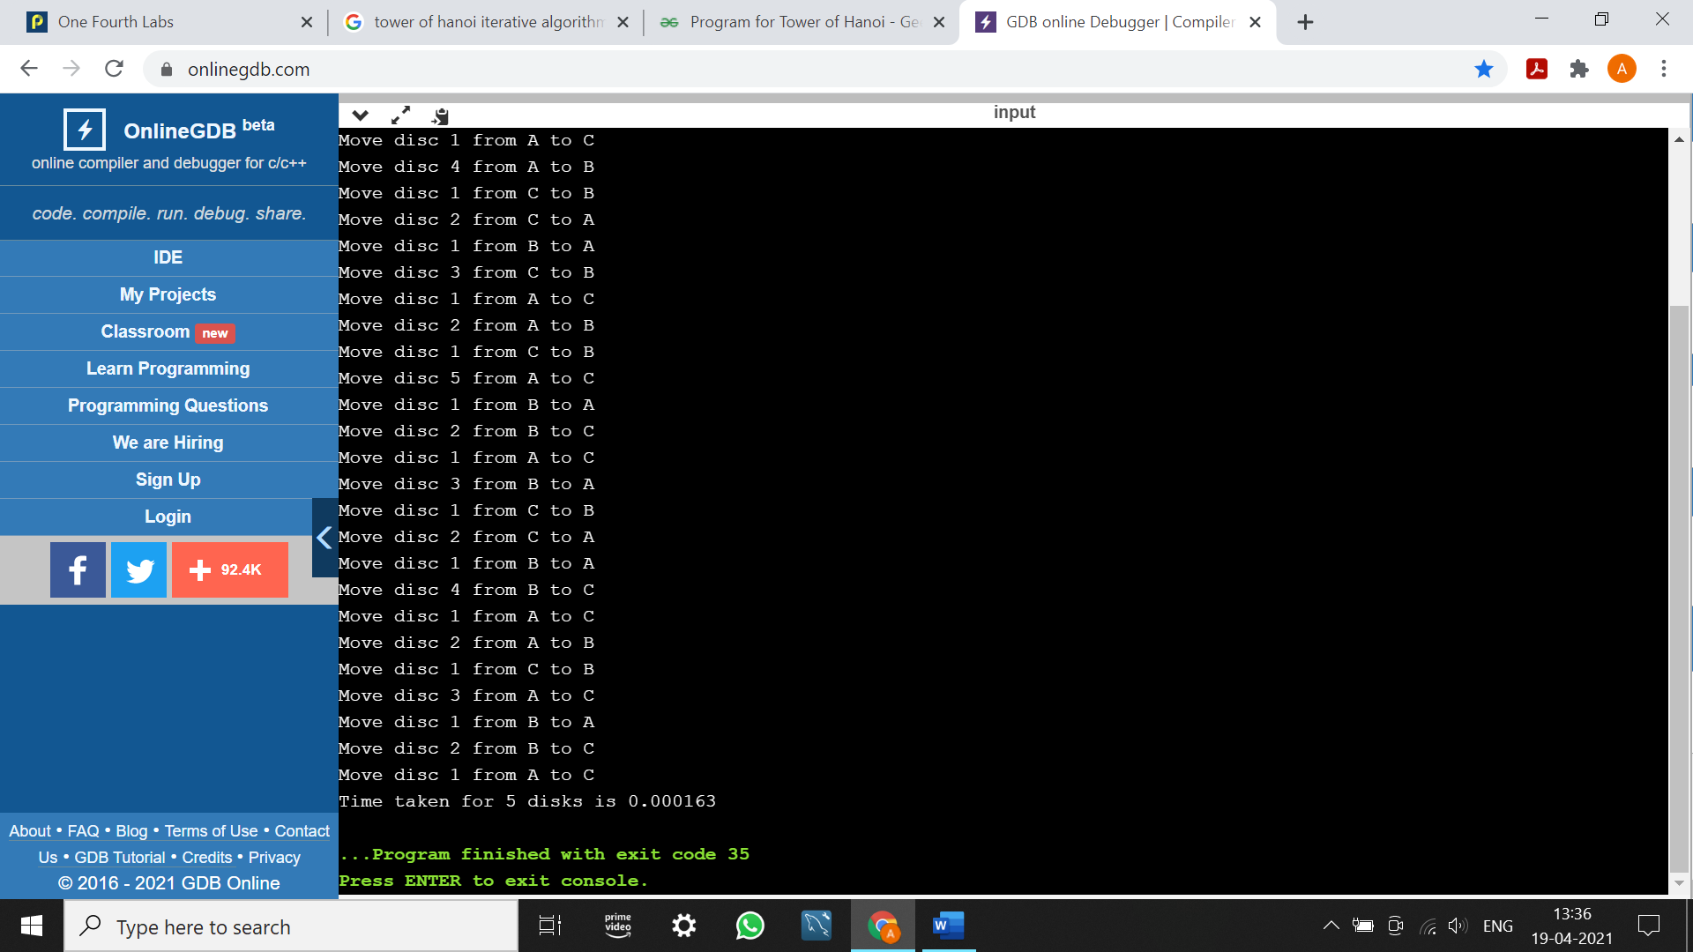

1B.  Write a recursive program to find GCD

#include<stdio.h>

#include<time.h>

int gcd(int m, int n){

if(n==0)

return m;

else

return gcd(n,m%n);

}

void main(){

int m,n,val;

clock_t start,end;

double time;

printf("Enter the numbers\n");

scanf("%d %d",&m,&n);

start=clock();

val=gcd(m,n);

end=clock();

printf("GCD of %d and %d is %d", m,n,val);

time=((float)(end-start))/CLOCKS_PER_SEC;

printf("\nTime taken is %lf",time);

}

OUTPUT:

