ANAGHA ACHARYA

1BM19CS224

**Consider the schema for Movie Database:**

**ACTOR (*Act_id, Act_Name, Act_Gender*)**

**DIRECTOR (*Dir_id, Dir_Name, Dir_Phone*)**

**MOVIES (*Mov_id, Mov_Title, Mov_Year, Mov_Lang, Dir_id*)**

**MOVIE_CAST (*Act_id, Mov_id, Role*)**

**RATING (*Mov_id, Rev_Stars*)**

**Write SQL queries to**

**1. List the titles of all movies directed by ‘Hitchcock’.**

**2. Find the movie names where one or more actors acted in two or more movies.**

**3. List all actors who acted in a movie before 2000 and also in a movie after**

**2015 (use JOIN operation).**

**4. Find the title of movies and number of stars for each movie that has at least one rating and find the highest number of stars that movie received. Sort the result by movie title.**

**5. Update rating of all movies directed by ‘Steven Spielberg’ to 5.**

create database movie;

use movie;

create table actor(

act_id int,

act_name varchar(20),

act_gender char(1),

primary key(act_id));

desc actor;

create table director(

dir_id int,

dir_name varchar(20),

dir_phone int(10),

primary key(dir_id));

desc director;

alter table director

modify column dir_phone bigint;

desc director;

create table movies(

mov_id int,

mov_title varchar(25),

mov_year int,

mov_lang varchar(12),

dir_id int,

primary key(mov_id),

foreign key(dir_id) references director(dir_id));

desc movies;

create table movie_cast(

act_id int,

mov_id int,

role varchar(10),

primary key(act_id,mov_id),

foreign key(act_id) references actor(act_id),

foreign key(mov_id) references movies(mov_id));

desc movie_cast;

create table rating(

mov_id int,

rev_stars varchar(25),

primary key(mov_id),

foreign key(mov_id) references movies(mov_id));

desc rating;

insert into actor values(301,'ANUSHKA','F');

insert into actor values (302,'PRABHAS','M');

insert into actor values(303,'PUNITH','M');

insert into actor values(304,'JERMY','M');

commit;

select * from actor;

insert into director values(60,'RAJAMOULI', 8751611001);

insert into director values(61,'HITCHCOCK', 7766138911);

insert into director values(62,'FARAN', 9986776531);

insert into director values(63,'STEVEN SPIELBERG', 8989776530);

commit;

select * from director;

insert into movies values(1001,'BAHUBALI-2', 2017, 'TELAGU', 60);

insert into movies values(1002,'BAHUBALI-1', 2015, 'TELAGU', 60);

insert into movies values(1003,'AKASH', 2008, 'KANNADA', 61);

insert into movies values(1004,'WAR HORSE', 2011, 'ENGLISH', 63);

commit;

select * from movies;

insert into movie_cast values(301, 1002, 'HEROINE');

insert into movie_cast values(301, 1001, 'HEROINE');

insert into movie_cast values(303, 1003, 'HERO');

insert into movie_cast values(303, 1002, 'GUEST');

insert into movie_cast values(304, 1004, 'HERO');

commit;

select * from movie_cast;

insert into rating values(1001, 4);

insert into rating values(1002, 2);

insert into rating values(1003, 5);

insert into rating values(1004, 4);

commit;

select * from rating;

#Query1

select mov_title

from movies

where dir_id=(select dir_id from director where dir_name='Hitchcock')

group by mov_title;

#Query2

select m.mov_title

from movies m, movie_cast mc

where m.mov_id=mc.mov_id

and mc.act_id in( select act_id from movie_cast group by act_id having count(act_id)>1)

group by mov_title

having count(*)>1;

#Query3

select act_name,mov_title,mov_year

from actor a

join movie_cast mc

on a.act_id=mc.act_id

join movies m

on m.mov_id=mc.mov_id

where m.mov_year not between 2000 and 2015;

#Query4

select mov_title,max(rev_stars)

from movies

inner join rating using(mov_id)

group by mov_id

having max(rev_stars)>0

order by mov_title;

#Query5

update rating

set rev_stars=5

where mov_id in(select mov_id from movies

where dir_id in(select dir_id from director

where dir_name='Steven Spielberg'));

select * from rating;

ACTOR TABLE DIRECTOR TABLE

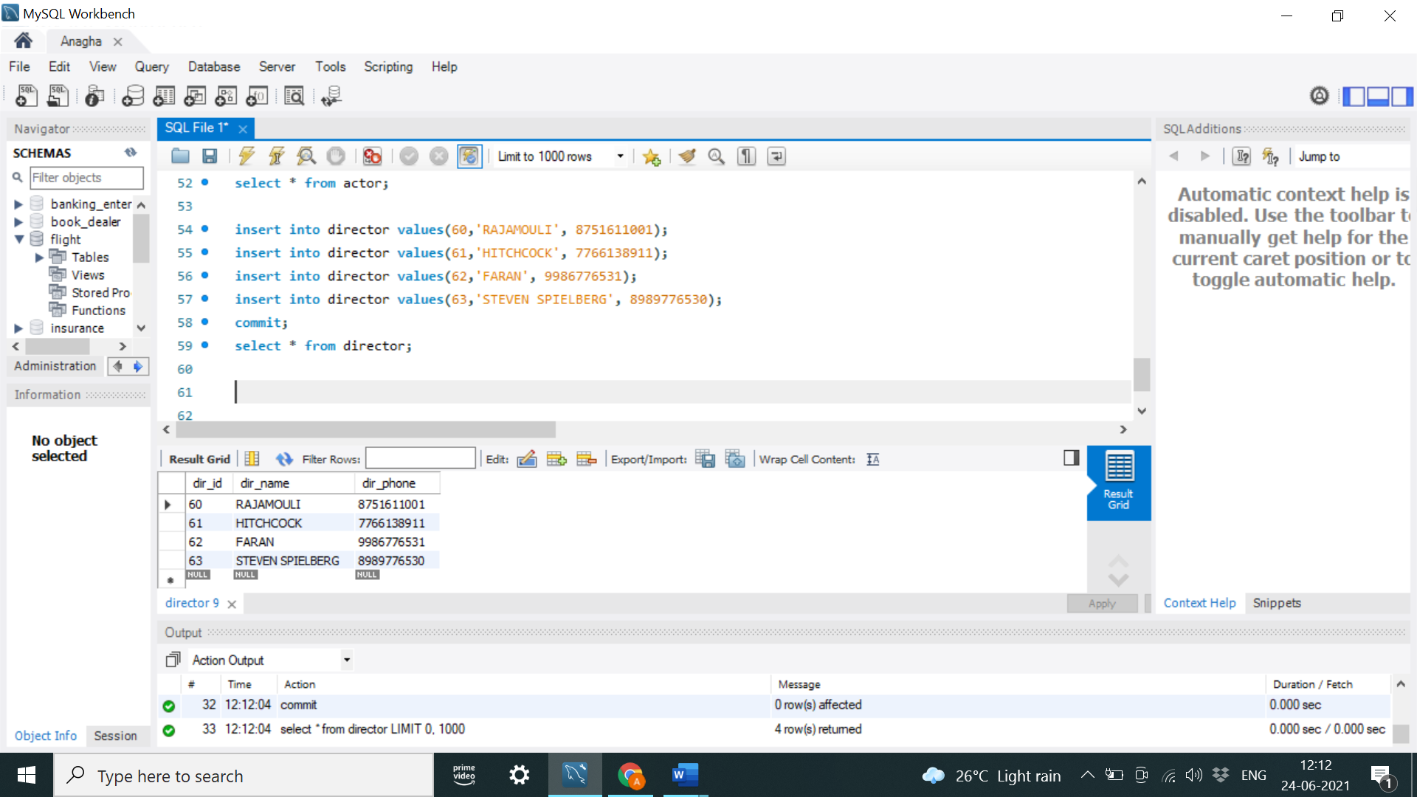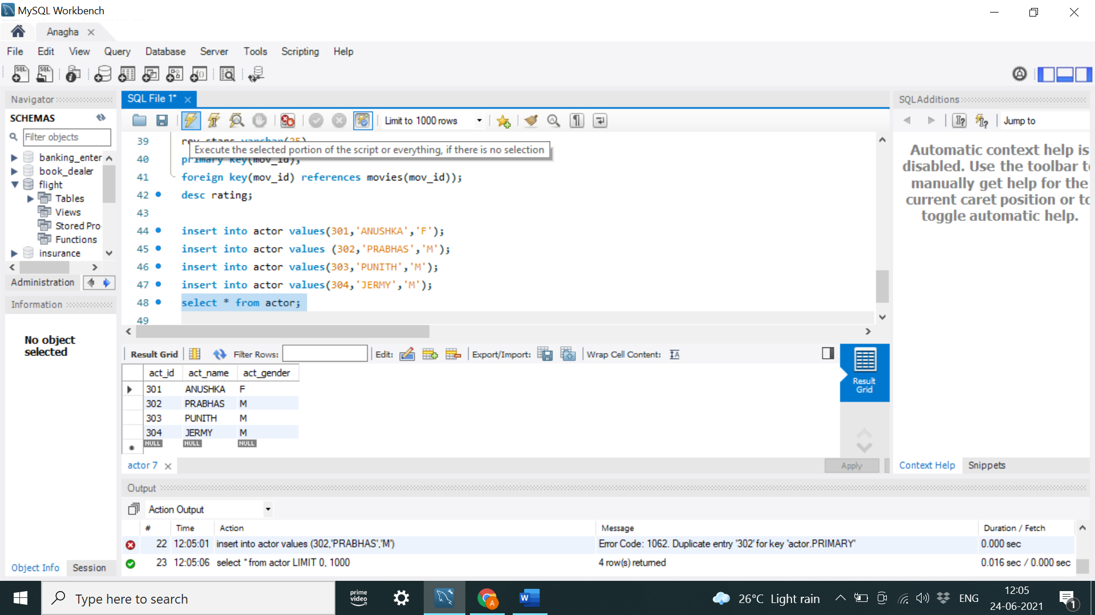

MOVIES TABLE MOVIE_CAST TABLE

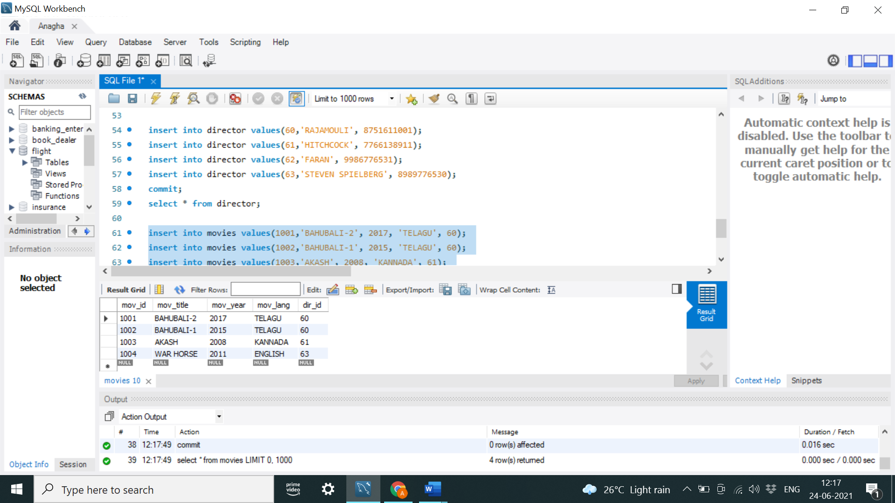 

RATING TABLE

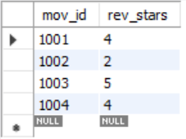

Query1: List the titles of all movies directed by ‘Hitchcock’.



Query 2: Find the movie names where one or more actors acted in two or more movies.



Query 3:List all actors who acted in a movie before 2000 and also in a movie after



Query 4: Find the title of movies and number of stars for each movie that has at least one rating and find the highest number of stars that movie received. Sort the result by movie title.



Query 5: Update rating of all movies directed by ‘Steven Spielberg’ to 5

