ANAGHA ACHARYA

1BM19CS224

STUDENT ENROLLMENT DATABASE

create database student_enroll;

use student_enroll;

create table student(

regno varchar(15),

name varchar(20),

major varchar(20),

bdate date,

primary key(regno));

desc student;

create table course(

courseno int,

cname varchar(20),

dept varchar(20),

primary key(courseno));

desc course;

create table enroll(

regno varchar(15),

courseno int,

sem int,

marks int,

primary key(regno,courseno),

foreign key(regno) references student(regno),

foreign key(courseno) references course(courseno));

desc enroll;

create table textbook(

book_isbn int,

book_title varchar(20),

publisher varchar(20),

author varchar(20),

primary key(book_isbn));

desc textbook;

create table book_adoption(

courseno int,

sem int,

book_isbn int,

primary key(courseno,book_isbn),

foreign key(courseno) references course(courseno),

foreign key(book_isbn) references textbook(book_isbn));

desc book_adoption;

insert into student values('1BM11CS001','A','Sr','19931230');

insert into student values('1BM11CS002','B','Sr','19930924');

insert into student values('1BM11CS003','C','Sr','19931127');

insert into student values('1BM11CS004','D','Sr','19930413');

insert into student values('1BM11CS005','E','Jr','19940824');

commit;

select * from student;

insert into course values(111,'OS','CSE');

insert into course values(112,'EC','ECE');

insert into course values(113,'SS','ISE');

insert into course values(114,'DBMS','CSE');

insert into course values(115,'SIGNALS','ECE');

commit;

select * from course;

insert into textbook values(10,'DATABASE SYSTEMS','PEARSON','SCHIELD');

insert into textbook values(900,'OPERATING SYSTEMS','PEARSON','LELAND');

insert into textbook values(901,'CIRCUITS','HALL INDIA','BOB');

insert into textbook values(902,'SYSTEM SOFTWARE','PETERSON','JACOB');

insert into textbook values(903,'SCHEDULING','PEARSON','PATIL');

insert into textbook values(904,'DATABASE SYSTEMS','PEARSON','JACOB');

insert into textbook values(905,'DATABASE MANAGER','PEARSON','BOB');

insert into textbook values(906,'SIGNALS','HALL INDIA','SUMIT');

commit;

select * from textbook;

insert into enroll values('1BM11CS001',115,3,100);

insert into enroll values('1BM11CS002',114,5,100);

insert into enroll values('1BM11CS003',113,5,100);

insert into enroll values('1BM11CS004',111,5,100);

insert into enroll values('1BM11CS005',112,3,100);

commit;

select * from enroll;

insert into book_adoption values(111,5,900);

insert into book_adoption values(111,5,903);

insert into book_adoption values(111,5,904);

insert into book_adoption values(112,3,901);

insert into book_adoption values(113,3,10);

insert into book_adoption values(114,5,905);

insert into book_adoption values(113,5,902);

insert into book_adoption values(115,3,906);

commit;

select * from book_adoption;

#Query1

insert into textbook values(908,'UNIX CONCEPTS','TATA MCGRAW HILL','SUMITABHA DAS');

insert into book_adoption values(113,4,908);

select * from textbook;

select * from book_adoption;

#Query2

select c.courseno,t.book_isbn,t.book_title

from course c,book_adoption ba,textbook t

where c.courseno=ba.courseno

and ba.book_isbn=t.book_isbn

and c.dept='CSE'

and 2<(select COUNT(book_isbn)

from book_adoption b

where c.courseno=b.courseno)

order by t.book_title;

#Query3

select distinct c.dept

from course c

where c.dept in(select c.dept

from course c,book_adoption b,textbook t

where c.courseno=b.courseno

and t.book_isbn=b.book_isbn

and t.publisher='PEARSON')

and c.dept not in(select c.dept

from course c,book_adoption b,textbook t

where c.courseno=b.courseno

and t.book_isbn=b.book_isbn

and t.publisher != 'PEARSON');

STUDENT TABLE COURSE TABLE

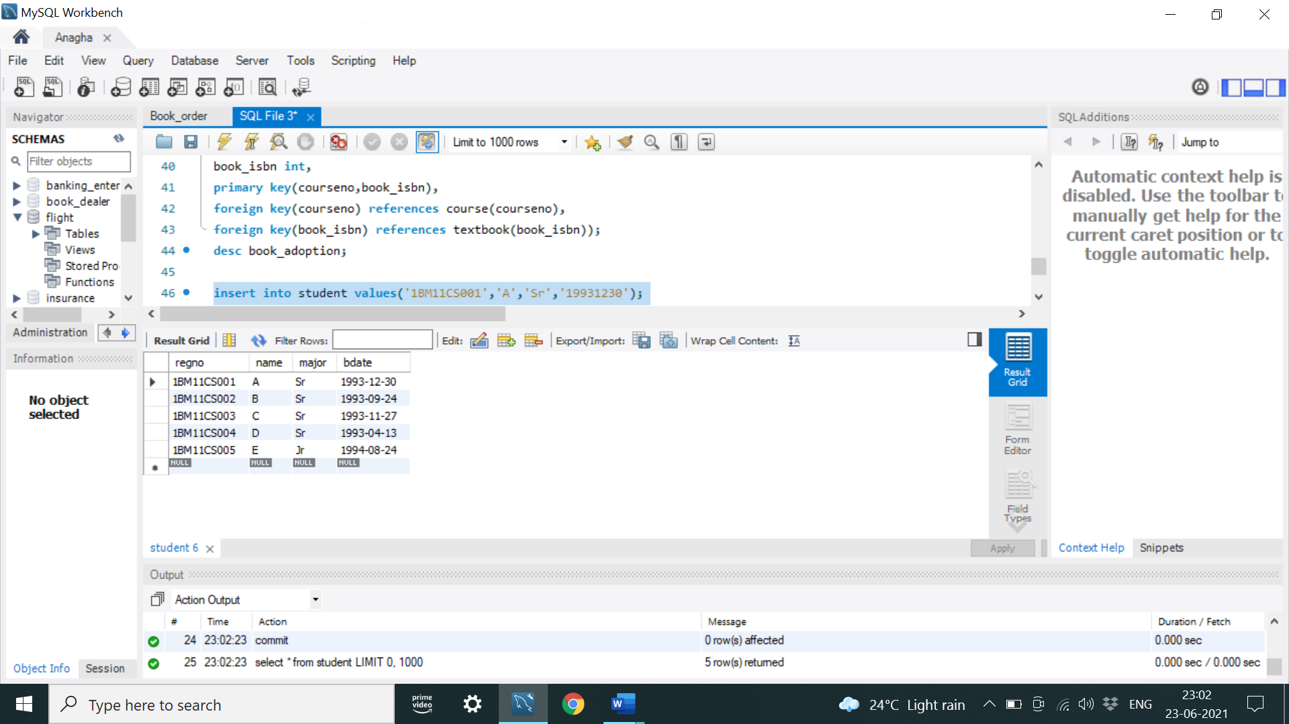 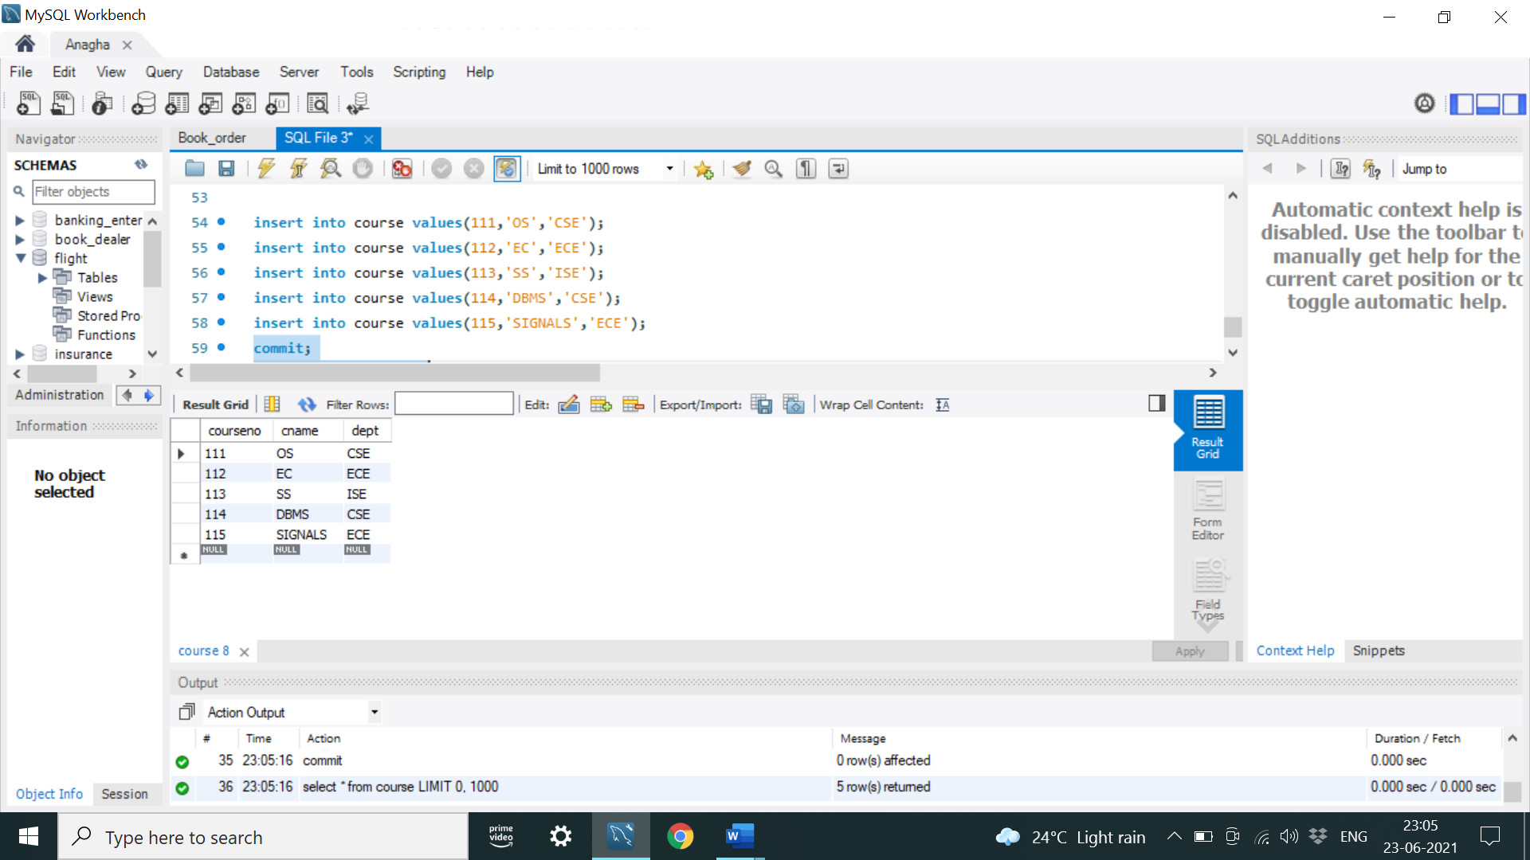

TEXTBOOK TABLE ENROLL TABLE

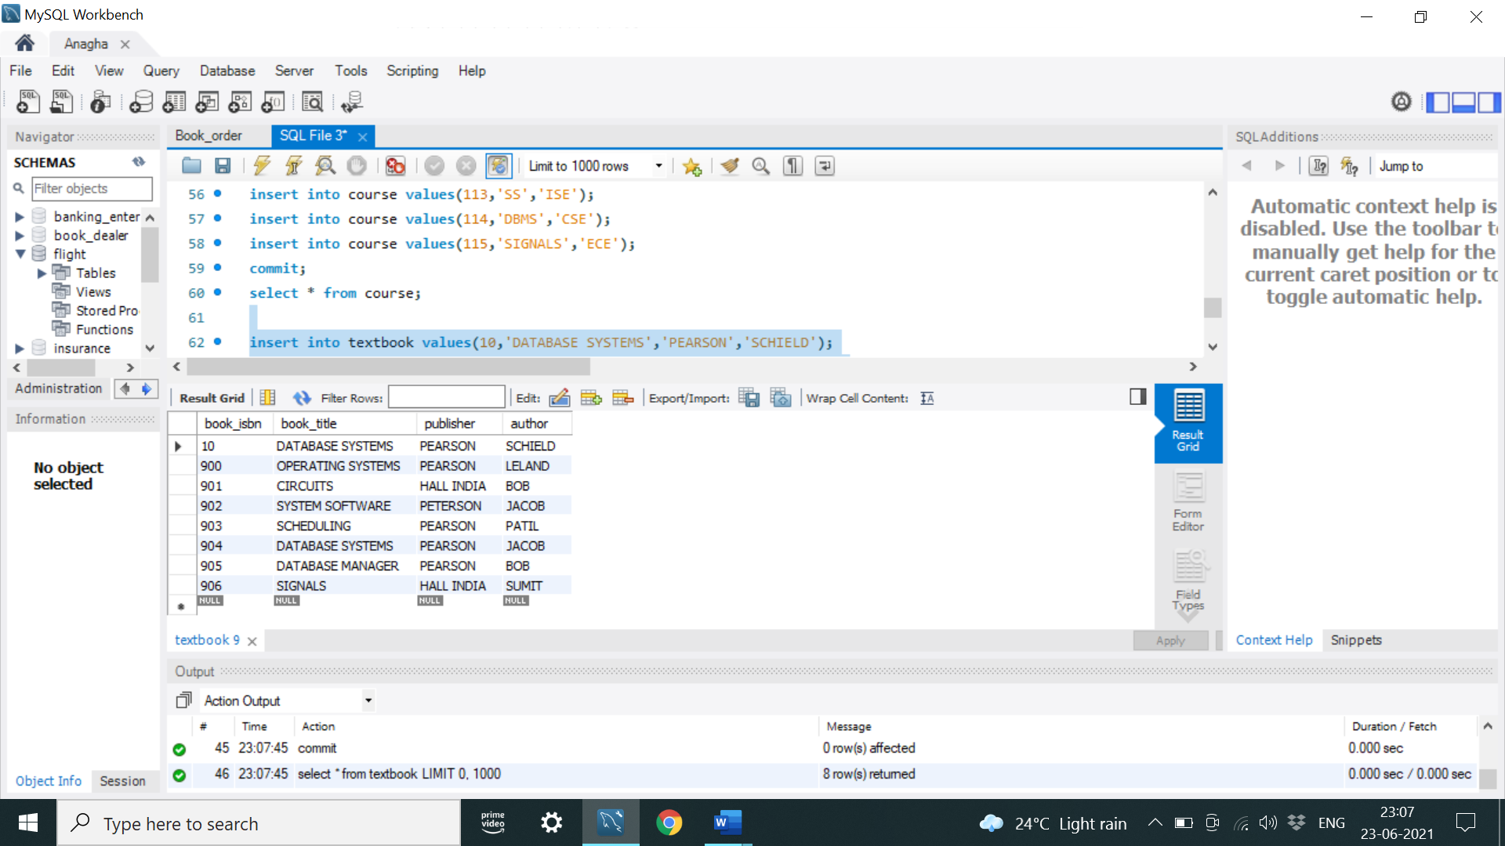 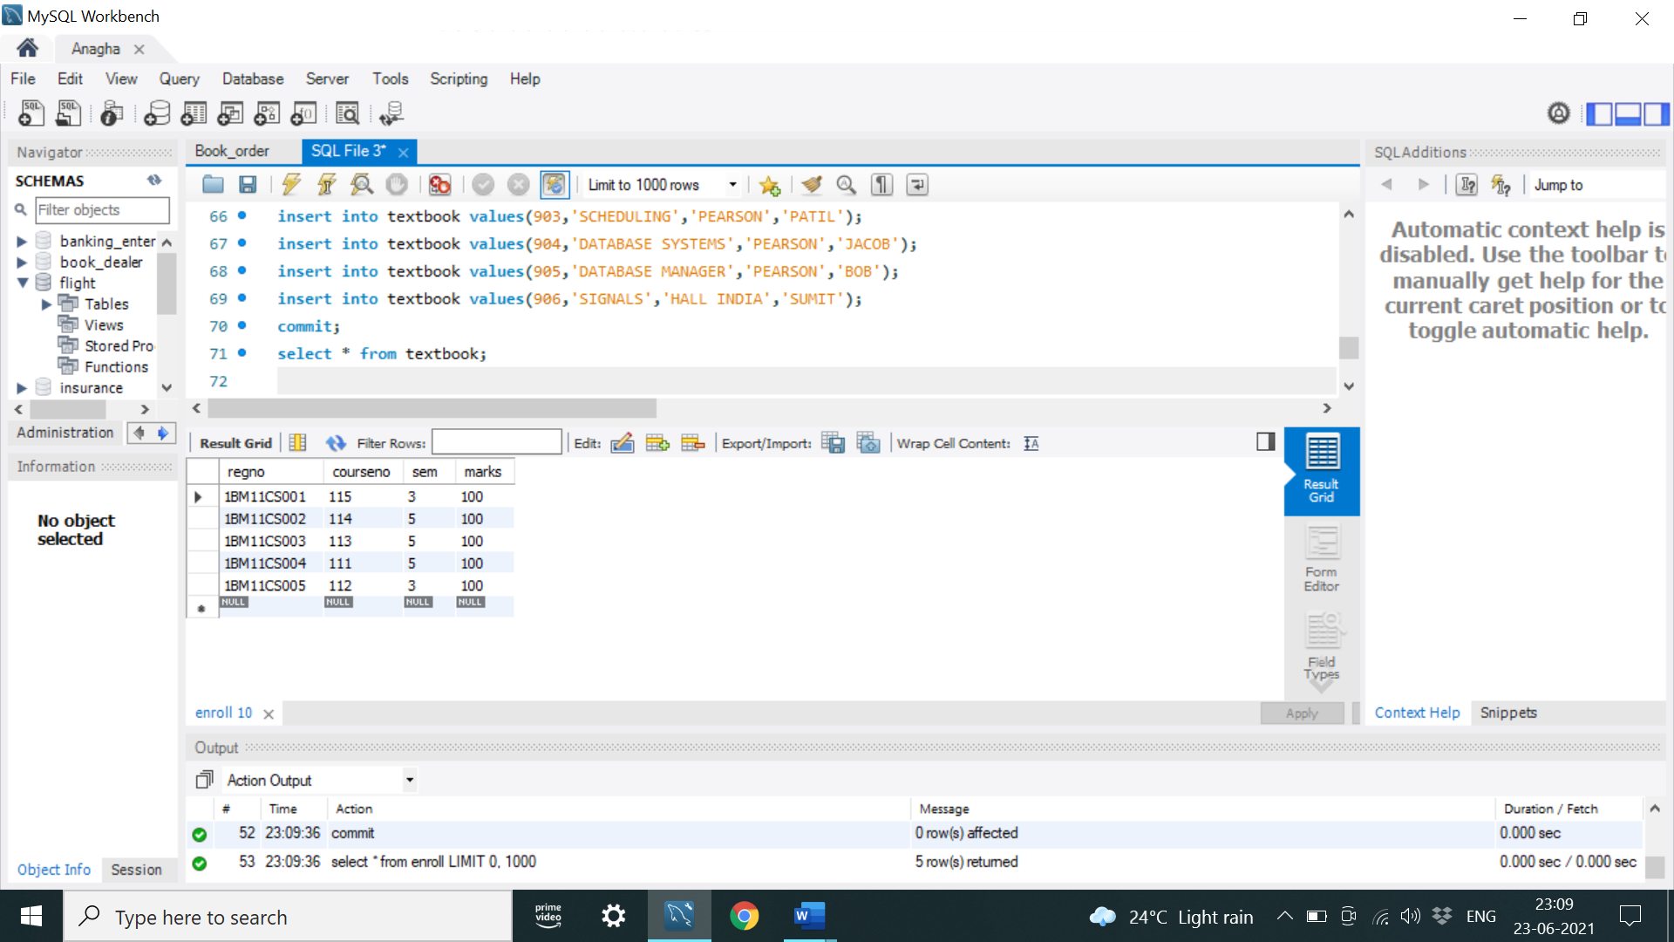

BOOK ADOPTION TABLE

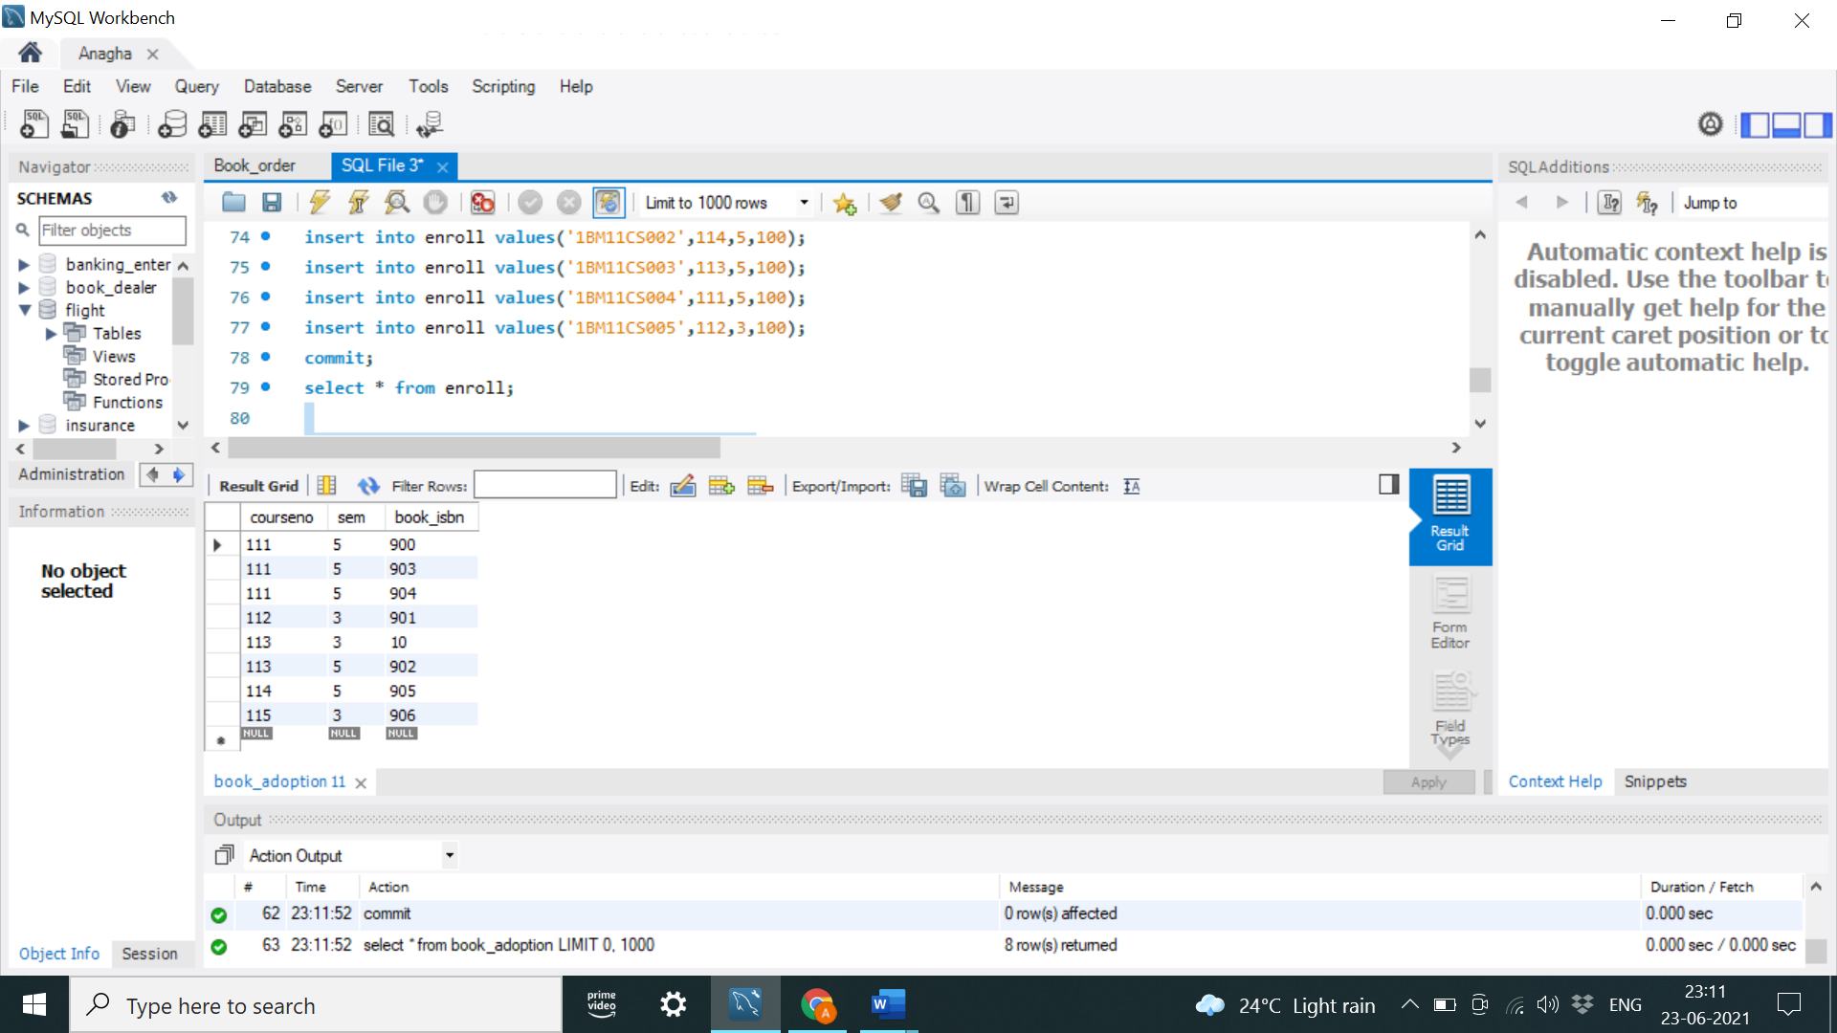

Query 1: Demonstrate how you add a new text book to the database and make this book be adopted by some department.

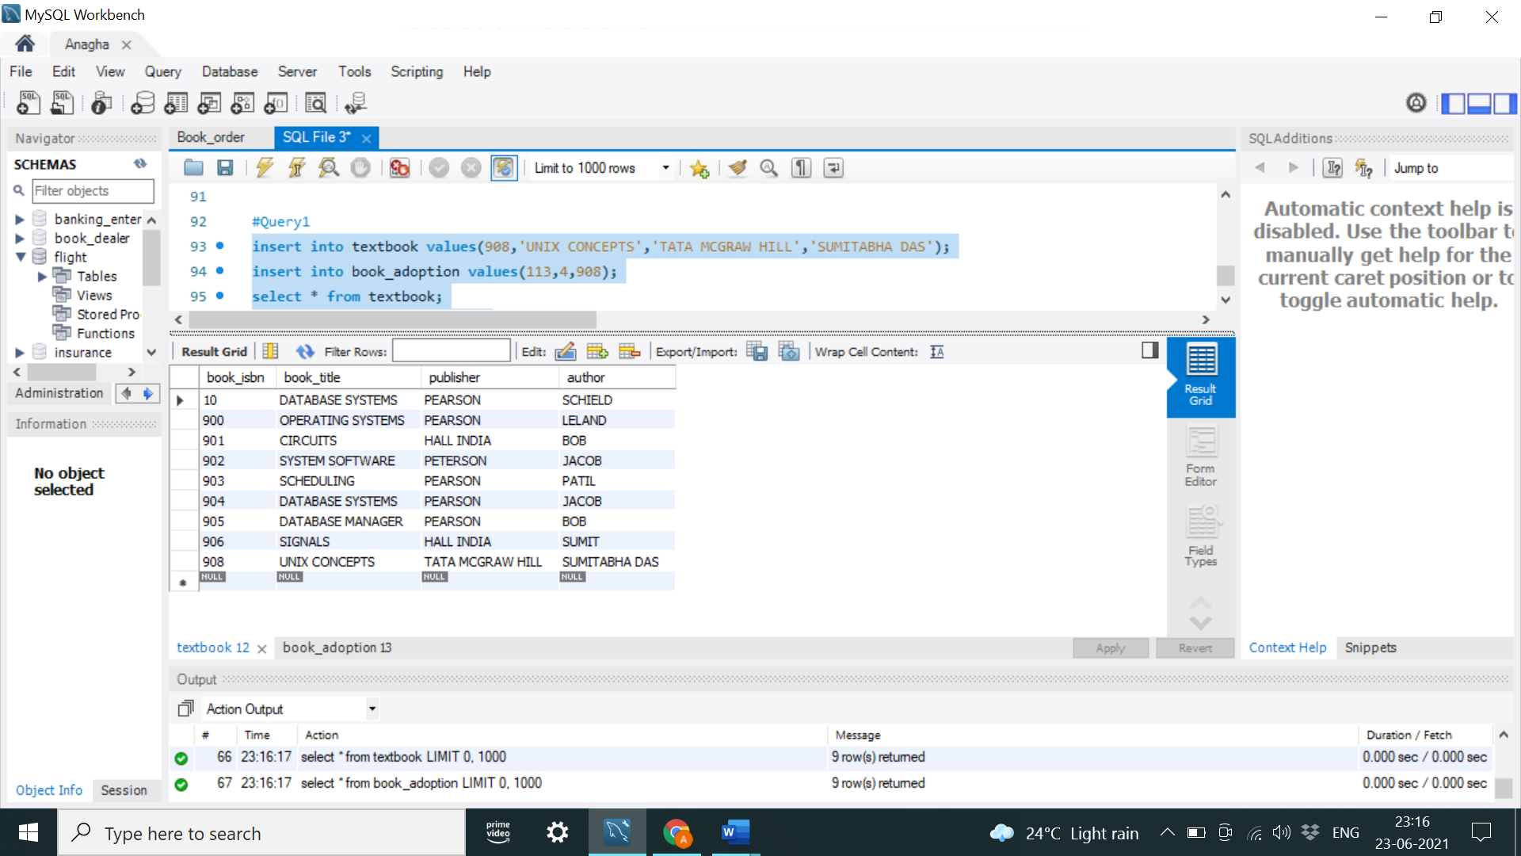 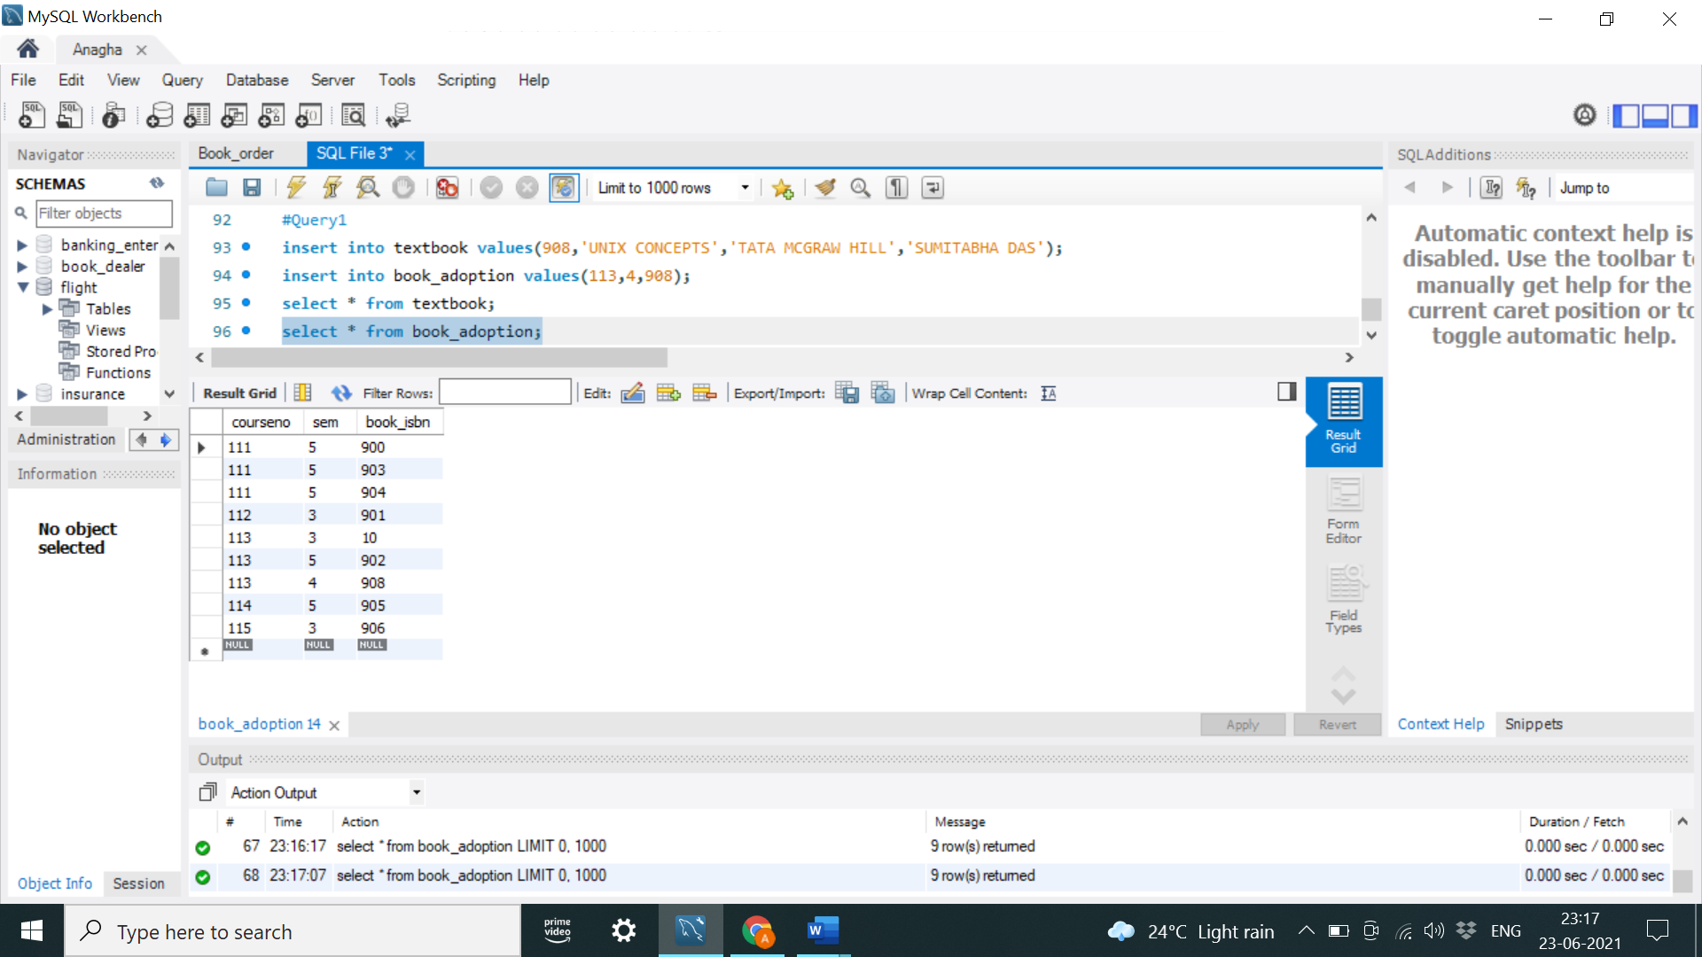

Query 2: Produce a list of text books (include Course #, Book-ISBN, Book-title) in the alphabetical order for courses offered by the ‘CS’ department that use more than two books.

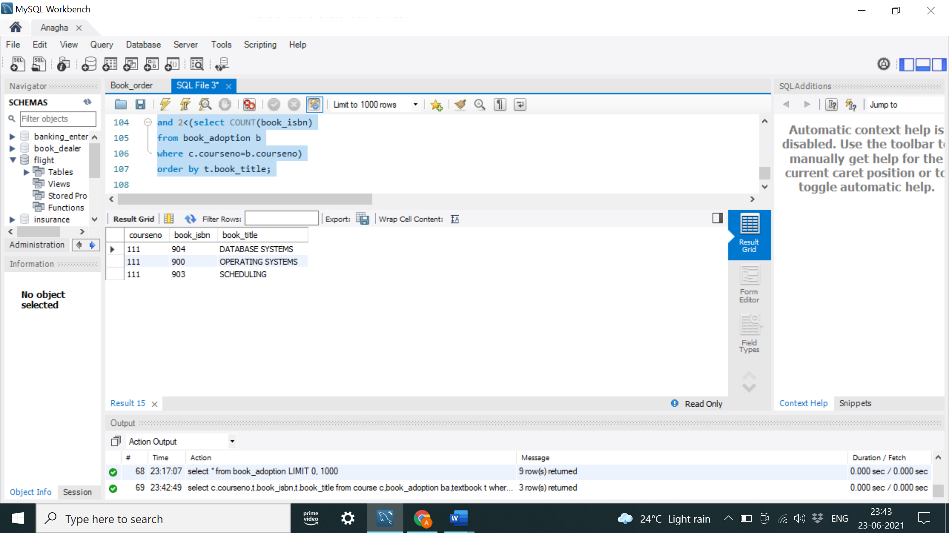

Query 3: List any department that has all its adopted books published by a specific publisher.

