ANAGHA ACHARYA

1BM19CS224

create database supplier;

use supplier;

create table Suppliers(

sid int,

sname varchar(20),

city varchar(20),

primary key(sid));

desc Suppliers;

create table Parts(

pid int,

pname varchar(20),

color varchar (10),

primary key(pid));

desc Parts;

create table Catalog(

sid int,

pid int,

cost real,

primary key(sid,pid),

foreign key(sid) references Suppliers(sid),

foreign key(pid) references Parts(pid));

desc Catalog;

insert into Suppliers values(10001,'Acme Widget','Bangalore');

insert into Suppliers values(10002,'Johns','Kolkata');

insert into Suppliers values(10003,'Vimal','Mumbai');

insert into Suppliers values(10004,'Reliance','Delhi');

commit;

select \* from Suppliers;

insert into Parts values(20001,'Book','Red');

insert into Parts values(20002,'Pen','Red');

insert into Parts values(20003,'Pencil','Green');

insert into Parts values(20004,'Mobile','Green');

insert into Parts values(20005,'Charger','Black');

commit;

select \* from Parts;

insert into Catalog values(10001,20001,10);

insert into Catalog values(10001,20002,10);

insert into Catalog values(10001,20003,30);

insert into Catalog values(10001,20004,10);

insert into Catalog values(10001,20005,10);

insert into Catalog values(10002,20001,10);

insert into Catalog values(10002,20002,20);

insert into Catalog values(10003,20003,30);

insert into Catalog values(10004,20003,40);

commit;

select \* from Catalog;

#Query1

select distinct p.pname

from Parts p, Catalog c

where p.pid=c.pid;

#Query2

select s.sname

from Suppliers s

where not exists(

select p.pid from Parts p where not exists(select c.sid from Catalog c where c.sid=s.sid));

#Query3

select s.sname

from Suppliers s

where not exists(select p.pid from Parts p where p.color='Red' and not exists(select c.sid from Catalog c where c.sid=s.sid and c.pid=p.pid));

#Query4

select p.pname

from Parts p,Catalog c,Suppliers s

where p.pid=c.pid and

c.sid=s.sid and

s.sname='Acme Widget' and not exists(select \* from Catalog ca,Suppliers su where p.pid=ca.pid and ca.sid=su.sid and su.sname<>'Acme Widget');

#Query5

select distinct c.sid

from Catalog c

where c.cost>(select avg(ca.cost) from Catalog ca where ca.pid=c.pid);

#Query6

select p.pid,s.sname

from Parts p, Suppliers s, Catalog c

where

c.pid=p.pid and

c.sid=s.sid and

c.cost=(select max(ca.cost) from Catalog ca where ca.pid=p.pid);

Suppliers: Parts:

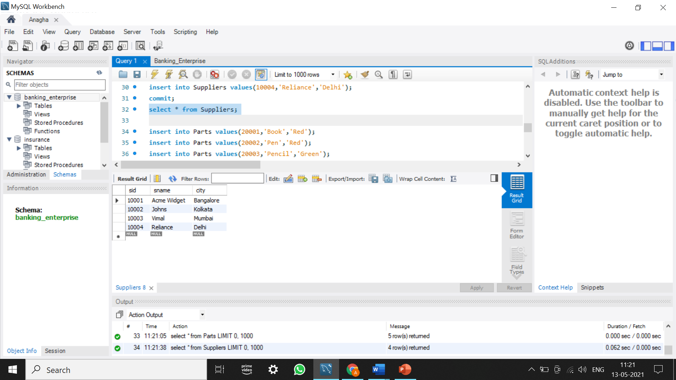 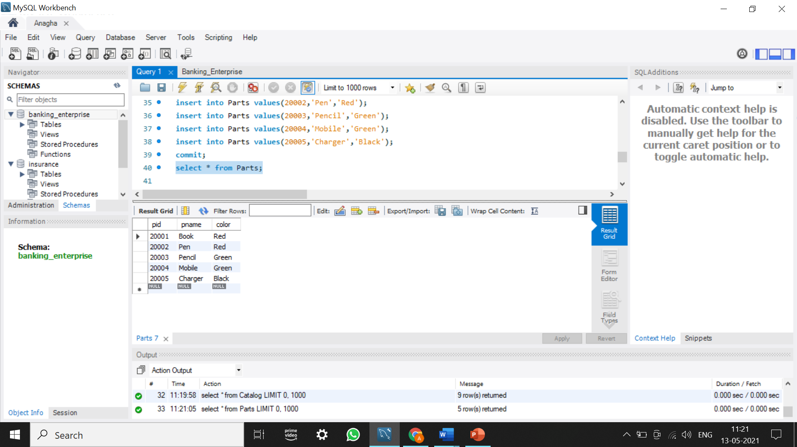

Catalog:

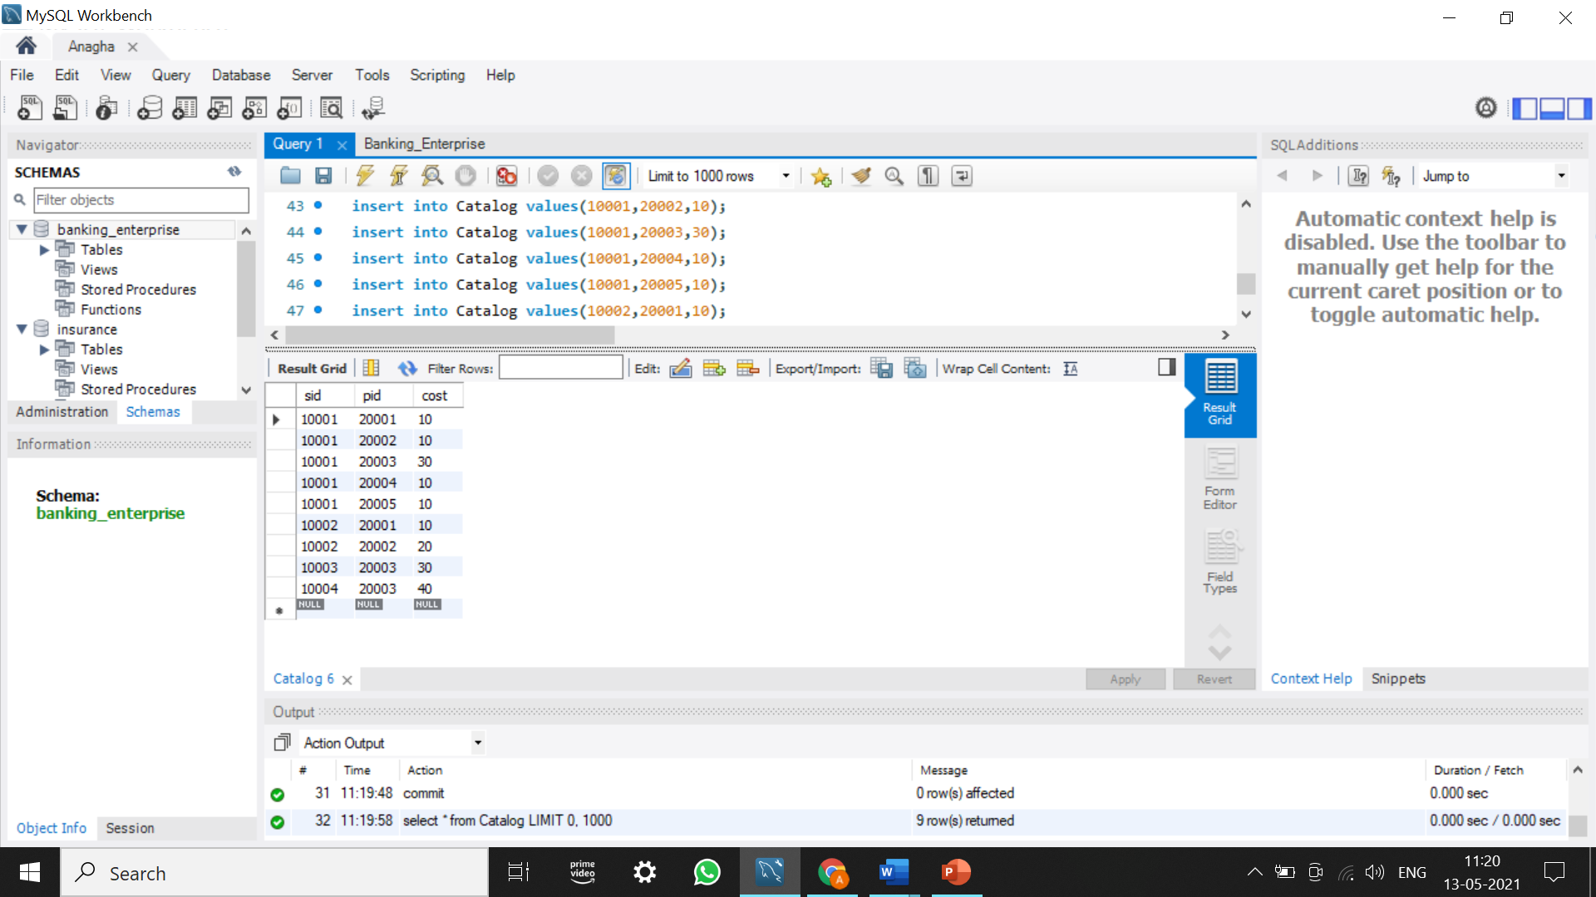

1.Find the pnames of parts for which there is some supplier.

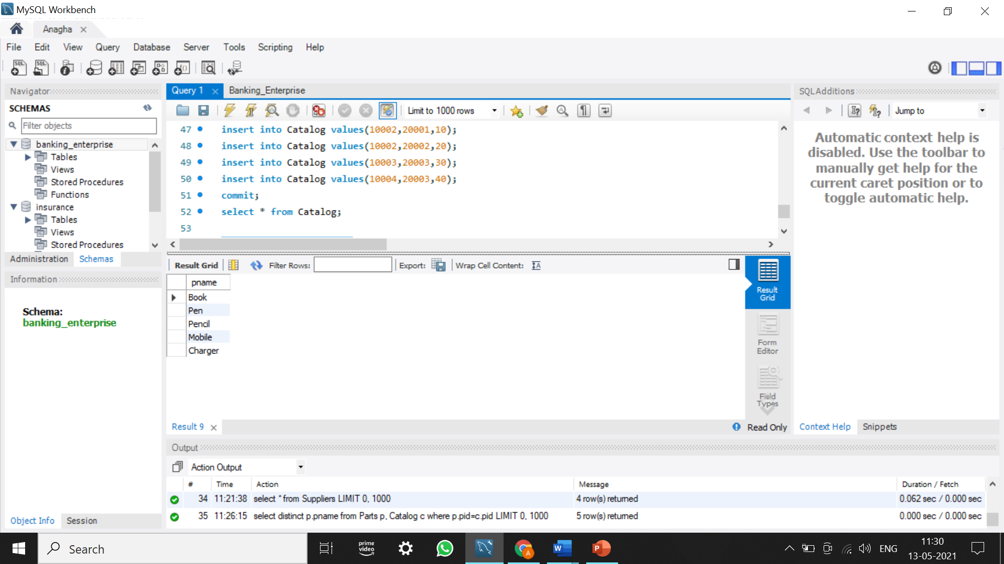

2.Find the snames of suppliers who supply every part.

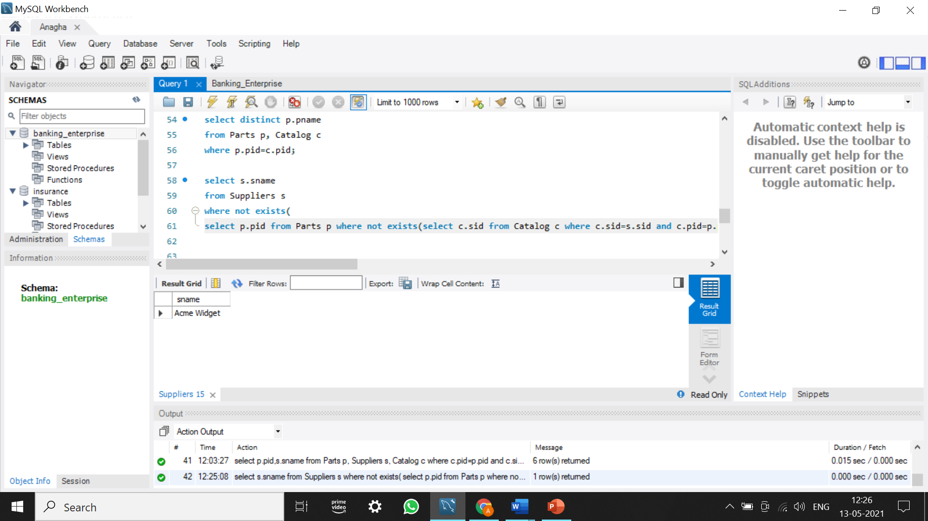

3.Find the snames of suppliers who supply every red part.

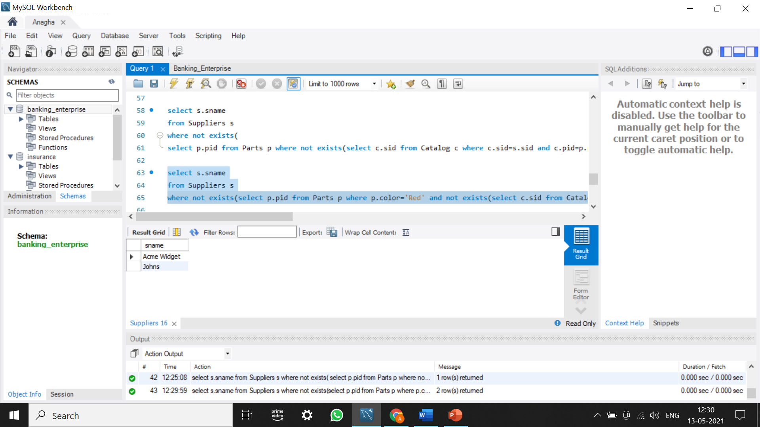

4.Find the pnames of parts supplied by Acme Widget Suppliers and by no one else.

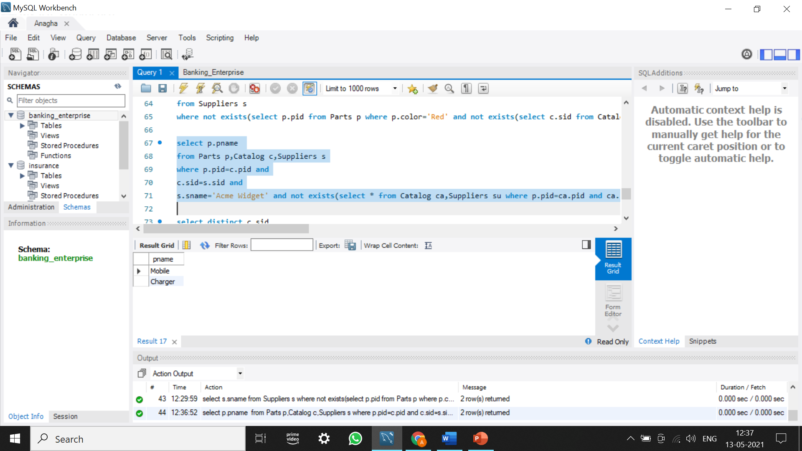

5.Find the sids of suppliers who charge more for some part than the average cost of that part (averaged over all the suppliers who supply that part).

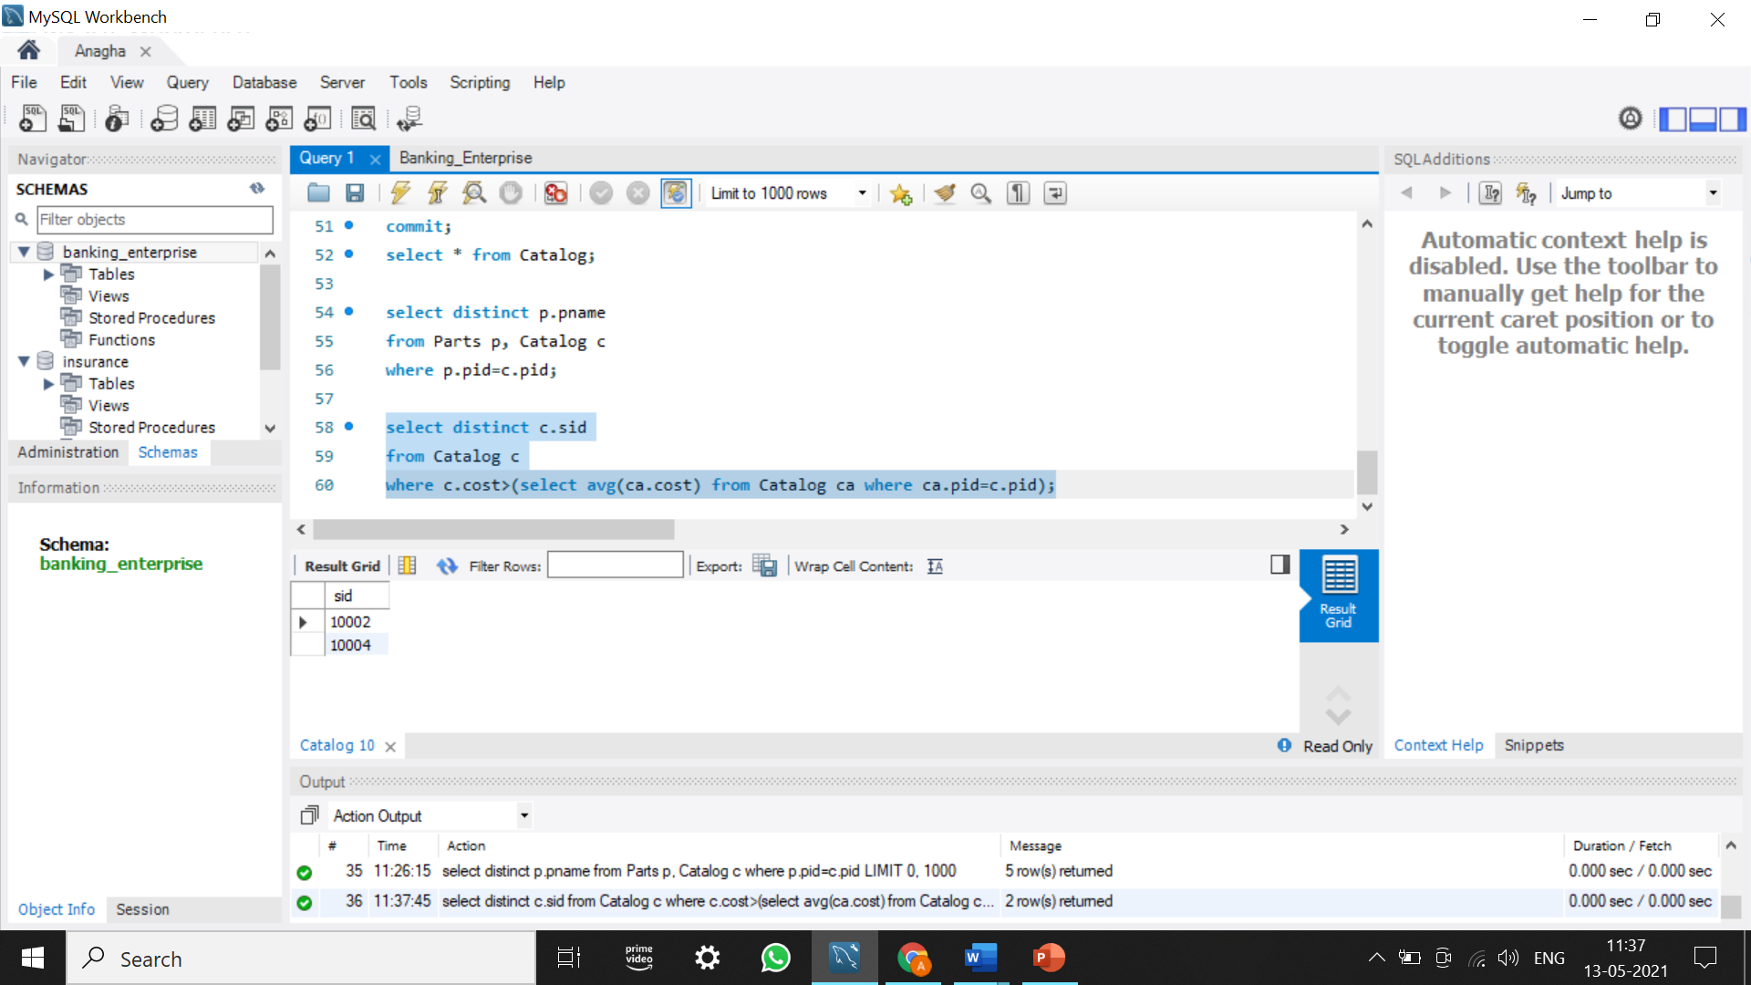

6.For each part, find the sname of the supplier who charges the most for that part.

