A Mini Project Report on

# Online Document Management System

S.E. I.T Engineering.

Submitted By

Lakshit Patil 20104043

Shreyash Ghute 20104051

Under the guidance of

Prof. Ganesh Gourshete



Department of Information Technology

A.P. SHAH INSTITUTE OF TECHNOLOGY

G.B. Road, Kasarvadali, Thane (W), Mumbai – 400615

Academic Year – 2021-22

# CERTIFICATE

This to certify that the Mini Project report on Online Document Management System has been submitted by Lakshit Patil(20104043) and Shreyash Ghute(20104051), who are a Bonafide students of A. P. Shah Institute of Technology, Thane, Mumbai, as a partial fulfilment of the requirement for the degree in Information Technology, during the academic year 2021-2022 in the satisfactory manner as per the curriculum laid down by University of Mumbai.

Mr.

Guide :- Ganesh Gourshete

Prof. Kiran Deshpande Dr. Uttam D.Kolekar

Head Dept. of Information Technology Principal

External Examiner(s):

1.

2.

Place: A.P. Shah Institute Of Technology, Thane

Date:

ACKNOWLEDGEMENT

This project would not have come to fruition without the invaluable help of our guide Mr. Ganesh Gourshete Expressing gratitude towards our HoD, Prof. Kiran Deshpande, and the Department of Information Technology for providing us with the opportunity as well as the support required to pursue this project. And also, for giving us his valuable suggestions and ideas when we were in need of them. We would also like to thank our peers for their helpful suggestions.

# TABLE OF CONTENTS

1. Introduction. ..................................................................................................... 1
   1. Purpose ............................................................................................................. 1
   2. Objectives. ........................................................................................................ 2
   3. Scope ................................................................................................................ 3
2. Features and Functionality ............................................................................... 5-6
3. Project Outcomes ............................................................................................. 7
4. Software Requirements .................................................................................... 7
5. Project Design ................................................................................................... 8-9
6. Project Scheduling ............................................................................................ 10
7. Conclusion ........................................................................................................ 11

**Chapter 1:-**

**Introduction**

Online Document Management System, are designed to organize business files and records digitally, whether they started out in paper form or were generated by software applications. Paper files are first converted to electronic format by scanning. This provides a more compact means of storage, universal access for retrieval, and higher levels of data security and privacy.

A company-wide document management software, also know as an enterprise content management storage, controls digital files that are generated directly through applications — such as those in the Microsoft Office suite (Word, Excel and PowerPoint), accounting software, CAD, email, and so on. Managing (rather than simply storing) documents enables quicker access to, and greater command over, business information.

.

* 1. **Purpose:**

More and more companies are trying to go paperless. It is convenient in every manner- eliminate errors, easy to manage, no stress of, damage and theft. They can be easily stored in a pen drive, hard disk and even on the cloud. In the case of cloud-based storage, you enjoy the access to your documents anytime, anywhere. Although going paperless has advantages over physical documentation, but the former comes with its own negatives as well. And security is one of the concerns. Therefore, document management software.

Document management is software that controls and organizes documents throughout an organization. It incorporates document and content capture, workflow, document repositories, COLD/ERM, and output systems, and information retrieval systems. Also, the processes used to track, store and control documents.

1.2 **Objectives:**

* Reduce lost and misfiled documents.
* Provide faster search and retrieval of documents.
* Reduce the amount of physical space used to store documents, such as file cabinets, boxes and shelving.
* Better organize existing documents.
* Streamline information and workflow.
* Allow instant access to documents.

**1.3 Scope:**

For many years, paper documents were used to store information. However, papers can be expensive and are wasteful as well. On the other hand, DMS can solve this paper issue by letting users access, track, and edit information stored in the document. DMS is a type of electronic cabinet that is used to store and organize paper and digital files.

# CHAPTER 2

**Features And Functionality: -**

* Document Input
* Document Indexing
* Document Search
* Document Processing
* Workflow Automation
* Document Security
* User Dashboard
* Customization

# CHAPTER 3

**Project Outcomes:-**

1. Document management systems empower enterprises to tick the boxes that demonstrate regulatory compliance, with improved visibility and control. The best DMSs let you graphically depict business process flow on your company intranet, which allows you to take a risk-based approach to quality processes.
2. A DMS provides an extra layer of control through granular access and dedicated partner login, empowering you to securely share controlled information with customers and suppliers.
3. A DMS facilitates internal collaboration, but the real benefit comes from the power to support collaboration between different stakeholders.

**Chapter 4:-**

**Software Requirements**

|  |  |  |
| --- | --- | --- |
| • | Language: - | Java 16 |
| • | Database:- | MySQL Workbench ver 8.0 CE , MYSQL ver 8.0.26 |
| • | Software Development Kit: - | Java JDK 16.0.2 windows , JavaFX – SDK – 17.0.0.1 |

# **Chapter 6:-**

**User Interface Design:**

User Interface Design is concerned with the dialogue between a user and the computer. It is concerned with everything from starting the system or logging into the system to the eventually presentation of desired inputs and outputs. User interface (UI) design is about building interfaces with a focus on styling and interactivity. The UI designer’s goal is to create an interface the user. 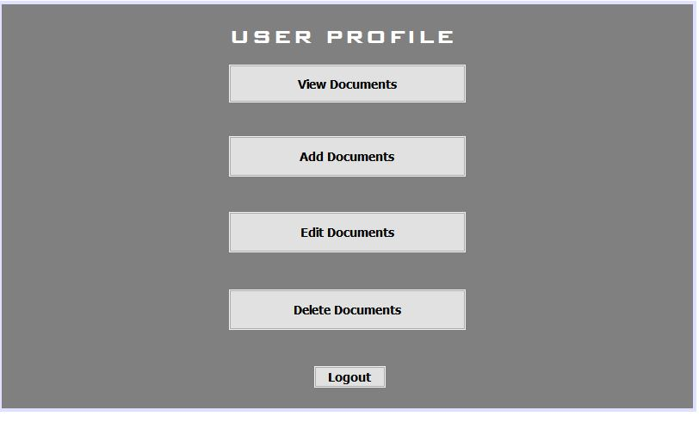

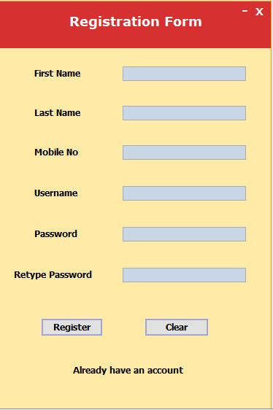

**Chapter 7:**

Project Scheduling Template

|  |  |  |
| --- | --- | --- |
| Group Member | Time duration | Work to be done |
| Lakshit Patil  Shreyash Ghute | 4th week of September | Implementing 1st module/ functionality    (Designing the registration page .  User can register with his credentials and will be able to access his username & password) |
| 1st week of October | Testing 1st module    (Registration page: After registration is done successfully user can login with his username & password in login page.     * USERNAME * PASSWORD |
| 2nd week of October | Implementing 2nd module / Functionality    (Designing next page / functionality: Next page is our user profile page. It shows the info. registered by the user in registration form.) |
|  | 2nd week of November | Implementing 3rd module / Functionality    (Designing Final page / functionality: Here we have created some tabs where the user can upload his various documents.) |

# **Chapter 8**

**Conclusion:**

Using DMS systems effectively within an organization ensures that data and knowledge is safe, accurate, and accessible. With that comfort, employees feel more apt to reduce paper and rely on the DMS system. It is one important step to becoming a paperless office.