TGM 553: GLOBAL CUSTOMER DECISION MAKING
Why the Same Speaker Can Win Alone and Lose Together
A Replication of Hsee's (1996) Evaluability Hypothesis and an Extension Testing an Extrinsic Celebrity Cue
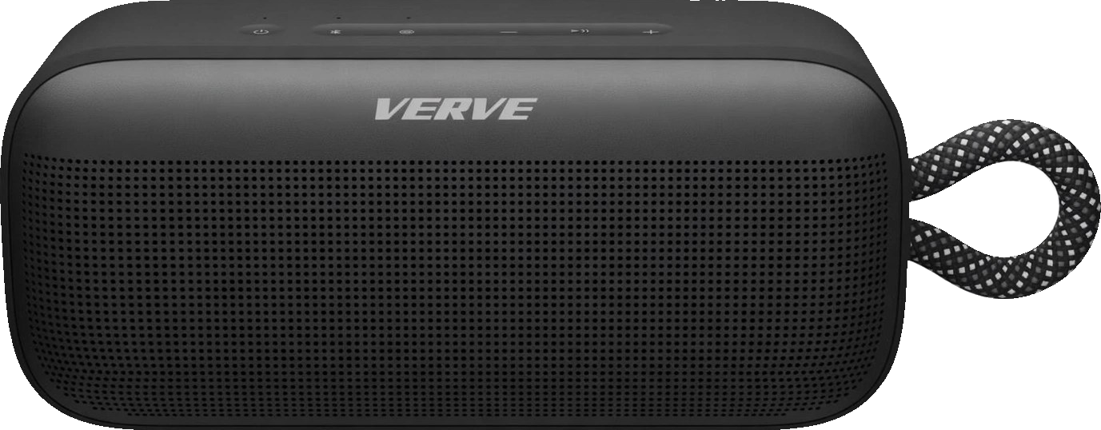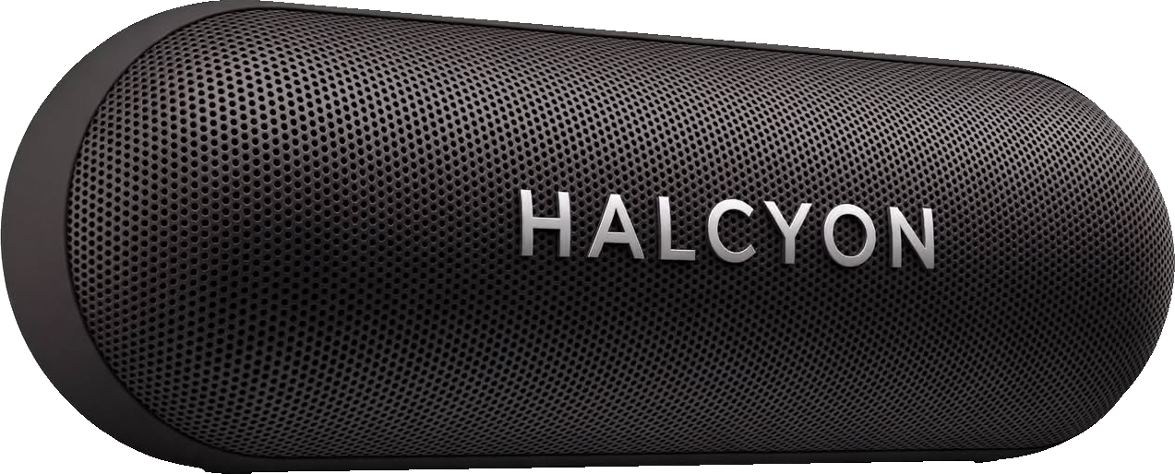
Group F Project Report: Replication Experiment and Extension Experiment
Abstract
A product can look more valuable when seen alone and less valuable when placed next to a competitor. We tested this idea in two online experiments (N = 111) using two fictional Bluetooth speakers. Study 1 replicated Hsee's (1996) evaluability experiment using star rating as the easy-to-evaluate attribute and total harmonic distortion as the hard-to-evaluate attribute. The expected preference reversal did not appear: both speakers had lower, though not significantly lower, willingness to pay (WTP) when shown together. Study 2 asked whether a celebrity association could help the technically weaker speaker in a side-by-side comparison. The cue raised WTP for both speakers by about $15 to $16 but did not change the gap between them. Neither hypothesis was supported. We test the results from several angles and discuss likely reasons, including a small star-rating gap, distortion values that were easier to interpret than Hsee's, a nine-country sample, limited power, and a no-cue baseline in which the predicted Halcyon advantage never appeared. We end with practical implications for how managers present, compare, and endorse products.

Introduction
Consumer preferences are often formed while a decision is being made rather than pulled from memory, so the way a choice is presented can change how the same options are valued (Levin et al., 2002; Park et al., 2000; Hsee & Leclerc, 1998). Hsee's (1996) evaluability hypothesis explains one important version of this effect: preference reversal between separate and joint evaluation.
Our project has two parts. The replication tests whether Hsee's preference reversal appears in a modern online product category: portable Bluetooth speakers, where shoppers often move between individual product pages and comparison tables. The extension asks something the original evaluability work does not directly test: if a brand loses a side-by-side comparison on a hard-to-judge technical attribute, can an outside cue help it regain value?

Part I: Replication Experiment

(a) Hypothesis Statement
We replicated Hsee's (1996) Study 1 using two fictional Bluetooth speakers instead of music dictionaries and using distortion as the technical attribute, as in his Study 4. Verve Sound had the stronger star rating, 4.7 versus 4.1. Halcyon Sound had the better distortion level, 0.3% versus 0.8%, because lower distortion indicates clearer sound.
H1: Verve Sound will have a higher willingness to pay (WTP) than Halcyon Sound when each is evaluated separately. When the two are evaluated together, the preference will reverse in favor of Halcyon Sound.
We tested H1 in two directions. Verve's WTP should fall from separate to joint evaluation (H1a), while Halcyon's WTP should rise from separate to joint evaluation (H1b).

(b) Theoretical Justification
The evaluability hypothesis says that an attribute matters more when people can easily judge whether its value is good or bad (Hsee, 1996). Some attributes come with a familiar reference scale, while others are difficult to interpret without something to compare them with.
Our two attributes were chosen to represent these two situations. Star ratings are familiar. Most online shoppers understand that 4.7 out of 5 is a strong rating even when no other product is shown. Total harmonic distortion is different. Most people do not know whether 0.8% is good or bad for a speaker without a benchmark. Hsee (1996) similarly used distortion, 0.003% versus 0.01%, as a hard-to-evaluate attribute.
When a speaker is shown alone, the distortion number has little context, so we expected shoppers to rely more on the star rating and value Verve more. When both speakers are shown together, the comparison provides the missing benchmark. Halcyon's 0.3% distortion is clearly lower than Verve's 0.8%, so the technical advantage becomes easier to see. We therefore expected value to shift toward Halcyon. This follows Hsee's dictionary study, where WTP shifted from $24 versus $20 in separate evaluation to $19 versus $27 in joint evaluation, favoring the larger but damaged dictionary once comparison made its advantage easier to judge.
There is also a second reason to expect this pattern. Separate evaluation encourages a more overall judgment against a general category standard, while joint evaluation encourages people to compare attributes directly across options (Hsee & Leclerc, 1998). Since the product information itself stays the same and only the evaluation mode changes, any reversal should come from how the choice is structured.

(c) Sample Description
Nature of sample. Across both studies, 75 of the 111 respondents (68%) were current students and 36 were non-students, reached through group members' university and personal networks. Most were aged 18 to 24 (40%) or 25 to 34 (40%), and the sample was split almost evenly by gender (57 men, 54 women). Respondents lived in nine countries: the United States (49), India (33), Zimbabwe (15), South Africa (8), the United Kingdom (2), and Ghana, Rwanda, Uruguay, and Vietnam (1 each).
Sample size. After cleaning the data (removing one person who completed two forms and one response with no price), 84 respondents were included in the replication: 26 evaluated Verve alone, 28 evaluated Halcyon alone, and 30 evaluated both speakers together. One Halcyon response of $40 was treated as missing because the form required a value between $50 and $200, leaving 29 valid Halcyon prices in the joint condition. Hsee (1996) used 116 students across the same three conditions.
Procedure. We ran the experiment online through Google Forms using a between-subjects design. Respondents were randomly assigned: each of the five group members split their contacts across all four forms, and each respondent completed one form. Every form used the same shopping scenario (a $50 to $200 budget) and fictional brand names. Each product card showed the speaker's image, star rating, review count (512 for both) and distortion percentage, and the scenario text stated that a lower distortion percentage means clearer sound (Appendix C). Participants entered the most they would pay in U.S. dollars. In the joint condition, both cards appeared side by side, so respondents could compare the two distortion percentages directly. Participants in the separate conditions also rated, on a 1-to-5 scale, how clearly they could judge each attribute value, which served as our manipulation check. We converted text and range answers into single dollar values and tested the hypotheses in SPSS using independent-samples t tests. By chance, the mix of countries and students differed somewhat across forms, so we also ran checks controlling for both (Table A7).

(d) Results
The manipulation check worked as intended. Participants found the star rating much easier to judge than distortion (M = 3.74 vs. 2.59), t(53) = 5.54, p < .001 (Table A1). This confirms that the two attributes differed in evaluability as planned.
H1 was not supported (Figure 1; Tables A2 and A3). Verve moved in the predicted direction, with WTP falling from $94.88 in separate evaluation to $89.53 in joint evaluation, but not significantly, t(54) = 0.59, p = .558 (one-sided p = .279). Halcyon moved opposite to the prediction: its WTP also fell, from $96.93 to $84.59, t(55) = 1.46, p = .149 (one-sided p in the predicted direction = .926). Verve received no premium for its higher rating in separate evaluation ($94.88 vs. $96.93), t(52) = -0.22, p = .825. In joint evaluation, the same respondents priced Verve $6.31 higher, t(28) = 1.00, p = .326, with 15 favoring Verve and 10 favoring Halcyon (Table A5), the opposite of the predicted reversal. The conclusion holds when the out-of-range $40 response is kept (Table A6) and when country and student status are controlled (Table A7).
Why H1 was not supported. The manipulation check shows that participants did see stars as easier to judge than distortion, so the basic easy-versus-hard distinction was present. We see eight possible reasons for the null result.
1. Hsee's original separate-evaluation result was itself only a trend (t = 1.69, p = .10); the clear significance appeared in the reversal (p < .001). Replications also often produce smaller effects than original studies (Open Science Collaboration, 2015).
2. Our products were more abstract. Hsee's dictionaries were tangible products that participants could picture and handle. Our speakers were shown through text and images, which may have given respondents a weaker basis for judging value.
3. The easy-attribute gap may have been too small. A difference between 4.7 and 4.1 stars is much less dramatic than a visibly torn dictionary cover. Online ratings also tend to cluster near the top of the scale (Hu et al., 2009), so participants may have viewed both ratings as simply 'good.' Verve's higher rating did not create a WTP premium.
4. Our sample was diverse and unevenly mixed across forms. Respondents lived in nine countries, where a dollar does not mean the same thing. Non-students priced Verve about $26 higher than students, F(1, 54) = 8.60, p = .005 (Peterson, 2001), and the Verve-alone form happened to include more non-students (12 of 26) than the joint form (8 of 30); once student status and country are controlled, evaluation mode explains essentially none of Verve's price difference (Table A7). Hypothetical WTP is also noisy (Murphy et al., 2005; Ariely et al., 2003).
5. Participants knew they were completing a survey. That awareness can make people answer more deliberately and self-consciously than they would during a real purchase (Orne, 1962).
6. The sample size limited our power. We had about 28 respondents per cell and standard deviations of roughly $28 to $39. The Halcyon effect (d about 0.39) had only about 30% power; around 106 respondents per cell would be needed for 80% power (Cohen, 1992).
7. Our distortion attribute was probably easier to understand than Hsee's, for three reasons. First, we labeled it simply 'Distortion', a word most people already know is bad for sound, whereas Hsee used the technical term total harmonic distortion (THD). Second, our values were below 1%, so a figure like 0.3% reads as 'very little distortion' even without a comparison, while Hsee's tiny decimals (.003% and .01%) are hard to picture. Third, our scenario text told respondents that a lower percentage means clearer sound. Hsee gave the same explanation and still found a reversal, but our clarity scores place our attribute closer to his easy condition: rescaled from 0 to 1, our distortion score (0.40) fell between his hard version (0.33) and his version with a benchmark range (0.51). Prices point the same way, since Halcyon was valued as highly as Verve even when shown alone ($96.93 vs. $94.88), leaving little room for the reversal.
8. Both speakers may already have looked attractive. Hsee and Leclerc (1998) show that when options are above the category reference point, putting them side by side can lower the value of both. That is what we observed directionally: both WTP means fell in joint evaluation, although neither decrease was significant. Because we did not measure the reference point for distortion, this remains a possible explanation rather than a confirmed one.

(e) Managerial Implications
As the assignment asks, these implications are written as if H1 had been supported; where our data add a caution, we note it.
1. Invite comparison when your advantage is hard to judge. If H1 holds, a product that leads on a hard-to-evaluate specification, like Halcyon's lower distortion, gains value when shoppers compare. Managers of such products should create comparison moments: side-by-side tables on product pages, 'compare with similar items' widgets, comparison shelf displays, and review-site placements next to named rivals. They should measure success as accepted price and conversion in comparison contexts versus single-product contexts.
2. Win the single-product moment when your advantage is easy to judge. A product that leads on an easy attribute, like Verve's 4.7 stars, does best when it is evaluated alone. Its managers should invest in channels where products are seen one at a time, such as social media ads, influencer posts, gift guides, and dedicated product pages, lead with the rating, and avoid comparison tables that place it next to technically stronger rivals. Our data add one caution: comparison lowered WTP for both speakers, so even strong products can lose value when compared directly (Hsee & Leclerc, 1998).
3. Manage how easy your specifications are to judge. Evaluability is not fixed. The technical leader can supply a benchmark on its own product page, such as '0.3% distortion: clearer than most speakers under $150' or a simple good-to-poor scale, so its advantage counts even without a comparison. The technical laggard should focus its messaging on its easy-to-judge strengths rather than on the specification. Managers can A/B test benchmarked versus raw specifications and track conversion and price acceptance.

(f) Summary of Findings
We replicated Hsee's (1996) separate-versus-joint evaluation experiment using two fictional Bluetooth speakers. Verve was stronger on the easy-to-evaluate attribute, star rating, while Halcyon was stronger on the hard-to-evaluate attribute, distortion. Eighty-four respondents gave WTP in one of three conditions. The manipulation check confirmed that star ratings were much easier to judge than distortion, but the expected preference reversal did not appear. Verve received no premium when shown alone. When the speakers were shown together, WTP fell for both: by $5.35 for Verve and $12.34 for Halcyon. Neither change was statistically significant.
The result does not mean evaluability is unimportant. It shows how sensitive evaluability is to the way information is communicated, and that comparison itself can lower value when both products already look strong.

Part II: Extension Experiment

(a) Hypothesis Statement
The replication focused on attributes inside the product, such as ratings and distortion. For the extension, we asked a different question. According to Hsee's (1996) evaluability hypothesis, Halcyon should win when the two speakers are compared, because comparison makes its distortion advantage visible. If a brand is weaker on a technical specification in a side-by-side comparison, can a positive signal from outside the product help it regain value?
H2: In joint evaluation, adding a celebrity association to Verve Sound will increase the Verve-minus-Halcyon WTP gap compared with joint evaluation without the celebrity cue.
This produced three tests. We expected Verve's WTP to increase with the cue (H2a), Halcyon's WTP not to increase because the cue belonged to Verve (H2b), and, most importantly, the Verve-minus-Halcyon WTP gap to become larger with the cue (H2c).

(b) Theoretical Justification
Cue Utilization Theory. Consumers judge quality using both intrinsic cues, which are part of the product, and extrinsic cues, such as brand, price, or endorsement (Olson & Jacoby, 1972). How much a cue matters depends partly on how confident consumers feel interpreting it. Distortion is relevant to speaker quality, but most shoppers have low confidence judging what the numbers actually mean. Even side by side, they can see that 0.3% is lower than 0.8% without knowing whether that difference is noticeable. This uncertainty leaves room for an external cue to influence judgment.
Elaboration Likelihood Model. When people have less ability or motivation to process a central argument, they rely more on peripheral cues that require less effort (Petty & Cacioppo, 1986). A celebrity is a classic peripheral cue. A mid-priced speaker is a moderate-involvement purchase, while interpreting distortion takes effort, so we expected the celebrity cue to carry weight.
Link to evaluability. A celebrity association is easy to understand without a comparison, so we expected it to stay influential in joint evaluation, where side-by-side display highlights differences between options (Hsee, 1996). Halcyon held the intrinsic technical advantage; Verve held the extrinsic celebrity advantage. We chose a recording artist because the association relates to music and sound, and, following McCracken's (1989) meaning-transfer model, showed her holding the speaker in the style of an influencer post so that her meaning would transfer to Verve specifically.
We also considered another possibility. The celebrity could make the whole comparison feel more premium, raising WTP for both speakers while leaving the gap between them unchanged. This would be consistent with the reference-point logic of Hsee and Leclerc (1998). Our main hypothesis predicted a Verve-specific effect, while the data allowed us to see which pattern appeared.

(c) Sample Description
Nature and size of sample. We recruited 27 new respondents from the same multinational pool (21 students and 6 non-students, mostly from the United States and India). We compared them with the 30 joint-evaluation respondents from Part I, 29 of whom provided valid prices for both speakers. This gave us 57 respondents in the extension and 111 respondents across the full project.
Procedure. Form 4 repeated Form 3's scenario and attribute levels, but Verve's card showed pop artist Dua Lipa holding the speaker, captioned "Dua Lipa's Verve Era: Can't put it down, can't turn it off, on repeat all day" (Appendix C). The design intentionally mirrored an influencer-style post rather than a formal advertisement. On a recall question, 20 of 27 respondents (74%) correctly chose Dua Lipa. We used independent-samples t tests to compare the no-cue and cue conditions on Verve's WTP, Halcyon's WTP, and each respondent's Verve-minus-Halcyon gap.

(d) Results
H2 was not supported (Figure 2; Table A4). Verve's WTP increased from $89.53 to $104.96, t(55) = -1.50, p = .139 (one-sided p = .069; H2a). However, Halcyon's WTP also increased, from $84.59 to $100.33, t(54) = -1.96, p = .055, contrary to H2b. In the key test, the Verve-minus-Halcyon gap moved from $6.31 to $4.63, t(54) = 0.14, p = .890; because it narrowed rather than widened, the one-sided p in the predicted direction is .555 (H2c). Choice shares agreed: Verve was priced higher by 15 of 29 respondents without the cue and 13 of 27 with it (Table A5). The conclusion held when we kept the $40 response (Table A6), used only respondents who correctly recalled the celebrity (gap p = .863), and controlled for country and student status (gap p = .370; Table A7).
One reading is a category halo: the celebrity may have made the whole comparison feel more valuable rather than giving Verve a unique advantage, raising the reference point against which both products were judged (Hsee & Leclerc, 1998; Thorndike, 1920). We treat this cautiously. By chance, Form 4 drew more respondents from India and fewer from Africa than Form 3, and much of the rise in both prices came from Indian respondents. After controlling for country and student status, Halcyon's increase remained (+$19, p = .021) but Verve's did not (+$9, p = .405; Table A7), so who answered each form explains at least part of the shared lift.
Why H2 was not supported. Some of the Study 1 limitations still apply, especially the abstract stimuli. We see four likely reasons for the extension's null result.
1. The comparison Verve was meant to win back never went against it. Following Hsee (1996), H2 assumed that Halcyon would lead in joint evaluation once its distortion advantage became visible. In our no-cue joint condition, however, Verve was already priced $6.31 higher. With no deficit for the cue to offset, the extension had little room to show a Verve-specific gain.
2. Respondents knew they were completing an academic survey. Because the prices were hypothetical, respondents may not have answered as they would in a real purchase decision, and awareness of being studied can make answers more deliberate and less responsive to persuasive cues (Orne, 1962). Hypothetical willingness to pay is also known to be inflated and noisy (Murphy et al., 2005).
3. Many respondents do not use the dollar every day. For people outside the United States, a dollar price has no everyday reference point, so they judge it by their own notions: some convert it into local currency, while others read the small face value as cheap, since $50 or $60 sounds like far less than 5,000 or 6,000 rupees. Consumers are known to misjudge prices in unfamiliar currencies, overpaying or underpaying depending on how large the number looks (Raghubir & Srivastava, 2002). This makes WTP less comparable across respondents, especially because Form 4 drew more respondents from India than Form 3.
4. Endorsement effects vary, and our extension had limited statistical power. Research shows that endorsement effects depend on the endorser, product, and message (Knoll & Matthes, 2017). With a standard deviation of roughly $45 for the within-person WTP gap, detecting a reliable change would require a much larger sample than the 56 respondents available for that test (Cohen, 1992).

(e) Managerial Implications
As required by the assignment, the following implications are written from the logic of H2 as if it had been supported, while also using what our actual data taught us.
1. If your product loses on a hard technical specification, change what shoppers are evaluating at the point of comparison. An easy-to-understand extrinsic cue can give consumers another reason to value the product without trying to win the same specification battle. Managers should place that cue where comparison actually happens, such as marketplace comparison charts, shelf talkers, or enhanced product pages, rather than using it only in general awareness advertising. The headphone market gives a real-world parallel: Beats, a brand strongly associated with culture and celebrity, is used by 15.3% of U.S. respondents, compared with Bose at 12.5% and Sony at 11.4% (ElectroIQ, 2025; Figure 3).
2. Make the endorsement clearly product-specific, or the competitor may benefit too. In our study, average WTP rose for both speakers with the cue and Verve's relative lead stayed almost unchanged. Managers should connect the celebrity directly to the product through a clear usage claim and visible brand mark. They should also judge success using relative measures, such as price premium over competitors or share of preference, because a rise in absolute WTP may simply reflect category inflation. Retailers could also use this halo intentionally: an endorsed hero product may raise price acceptance across an aisle, including private-label products.
3. Use different strategies depending on how the shopper sees the product. If the brand leads on the hard attribute, invite comparison and make that specification easy to see. If the brand trails on the hard attribute, lead with easy cues when the product is shown alone and use a clearly product-specific extrinsic cue when comparison happens (Appendix D). Celebrity endorsement is only one option. Managers can also test expert recommendations, awards, country of origin, packaging, or retailer prestige.

(f) Summary of Findings
Our extension asked whether a brand that is weaker on a hard-to-judge technical specification could regain value in a side-by-side comparison through an outside cue. Based on Cue Utilization Theory, the Elaboration Likelihood Model, and the evaluability hypothesis, we predicted that a celebrity association would widen Verve's WTP advantage over the technically stronger Halcyon. Among 57 respondents, Verve's WTP rose by $15.43 and Halcyon's rose by $15.75. Because the gap between them did not increase (p = .890), H2 was not supported.
Still, the unexpected result gave us a useful lesson. Even an endorsement that names the brand can lift the perceived value of the whole comparison, allowing the rival to benefit as well, although part of this lift may reflect who answered each form. Extrinsic cues may still help a brand that trails on a technical attribute, but the cue needs to carry credible, product-relevant meaning, be placed where comparison happens, and be judged by relative rather than only absolute gains.

General Discussion: Limitations and Future Research
Two lessons cut across both studies. Small samples are sensitive: keeping one out-of-range $40 response moved the Halcyon celebrity-effect p value from .055 to .037 (Table A6), and controlling for sample mix shifted some estimates (Table A7), although no conclusion changed. Future research should use at least 100 respondents per cell, balance assignment by country, use distortion values that are harder to judge without a benchmark, compare an influencer-style post with an explicit expert endorsement, and test the cue in a full 2 x 2 design across separate and joint evaluation.
References
- Ariely, D., Loewenstein, G., & Prelec, D. (2003). "Coherent arbitrariness": Stable demand curves without stable preferences. The Quarterly Journal of Economics, 118(1), 73–106.
- Cohen, J. (1992). A power primer. Psychological Bulletin, 112(1), 155–159.
- ElectroIQ. (2025, November 18). Headphones statistics by market size, usage, ownership and facts (2025). https://electroiq.com/stats/headphones-statistics/
- Hsee, C. K. (1996). The evaluability hypothesis: An explanation for preference reversals between joint and separate evaluations of alternatives. Organizational Behavior and Human Decision Processes, 67(3), 247–257.
- Hsee, C. K., & Leclerc, F. (1998). Will products look more attractive when presented separately or together? Journal of Consumer Research, 25(2), 175–186.
- Hu, N., Pavlou, P. A., & Zhang, J. (2009). Overcoming the J-shaped distribution of product reviews. Communications of the ACM, 52(10), 144–147.
- Knoll, J., & Matthes, J. (2017). The effectiveness of celebrity endorsements: A meta-analysis. Journal of the Academy of Marketing Science, 45(1), 55–75.
- Levin, I. P., Schreiber, J., Lauriola, M., & Gaeth, G. J. (2002). A tale of two pizzas: Building up from a basic product versus scaling down from a fully loaded product. Marketing Letters, 13(4), 335–344.
- McCracken, G. (1989). Who is the celebrity endorser? Cultural foundations of the endorsement process. Journal of Consumer Research, 16(3), 310–321.
- Murphy, J. J., Allen, P. G., Stevens, T. H., & Weatherhead, D. (2005). A meta-analysis of hypothetical bias in stated preference valuation. Environmental and Resource Economics, 30(3), 313–325.
- Olson, J. C., & Jacoby, J. (1972). Cue utilization in the quality perception process. In M. Venkatesan (Ed.), Proceedings of the Third Annual Conference of the Association for Consumer Research (pp. 167–179). Association for Consumer Research.
- Open Science Collaboration. (2015). Estimating the reproducibility of psychological science. Science, 349(6251), aac4716.
- Orne, M. T. (1962). On the social psychology of the psychological experiment: With particular reference to demand characteristics and their implications. American Psychologist, 17(11), 776–783.
- Park, C. W., Jun, S. Y., & MacInnis, D. J. (2000). Choosing what I want versus rejecting what I do not want: An application of decision framing to product option choice decisions. Journal of Marketing Research, 37(2), 187–202.
- Peterson, R. A. (2001). On the use of college students in social science research: Insights from a second-order meta-analysis. Journal of Consumer Research, 28(3), 450–461.
- Petty, R. E., & Cacioppo, J. T. (1986). The elaboration likelihood model of persuasion. Advances in Experimental Social Psychology, 19, 123–205.
- Raghubir, P., & Srivastava, J. (2002). Effect of face value on product valuation in foreign currencies. Journal of Consumer Research, 29(3), 335–347.
- Thorndike, E. L. (1920). A constant error in psychological ratings. Journal of Applied Psychology, 4(1), 25–29.

Appendix A: Statistical Output Tables
Table A1
Manipulation Check: Perceived Clarity of Each Attribute (Separate Evaluation Forms)
Item (1 = not at all clear, 5 = very clear) | N | Mean (SD) | Paired t test
How clear is it whether the star rating is good or bad? | 54 | 3.74 (1.01)
How clear is it whether the distortion rating is good or bad? | 54 | 2.59 (1.39) | t(53) = 5.54, p < .001
Table A2
Group Statistics: Willingness to Pay (U.S. Dollars) by Condition, Final Cleaned Data
Variable | Condition (form) | N | Mean (SD) | Test
WTP Verve | Separate, Verve alone (Form 1) | 26 | 94.88 (30.73) | Separate test; H1a
WTP Halcyon | Separate, Halcyon alone (Form 2) | 28 | 96.93 (36.22) | Separate test; H1b
WTP Verve | Joint, no cue (Form 3) | 30 | 89.53 (36.31) | H1a; H2a
WTP Halcyon | Joint, no cue (Form 3) | 29 | 84.59 (26.87) | H1b; H2b
WTP Verve | Joint, celebrity cue (Form 4) | 27 | 104.96 (41.26) | H2a
WTP Halcyon | Joint, celebrity cue (Form 4) | 27 | 100.33 (33.04) | H2b
WTP gap (Verve minus Halcyon) | Joint, no cue (Form 3) | 29 | 6.31 (33.98) | H2c
WTP gap (Verve minus Halcyon) | Joint, celebrity cue (Form 4) | 27 | 4.63 (54.91) | H2c
Table A3
Independent Samples Test, t Test for Equality of Means: Replication (H1), Equal Variances Assumed
Comparison (Group 1 vs. Group 2) | t | df | Predicted direction | Observed direction | One-sided p (predicted direction) | Two-sided p | Mean difference | 95% CI
Separate: Verve alone vs. Halcyon alone | -0.22 | 52 | Verve > Halcyon | Halcyon > Verve (opposite) | .588 | .825 | -2.04 | [-20.46, 16.37]
H1a Verve: separate vs. joint | 0.59 | 54 | Separate > joint | Separate > joint | .279 | .558 | 5.35 | [-12.83, 23.53]
H1b Halcyon: separate vs. joint | 1.46 | 55 | Joint > separate | Separate > joint (opposite) | .926 | .149 | 12.34 | [-4.54, 29.23]
Table A4
Independent Samples Test, t Test for Equality of Means: Extension (H2), Equal Variances Assumed
Comparison (Group 1 vs. Group 2) | t | df | Predicted direction | Observed direction | One-sided p (predicted direction) | Two-sided p | Mean difference | 95% CI
H2a Verve: no cue vs. cue | -1.50 | 55 | Cue > no cue | Cue > no cue | .069 | .139 | -15.43 | [-36.02, 5.16]
H2b Halcyon: no cue vs. cue | -1.96 | 54 | No increase | Cue > no cue | n/a | .055 | -15.75 | [-31.83, 0.34]
H2c Verve minus Halcyon gap: no cue vs. cue | 0.14 | 54 | Cue > no cue | Cue < no cue (opposite) | .555 | .890 | 1.68 | [-22.60, 25.96]
Note. Equal variances assumed; Levene's test was not significant for any comparison (all p > .05). One-sided p is for the predicted direction: when the result moved opposite to the prediction, it equals 1 minus half the two-sided p, so it is large. H2b predicted no increase, so no one-sided test applies. Mean difference is Group 1 minus Group 2, in U.S. dollars.
Table A5
Which Speaker Each Joint Evaluation Respondent Valued More Highly
Condition | Verve higher | Halcyon higher | Tie | Total
Joint, no cue | 15 | 10 | 4 | 29
Joint, celebrity cue | 13 | 11 | 3 | 27
Note. Totals include only respondents who priced both speakers.
Table A6
Sensitivity Check: Excluding Versus Keeping the Out-of-Range $40 Halcyon Response
Test | Main analysis (excluding $40) | p | Keeping the $40 response | p
H1b Halcyon: separate vs. joint | $96.93 → $84.59, t = 1.46 | .149 | $96.93 → $83.10, t = 1.64 | .106
H2b Halcyon: no cue vs. cue | $84.59 → $100.33, t = −1.96 | .055 | $83.10 → $100.33, t = −2.14 | .037
H2c Verve minus Halcyon gap | $6.31 → $4.63, t = 0.14 | .890 | $6.43 → $4.63, t = 0.15 | .880
Note. One Form 3 respondent priced Halcyon at $40, below the form's $50 to $200 range. All Verve results are identical in both analyses.
Table A7
Robustness Checks: Testing the Results From Additional Angles
Check | Estimate | Test | What it shows
Within-person comparison, joint, no cue | Verve − Halcyon = $6.31 | t(28) = 1.00, p = .326 | No reliable preference; the predicted Halcyon lead did not appear
Within-person comparison, joint, with cue | Verve − Halcyon = $4.63 | t(26) = 0.44, p = .665 | No reliable preference with the cue
Choice shares, no cue vs. cue | 15/10/4 vs. 13/11/3 (Verve/Halcyon/tie) | χ²(2) = 0.26, p = .877 | The cue did not shift which speaker was priced higher
H1a with controls | Joint − separate, Verve = +$0.53 | p = .953 | Verve's small drop disappears once sample mix is controlled
H1b with controls | Joint − separate, Halcyon = −$12.66 | p = .154 | Halcyon's drop remains non-significant
H2a with controls | Cue effect on Verve = +$8.96 | p = .405 | Verve's rise is smaller and non-significant
H2b with controls | Cue effect on Halcyon = +$19.34 | p = .021 | Halcyon's rise survives the controls
H2c with controls | Cue effect on gap = −$10.71 | p = .370 | Still no Verve-specific gain
H2 among correct recallers only (Form 4 n = 20) | Gap: $6.31 vs. $4.25 | t(47) = 0.17, p = .863 | Same conclusion among respondents who identified the celebrity
Note. Controls are country group (United States, India, Africa, other) and student status, estimated with a general linear model. Estimates are differences in mean WTP in U.S. dollars.

Appendix B: Figures
Figure 1
Replication Results Compared with Hsee (1996): Mean WTP by Evaluation Mode
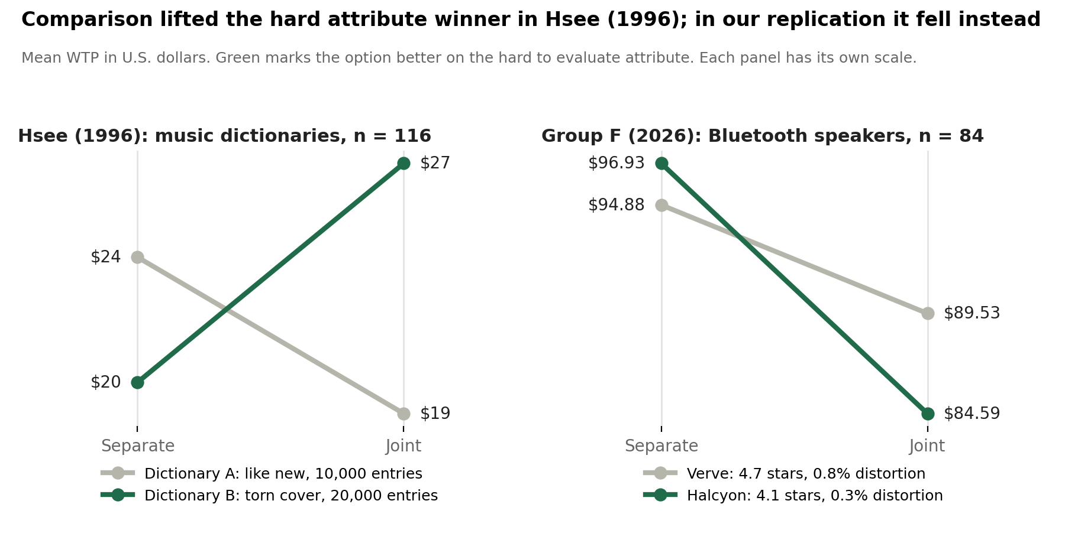
Note. Hsee (1996), Study 1; Group F, Forms 1 to 3 (n = 84). In Hsee's study the green option gained when compared. In ours, comparison lowered both speakers and the green option fell further, so the small crossing runs opposite to the prediction and is not significant.
Figure 2
Extension Results: Mean WTP With and Without the Celebrity Cue
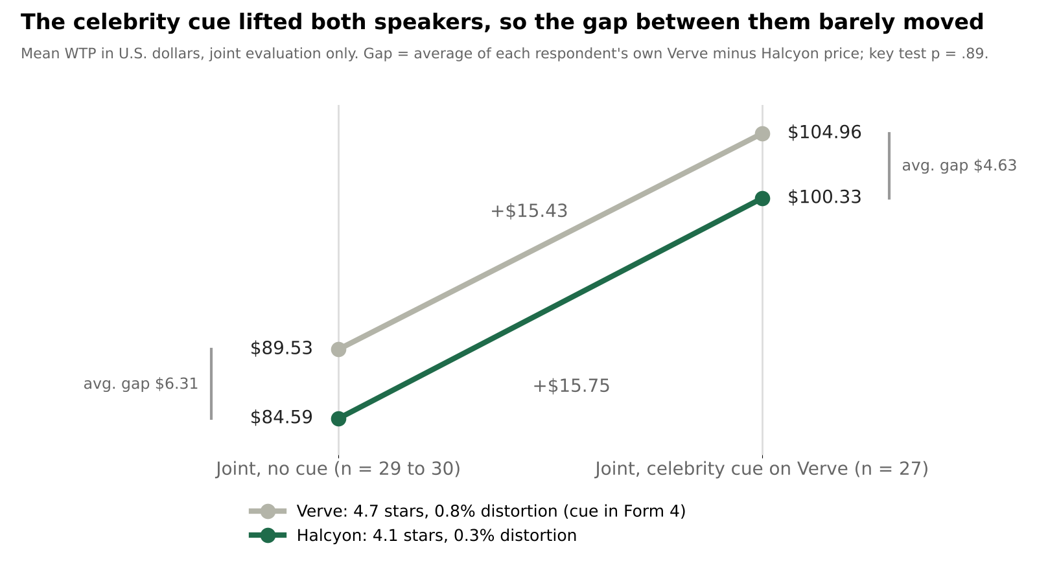
Note. Group F, Forms 3 and 4 (n = 57). Parallel lines indicate a shared lift rather than a targeted one; part of this lift may reflect differences in who answered each form (Table A7).
Figure 3
Real World Parallel: U.S. Headphone Brand Usage Share, 2024
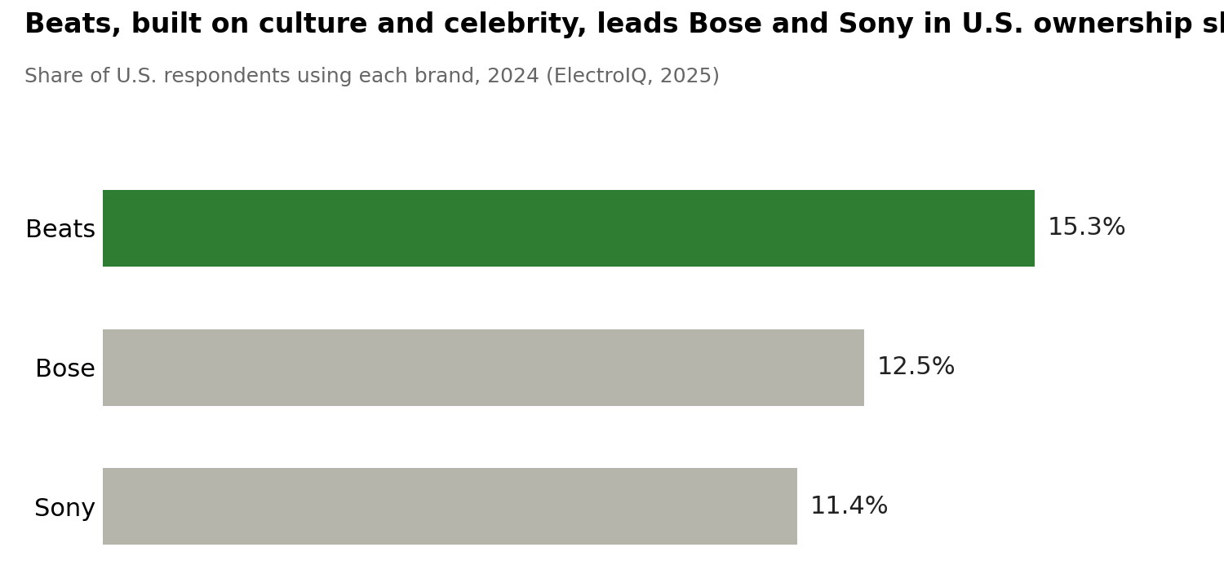
Note. Data from ElectroIQ (2025). Correlational only: real markets confound price, design and marketing, whereas our experiment isolates the cue itself.
Appendix C: Experimental Stimuli
Table C1
Attribute Levels and Their Role in the Design
Attribute | Verve Sound | Halcyon Sound | Role in the design
Star rating | 4.7 | 4.1 | Easy to evaluate; favors Verve
Number of reviews | 512 | 512 | Held equal to rule out popularity
Distortion | 0.8% | 0.3% | Hard to evaluate; favors Halcyon
Celebrity cue (Form 4 only) | Photo of Dua Lipa holding the speaker; caption "Dua Lipa's Verve Era: Can't put it down, can't turn it off, on repeat all day" | None | Extrinsic cue tested in the extension
Note. Every form's scenario text stated that a lower distortion percentage means clearer sound. Brand names were fictional.
Exhibit C1
Separate Evaluation Stimuli as Shown on Forms 1 and 2
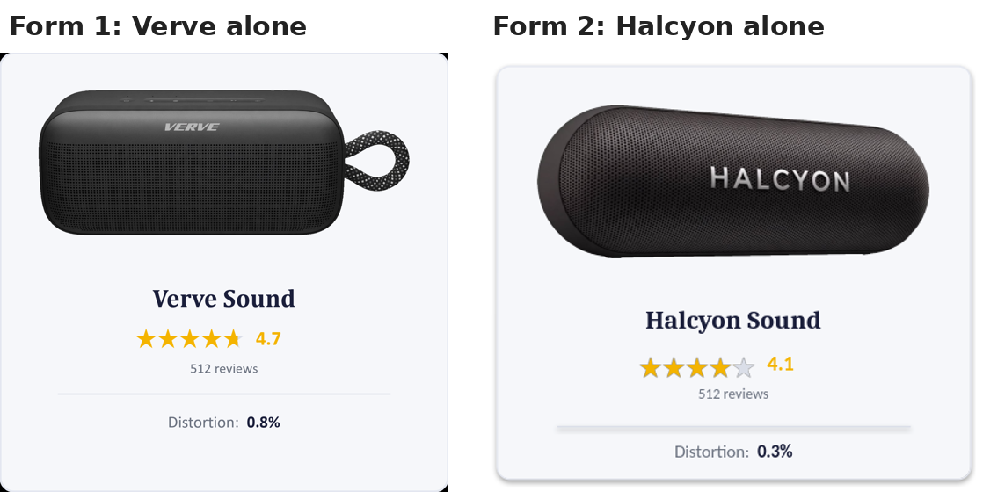
Exhibit C2
Joint Evaluation Stimuli: Form 3 (No Cue) and Form 4 (Celebrity Cue)
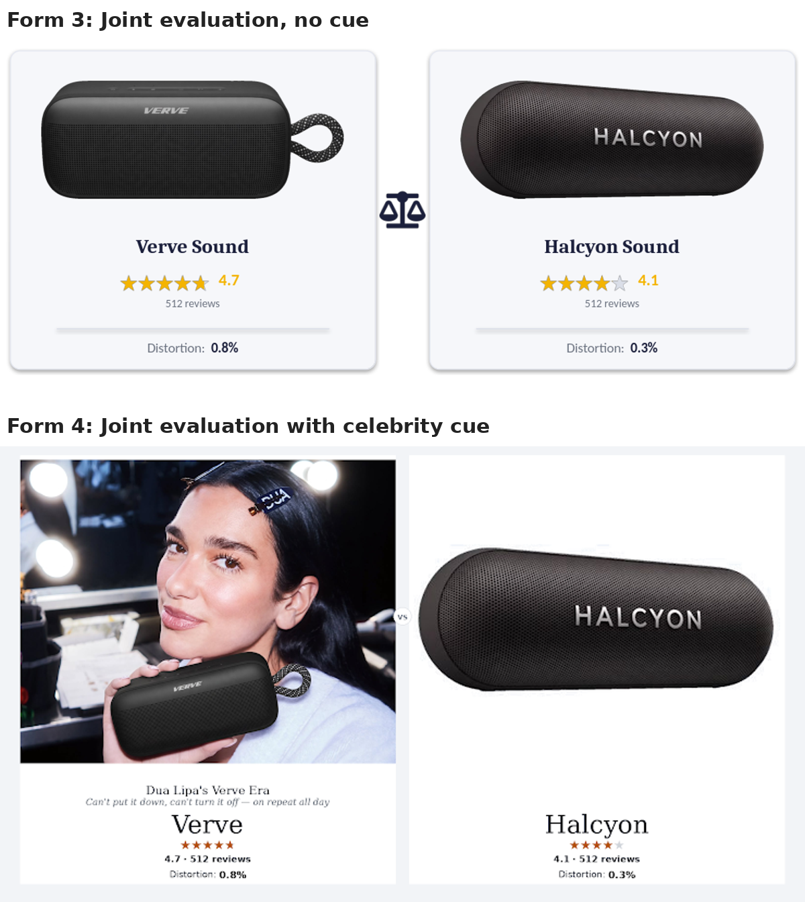

Appendix D: Managerial Playbooks
Table D1
Two Mode Playbook: Choosing the Lever by Evaluation Mode and Competitive Position
Your position | Shopper sees you alone (social feed, single listing) | Shopper compares (comparison site, retail aisle)
You lead on the hard attribute | Anchor the specification in plain language; do not rely on stars | Invite comparison; show the specification visually against rivals
You trail on the hard attribute | Lead with easy cues: rating, endorsement, design | Deploy a product specific extrinsic cue; avoid near equal rivals in the set
Table D2
Extrinsic Cues Recommended for Future Testing
Extrinsic cue | Example
Awards and certifications | Industry awards, safety certifications, quality seals
Celebrity endorsement | A well-known figure using the product (tested in this study)
Expert recommendation | A professional reviewer or audio engineer endorsing the product
Country of origin | "Made in Germany" signalling engineering quality
Packaging design | Premium packaging raising perceived quality with the product unchanged
Retailer prestige | Sold through a premium retailer rather than a discount store

