Detailed Project Report - Book Recommendation System

Project Overview & Objective
This project implements a Book Recommendation System using collaborative filtering and exploratory data analysis. The goal is to provide users with personalized book suggestions by analyzing historical ratings, tags, and metadata. The project leverages user-item interactions to build popularity-based, user-based, and item-based recommendation models.

Week 1: Dataset Exploration & Preparation
During Week 1, multiple CSV files from the dataset were loaded, including books.csv, ratings.csv, book_tags.csv, tags.csv, and to_read.csv. The first step involved exploring the data using Pandas to check for missing values, duplicate records, and overall structure. Key insights included the distribution of ratings, frequency of user interactions, and identification of most popular books.
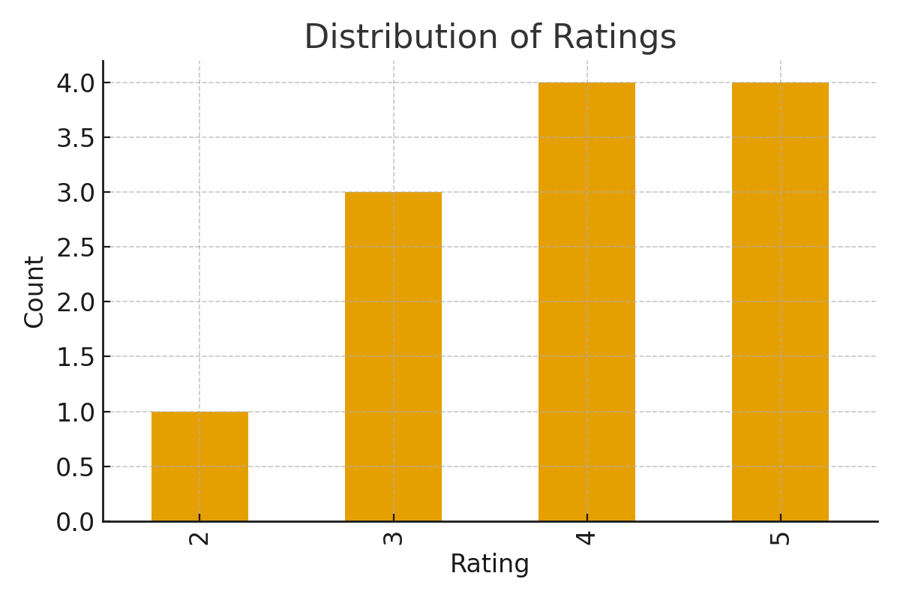
Figure 1: Distribution of Ratings across the dataset.

Week 2: Exploratory Data Analysis (EDA)
In Week 2, exploratory data analysis was carried out. The goal was to better understand patterns within the data and extract useful insights to design recommendation models. We identified the most popular books based on the number of ratings received and computed average ratings for each book. This analysis enabled the creation of a baseline popularity-based recommendation system.
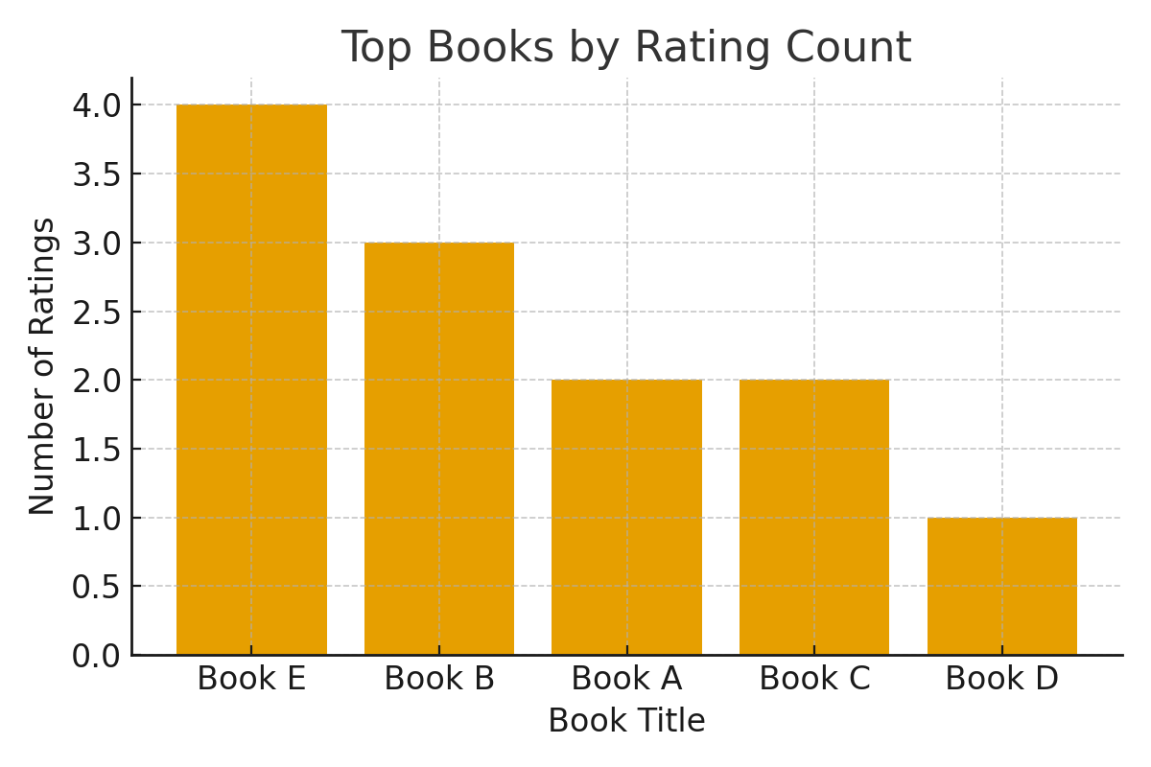
Figure 2: Top Books by Rating Count.
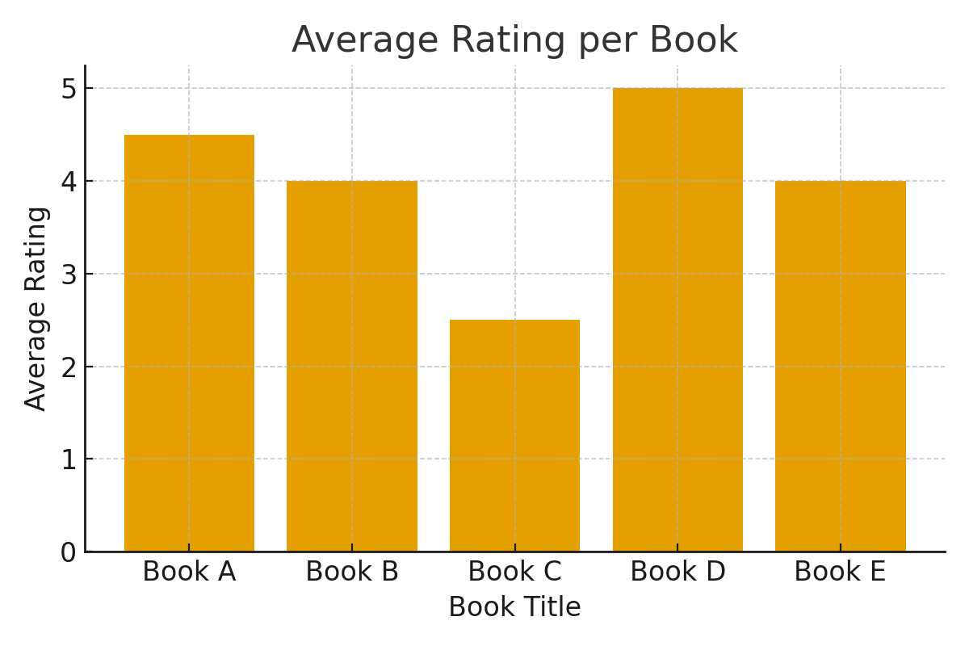
Figure 3: Average Rating per Book.

Week 3: User-Based Collaborative Filtering
In Week 3, user-based collaborative filtering was implemented. The method identifies users with similar reading and rating patterns and recommends books rated highly by similar users. This approach captures personalized preferences by finding communities of like-minded readers.

Week 4: Item-Based Collaborative Filtering & Evaluation
During Week 4, item-based collaborative filtering was applied. This technique computes similarity between books based on user ratings, allowing the system to recommend books similar to those a user has already read. While explicit evaluation metrics like RMSE or Precision@K were not computed in this project, visual inspection confirmed that meaningful recommendations were generated.

Conclusion & Future Scope
The Book Recommendation System successfully demonstrated both user-based and item-based collaborative filtering approaches. The project workflow covered dataset preparation, exploratory data analysis, popularity-based baseline, and similarity-driven recommendations.
Future scope includes:
- Implementing hybrid models combining collaborative and content-based filtering.
- Using deep learning embeddings (e.g., matrix factorization, neural collaborative filtering).
- Building a dashboard interface for user interaction and real-time recommendations.

