SCOPE OF WORK
Human Resource Management System (HRMS)
Design, Development & On-Premise Implementation
Document Classification: Internal — Planning
Version 1.0 · 10 July 2026
Prepared by: NL Tec Solutions — Internal Project Team

Table of Contents
Table of Contents 2
1. Introduction 4
1.1 Objectives 4
1.2 Intended Audience 4
2. Project Scope 4
2.1 In Scope 4
2.2 Out of Scope 4
3. System Architecture 6
3.1 Architecture Layers 6
3.2 Recommended Technology Stack (Indicative) 7
4. Functional Scope — HRMS Modules 8
4.1 Core HR & Employee Records 8
4.2 Organization & Position Management 8
4.3 Recruitment (Applicant Tracking) 8
4.4 Onboarding & Offboarding 8
4.5 Time & Attendance 9
4.6 Leave Management 9
4.7 Payroll & Statutory Compliance 9
4.8 Benefits Administration 9
4.9 Performance Management 10
4.10 Training & Development (LMS) 10
4.11 Employee & Manager Self-Service (ESS/MSS) 10
4.12 Travel & Expense Management 10
4.13 Asset & Document Management 10
4.14 Employee Helpdesk & Grievance 11
4.15 Exit & Full-and-Final Settlement 11
4.16 Succession & Workforce Planning 11
4.17 HR Analytics & Reporting 11
4.18 System Administration & Security 11
5. Non-Functional Requirements 13
6. Deliverables 13
12. Document Control 14

1. Introduction
This Scope of Work (SOW) defines the objectives, functional scope, system architecture, deliverables, and delivery approach for the design, development, and on-premise implementation of a professional Human Resource Management System (HRMS). It is intended as an internal planning and reference document for the development team and will serve as the baseline for detailed requirement specification, effort estimation, and sprint planning.

1.1 Objectives
- Digitize and centralize the complete employee lifecycle — hire to retire — in a single integrated platform.
- Automate routine HR operations (attendance, leave, payroll, approvals) to reduce manual effort and errors.
- Provide employee and manager self-service to reduce HR helpdesk load.
- Ensure statutory and regulatory compliance with full audit trails.
- Deliver actionable workforce analytics and reporting to management.
- Deploy fully on-premise within the organization's data center, meeting internal data-residency and security policies.

1.2 Intended Audience
Project managers, business analysts, solution architects, developers, QA engineers, and infrastructure/IT operations staff involved in the HRMS program.

2. Project Scope

2.1 In Scope
- Design, development, testing, and deployment of all HRMS functional modules listed in Section 4.
- System architecture, database design, and API design for on-premise deployment.
- Integration with biometric attendance devices, Active Directory/LDAP, email/SMS gateways, banking file formats for salary disbursement, and the existing ERP/finance system.
- Role-based web portals (employee, manager, HR admin) and mobile applications (iOS/Android, VPN-secured).
- Data migration from existing HR records (spreadsheets/legacy system) into the new HRMS.
- User training, administrator training, and system documentation.
- Post-go-live hypercare support for a defined stabilization period.

2.2 Out of Scope
- Procurement of server hardware, networking equipment, and third-party software licenses (handled by IT infrastructure team).
- Changes to non-HR systems (ERP/finance) beyond the agreed integration interfaces.
- Ongoing statutory rule updates after the warranty period (to be covered under a separate AMC).
- Public cloud hosting or SaaS delivery of any component.

3. System Architecture
The HRMS follows a layered, modular architecture deployed entirely within the organization's on-premise data center. All access is over the enterprise LAN or VPN; no HR data leaves the organization's network.
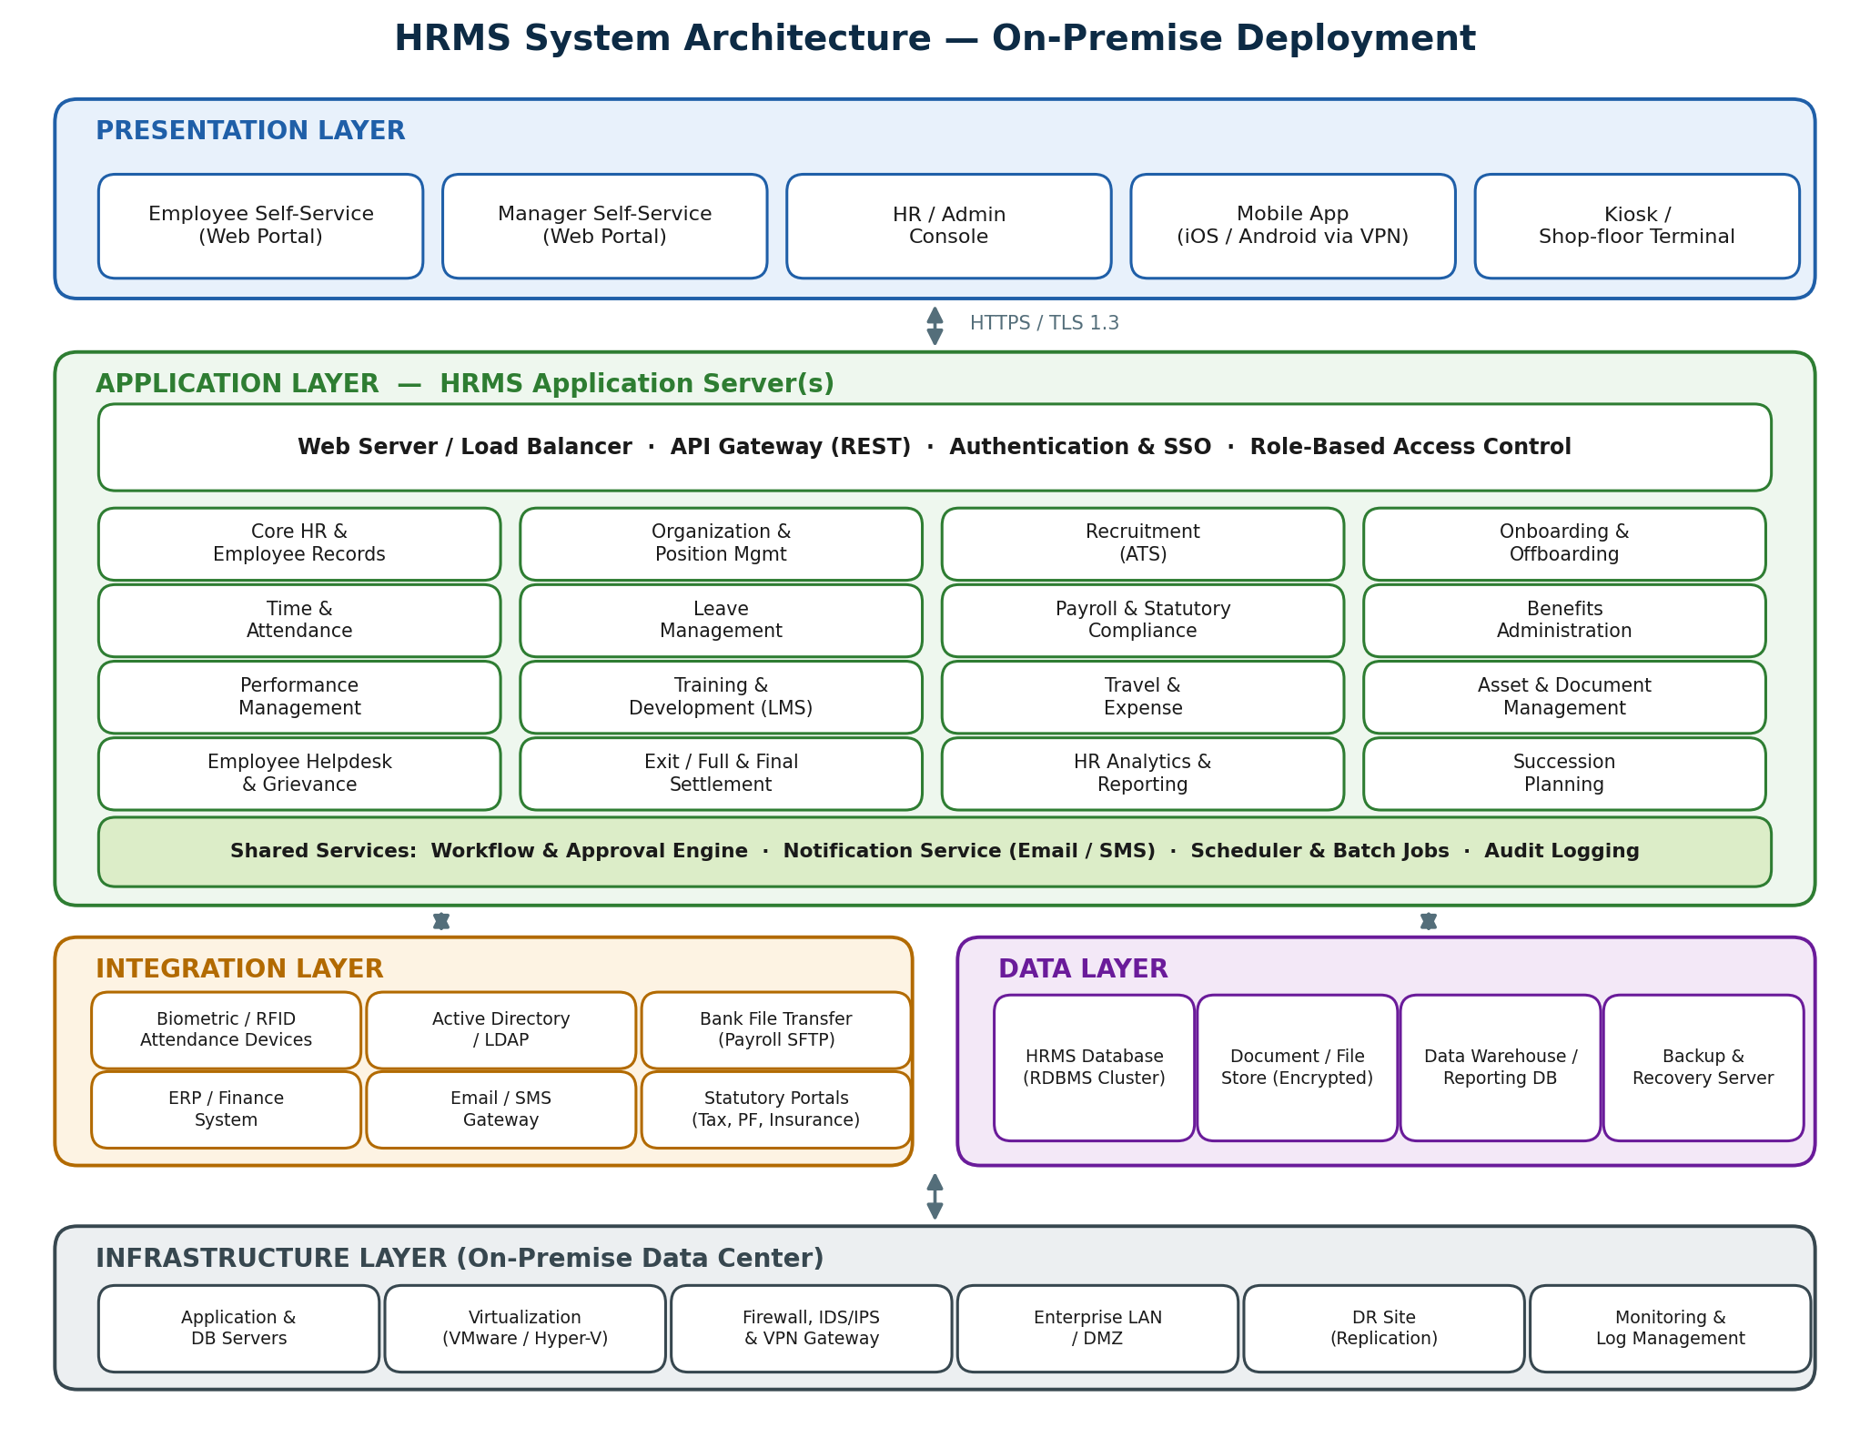
Figure 1 — HRMS layered system architecture (on-premise)

3.1 Architecture Layers
Layer | Description
Presentation | Browser-based portals for employee self-service (ESS), manager self-service (MSS), and HR administration; native mobile apps accessed via VPN; kiosk terminals for shop-floor/non-desk staff. All traffic over HTTPS (TLS 1.3).
Application | Modular HRMS application server(s) behind a web server/load balancer. A REST API gateway fronts all functional modules. Cross-cutting services: authentication & SSO, role-based access control, workflow/approval engine, notification service, scheduler, and audit logging.
Integration | Adapters and connectors for biometric/RFID attendance devices, Active Directory/LDAP for identity, SFTP bank file transfer for salary disbursement, ERP/finance posting, email/SMS gateways, and statutory portals (tax, provident fund, insurance).
Data | Clustered RDBMS for transactional data, encrypted document/file store for employee documents, a separate reporting database/data warehouse for analytics, and backup & recovery services.
Infrastructure | Virtualized on-premise servers (application, database), firewall/IDS/IPS and VPN gateway, DMZ segmentation, disaster-recovery replication to a secondary site, and centralized monitoring/log management.

3.2 Recommended Technology Stack (Indicative)
Component | Recommended Options
Frontend | React or Angular SPA; responsive design; native mobile (Flutter / React Native)
Backend / API | Java (Spring Boot) or .NET Core microservice-oriented modules; REST + JSON
Database | PostgreSQL or MS SQL Server (clustered, encrypted at rest)
Reporting | Dedicated reporting DB with a BI layer (e.g., Power BI Report Server on-premise / Metabase)
Identity | Active Directory / LDAP integration, SAML or OpenID Connect SSO, MFA
Infrastructure | VMware / Hyper-V virtualization; Linux or Windows Server; NGINX / IIS; DR replication
Final stack selection will be confirmed during the architecture design phase based on in-house skills and licensing.

4. Functional Scope — HRMS Modules
The following modules constitute the complete functional scope of a professional HRMS. Each module includes role-based access, configurable workflows, notifications, and audit trails.

4.1 Core HR & Employee Records
Single source of truth for all employee master data across the lifecycle.
- Employee master: personal, contact, statutory IDs, bank details, dependents, emergency contacts
- Employment records: designation, grade, department, location, reporting manager, employment type
- Document repository per employee (contracts, certificates, IDs) with expiry alerts
- Confirmation, transfer, promotion, and re-designation workflows with letters generation
- Complete history/audit of every change to employee data

4.2 Organization & Position Management
Model and maintain the organizational structure.
- Company, business unit, department, cost-center, and location hierarchy
- Position/headcount management with vacancy tracking and budgeted vs. actual headcount
- Dynamic org charts and reporting-line visualization
- Grade/band structure with salary ranges

4.3 Recruitment (Applicant Tracking)
End-to-end hiring from requisition to offer.
- Manpower requisition with approval workflow linked to budgeted positions
- Job posting to career page and external portals; employee referral tracking
- Candidate database, resume parsing, and duplicate detection
- Interview scheduling, evaluation scorecards, and panel feedback
- Offer management with approval matrix and digital offer letters

4.4 Onboarding & Offboarding
Structured joining and induction experience.
- Pre-joining portal for document upload and form filling
- Configurable onboarding checklists (HR, IT, admin, finance tasks) with owners and SLAs
- Automatic employee-ID creation and AD/e-mail provisioning trigger
- Probation tracking and confirmation workflow
- Buddy/induction program scheduling

4.5 Time & Attendance
Accurate capture of work hours from multiple sources.
- Real-time integration with biometric/RFID devices; web and mobile check-in with geo-fencing
- Shift management: shift patterns, rosters, rotations, and shift-change requests
- Overtime capture with approval and payroll integration
- Late/early/absence tracking with configurable regularization workflow
- Attendance dashboards and exception reports for managers

4.6 Leave Management
Policy-driven leave administration.
- Configurable leave types, accrual rules, carry-forward, encashment, and holiday calendars (multi-location)
- Leave application and multi-level approval via web/mobile
- Team leave calendar and clash detection for managers
- Automatic balance updates and payroll integration (LOP/encashment)
- Comp-off and short-leave handling

4.7 Payroll & Statutory Compliance
Accurate, compliant payroll processing.
- Configurable salary structures, pay components, and formula engine
- Automated inputs from attendance, leave, overtime, and one-time payments/deductions
- Full payroll run with validation, simulation, approval, and lock
- Statutory computation: income tax (TDS), provident fund, social insurance, professional tax as applicable
- Bank transfer file generation (SFTP), digital payslips, and tax statements
- Loans, advances, and reimbursement processing; full & final settlement
- GL posting file/interface to ERP finance

4.8 Benefits Administration
Manage employee benefits programs.
- Benefit plan setup: medical insurance, life cover, allowances, flexible benefits
- Enrollment windows, dependent enrollment, and life-event changes
- Claims submission and tracking with document upload
- Insurer data exchange and premium reconciliation reports

4.9 Performance Management
Continuous, goal-driven performance processes.
- Goal/KPI setting with cascading from organizational objectives (MBO/OKR)
- Configurable appraisal cycles: self, manager, 360-degree, and normalization
- Continuous feedback, check-ins, and recognition
- Rating calibration, bell-curve analytics, and increment/promotion recommendations
- Performance improvement plan (PIP) tracking

4.10 Training & Development (LMS)
Build workforce capability.
- Training-needs identification from appraisals and skill-gap analysis
- Training calendar, nominations, approvals, and waitlists
- e-Learning content hosting (SCORM-compatible), assessments, and certifications
- Trainer/venue/cost management and post-training feedback & effectiveness scoring
- Skill and competency matrix per employee

4.11 Employee & Manager Self-Service (ESS/MSS)
Reduce HR dependency through self-service.
- Employee: profile updates, payslips, tax declarations, leave/attendance, claims, letters, helpdesk
- Manager: team approvals, team calendar, attendance regularization, performance actions, headcount view
- Mobile app parity for all high-frequency actions with push notifications

4.12 Travel & Expense Management
Controlled travel and reimbursement processing.
- Travel request and approval with policy/entitlement checks by grade
- Advance requests and settlement tracking
- Expense claims with receipt capture (mobile camera), policy validation, and multi-level approval
- Payroll/finance integration for reimbursement payout

4.13 Asset & Document Management
Track company property and HR documents.
- Asset issue/return tracking per employee (laptop, ID card, tools) with clearance linkage at exit
- HR letter generation from templates (offer, confirmation, experience, address proof) with digital signatures
- Policy document library with read-and-acknowledge tracking

4.14 Employee Helpdesk & Grievance
Structured query and grievance resolution.
- Ticket categories, SLAs, assignment rules, and escalation matrix
- Grievance and disciplinary case management with confidentiality controls
- Knowledge base / FAQ for common HR queries

4.15 Exit & Full-and-Final Settlement
Clean, compliant separations.
- Resignation submission, notice-period computation, and approval workflow
- Multi-department clearance checklist (IT, finance, admin, HR)
- Exit interviews and attrition-reason analytics
- Automated full & final settlement: dues, recoveries, leave encashment, gratuity

4.16 Succession & Workforce Planning
Prepare for future talent needs.
- Critical-role identification and successor readiness mapping
- High-potential (HiPo) identification linked to performance data
- Workforce planning: headcount forecasting and attrition modelling

4.17 HR Analytics & Reporting
Decision support for HR and leadership.
- Standard reports: headcount, attrition, attendance, leave, payroll registers, compliance registers
- Self-service report builder with export (Excel/PDF) and scheduled email delivery
- Executive dashboards: workforce demographics, cost, attrition trends, recruitment funnel
- Statutory/audit reports with drill-down

4.18 System Administration & Security
Platform-level controls (cross-cutting).
- Role-based access control with field-level sensitivity (e.g., salary data)
- AD/LDAP integration, SSO, multi-factor authentication, password policies
- Configurable approval workflows, delegation, and holiday-aware escalations
- Complete audit logging of user and admin actions
- Master data management, bulk import/export utilities, and environment configuration

5. Non-Functional Requirements
Category | Requirement
Performance | Page response < 3 s at 95th percentile; payroll run for 5,000 employees < 30 minutes; support 500 concurrent users (sizing to be validated in design phase).
Availability | 99.5% uptime during business hours; planned maintenance windows outside working hours; DR RPO ≤ 24 h, RTO ≤ 8 h.
Security | TLS 1.3 in transit, AES-256 at rest for sensitive fields and documents; OWASP Top-10 hardening; VAPT before go-live; segregation of duties.
Privacy & Compliance | Data-residency fully on-premise; consent and retention policies for employee data; audit trails retained ≥ 7 years.
Scalability | Modular deployment able to scale application nodes horizontally behind the load balancer.
Usability | Responsive UI, WCAG 2.1 AA accessibility, multi-language support (English + local language).
Backup | Daily full + hourly incremental database backups; quarterly restore drills.
Auditability | Immutable audit log of all create/update/delete and approval actions with user, timestamp, old/new values.

6. Deliverables
# | Deliverable | Description
D1 | SRS & Design Documents | Detailed requirements, architecture design, database schema, API specifications, UI wireframes
D2 | Configured HRMS Application | All modules in Section 4 developed, configured, and deployed on staging and production
D3 | Integrations | Biometric, AD/LDAP, bank file, ERP/finance, email/SMS gateway interfaces — tested end-to-end
D4 | Migrated Data | Validated migration of employee master, balances, and historical records with reconciliation report
D5 | Test Artifacts | Test plans, test cases, SIT/UAT reports, VAPT report and closure
D6 | Documentation | User manuals, admin guide, operations runbook, training materials
D7 | Training | HR admin, manager, and end-user training sessions; train-the-trainer program
D8 | Hypercare & Handover | Post-go-live support for stabilization period and formal handover to IT operations

12. Document Control
Version | Date | Author | Change Description
1.0 | 10 Jul 2026 | NL Team | Initial draft for internal planning

