Design Patterns in Practice
Factory, Strategy, and Observer Patterns
A Cross-Language Implementation in Java, Kotlin, and Python
Travel Agency Simulator
Object-Oriented Programming Paradigms

Authors: Alba Gjergji, Ana Gjergji, Dion Hasanbashaj

1. Introduction
This report documents the design and implementation of three classic object-oriented design patterns - the Factory, Strategy, and Observer patterns - within a single coherent application called the Travel Agency Simulator. The same application has been implemented three times, once each in Java, Kotlin, and Python, so that the patterns can be compared across languages that differ in syntax and type system while sharing the same underlying object model.
The purpose of the exercise is not to build a production booking system but to demonstrate the structure and intent of each pattern in a setting small enough to reason about in full. The simulator deliberately avoids databases, user interfaces, and network communication: every action is expressed as a console message. This keeps the focus on how the classes are arranged and how responsibility for object creation, behaviour selection, and event notification is distributed among them.
Throughout the report, the three implementations are treated as one system expressed in three languages. Because the class names, method signatures, and relationships are identical across all three, a single set of class diagrams describes the structure of every version. Java is used as the reference language for code excerpts; the Kotlin and Python equivalents follow the same logic line for line.

2. System Overview
The Travel Agency Simulator models the moment a price quotation is turned into a confirmed booking. A customer receives a quotation; accepting that quotation produces a booking; the booking is then checked against an eligibility rule and, if the check passes, confirmed. Confirmation triggers a set of notifications, such as writing to a log and sending a confirmation email.
The system is built from the following classes and interfaces:
- Customer — a plain data holder for a traveller’s name, age, and passport status.
- Quotation — holds a price and, through its accept() method, creates a Booking.
- Booking — the central class; it carries the booking status, holds an eligibility strategy, and maintains a list of observers.
- EligibilityStrategy — an interface defining a single validate() check, implemented by AgeStrategy and PassportStrategy.
- BookingObserver — an interface defining a single update() notification, implemented by LogObserver and EmailObserver.
The Booking class is the point where all three patterns meet. It is the product created by the factory, the context that holds and runs a strategy, and the subject that notifies its observers. This concentration of roles in one class is intentional: it shows the three patterns cooperating in a realistic object rather than each living in isolation. Booking does not need to be modified to add a new eligibility rule or a new notification channel, which is precisely the flexibility the patterns are intended to provide.
It is worth noting that the simulator is a deliberately narrow slice of a larger system. In a complete travel agency platform there would be many eligibility rules, many notification channels, and potentially several kinds of booking. The patterns shown here are the extension mechanisms that such a system would rely on; the two strategies and two observers included are enough to demonstrate that the mechanisms work.

3. The Design Patterns

3.1 Factory Pattern
The Factory pattern provides a dedicated method for creating objects, so that the code requesting an object does not call a constructor directly. In the simulator, the Quotation class plays the role of the creator and its accept() method is the factory method. When a quotation is accepted, accept() constructs a new Booking, copies the agreed price into it, sets its initial status to “Pending”, and returns it.
Routing creation through a single method has a clear benefit even though only one kind of product is created today. It means that no other part of the codebase constructs a Booking on its own; creation is centralised in one place where invariants — such as the starting status — can be enforced. In the broader system this is the seam at which different booking subtypes could be selected, or where an invoice could be attached at the moment of creation, all without changing any of the calling code.

Reference implementation (Java)
public Booking accept() {
Booking newBooking = new Booking(this.price);
System.out.println("[QUOTATION] Quotation accepted...");
return newBooking;
}
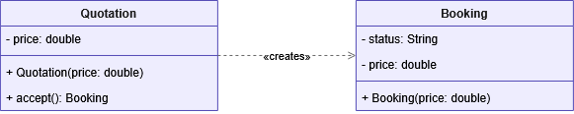
Figure 1. Factory pattern: Quotation creates Booking through its accept() method.

3.2 Strategy Pattern
The Strategy pattern lets an algorithm be selected at runtime by encapsulating each variant behind a common interface. In the simulator, the eligibility check is the algorithm that varies. The EligibilityStrategy interface declares a single validate() method, and two concrete classes implement it: AgeStrategy passes customers over the age of 65, while PassportStrategy passes customers who hold a valid passport.
The Booking class is the context. It holds a reference to an EligibilityStrategy but never refers to either concrete rule by name. The strategy is supplied through setStrategy(), and verifyEligibility() simply delegates to whichever strategy is currently set. Because Booking depends only on the interface, a new eligibility rule can be introduced by writing one new class that implements EligibilityStrategy, with no change to Booking itself.

Reference implementation (Java)
public void setStrategy(EligibilityStrategy strategy) {
this.strategy = strategy;
}
public boolean verifyEligibility(Customer customer) {
return this.strategy.validate(customer);
}
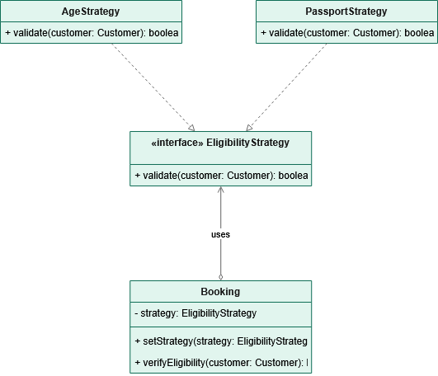
Figure 2. Strategy pattern: Booking delegates eligibility to an interchangeable EligibilityStrategy

.

3.3 Observer Pattern
The Observer pattern establishes a one-to-many relationship in which a single subject notifies any number of dependent objects when its state changes. In the simulator, a confirmed booking is the event that interested parties need to know about. The BookingObserver interface declares a single update() method, and two concrete observers implement it: LogObserver records the change to a history log, and EmailObserver sends a confirmation message to the customer.
Booking is the subject. It maintains a list of observers, registers new ones through addObserver(), and, inside confirm(), iterates over that list calling update() on each. Booking neither knows nor cares what each observer does; it only knows that each can be notified. Adding a new notification channel — a text message, an analytics event, a loyalty-points update — requires only a new class implementing BookingObserver and a call to addObserver(), with no change to the confirmation logic.

Reference implementation (Java)
public void confirm() {
this.status = "Confirmed";
for (BookingObserver observer : this.observers) {
observer.update();
}
}
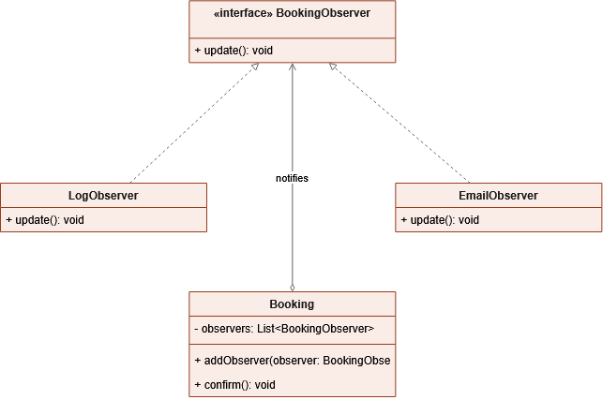
Figure 3. Observer pattern: Booking notifies a list of BookingObserver instances on confirmation.

4. Cross-Language Implementation
Each pattern was implemented identically in Java, Kotlin, and Python. The class names, method names, and relationships match exactly, which is why a single set of diagrams serves all three versions. The differences between the implementations are confined to syntax and to each language’s idioms for expressing the same concepts. The table below summarises the most visible of these differences.

Concept | Java | Kotlin | Python
Abstraction for a pattern role | interface | interface | Base class with method bodies as “ pass ”
Implementing an abstraction | implements | : Interface | Subclassing the base class
List of observers | ArrayList<> | mutableListOf() | Built-in “ list ”
Null-safe strategy call | Direct call | strategy?.validate() | Guarded by an “ if ” check
Console output | System.out.println | println | print

Despite these surface differences, the three programs produce byte-for-byte identical console output when given the same inputs. This was verified by running each version with the same sequence of values and comparing the results. The equivalence confirms that the implementations are genuine translations of one another rather than three loosely related programs.

5. Testing and Sample Output
Each implementation includes an interactive entry point that prompts for the customer’s details, the quotation price, and the choice of eligibility strategy, then runs the full sequence and reports the result. The program loops so that several bookings can be processed in one session, allowing the strategy and observers to be exercised repeatedly without restarting. The sample below shows a passing case using the age rule.
[QUOTATION] Quotation accepted. New booking created with price: $1200.0
[AGE CHECK] Customer is over 65. Eligibility passed.
[BOOKING] Eligibility check PASSED for customer: Jane
[BOOKING] Status updated to: Confirmed
[LOG] Booking status changed. Saved to history.
[EMAIL] Booking confirmed! Message sent to customer.
The output traces the patterns in action: the first line is the factory creating the booking, the age-check line is the selected strategy running, and the final two lines are the two observers responding to confirmation. When the eligibility check fails, the booking is not confirmed and the observer notifications are correctly suppressed.

6. Conclusion
The Travel Agency Simulator demonstrates the Factory, Strategy, and Observer patterns working together within a single small application, implemented consistently across three languages. The Factory centralises object creation in Quotation.accept(); the Strategy lets the eligibility rule be swapped at runtime without altering Booking; and the Observer lets any number of notification channels respond to a confirmed booking. The Booking class ties the three together, acting as product, context, and subject at once.
The chief value of the exercise is in showing where each pattern’s flexibility lives. New booking types, new eligibility rules, and new notification channels can each be added by writing a single new class, leaving the existing code untouched. That property — extension without modification — is the reason these patterns remain a standard part of object-oriented design, and the cross-language implementation shows that the same structural ideas carry cleanly from Java to Kotlin to Python.

