**HBOI-FAU SLP-Funded Research Project**

**Final Report**

Molecular responses of coral larvae to ultraviolet radiation, elevated temperature, and decreased salinity.

**Personnel involved in the project:**

**PI:** Sara Edge, Ph.D.

**Staff:** Lisa Cohen

**Subcontractors:** BaseClear

**Period of Performance:** January 1, 2013 – June 30, 2013

**Table of Contents**

1. **Project Overview**
2. **Project Goals:**
3. Microarray printing
4. Lab prep of samples for gene expression analysis
5. Microarray data analysis and statistical analyses
6. Protein lab setup
7. Protein and enzyme assays and optimization
   * 1. extraction of proteins from TRIzol
     2. separation of proteins with SDS-PAGE
     3. membrane transfer
     4. immunodetection
8. Contract for transcriptional sequencing
9. *de novo* contig assembly and annotation of transcriptome
10. qPCR optimization and analysis
11. Report and manuscript submissions
12. **Progress towards project goals for the period of January 1, 2013-June 31, 2013:**
13. **Any unexpected issues or project changes:**
14. **Findings**
15. **References**

**Appendix 1:** Invitrogen EXPRESS One-Step SYBR Green ER Kit protocol

**Appendix 2:** Protein Western Blotting protocol

**Appendix 3:** Notes For Using the Eppendorf Mastercycler® ep *realplex*

1. **Project Overview**

Global and local disturbances, such as climate change and pollution from runoff, are threatening long-term survival of coral reef ecosystems. Coral larvae are an important source of recruitment for reefs, yet are sensitive to environmental changes.

This project aimed to characterize molecular-level responses of coral larvae to factors associated with climate change, including decreases in salinity, UV radiation (UVR), and elevated sea surface temperature. Data will enable future diagnoses of stressed populations and aid in the implementation of adaptive management strategies for the mitigation of local disturbances. Effects of these stressors were tested by: (1) characterizing gene expression profiles of coral larvae using microarray technology; (2) developing and optimizing qPCR and protein expression assays for gene expression validation; and (3) transcriptome sequencing of *P. astreoides* larvae.

1. **Project Goals:**
2. Microarray printing
3. Lab prep of samples for gene expression analysis
4. Microarray data analysis and statistical analyses
5. Protein lab setup
6. Protein and enzyme assays and optimization
7. Contract for transcriptional sequencing
8. *De novo* contig assembly and annotation of transcriptome
9. qPCR optimization and analysis
10. Report and manuscript submissions
11. **Progress towards project goals for the period of January 1, 2013-June 31, 2013:**
12. Microarray printing

Previously-developed custom microarray slides from Agilent Technologies were printed for this project in Spring 2012. Identical arrays have been successfully used for other projects analyzing adult forms of different coral species: *Montastraea faveolata, Montipora digitata,* and *Acropora cervicornis*. Results from this project further demonstrate, with *Porites astreoides* larvae, that these custom chips are suitable for gene expression analysis of both multiple species and life history stages of Scleractinian (hard, reef building) corals.

Custom microarray slides used for this project were developed in 2011 using advanced bioinformatics techniques with funding from the Florida Institute of Oceanography (Contract Number: SUBAGR# 4710-1101-00-S). The microarrays include 3 replicate spots of each probe (short gene sequences) representing 1,368 coral genes and 327 *Symbiodinium* sp. genes as well as positive and negative control sequences. The array design is stored on a secure server and coral microarray chips may be ordered through Dr. Sara Edge’s lab (produced by Agilent Technologies) for coral health analysis.

1. Lab prep of sample for gene expression analysis

Prior to this reporting period, in July 2012, Ana Gonzalez-Angel (2012 HBOI summer intern and Master’s student at Nova Southeastern University, Oceanographic Center), with assistance from Lisa Cohen (HBOI-FAU staff, Marine Genomics Lab), processed and analyzed *P. astreoides* larvae for gene expression analysis using the custom microarrays. These analyses were completed during Ana’s summer internship from May to July of 2012.

Results and statistical analyses have been completed and are included in Ana’s Master’s thesis, which was successfully defended on July 25, 2013 (González-Angel, 2013). Ana’s thesis will be revised as a manuscript for submission for publication in 2013.

Sample processing for gene expression analyses included RNA extraction, RNA purification, RNA quantification, quality-control with the Agilent Bioanalyzer (Figure 1), RNA labeling with Cyanine-3 fluorescent dye, and hybridization procedures (Figure 2). These methods were described in previous SLP quarterly reports and can also be found, in detail, in Ana’s thesis (González-Angel, 2013).

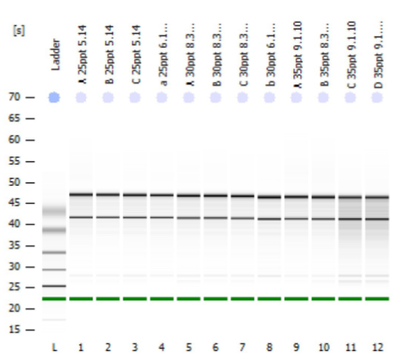

Figure 1. Electropherogramfrom examining the quality and quantity of RNA extracted from each sample. The distinct bands indicate that total RNAs extracted from these samples are pure with little contamination. These samples were further processed for microarray analysis (Agilent Bioanalyzer 2100).

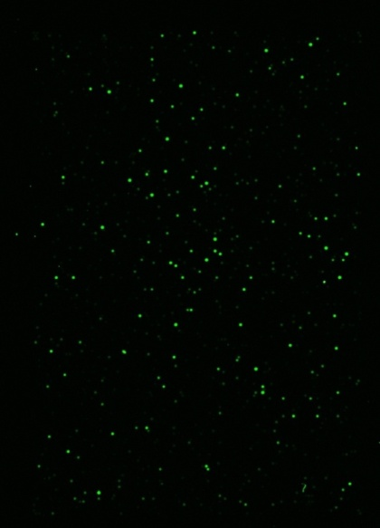

Figure 2. Representative microarray image. The fluorescent green spots are measurable signals of varying intensities representing unique gene sequences on the array. Genes isolated from *P. astreoides* larvae and labeled with Cyanine-3 dye hybridize to matching sequences on the microarray and produce the quantifiable signals.

1. Microarray data analysis and statistical analyses

Analyses of *P. astreoides* larvae revealed 72 differentially expressed genes among treatment groups (25 ppt, 30 ppt, 35 ppt). For a description of the experimental exposure treatment design, see González-Angel (2013). Clusters of genes performing similar cellular functions were combined for analyses as “functional groups” (specific) and “functional categories” (broad). The functional category with the highest number of genes expressed was “Normal Cell Function” (Figure 3, left) and the functional group with the highest number of genes expressed was “Cellular Signaling” (Figure 3, right).

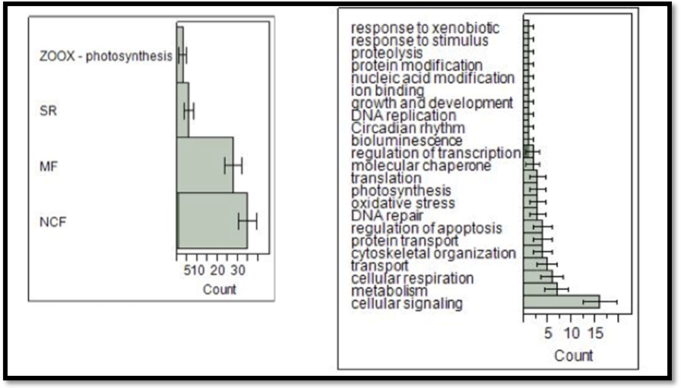

Figure 3. Functional categories (left) and groups (right) of differentially expressed genes. ZOOX: Zooxanthellae photosynthesis, SR: Stress response, MF: Multifunctional, NCF: Normal Cellular Functions. NCF genes were more expressed relative to the other functional categories (left). Cellular signaling genes were expressed more than those in the other functional groups (right).

Gene expression profiles of the 72 significantly expressed genes examined for each treatment group (Figure 4), indicated that genes generally associated with a stress response were up-regulated at 25 ppt, whereas those associated with normal cell functioning were down-regulated. Zooxanthellae photosynthesis genes were also down-regulated at 25 ppt. Interestingly, the middle 30 ppt salinity treatment group had a similar profile to the control (35 ppt), suggesting that larvae can tolerate acute exposures to 30 ppt hyposalinity conditions, but further investigation at different time scales and life coral history stages are required to confirm this hypothesis.

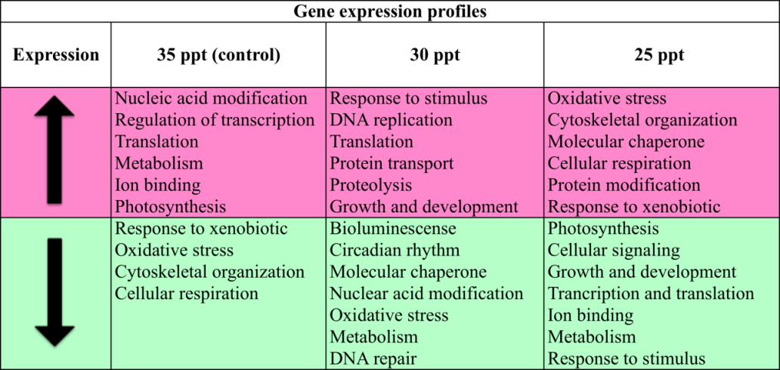

Figure 4. Functional groups differentially expressed at low salinities. Groups up- and down-regulated at 25 ppt are similar to genes differentially expressed in other studies with adult corals exposed to low salinities (Edge et al. 2013).

1. Protein lab setup

Establishment of a protein lab enabled the analysis of proteins isolated from coral larvae. Analysis of proteins produced under various conditions can be used to verify gene expression data or as an end-point indicator of a stress response at the protein level. Detailed protocols and a list of supplies and reagents used in the development of these protein assays for gene expression can be found in Appendix 1. The equipment and supplies used to establish the Marine Genomics Protein Lab are available for use by other researchers at HBOI/FAU.

1. Protein and enzyme assays and optimization

The main procedures developed and optimized for the protein analysis portion of this project include: i.) extraction of proteins from samples preserved in TRIzol (Invitrogen), ii.) separation of proteins with SDS-PAGE, iii.) transfer of proteins from a gel onto a membrane, and iv.) immunodetection of a specific protein on the membrane.

The methods developed as part of this project will benefit other researchers and students at HBOI/FAU interested in isolating and measuring protein from biological tissue. These methods have been optimized using small amounts of tissue from a non-model, invertebrate organism, indicating a broad range of applications for multiple marine species.

**Optimization and Analysis of Proteins:**

1. Protein extractions from TRIzol

Proteins were successfully extracted and analyzed from coral larvae samples preserved in TRIzol (see Appendix 1 for detailed methods). Concentrations of isolated proteins were measured by comparing absorbance values to a standard curve made from a series of seven protein standards ranging in concentration from 0-2,000 µg/mL (Figure 5).

Because proteins are denatured in TRIzol, information beyond protein quantity cannot be obtained, i.e. enzyme activity is not measurable. However, the primary amino acid sequence is still in-tact and is quantifiable with immunodetection, which is also known as western blotting. The project presented here is the first time this type of measurement has been performed with coral at Harbor Branch Oceanographic Institute. Results from this project have indicated this type of measurement is possible and can be used in the future to gain useful information.

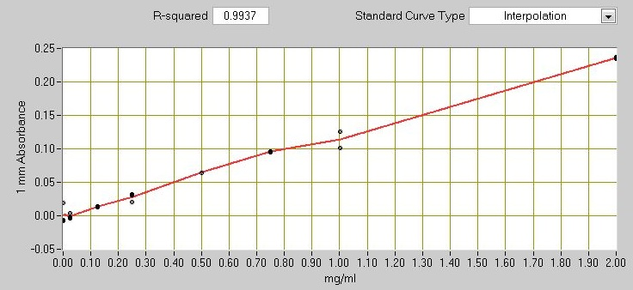

11

Figure 5. Standard curve for measuring protein concentrations. The Pierce BSA protein quantification kit is used to measure and plot seven protein standards ranging in concentration from 0.025 mg/mL to 2.0 mg/mL.

1. Separation of proteins with SDS-PAGE

Once proteins are extracted, they are separated by size using polyacrylamide gel electrophoresis (SDS-PAGE). Proteins separated on a gel are stained with Coomassie blue and then imaged (Figure 6).

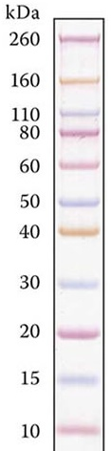

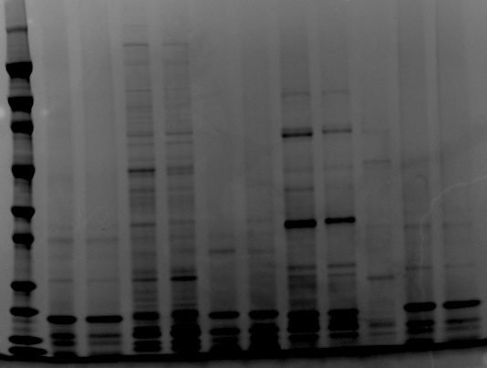

L

11

Figure 6. Proteins extracted from adult and larval corals are separated with SDS-PAGE and sizes are determined by comparing protein bands with the protein standard on the left axis.

1. Membrane Transfer

The iBlot (Life Technologies) purchased for this project enables the rapid electrotransfer of membranes from a gel to a plastic membrane (polyvinylidene fluoride or PVDF) membrane in 7 minutes. In contrast, the standard electrotransfer procedure is done overnight in a vertical gel electrophoresis box in a liquid buffer medium. The iBlot saves time and reagents.

Six western blotting attempts were made using the iBlot for this project. Two of these attempts resulted in incomplete transfers, indicated by the lack of bands after reverse staining (Figure 7, left). Due to these results, we recommend that researchers interested in using these methods proceed first with the standard method of electro-transfer using a protein gel box to verify successful transfer of proteins from the gel onto the membrane, and then use the iBlot to simplify procedures later.

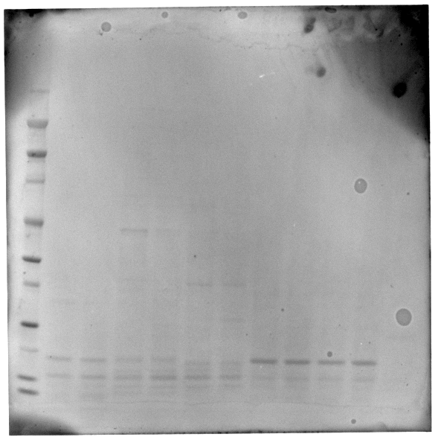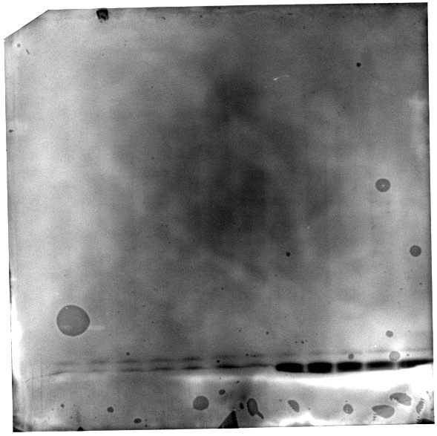Figure 7. Comparison of unsuccessful (left) and successful (right) protein transfers from gel to membrane using the iBlot system, demonstrating the inconsistency of the system. Red arrows indicate proteins successfully transferred and visualized using reversible staining.

1. Immunodetection

Three primary antibodies of interest (Table 2) were identified for use in this project based on their successful use in previous studies analyzing Cnidarians (Barshis et al., 2010, Rossi et al., 2006). In addition, transcript sequences corresponding to genes coding for these proteins are included on the microarray. If a transcript is shown to be expressed in a sample, detection of the corresponding protein in a western blot would verify results obtained from microarray analyses and indicate that the gene is being translated.

Table 2. List of antibodies we have and their positive controls.

|  |  |  |  |  |  |  |  |  |
| --- | --- | --- | --- | --- | --- | --- | --- | --- |
| **Antibody** | **Company** | **Catalogue Number** | **Reference** | **Amt** | **Price** | **Positive Control** | **Amt** | **Price** |
| [HSP70](http://www.enzolifesciences.com/ADI-SPA-822/hsc70-hsp70-mab-bb70/) | Enzo | ADI-SPA-822 | Rossi et al., 2006 | 50 ug | $180 | ADI-LYC-HL101-F | 200 ug | $98 |
| [Mn SOD](http://www.enzolifesciences.com/ADI-SOD-110/mn-sod-pab/) | Enzo | ADI-SOD-110 | Barshis et al., 2010 | 50ug | $170 | ADI-LYT-RB100-F | 200 ug | $98 |
| [Ubiquitin](http://www.enzolifesciences.com/ADI-SPA-200/ubiquitin-pab/) | Enzo | ADI-SPA-200-D | Barshis et al., 2010 | 50 ug | $150 | VWR, product #: PIORP07318 | 200 ug | Not purchased |

Methods for western blotting were optimized using the primary antibody for heat shock protein, 70 kD (Hsp70). Antibodies for manganese superoxide dismutase (MnSOD) and ubiquitin were also selected and purchased but have not been used to analyze coral larvae samples in this project. All antibodies are available for use in future analyses. Each primary antibody must be accompanied by a secondary antibody produced by and isolated from the host organism. For example, if the primary antibody was produced by a mouse, an anti-mouse secondary antibody must be used. MnSOD and Ubiquitin both require anti-rabbit secondary antibodies, whereas Hsp70 requires an anti-mouse secondary antibody.

Optimization of primary and secondary antibody concentrations is required to reduce background noise and produce a detectable signal. For example, using the recommended 1:1000 concentration of Hsp70 primary antibody in dilution buffer, we saw high amounts of background noise on the membrane in our immunodection image (Figure 8, right). The concentrations of primary and/or secondary antibody may need to be adjusted, or it could also be from insufficient blocks, washes, or failure to remove excess chemiluminescent detection chemical (ECL). A single band was observed around the 70 kD region (Figure 8, right). This indicates the presence of Hsp70 in the corresponding sample being analyzed.

Figure 8. Western blot/immunodetection of Hsp70 protein in coral larvae samples. The membrane with transferred proteins from coral larvae samples is shown on the left, with red arrows indicating proteins successfully transferred and visualized with reversible stain. The membrane was blocked and then incubated with primary Hsp70 and secondary antibodies. Chemiluminescent detection was used to visualize only the presence of Hsp70 proteins on the membrane (right).

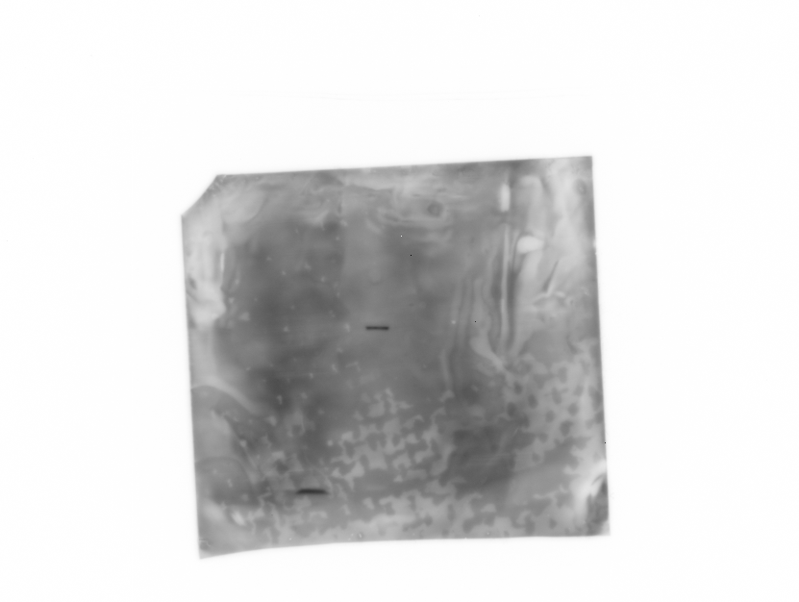

**1**

**2**

**3**

**4**

**5**

**6**

**7**

**8**

**9**

**10**

**11**

**12**

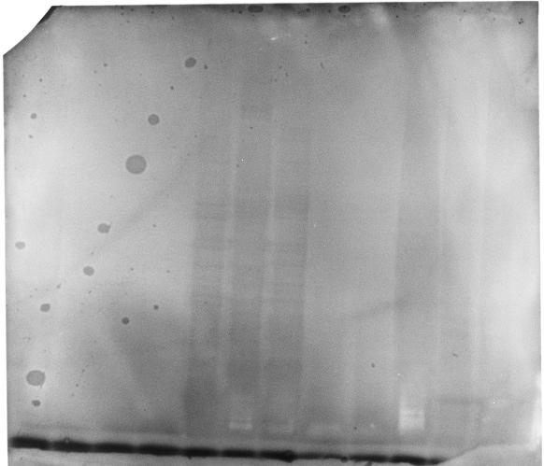

**1**1

**2**2

**3**3

**4**4

**5**5

**6**6

**7**7

**8**8

**9**9

**10**10

**11**

**12**

**Enzyme Activity Assays**

Samples were collected and preserved by a different research group (Mason, University of Miami). Assays and analyses were limited by the preservation method of the samples obtained. Because the conformation of an enzyme is critical to the biochemistry of the reaction being catalyzed, steps should be taken during tissue collection in the future to preserve the integrity of enzyme and protein structures. For example, tissue samples could be flash-frozen in liquid nitrogen at the time of collection and frozen at -80ºC until processed for analysis.

1. Contract for transcriptional sequencing

Vendors with expertise in next-generation, whole transcriptome sequencing were researched. Non-academic services were preferred over academic services for this project due to the need for professional post-sequencing analysis (such as contig assembly, annotation, etc.). Based on quoted cost and services, the vendor BaseClear (Netherlands) was chosen over Centrillion Biosciences (California), John P. Hussman Institute for Human Genomics (University of Miami Miller School of Medicine) and BMR Genomics (Italy).

RNA samples extracted from larvae of *P. astreoides* exposed to three salinity treatments (25 ppt, 30 ppt, and 35 ppt) were pooled by treatment and sent to BaseClear in November 2012 for analysis using an Illumina HiSeq™ 2000 sequencing system (Figure 9).

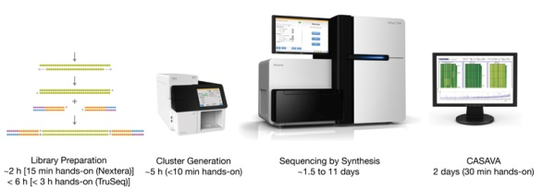

Figure 9. Workflow for samples processing and sequencing with the HiSeq™ 2000 sequencing system. All steps were conducted at BaseClear in the Netherlands and the resulting data are currently being analyzed.

1. *De novo* contig assembly and annotation of transcriptome

All sequencing and data analysis services have been completed by BaseClear. Raw FASTQ read files were created with the Consensus Assessment of Sequence and Variation (CASAVA) pipeline version 1.8.3 software, which converts raw images from the HiSeq™ system into intensity values. Data were downloaded in February 2013, stored on a secure server and backed up on two hard drives at HBOI/FAU. The following raw sequences files are saved on a secure server at HBOI:

25ppt_TTAGGC_L003_R1_001_AD1H1RACXX.filt.fastq.gz

25ppt_TTAGGC_L003_R2_001_AD1H1RACXX.filt.fastq.gz

30ppt_GATCAG_L003_R1_001_AD1H1RACXX.filt.fastq.gz

30ppt_GATCAG_L003_R2_001_AD1H1RACXX.filt.fastq.gz

35ppt_ACTGAT_L003_R1_001_AD1H1RACXX.filt.fastq.gz

35ppt_ACTGAT_L003_R2_001_AD1H1RACXX.filt.fastq.gz

BaseClear performed a *de novo* transcriptome library assembly using closely-related sequences. For each sample, a report is available with information related to the selected input sequences (sequence reads and reference sequences, in terms of the number of sequences, longest read, longest sequence), references used, transcripts per gene, exons per gene, exons per transcript, and mapping statistics (fragment counting, paired reads, matching specificity, paired distance, uniquely mapped, fraction, non-specifically mapped).

Resulting transcriptome files are currently being analyzed by Dr. Edge and Lisa Cohen for differences in the presence and level of transcriptome sequences between samples. Methods may include advanced bioinformatics methods, such as pipeline scripts using BioPython programming and packages written for R/Bioconductor. As the field of RNA-Seq analyses is rapidly being developed at a fast pace, additional training may be necessary to complete these analyses. Expression profiles and sequences will be submitted to the National Center for Biotechnology Information (NCBI) databases for use by researchers all over the world. Final results are expected to be published in 2014.

1. qPCR optimization and analysis

A protocol using EXPRESS SYBR GreenER™ qPCR SuperMix Universal kit (Life Technologies, Catalogue 11784-01K) was tested and written up in Appendix 2. Instructions for the real-time quantitative PCR (qPCR) thermal cycler instrument (Eppendorf, Mastercyclerep gradient S) are also included in Appendix 3.

Eleven sets of forward and reverse DNA primers for qPCR were ordered from Integrated DNA Technologies and verified. See Appendix 4 for details and protocols. These primers represent mRNA sequences encoding the following proteins: *M. faveolata* large ribosomal subunit, *Symbiodinium sp*. cytochrome oxidase, *Aiptasia pulchella* (anemone) Rab7, *Symbiodinium sp*. RuBisCo, and *A. pulchella* multidrug resistant protein.

Additional primers were ordered corresponding to sequences spotted on the microarray. These have not been verified to date and require additional troubleshooting.

1. Report and manuscript submissions

There will be at least two manuscripts submitted for publication as a result of this project.

1. **Any unexpected issues or project changes:**
   1. Problems with extraction of protein from coral larvae samples
   2. The experimental design was conceived and executed by external researchers outside of Dr. Edge’s lab. This resulted in unexpected problems with the number of replicates and adequate controls for some of the exposures. In addition, the initial method of sample preservation caused problems with RNA extraction, resulting in low quality or degraded RNA from some samples. As a result, not all species and samples available were examined.
   3. Delay in purchase of protein assay/analysis equipment due to relocation of lab into new building (November 2011)
   4. Difficulty in finding an appropriate sequencing contractor due to the limited budget (very low for a high-throughput sequencing job), the scope of the project and sequencing of a non-model organism (lack of a reference genome) and high yields/purity of RNA required for sequencing. While we did extract good quality RNA for *P. astreoides* UV/temp exposures, no funding was available to sequence these.
   5. Additionally, due to unforeseen circumstances (personal and professional), Dr. Edge became back-logged with too many ongoing, concurrent projects and not enough people to work on them (FIO, CIOERT, JIMAR, SLP-sponge, SLP-larvae, SLP-St. Lucie Reef, teaching, mentoring and other academic duties). All of these projects had overlapping deadlines. This overextension was in part due to the unexpected departure of her graduate student, Kori Mulholland, in the spring of 2011. Dr. Edge discussed the possibility of postponing this project (SLP-larvae) with Megan Davis to start in 2012 (instead of 2011). However, a decision was made to wait and see if a delay was necessary. Dr. Edge believed that it should have been postponed.
   6. Although continuing in a supervisory role and with affiliate faculty status, Dr. Edge left before the due date of this project. The direction of the project fell to Dr. Edge’s staff-member, Lisa Cohen and PI, Dr. Voss, who were also both overloaded with supervising and implementing other simultaneous projects and academic duties.
   7. Dr. Edge put a lot of time and effort into preparing NSF MRI proposals for a next-generation sequencer to complement existing equipment at Harbor Branch and form the basis for a genomics facility as part of the recently proposed CLIMB initiative. As lead PI on the proposal, Dr. Edge spent extensive amounts of time and effort in researching and writing, as well as coordinating meetings between various institutions to increase participation in the acquisition endeavor. This effort reduced the amount of time Dr. Edge was able to spend on other projects and academic services.
   8. The general trend of scientific studies using microarray data are moving away from using qPCR as a method for validation and more towards RNA-Seq transcriptome sequencing data, which will also validate expression results from the microarray (Allison et al., 2006, Morey et al., 2006, Kvist et al. 2013)
   9. Additional time required to prepare a presentation for the SLP Symposium in May 2013.
   10. Troubleshooting methods required more time and effort than anticipated.
   11. Time to prepare additional deliverables, which are included appendices with this report:
       1. Protein extraction and western blot protocol
       2. Synopsis of RNA-Seq transcriptome data
       3. Thesis by Ana Gonzales
2. **Findings**
3. **Extent to which project advances solutions for challenges facing FL**

Coral larvae are an important source of recruitment for reefs, yet are sensitive to environmental changes. This project characterizes responses of coral larvae at the molecular level to sublethal stressors influenced by climate change, such as salinity, UV radiation (UVR), and sea surface temperature. These data will enable future diagnoses of stressed populations to aid in the implementation of adaptive management strategies for the mitigation of local disturbances.

1. **Extent to which project produces or enables program expansion**

Sequencing of the transcriptome using next-generation technology will be the first of its kind using these coral larvae species and experimental treatments. The results will be used to pursue additional funding for coral and sponge transcriptome sequencing projects and will assist in completing projects related to the recent CLIMB initiative set forth by Harbor Branch FAU.

1. **Potential for award to generate further program funding and/or in-kind support**

Although no grant has been funded yet that directly relates to this proposal, Dr. Edge has discussed the project with several coral reef scientists at the 12th*International Coral Reef Symposium* in Cairns, Australia. Two potential collaborations are in progress based on these discussions and the preliminary results.

1. **For research projects, the potential for published results**

Results from this project and Ana’s thesis will result in at least one publication on changes in gene expression associated with larvae stress. However, additional publications may results associated with protein expression and/or transcriptome sequencing.

**References**

# Allison DB, Xiangqin C, Page GP, Sabripour M. 2006. Microarray data analysis: from disarray to consolidation and consensus. *Nature Reviews Genetics*. 7: 55-65.

# Barshis DJ, Stillman JH, Gates RD, Toonen RJ, Smith LW, Birkeland C. 2010. Protein expression and genetic structure of the coral Porites lobata in an environmentally extreme Samoan back reef: does host genotype limit phenotypic plasticity? *Mol Ecol*. 19(8):1705-20.

Edge et al. 2013. Sub-lethal coral stress: Detecting molecular responses of coral populations to environmental conditions over space and time. *Aquatic Toxicology*. 128-129: 135-146.

González-Angel, A.M. 2013, ‘*Porites astreoides* larval response to acute salinity stress’, Master’s thesis, Nova Southeastern University, Fort Lauderdale, Florida USA.

Hummon AB., Lim SR, Difilippantonio,MJ, Ried T. 2007. Isolation and solubilization of proteins after TRIzol extraction of RNA and DNA from patient material following prolonged storage.*BioTechniques*. 42(4): 467-472.

Invitrogen, Life Technologies. Rev. 13 Dec. 2012. Part no. 15596026.PPS (MAN0001271) Available at: <http://tools.invitrogen.com/content/sfs/manuals/trizol_reagent.pdf> (Accessed 7/29/2013)

Kvist J, Wheat CW, Kallioniemi E, Saastamoinen S, Hanski I, Frilander M. 2013. Temperature treatments during larval development reveal extensive heritable and plastic variation in gene expression and life history traits. *Molecular Ecology*. 22: 602-619.

Likhite N and Warawdekar UM. 2011. A unique method for isolation and solubilization of proteins after extraction of RNA from tumor tissue using TRIzol. *J. Biomolecular Techniques*. 22: 37-44.

Morey JS, Ryan JC, Van Dolah, FM. 2006. Microarray validation: factors influencing correlation between oligonucleotide microarrays and real-time PCR. *Biol. Proced. Online*. 8(1): 175-193.

# Rossi S, Snyder MJ, Gili JM. 2006. Protein, carbohydrate, lipid concentrations and HSP 70-HSP 90 (stress protein) expression over an annual cycle: useful tools to detect feeding constraints in a benthic suspension feeder. *Helgol. Mar. Res*. 60: 7-17.

**Appendix 1**

Protein Western Blotting protocol with the [iBlot](http://www.invitrogen.com/site/us/en/home/Products-and-Services/Applications/Protein-Expression-and-Analysis/Western-Blotting/Western-Blot-Transfer/iBlot-Dry-Blotting-System.html?s_kwcid=TC|12126|iblot||S|p|10481774761)® Dry Blotting System

Adapted from [NuPAGE® Technical Guide](http://tools.invitrogen.com/content/sfs/manuals/nupage_tech_man.pdf); MAN0003188;

[XCell *Sure*Lock® Mini-Cell User Guide](http://tools.invitrogen.com/content/sfs/manuals/surelock_man.pdf); MAN0000739;

[iBlot® Dry Blotting System User Guide](http://tools.invitrogen.com/content/sfs/manuals/iblotsystem_man.pdf); MAN0000560

Marine Genomics Lab, HBOI/FAU

July 2013

**Supplies:**

|  |  |
| --- | --- |
| **Equipment** | **Catalogue** |
| * [iBlot®](http://www.invitrogen.com/etc/medialib/en/filelibrary/protein_expression/pdfs.Par.54060.File.dat/iblotsystem_qrc.pdf) [Gel Transfer Device](http://tools.invitrogen.com/content/sfs/manuals/iblotsystem_man.pdf) | [IB1001](http://www.invitrogen.com/site/us/en/home/Products-and-Services/Applications/Protein-Expression-and-Analysis/Western-Blotting/Western-Blot-Transfer/iBlot-Dry-Blotting-System.html?s_kwcid=TC|12126|iblot||S|p|10481774761) |
| * [XCell *Sure*Lock™ Mini-Cell](http://tools.invitrogen.com/content/sfs/manuals/surelock_man.pdf) | [EI0001](http://products.invitrogen.com/ivgn/product/EI0001) |
| * [FluorChem E system](http://www.proteinsimple.com/fluorchem_em.html) with 8MP, -25ºC cooled CCD camera | 92-14860-00 |
| **Consumables** |  |
| * NuPAGE® Novex 4-12% Bis-Tris Gels   1.0 mm, 12 well; | [NP0322BOX](https://products.invitrogen.com/ivgn/product/NP0322BOX?ICID=search-np0322box)  1 box/10 gels: $139 |
| * iBlot® Transfer Stack, Mini (PVDF) | [IB401032](https://products.invitrogen.com/ivgn/product/IB401032?ICID=search-ib401032), $412  3 x 10 sets/box |
| * iBlot® Western Detection, Chemiluminescent kit (anti mouse) - Regular | [IB7110-01](https://products.invitrogen.com/ivgn/product/IB711001?ICID=search-ib711001)  10-pak $436 |
| * iBlot® Western Detection, Chemiluminescent kit (anti rabbit) - Mini | [IB7210-02](https://products.invitrogen.com/ivgn/product/IB721002?ICID=search-ib721002), 10-pak  $324 |
| * Novex® Sharp Pre-stained Protein Standard, | [LC5800](https://products.invitrogen.com/ivgn/product/LC5800?ICID=search-lc5800)  $144 |
| * SimplyBlue™ SafeStain; 1 L | [LC6060](https://products.invitrogen.com/ivgn/product/LC6060?ICID=search-lc6060)  $129 |
| * NuPAGE® MOPS SDS Buffer Kit contains:   + MOPS SDS Running Buffer (20X, 500 ml - NP0001)   + NuPAGE® Sample Reducing Agent (10X, 250 μl - NP0004)   + NuPAGE® Antioxidant (NP0005)   + NuPAGE® LDS Sample Buffer (4X, 10 ml - NP0007) | [NP0050](https://products.invitrogen.com/ivgn/product/NP0050?ICID=search-np0050)  $86 |
| * Novex® Reversible Membrane Protein Stain Kit | [IB7710](https://products.invitrogen.com/ivgn/product/IB7710?ICID=search-ib7710)  $86 |

**MOPS SDS Running Buffer (20X)**

This can be purchased (500 ml - NP0001) or made with the following recipe:

Dissolve the following reagents in 400 mL DI water:

* 50 mM MOPS (104.6 g)
* 50 mM Tris Base (60.6 g)
* 0.1% SDS (10 g)
* 1 mM EDTA (3.0 g)
* pH 7.7

1. Mix well and adjust the volume to 500 mL with DI water.
2. Store at +4°C. The buffer is stable for 6 months when stored at +4°C.
3. For electrophoresis, dilute this buffer to 1X with water.
4. The pH of the 1X solution is 7.7. Do not use acid or base to adjust the pH.

Protein Extractions from TRIzol

Reagents:

* Chloroform
* Isopropyl alcohol
* 100% ethanol
* 0.3 M Guanidine hydrochloride in 95% ethanol

(make 50mL: weigh 1.45g Guanidine HCl in 95% EtOH)

* 1% SDS

Allow samples to thaw slowly at room temperature.

Phase separation:

1. Add 0.2 mL chloroform for every 1 mL Trizol. (0.3 mL for 1.5 mL TRIzol)
2. Shake tubes vigorously by hand for 15 sec.
3. Incubate for 2-3 min at RT.
4. Centrifuge the samples at 12,000 x *g* for 15 min at 4ºC.
5. Remove as much of the upper aqueous phase, which contains RNA, as possible. (This can be transferred to a clean tube to proceed into the RNA extraction protocol.)
6. Carefully, but forcibly, stick the pipette below the middle phase into the lower, organic phase and remove as much of this as possible. Transfer to a clean tube. Be careful not to transfer any of the middle, fatty (lipid) layer.

**\*\* Optional stopping place: Organic phase can be frozen at -80ºC for several months (Likhite and Warawdekar, 2011) or at 4ºC overnight.**

DNA isolation:

1. Add 0.3 mL of 100% EtOH per 1 mL TRIzol. (450µL for 1.5 mL TRIzol)
2. Invert sample several times to ensure mixing.
3. Incubate for 2-3 min at RT.
4. Centrifuge at 2,000 x *g* for 5 min at 4ºC to pellet DNA.
5. The supernatant contains protein. The pellet contains DNA.

Protein Isolation:

**\*\* NOTE: If you started with >1.5 mL, split this supernatant into 2 tubes BEFORE proceeding to the next pelleting step. Adjust volumes below according to the starting volume.**

1. Add 1.5 mL of 100% isopropanol per 1 mL TRIzol.
2. Incubate for 10 min at RT.
3. Centrifuge at 12,000 x *g* for 10 min at 4ºC to pellet the protein.
4. Discard supernatant

Protein wash:

1. Add 2 mL of 0.3 M guanidine hydrochloride in 95% EtOH per 1mL TRIzol.
2. Incubate for 20 min at RT.
3. Centrifuge at 7,500 x *g* for 5 min at 4ºC. Remove supernatant.
4. Repeat wash 2 more times. (total of 3 washes)

**\*\*Optional stopping place: Protein samples can be stored at 4ºC in 0.3M guanidine HCl/95% EtOH solution for one month or -20ºC for one year.**

1. Add 2 mL of 100% EtOH
2. Incubate for 20 min at RT.
3. Centrifuge at 7,500 x *g* for 5 min at 4ºC. Remove supernatant.
4. Air dry pellet for 5-10 min. Do not overdry the pellet.
5. Suspend in 200µL of 1% SDS
6. To completely dissolve, incubate for 10 min at 50ºC in the circulating waterbath.
7. Centrifuge at 10,000 x *g* for 10 min at 4ºC to sediment any insoluble material.
8. Transfer supernatant to a new 0.5 mL tube.
9. Store at -20ºC
10. Proceed to quantification.

Quantification with Pierce® BCA Protein Assay Kit, Kit No. 23225

This is a colorimetric assay. If there is protein present in the sample, it will react with the working reagent to create a product that can be measured at a wavelength of 562 nm. The amount of product is directly proportional to the amount of protein present in the sample. Protein concentrations in each sample are determined by comparison to a standard curve that must be created each time the assay is performed.

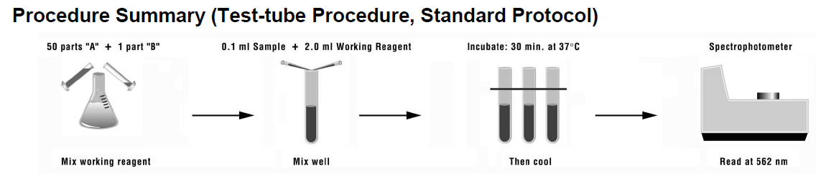

Kit contents (store at RT):

BCA Reagent A:

BCA Reagent B:

Albumin protein standard, 1mL ampules of 2 mg/mL

1. Use 1% SDS (same diluent as protein samples) to prepare standard curve samples.

|  |  |  |  |
| --- | --- | --- | --- |
| Dilution Scheme for Standard Test Tube Protocol (Range = 20-2,000μg/mL)  ** The Nandrop program for the BCA assay takes 8 different standard concentrations to compute the standard curve. | | | |
| **Vial** | **Volume of Diluent**  **(μL)** | **Volume and Source of BSA (**μ**L)** | **Final BSA Concentration (**μ**g/mL)** |
| A | 0 | 300 of stock | 2000 |
| B | 125 | 375 of stock | 1500 |
| C | 325 | 325 of stock | 1000 |
| D | 175 | 175 of vial B dilution | 750 |
| E | 325 | 325 of vial C dilution | 500 |
| F | 325 | 325 of vial E dilution | 250 |
| G | 325 | 325 of F dilution | 125 |
| H | 400 | 100 of vial G dilution | 25 |
| I | 400 | 0 | 0 |

1. Make working reagent (WR) by mixing 50 parts of BCA Reagent A with 1 part of BCA Reagent B (50:1, Reagent A:B). Calculate how much working reagent you need based on the number of samples you have. (50µL of sample (or standard) will be added to 1 mL of working reagent.) Or 200 µL WR and 25 µL sample. Or 20 µL WR and 2.5 µL sample.
2. Add 1 mL sample to each tube, 50µL of each standard or protein sample.
3. Incubate tubes at 37ºC in circulating water bath for 30 min.
4. Measure absorbance of all samples within 10 min. Stagger incubating the standards with incubating the samples by about 30 min (or however long you will need to make the standard curve measurements).
5. From the Nanodrop menu, choose the “Protein BCA” program.
6. From Chapter 10 of the Nanodrop manual: a 2 µL sample is required for these measurements.
7. Initialize with water, the “Reference” is a “zero” standard, which is 1% SDS
8. Be sure to thoroughly clean the pedestal after each standard and sample and after use.
9. Follow the instructions in the program. Measure 2 µL of each standard at least 3 times to generate the standard curve.
10. Measure each sample. The sample can be measured more than once to gauge variance.

Notes/Lessons learned:

Every effort should be made to extract as much protein from the sample as possible. While Invitrogen recommends dissolving the final protein pellet in 200 µL of 1% SDS (Invitrogen protocol), I found that it is better to dissolve with 50 µL or less. Sometimes, if the pellet is particularly thick, and because the dissolving solution - 1% SDS - is viscous, it can be difficult to dissolve the protein pellet in anything less than 50 µL. Heating the samples for 10 min at 50ºC in a circulating water bath helps to dissolve the pellet. After storage at -20ºC, samples can be thawed at room temperature. If the sample looks cloudy or not dissolved after thawing, heating the samples again, in the water bath at 50ºC for 10 min, will dissolve the sample.

Protein Gel –SDS-PAGE

1. Prepare the following in a 0.5 mL tube:

**Reagent Volumes**

**2 µg** protein sample x μL

NuPAGE® LDS Sample Buffer (4X) 2.5 μL

NuPAGE® Reducing Agent (10X) 1 μL

Deionized Water to 6.5 μL

Total Volume 10 μL

1. Heat-denature samples at 95°C for 6 minutes.
2. Prepare Running Buffer: 1X NuPAGE® SDS Running Buffer
3. Prepare 1,000 mL of Running Buffer as follows: 50mL of 20X NuPAGE® SDS Running Buffer (MES, MOPS, or Tris-Acetate) to 950 mL DI water
4. Mix thoroughly
5. Set aside 800 mL buffer for use in the Lower (Outer) Buffer Chamber
6. Add 500 μL of NuPAGE® Antioxidant to 200 mL Buffer for use in the Upper (Inner) Buffer Chamber of the XCell *SureLock*™ Mini-Cell just prior to starting electrophoresis. Mix thoroughly. If the antioxidant is not added to the Upper Buffer Chamber, reoxidation of proteins during electrophoresis may cause certain bands to appear more diffuse.

XCell *SureLock*™ Mini-Cell requires 200 mL for the Upper Buffer Chamber and 600 mL for the Lower Buffer Chamber.

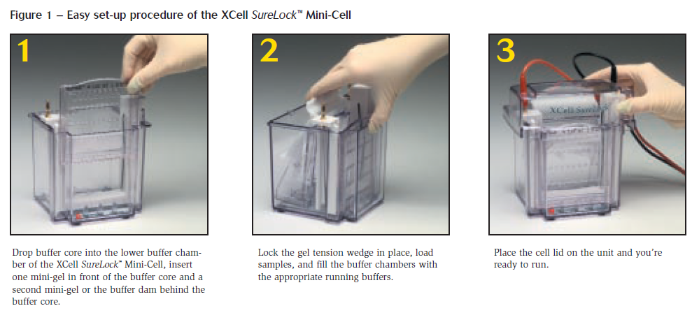

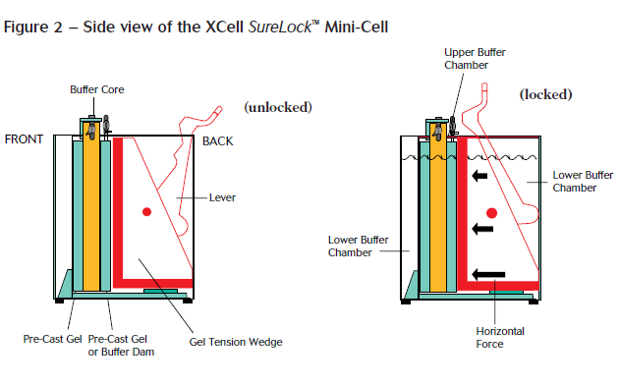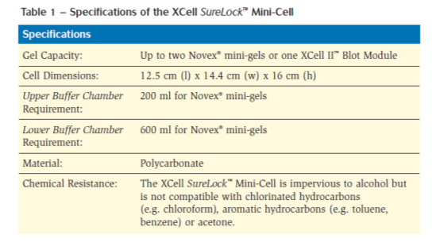

1. Remove the NuPAGE® Gel from the pouch.
2. Rinse the gel cassette with deionized water. Peel off the tape from the bottom of the cassette.
3. Gently pull the comb out of the cassette in one smooth motion.
4. Rinse the sample wells with 1X NuPAGE® SDS Running Buffer. Invert the gel and shake to remove the buffer. Repeat two more times.
5. Orient the two gels in the Mini-Cell such that the notched “well” side of the cassette faces inwards toward the Buffer Core. Seat the gels on the bottom of the Mini-Cell and lock into place with the Gel Tension Wedge. Refer to the XCell *SureLock*™ Mini-Cell manual (IM-9003) for detailed instructions. **Note:** If you are running just one gel, use the plastic Buffer Dam in place of the second gel cassette to form the Upper Buffer Chamber.
6. Fill the Upper Buffer Chamber with a small amount of the Running Buffer to check for tightness of seal. If you detect a leak from Upper to the Lower Buffer Chamber, discard the buffer, reseal the chamber, and check the seal again.
7. Once the seal is tight, fill the Upper Buffer Chamber (Inner) with the appropriate 1X Running Buffer. The buffer level must exceed the level of the wells.
8. Load an appropriate volume of sample at the desired protein concentration onto the gel.
9. Load protein molecular weight markers.
10. Fill the Lower (Outer) Buffer Chamber with 600 mL of the appropriate 1X Running Buffer.
11. Run. Electrophoresis Conditions for NuPAGE® Novex® Bis-Tris Gels with MOPS SDS Running Buffer: 200 V constant, 50 minutes
12. Image

**Notes, Lessons Learned:**

* Calculate and load the same quantity of protein per sample so that quantitative comparisons can be made with the immunodetection.
* For efficient transfer and immunodetection with western blotting, protein samples should be as concentrated as possible with at least 10 µg of protein per sample.
* While the recommended volume for the gels is 20 µl, the gels we use, listed in Table 1, can hold up to 22 µL of sample. If more volume is added, the sample will leak out of the gel.
* Dr. Esther Guzman, whose lab at HBOI routinely uses western blotting procedures, recommends loading as much protein as possible. While 10 µg should be sufficient to see a response with the antibody we are using, she has found that adding 20 µg ensures that efficient transfer from the gel to the membrane will take place and that the antibody will have sufficient material to bind to.

**Removing the Gel after electrophoresis**

1. After electrophoresis is complete, shut off the power, disconnect electrodes, and remove gel(s) from the XCell *SureLock*™ Mini-Cell.
2. Separate each of the three bonded sides of the cassette by inserting the Gel Knife into the gap between the two plastic plates that make up the cassette. The notched (“well”) side of the cassette should face up.
3. Push down gently on the knife handle to separate the plates. Repeat on each side of the cassette until the plates are completely separated.

**Caution**: Use caution while inserting the Gel Knife between the two plates to avoid excessive pressure on the gel.

1. Carefully remove and discard the top plate, allowing the gel to rest on the bottom (slotted) plate.
2. Remove the gel from the plate. Use the sharp edge of the Gel Knife to remove the gel foot from the bottom of the gel. Hold the Gel Knife at a 90° angle, perpendicular to the gel and the slotted half of the cassette. Push down on the knife, and then repeat the motion across the gel to cut off the entire foot. Hold the plate and gel over a container with the gel facing downward and use the knife to carefully loosen one lower corner of the gel and allow the gel to peel away from the plate.

**Optional Staining Step**

**Note:** Coomassie Blue staining fixes the proteins to the gel and will prohibit proteins from being transferred to a membrane for western blotting later. Only do this step if you want to visualize the proteins and nothing else.

1. **Rinse** the mini-gel 3 times for 5 minutes with 100 mL deionized water to remove SDS and buffer salts, which interfere with binding of the dye to the protein. Discard each rinse.
2. **Stain** the mini-gel with enough SimplyBlue™ SafeStain (~20 mL) to cover the gel. Stain for 1 hour at room temperature with gentle shaking. Bands begin to develop within minutes. After incubation, discard the stain. The stain cannot be re-used. **Note**: The gel can be stained for up to 3 hours, but after 3 hours, sensitivity decreases. If you need to leave the gel overnight in the stain, add 2 mL of 20% NaCl (w/v) in water for every 20 mL of stain. This procedure will not affect sensitivity.
3. **Wash** the mini-gel with 100 mL of water for 1–3 hours. The gel can be left in the water for several days without loss of sensitivity. There is a small amount of dye in the water that is in equilibrium with the dye bound to the protein, so proteins remain blue. To obtain the clearest background for photography, perform a second 1 hour wash with 100 mL water. **Note: Sensitivity will now decrease if the gel is allowed to stay in the water for more than 1 day.** Decrease in the amount of free dye in water favors dissociation of the dye from the protein. If you need to store the gel in water for a few days, add 20 mL of 20% NaCl.

Protein Transfer Protocol

1. The transfer membrane is supplied in a ready-to-use format in the stacks without any need for pretreatment. Do not treat the PVDF membrane with methanol as the PVDF membrane is preactivated prior to assembly with the transfer stack.
2. Open the lid of the iBlot® Gel Transfer Device. Ensure the blotting surface is clean.
3. Remove the iBlot® Anode Stack, Bottom (or Mini stack) from the package.

Remove the laminated sealing of the iBlot® Anode Stack, Bottom and keep

the stack in the transparent plastic tray. Place the iBlot® Anode Stack,

Bottom with the tray directly on the blotting surface (under the round lid).

Align the anode stack to the Gel barriers on right edge of the blotting

surface (see figure below) to avoid accidental contact of the electrical

contacts on lid with the iBlot® Anode Stack, Bottom. The alignment guide

on the left of the blotting surface should be visible and not hidden under

the rim of the tray. If the alignment guide is not visible, the Stack tray is not

properly positioned, and may fail to make the proper electrical connection.



Ensure no bubbles are visible between the membrane and the transfer stack

gel below the membrane. Remove any trapped air bubbles using the

Blotting Roller.

1. Open the cassette and immerse the pre-run gel briefly in deionized water

(1–10 seconds) to facilitate easy positioning of the gel on top of the transfer

membrane.

1. Place the pre-run gel on the transfer membrane of the anode stack 1 mini-gel on an iBlot® Gel Transfer Stack, Mini (figure B). Make sure there are no bubbles trapped between the gel and the membrane.



In a clean container, soak one iBlot® Filter Paper (or Mini Filter paper based

on the gel type used) in deionized water. iBlot® Filter Paper is included with

each iBlot® Gel Transfer Stacks.

7. Place the presoaked iBlot® Filter Paper on the pre-run gel. Use the Blotting

Roller to remove any air bubbles between the membrane and gel as shown

below for the Transfer Stack.

For E-PAGE™ gels, there is no need to use a filter paper, and be sure to use

the Blotting Roller over the well rows to flatten any remaining gel

protrusions to ensure even transfer.



Remove the iBlot® Cathode Stack, Top (or Cathode Stack, Mini) from the

package. Discard the red plastic tray. Place the iBlot® Cathode Stack, Top (or Cathode Stack, Mini) on top of the presoaked filter paper with the copper electrode side facing up (and agarose side facing down) and aligned to the right of the bottom stack.

Remove any air-bubbles using the Blotting Roller.



Place the iBlot® Disposable Sponge on the inner side of the lid (between the

small protrusions on the lid that hold the sponge in its place) such that the

metal contact is to the top right as shown below. The sponge absorbs any excess liquid generated during blotting and exerts

an even pressure on the stack surface.



Perform blotting within 15 minutes of assembling the stacks with the gel.

Close the iBlot® Lid and secure the latch. The red light is on indicating a

closed circuit. Ensure that the correct program is selected (P3 for 8 min).

2. Press the Start/Stop Button to start the transfer. The red status light changes

to green. The transfer continues using the programmed parameters (page 12).

3. At the end of the transfer, the current automatically shuts off and the iBlot®

Gel Transfer Device signals the end of transfer with repeated beeping sounds,

a flashing red light, and a digital display.

disassemble the device and

stacks within 30 minutes of ending the blotting procedure.

Open the lid of the iBlot® Device.

2. Remove the iBlot® E-PAGE™ Tab (used for blotting E-PAGE™ gels only).

Rinse the tab with deionized water and store in a dry place for future use.

Do not discard the iBlot® E-PAGE™ Tab.

3. Discard the iBlot® Disposable Sponge and iBlot® Cathode Stack, Top.

4. Carefully remove and discard the gel and filter paper (if used) as shown

below. Remove the transfer membrane from the stack and proceed with

the blocking procedure or stain the membrane (see next page for details).

Note: If you are using PVDF membranes, place the membrane immediately into

water, as PVDF membranes dry quickly. If the PVDF membrane is dried, re-wet the

membrane with methanol and rinse with deionized water a few times before use.

Transfer the membrane to your blocking or staining solution only after you are sure

that is completely wet, as reactivating after the membrane is exposed to the

blocking solution may be problematic.



Discard the iBlot® Anode stack, Bottom.

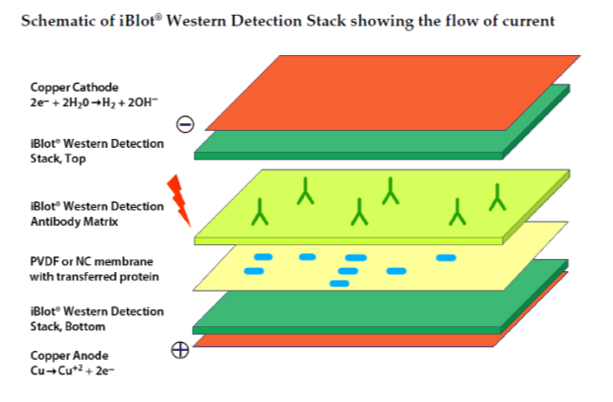

Troubleshooting:

* <http://www.mdbioproducts.com/resources/protocols/western-blotting>
* <http://biosupport.licor.com/docs/Chemi_Good_Westerns.pdf>
* <http://core.phmtox.msu.edu/Scheduling/ItemDocs/50/Optimizing_Chemiluminescent_Western_Blots.pdf>

**References**

Likhite and Warawdekar. 2011. [A unique method for isolation and solubilization of proteins after extraction of RNA from tumor tissue using TRIzol](http://www.ncbi.nlm.nih.gov/pmc/articles/PMC3059540/). J. Biomol. Tech. 22(1): 37-44.

**Appendix 2**

Invitrogen EXPRESS One-Step SYBR Green ER Kit protocol

(Life Technologies, Catalogue # [11784-01K](http://products.invitrogen.com/ivgn/product/1178401K))

July 2013

Marine Genomics Lab, HBOI/FAU

**Notes**

* Thaw samples on ice
* Keep all reagents on ice.
* Setup reactions on ice.
* Melting curve analysis?
* ROX reference dye is not required for the Eppendorf MasterCycler.

**Standard Cycling Program**

|  |
| --- |
| 50°C for 5 minutes (cDNA synthesis) |
| 95°C for 2 minutes |
| 40 cycles of:  95°C for 15 seconds  60°C for 1 minute |
| Melting curve analysis:  60°C–95°C (refer to instrument manual for specific programming) |

**Protocol**

1. Prepare a master mix, then add RNA:

|  |  |
| --- | --- |
|  | **20-μl rxn (can be scaled)** |
| EXPRESS SYBRR GreenER™ qPCR SuperMix Universal | 10 μl |
| 10 μM forward primer (200 nM final) | 0.4 μl |
| 10 μM reverse primer (200 nM final) | 0.4 μl |
| EXPRESS SuperScriptR Mix for  One-Step SYBRR GreenER™ | 0.5 μl |
| Template RNA (1 pg–1 μg total RNA) | 5 μl |
| DEPC-treated water | to 20 μl |

1. Prepare control reactions as follows:
   1. **No-RT controls:** Do not add the EXPRESS SuperScriptR Mix.
   2. **No-template controls:** Do not add template RNA.
2. Cap or seal each PCR tube/plate, and gently mix.
3. Place reactions in the instrument.
4. Collect data and analyze results.
5. **Optional:** Check PCR products by agarose gel electrophoresis.

**Appendix 4**

Notes For Using the Eppendorf Mastercycler® ep *realplex*

Marine Genomics Lab, HBOI/FAU

Installation on 11/4/2011

Manual available here: <http://www.geminibv.nl/labware/eppendorf-mastercycler-ep-gradient-s/eppendorf-mastercycler-ep-manual.pdf>

1. Use Administrator login (no password)

On/Off switch on back of instrument

Order of turning on/off computer or instrument doesn’t matter as long as there is good communication between the two.

Minimum = Turn off system 1 time per week

Recommended = Turn off when no one is using it

Startup time = 30 min to allow the instrument to warm up.

Turn on system first, then go prepare the assay. By the time you finish, the instrument will be warmed up.

1. Read the Realplex manual and Customer User guide (Summary)
2. Create new user account (or edit current users) – setup, system config, (left panel) users, new, specify either *Admin* or *Restricted user* (cannot edit or access databases other than ones they have created)
3. The **Database Tool** program (icon on desktop) is used to access saved information. Backup of databases once per month to flash drive is recommended, depending on the frequency of use. **Database Tool** cannot be opened with the Realplex software is open.

Default username: Eppendorf

Password: e (case sensitive)

**Realplex** Program

To make sure there is good communication with instrument and computer, check at the bottom left corner of the screen. There should be 1 red bar – reading *Current User Eppendorf* – and 1 green bar – reading *Cycler Status Idle*. If bar is red not green, then restart software with database tool or from the desktop.

** Label USB port the instrument is plugged into.

Before running assay, run background calibration of plate. Do this every time you switch to a new type of plate, otherwise, this calibration can be saved and used for later assays. It is important to keep the block clean. Keep an empty plate in the instrument. Clean with 70% ethanol if it does happen to get dirty.

Background Calibration

Fill wells with same vol. and type of water used in the assay. Select setup, background calibration, New, give plate name, e.g. “White well Eppendorf”, calibrate. Wait 5 min – there will be a new window instructing to turn plate 180º, calibrate again.

There are 4 filters. If you want to use a new type of dye not already in the system, click setup, dyes, new dye, enter information (Name, Filter, etc.), run color calibration, calibrate, window instructing to turn plate 180º, calibrate.

Setup Assay - Plate layout

* Hints box on right side
* Select *dye*, input *sample volume*, *probe*, *background plate*
* Have the ability to highlight multiple wells, specify unknown, standard, new unknown, etc.
* Autoseries- Define replicate patterns horizontally or vertically, will fill in automatically, can setup assay plate on different computer, save, load.
* In Edit mode, can retroactively change well designations

The Quick Reference Guide has plate setup layouts.