***REPORT:-***

***ONLINE Movie Ticket Booking System***



The proposed project “Online Movie Ticket Booking System” is the process whereby consumers directly buy movie tickets online from a multiplex website interactively in real-time without an intermediary service over the Internet. The Given System provides the detailed working of the Online Movie Ticket Booking Processing and what all happens whenever we or any one of us goes to book movie tickets online.

# Background of Project

“Online Movie Ticket Booking System” is an online ticket booking project , customers can book tickets 24 hours a day from anywhere in the world and interact with multiplex’s website to know about currently running movies and their schedule or service information provided by the multiplex. Multiplex customer relationship manager can interact with customers and enable them to learn more about customers’ needs, build good customer relationships, increase efficiency and reduce costs, and gain access to national markets quickly.

# Objective of Project

The project “Online Movie Ticket Booking System Management” is dedicated to the general requirements of multiplex theaters. The main objective of the project is to create an Online Movie Ticket Booking processing that allows customers to know about new movies, their schedules, cinema locations, class and ticket price etc. In the booking process when customer selects his city then cinemas of that city are filtered. In next step he/she selects his desired cinema where he/she wish to see movie, then selects movie and other details like show date, show time, class and no of tickets. Based on given parameters a graphical layout of seat status is visible to the customer. Now customer can select his desired seat location and number of seats. The Administrator will be able to see all booked and canceled ticke

The main purpose of this project is to provide a reliable, secure, efficient and user friendly environment to the customers and management authorities. Also benefit to the customer with efficient and faster service.

The Project “Online Movie Ticket Booking System” as a wide scope as it is generalized software and

can be easily used in any ticket booking process system with little or no change. The Changes in

software can be easily accommodated. The addition and deletion of the modules in software can be

easily adjusted. This project has a lot of scope for further enhancement too. This project can save money

and efforts in managing the record, just a mouse click can make the task easy and faster.

***Requirements***

# Research

Cinemas help in contributing to our daily memories as they provide an essential part of our culture,

going to cinemas has been the culture of almost all the families of today’s generation. It is a time

when the family can spend some time altogether by stealing some hours from their busy schedule.

Movie Ticket Booking System provides the customers facility to book tickets for a movie and to

gather information about the movies and theaters.Customers can book ticket of his choice and may cancel a ticket

# Objective of Online Movie Ticket Booking System

Online cinema Ticket Booking System project is aimed to provides facility to book cinema tickets anytime and from anywhere.

One objective of this project is to minimize the number of staff at the ticket-box window.

Promote new movie over the internet and gain maximum profit.

Provide a 24*7 service to the customer.

**Features**

Booking tickets Cancel tickets Change ticket price(only admin) View all booking records

**Benefits**

Movie Ticket Booking system provides wide range of benefit they are as follows For better performance

User Friendly Can Select the seats as per choice

***4W's and 1'H***

**Who**

Theater

**What**

To bulid a system to book ticket,cancel ticket,view reserverd seats,change price of ticket(only admin)

**When**

When user wants to carry out the tasks quickly and this reduces manual work and saves time

**Where**

This issue is in all parts of the world in theater where there is a lot of booking,cancellation of tickets

happening in all the time

**How**

By creating a system which will provide all the functionalities required,the booking of, cancelling of the

tickes and other actions will be take more time and system needs more workers for these actions

***GanTT Chart:-***

|  |  |  |  |  |  |  |  |  |  |  |  |  |  |  |
| --- | --- | --- | --- | --- | --- | --- | --- | --- | --- | --- | --- | --- | --- | --- |
|  |  |  |  |  |  |  |  |  |  |  |  |  |  |  |
| ***Online Movie Ticket Booking System*** |  |  |  | | | | | | | | | | | |
| ***Company- LTTS*** |  |  |
| ***Lead by- Aniket Nagpure*** |  |  |
| Task | Start Date | Days to complete |
| Requirement specification and Analysis | 19-Mar | 1 |
| Design | 20-Mar | 1 |
| Test Cases | 21-Mar | 2 |
| Coding with unit testing | 22-Mar | 4 |
| Testing | 28-Mar | 4 |
| Documentation | 31-Mar | 1 |
|  |  |  |
|  |  |  |
|  |  |  |
|  |  |  |
|  |  |  |
|  |  |  |
|  |  |  |
|  |  |  |
|  |  |  |
|  |  |  |
|  |  |  |
|  |  |  |
|  |  |  |
|  |  |  |
|  |  |  |
|  |  |  |  |  |  |  |  |  |  |  |  |  |  |  |

***Architecture :-***

***1.UML Diagram***

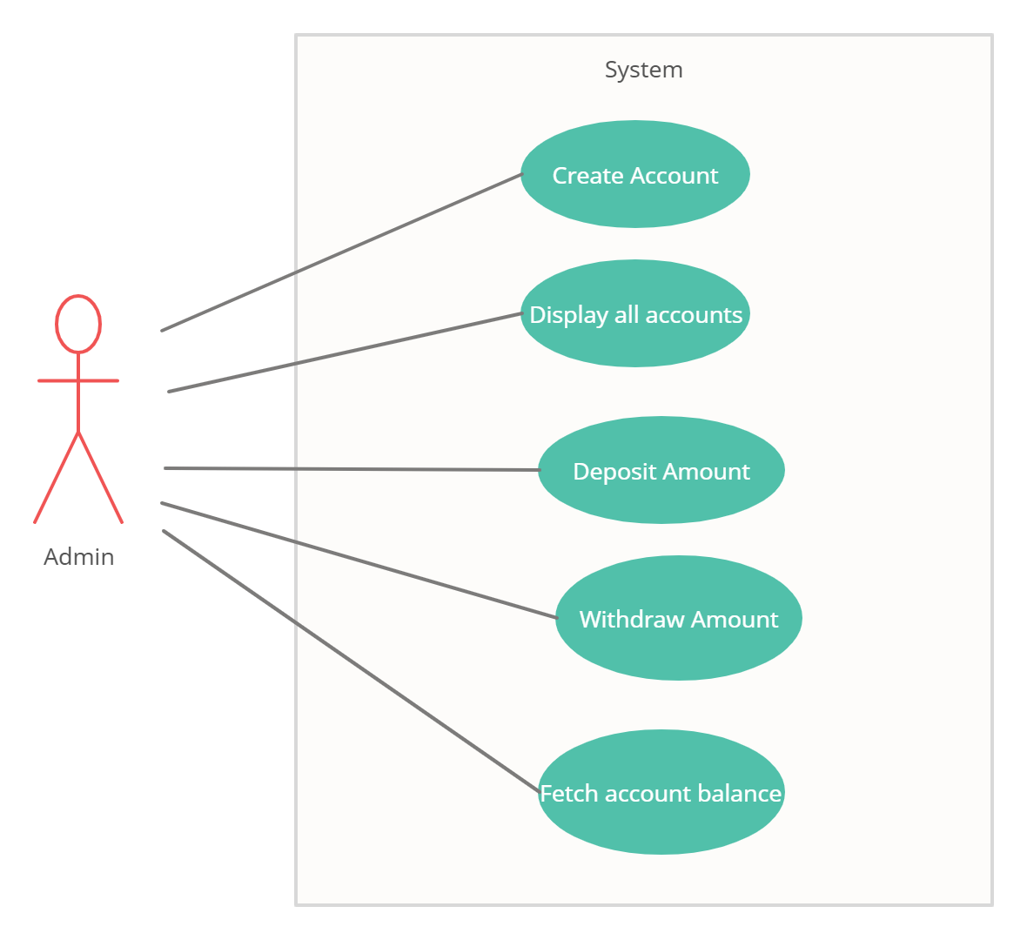

***2.High level Design***

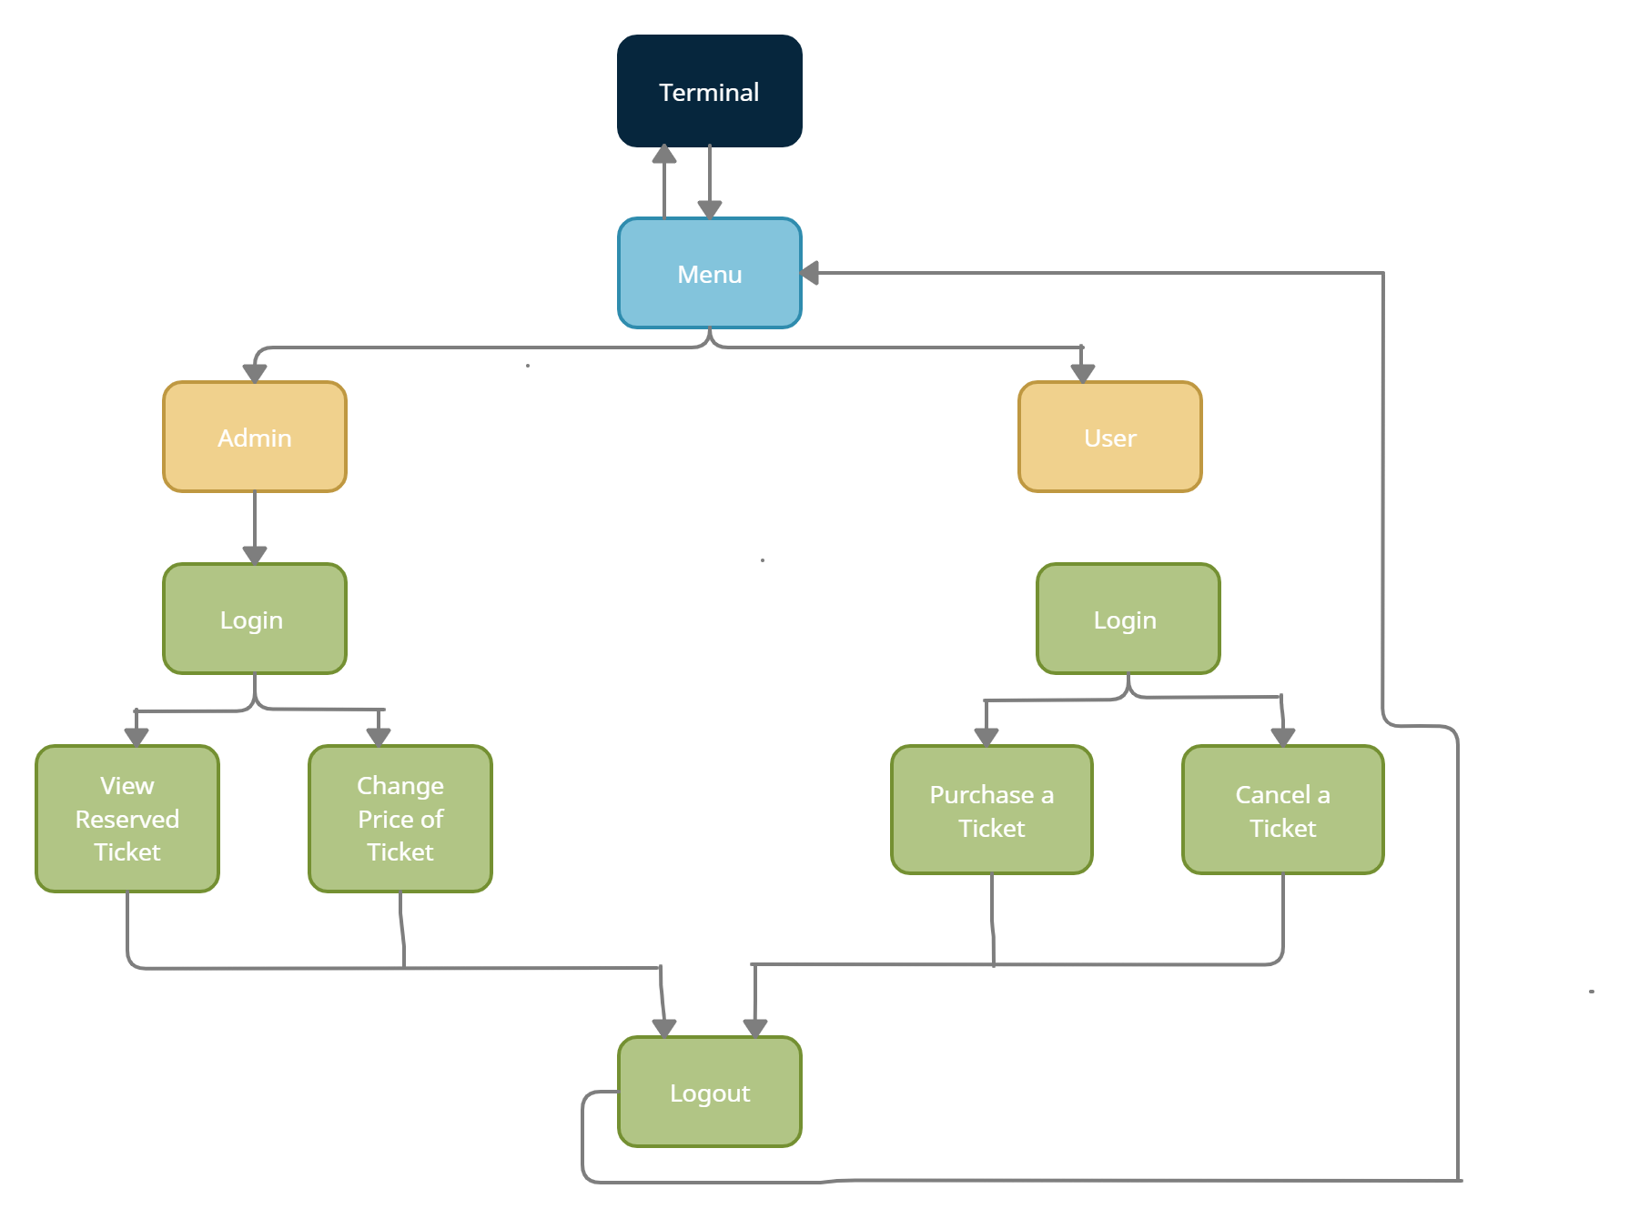

3. Low level Design

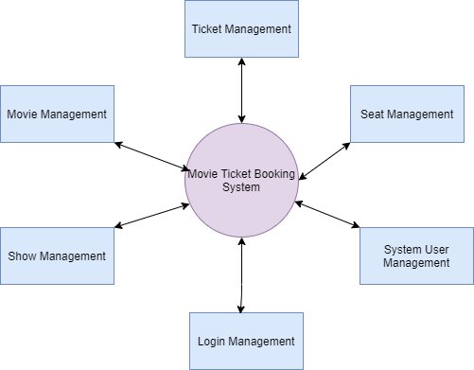

***Test plan and Output:-***

| Test ID | **HLT Id** | **Description** | **Exp IN** | **Exp OUT** | **Actual OUT** | **PASS/FAIL** |
| --- | --- | --- | --- | --- | --- | --- |
| T_01 | H_01 | Provide required details for login to book a ticket | Password | Successfully logged In | Successfully logged In | PASS |
| T_02 | H_01 | When wrong password is entered | Password | Entered Password is wrong | Entered Password is wrong | PASS |
|  | H_02 | Display the details of movie available | Enter choice | Display list | Display list | PASS |
| T_03T_04 | H_02 | Purchase a ticket for the movie available | Enter choice | Thank You for Booking Ticket | Thank You for Booking Ticket | PASS |
| T_05 | H_03 | Summary of a ticket for purchased movie | Enter choice | Booking ID,Customer name,Show Name,Hallno,Price | Booking ID,Customer name,Show Name,Hallno,Price | PASS |
| T_06 | H_04 | Cancel a ticket | ID number | Your ticket is cancelled | Your ticket is cancelled | PASS |
| T_07 | H_03 | Change the price of ticket (only admin) | Password | Please enter new price | Please enter new price | PASS |
| T_08 | H_03 | Change the price of ticket after login (only admin) | Enter new price | Price Updated Successfully | Price Updated Successfully | PASS |
| T_09 | H_03 | When wrong password is entered while Changing the price of ticket (only admin) | Password | Entered Password is wrong | Entered Password is wrong | PASS |
| T_10 | H_05 | To view the reserved Ticket | Password | Summary of Ticket | Summary of Ticket | PASS |
| T_11 | H_05 | When wrong password is entered to view the reserved ticket | Correct Password | Entered Password is wrong | Entered Password is wrong | PASS |

Folder structure

| Folder | Description |
| --- | --- |
| 1_Requirements | Documents detailing requirements and research |
| 2_Architecture | Documents specifying designed details |
| 3_Implementation | All code and documentation which is implemented |
| 4_Test_plan | Documents with test plans and procedures are mentioned |
| 5_Images | Screen-shots of the working code is there |

Features

| **Feature Id** | **Feature** |
| --- | --- |
| F_01 | Login to System |
| F_02 | Select Movie that is Avaliable |
| F_03 | Purchase a Ticket |
| F_04 | Summary of Ticket |
| F_05 | Cancel a Ticket |
| F_06 | Logout |