Report

1st version of structure of the website:

2st version of structure of the website:

Comments: The reason why I deleted the page “contact” was because it wasn’t really necessary as the person can get all our contacts in every page (on footer) and especially on the page “about.html”. The contacts are totally visible and easy to a user reach and find.

Change of layout

1st version: About.html 2nd version:

|  |  |  |
| --- | --- | --- |
| menu | | |
| Text membership | Text events | Text contact |
| Committees information | | |
| footer | | |

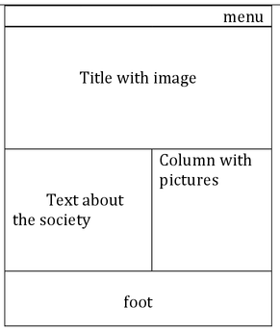

Validation of the website through W3C:

Index.html

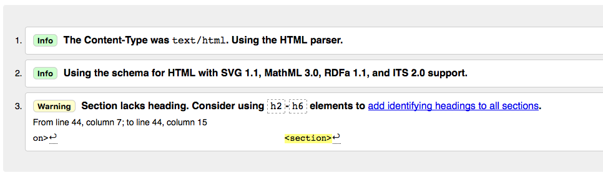

Comments:

The reason why W3C is warning about the se of headers, is because I am using the other headers(h2,h3,etc.) for parts of the website. Apart from these warnings, as it can be seen on the picture, it is validated successfully.

About.html

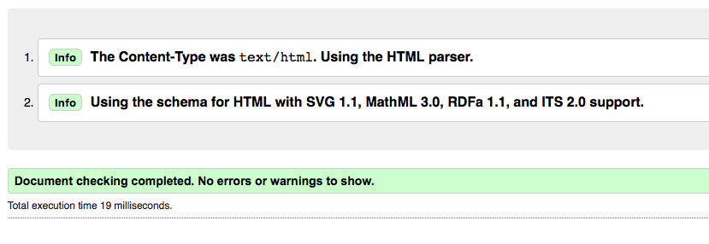

Events.html



Join.html



Validation through browsers:

|  |  |  |  |
| --- | --- | --- | --- |
|  | http://cdn-media-1.lifehack.org/wp-content/files/2007/03/20070306-firefox.jpg | https://upload.wikimedia.org/wikipedia/en/b/be/Google_Chrome_for_Android-_Android_5.0_Logo.png | http://vignette3.wikia.nocookie.net/logopedia/images/6/61/Apple_Safari.png/revision/20150324134451 |
| Structure | http://findicons.com/files/icons/808/on_stage/128/symbol_check.png | http://findicons.com/files/icons/808/on_stage/128/symbol_check.png | http://findicons.com/files/icons/808/on_stage/128/symbol_check.png |
| Fonts | http://findicons.com/files/icons/808/on_stage/128/symbol_check.png | http://findicons.com/files/icons/808/on_stage/128/symbol_check.png | http://findicons.com/files/icons/808/on_stage/128/symbol_check.png |
| Images | http://findicons.com/files/icons/808/on_stage/128/symbol_check.png | http://findicons.com/files/icons/808/on_stage/128/symbol_check.png | http://findicons.com/files/icons/808/on_stage/128/symbol_check.png |
| JavaScript | http://findicons.com/files/icons/808/on_stage/128/symbol_check.png | http://findicons.com/files/icons/808/on_stage/128/symbol_check.png | http://findicons.com/files/icons/808/on_stage/128/symbol_check.png |

IMAGES: I searched for images that are free-license for personal or educational purposes.