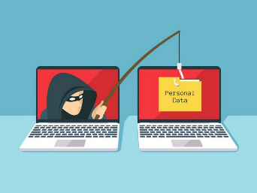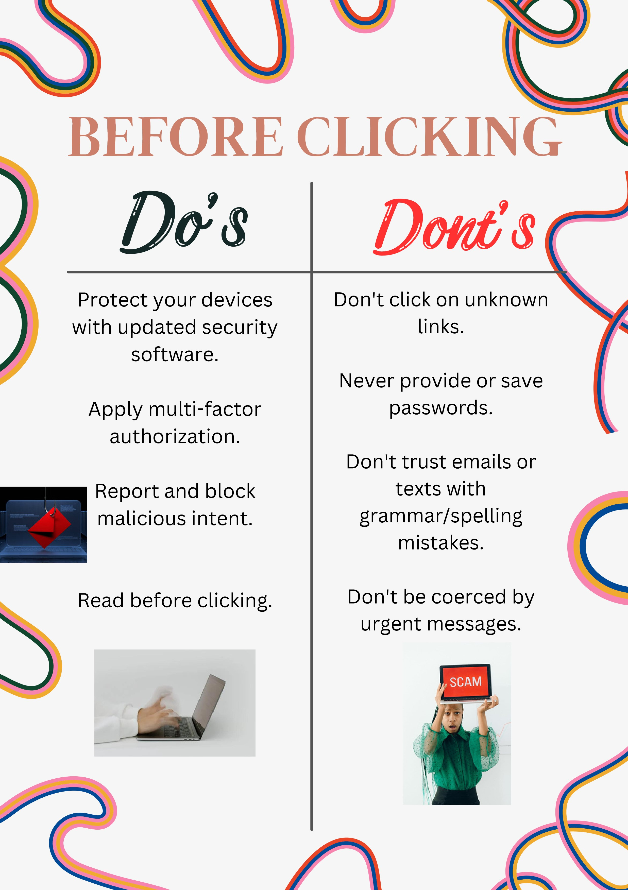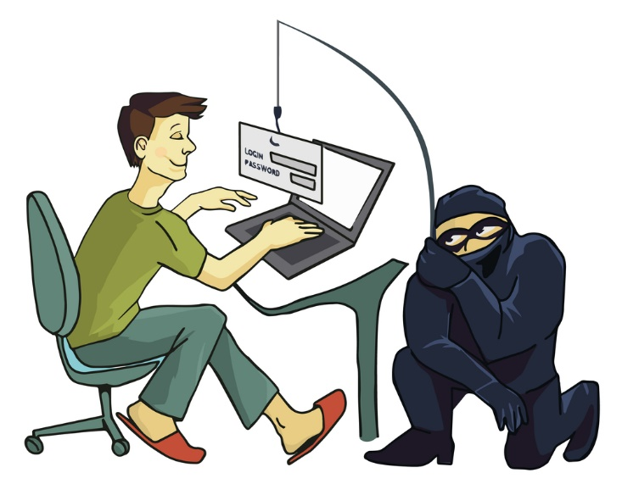

If you believe you have detected a phishing e-mail, follow the steps mentioned here: [https://staysafeonline.org/theft-fraud-cybercrime/phishing/"](https://staysafeonline.org/theft-fraud-cybercrime/phishing/)