

Foundations of Programming
Assignment No. : 10

PROBLEM STATEMENT:
Write a program in C to simulate a simple calculator that performs basic arithmetic operations such as addition, subtraction, multiplication, and division. The calculator should also perform special operations like computing xʸ (power) and x! (factorial).

OBJECTIVE:
• To understand the use of switch-case statements in C.
• To perform basic arithmetic and special mathematical operations.
• To enhance problem-solving skills using menu-driven programs.

THEORY:
A calculator is a basic computing device used to perform arithmetic operations. In C programming, a simple calculator can be implemented using conditional or switch-case statements. Arithmetic operations like addition, subtraction, multiplication, and division are fundamental operations. Special operations such as power (xʸ) and factorial (x!) require loops for repeated calculations.

PLATFORM:
Linux

ALGORITHM:
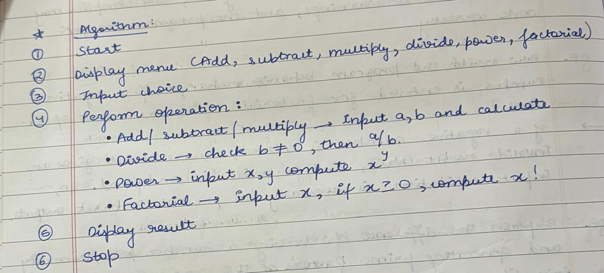

FLOWCHART:
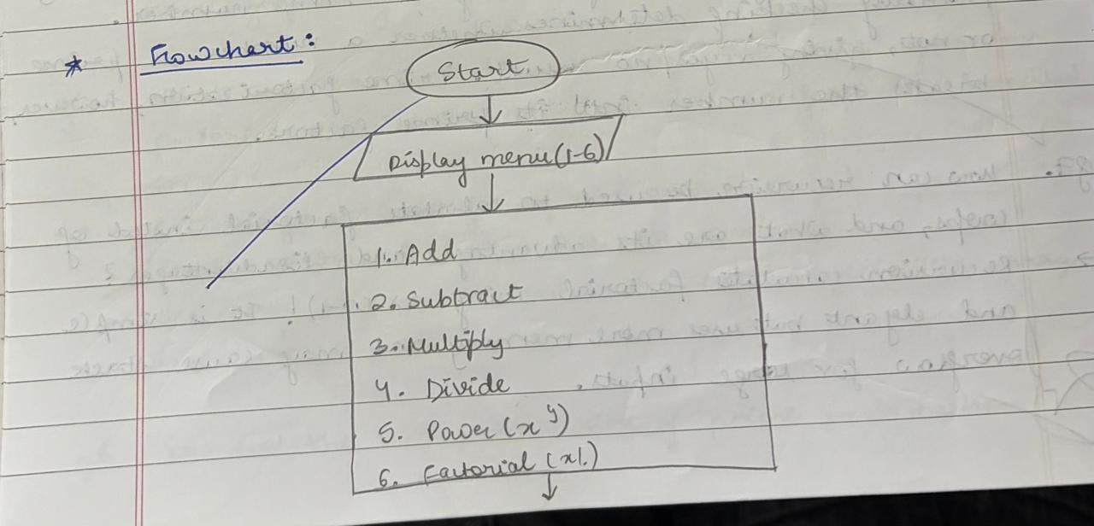
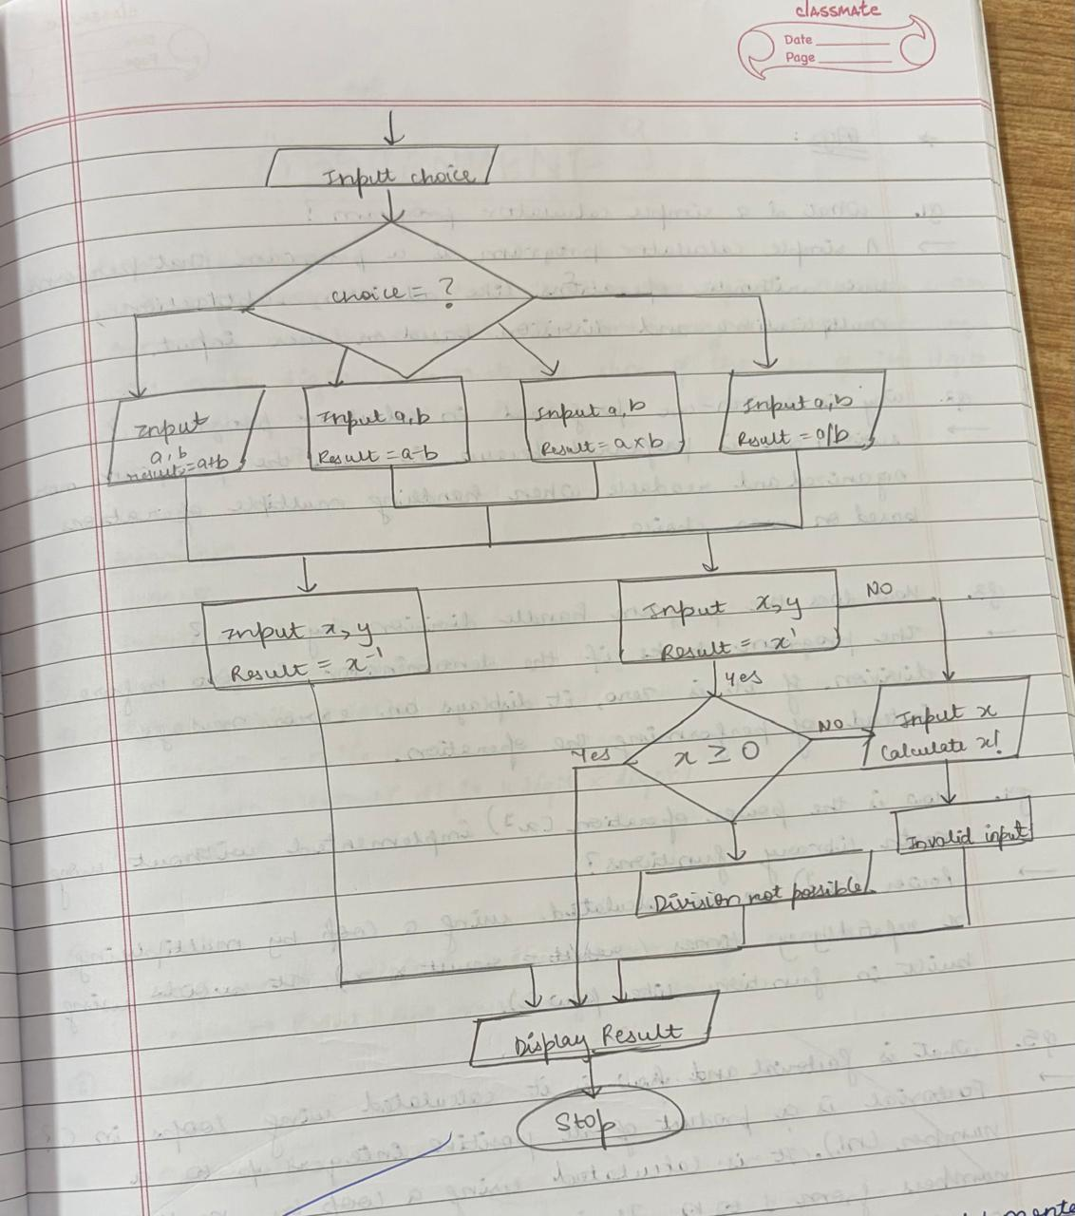

C PROGRAM:
#include <stdio.h>

// Function for factorial
int factorial(int n) {
int i, fact = 1;
for(i = 1; i <= n; i++)
fact = fact * i;
return fact;
}

int main() {
int choice;
float a, b, result;
int n, i;

do {
printf("\n--- CALCULATOR MENU ---\n");
printf("1. Addition\n2. Subtraction\n3. Multiplication\n4. Division\n");
printf("5. Power (x^y)\n6. Factorial (x!)\n7. Exit\n");

printf("Enter your choice: ");
scanf("%d", &choice);

switch(choice) {

case 1:
printf("Enter two numbers: ");
scanf("%f %f", &a, &b);
printf("Result = %.2f\n", a + b);
break;

case 2:
printf("Enter two numbers: ");
scanf("%f %f", &a, &b);
printf("Result = %.2f\n", a - b);
break;

case 3:
printf("Enter two numbers: ");
scanf("%f %f", &a, &b);
printf("Result = %.2f\n", a * b);
break;

case 4:
printf("Enter two numbers: ");
scanf("%f %f", &a, &b);
if(b != 0)
printf("Result = %.2f\n", a / b);
else
printf("Division by zero not allowed\n");
break;

case 5: // Power
printf("Enter base and exponent: ");
scanf("%f %f", &a, &b);
result = 1;
for(i = 1; i <= (int)b; i++)
result *= a;
printf("Result = %.2f\n", result);
break;

case 6: // Factorial
printf("Enter a number: ");
scanf("%d", &n);
if(n < 0)
printf("Factorial not defined\n");
else
printf("Result = %d\n", factorial(n));
break;

case 7:
printf("Exiting...\n");
break;

default:
printf("Invalid choice!\n");
}

} while(choice != 7);
return 0;
}
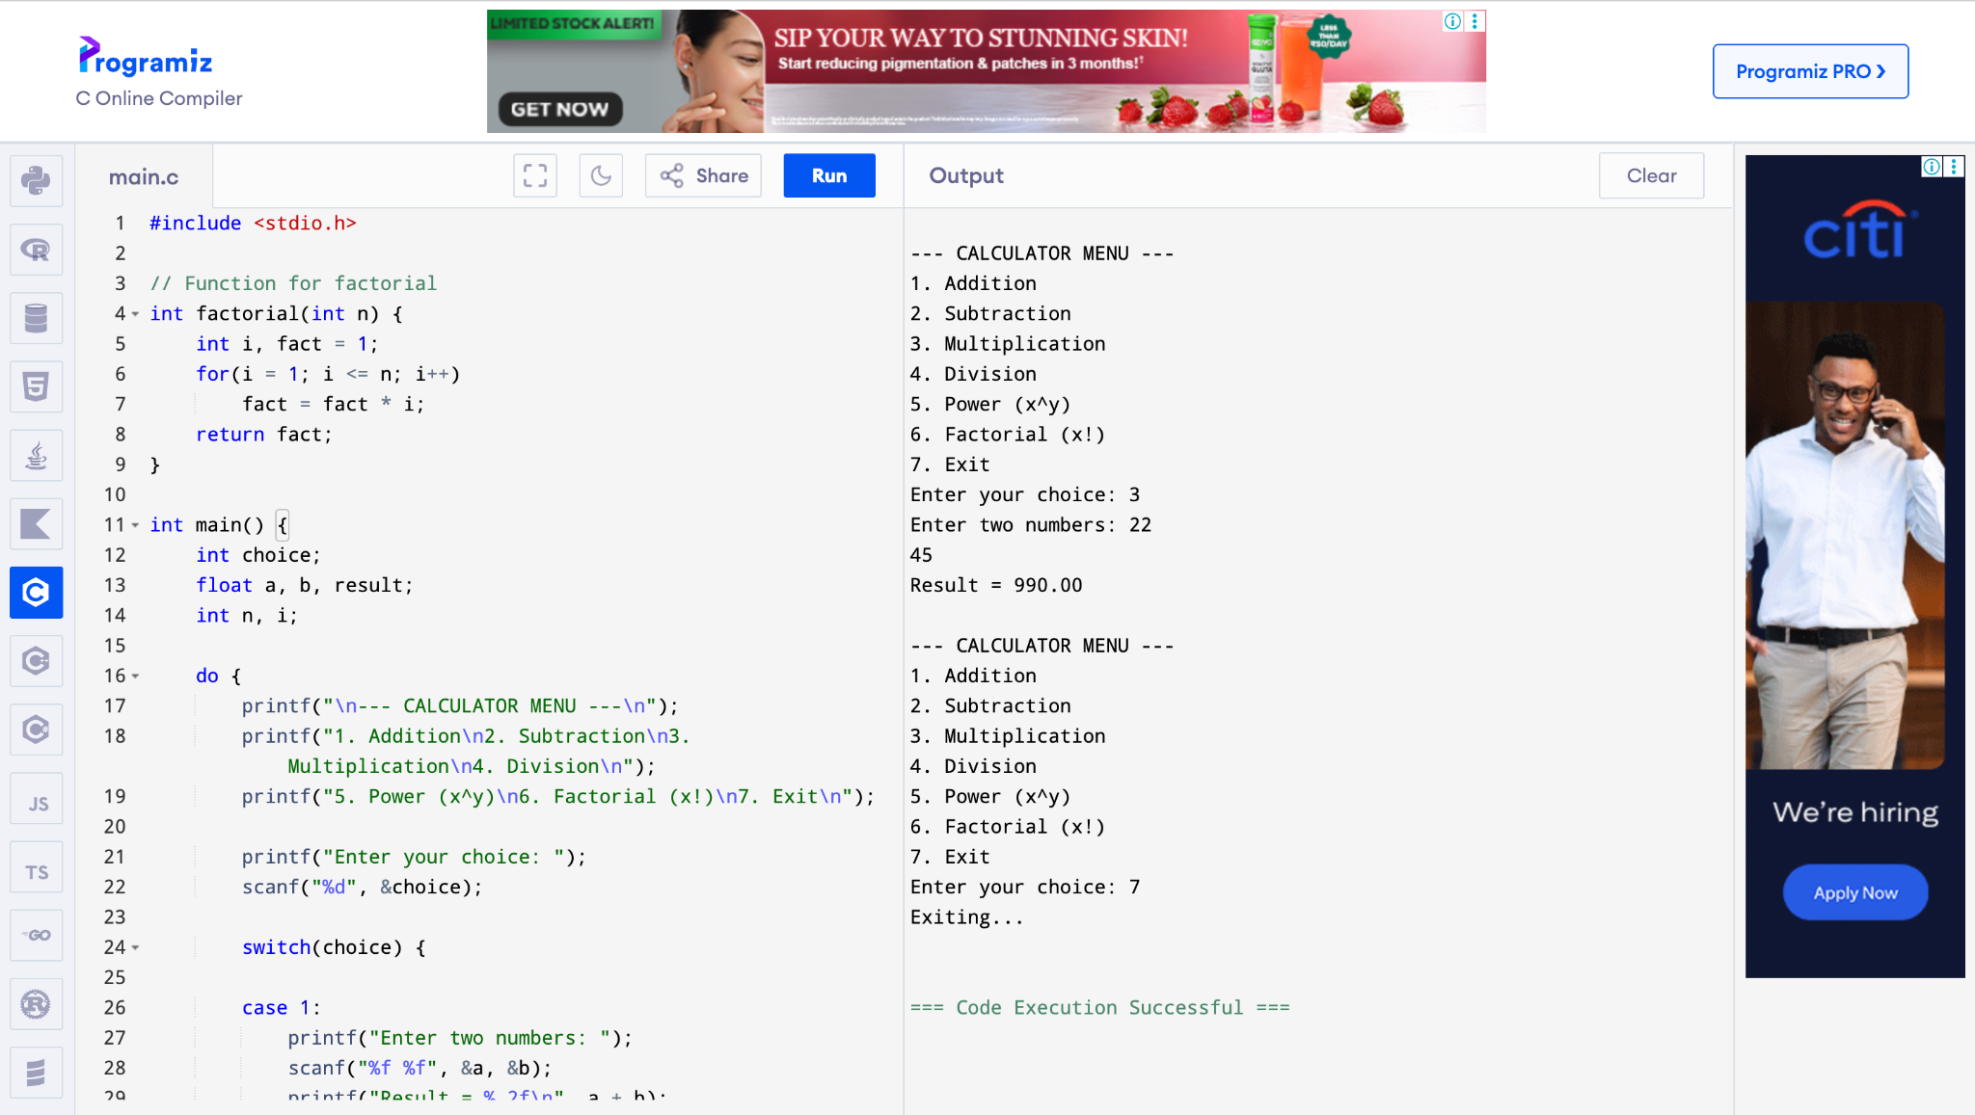

CONCLUSION:
Thus, a simple calculator program was successfully implemented using C programming. The program demonstrates the use of switch-case statements, loops, and arithmetic operations.

FAQs:
- What is a simple calculator program?
- Why is switch–case preferred in calculator programs?
- How does the program handle division by zero?
- How is the power operation (xʸ) implemented without using math library functions?
- What is factorial and how is it calculated using loops in C?

