

Foundations of Programming

Assignment No. : 06
PROBLEM STATEMENT:Write a C function to compute the factorial of a number with and without recursion.

OBJECTIVE:

To demonstrate two different approaches for calculating the factorial of a number: iterative (non-recursive) and recursive, showcasing the versatility of problem-solving methods in programming.

THEORY:
- Explain the difference between the iterative and recursive approaches to calculating the factorial of a number.
- What is the base case in the recursive function for computing factorials, and why is it necessary?
- How does the program handle invalid input, such as negative numbers, and why is this important?
ALGORITHM:
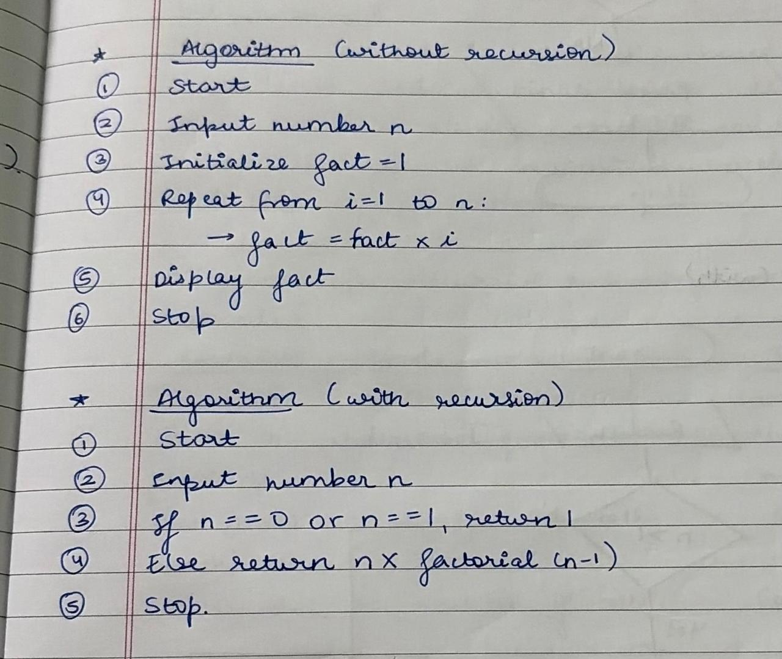
FLOWCHART:
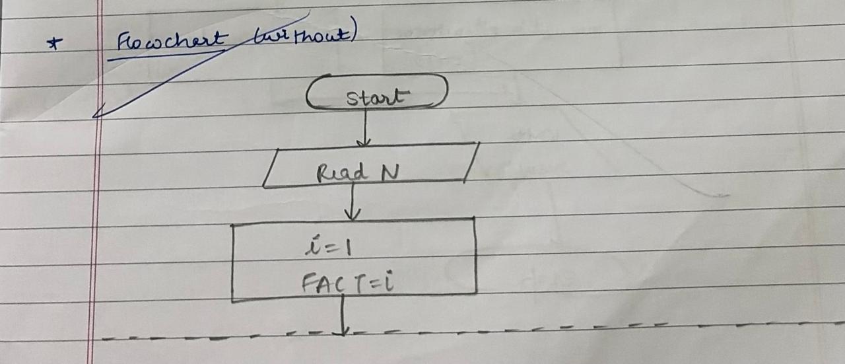
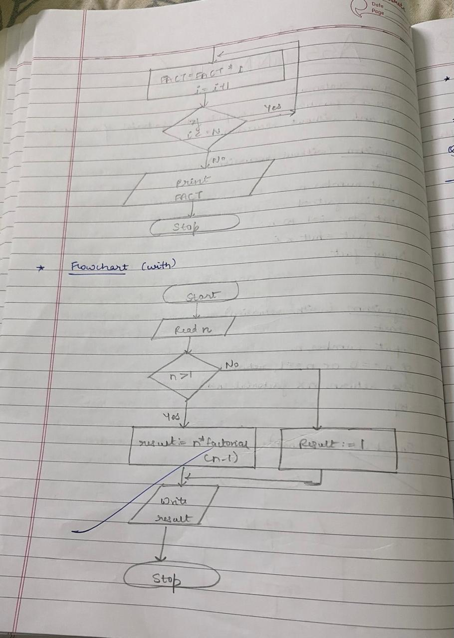
PLATFORM: Linux
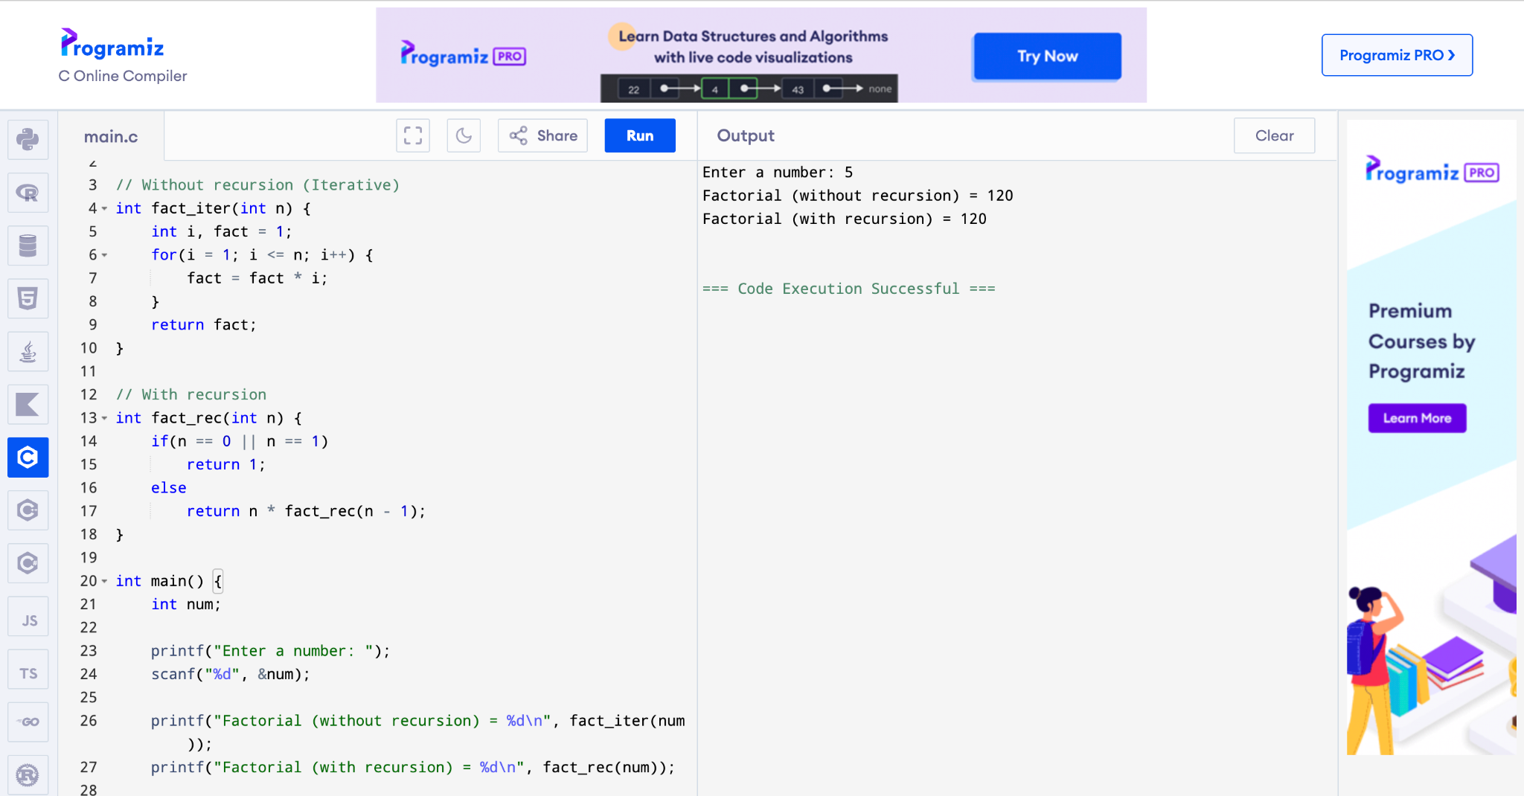
CONCLUSION: Thus, we have successfully executed factorial of a number with and without recursion.

FAQs:
1. What is the purpose of calculating factorial in programming?
2. What is the difference between recursive and non-recursive (iterative) methods?

