

Foundations of Programming

Assignment No.: 07
PROBLEM STATEMENT: Write a C program to accept student details and display their result using an array of structures.

OBJECTIVE:

- To understand the concept of structures in C.
- To learn how to store multiple records using an array of structures.
- To accept and process student details such as name, roll number, and marks.
- To calculate total and percentage and display the result.

THEORY:
In C programming, a structure is a user-defined data type that allows grouping of variables of different data types under a single name. When multiple records such as student details need to be stored, an array of structures is used. This allows efficient storage and processing of student information like roll number, name, and marks in different subjects. The program can compute total marks and percentage and display the result for each student.

ALGORITHM:
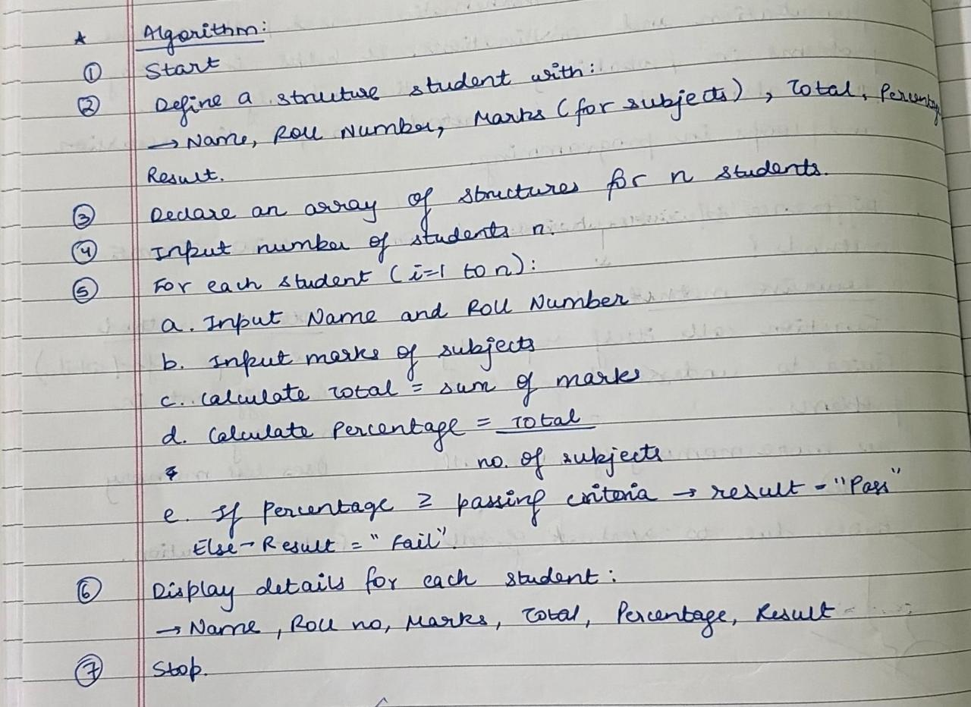
FLOWCHART:
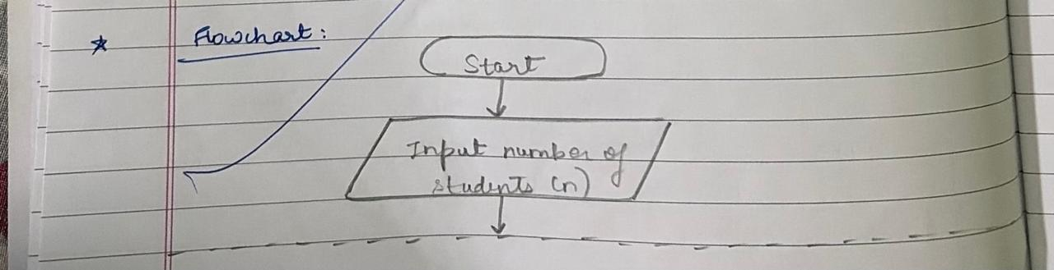
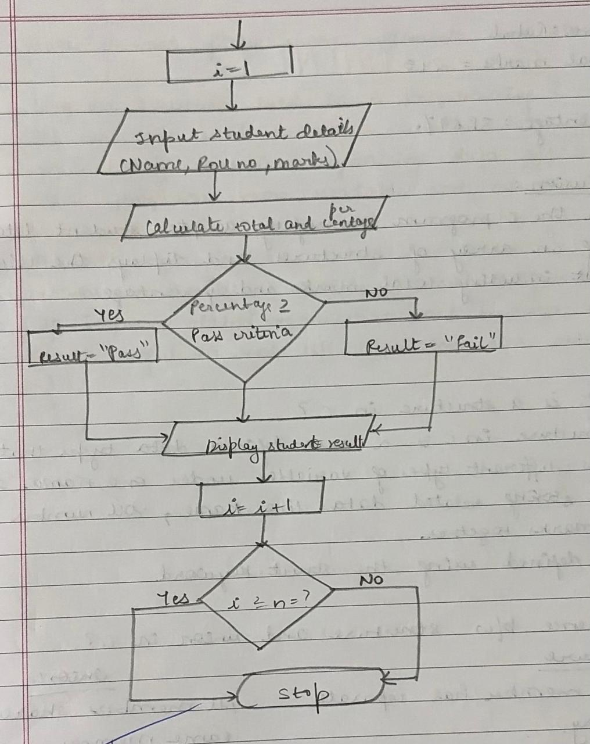
PLATFORM: Linux
CODE:
#include <stdio.h>

struct student {
int roll;
char name[50];
float m1, m2, m3, total, avg;
};

int main() {
struct student s[10];
int i, n;

printf("Enter number of students: ");
scanf("%d", &n);

// Input
for(i = 0; i < n; i++) {
printf("\nEnter details of student %d:\n", i + 1);

printf("Roll No: ");
scanf("%d", &s[i].roll);

printf("Name: ");
scanf("%s", s[i].name);

printf("Marks in 3 subjects: ");
scanf("%f %f %f", &s[i].m1, &s[i].m2, &s[i].m3);

// Calculation
s[i].total = s[i].m1 + s[i].m2 + s[i].m3;
s[i].avg = s[i].total / 3;
}

// Output
printf("\n--- Student Results ---\n");
for(i = 0; i < n; i++) {
printf("\nRoll No: %d", s[i].roll);
printf("\nName: %s", s[i].name);
printf("\nTotal: %.2f", s[i].total);
printf("\nAverage: %.2f\n", s[i].avg);
}

return 0;
}

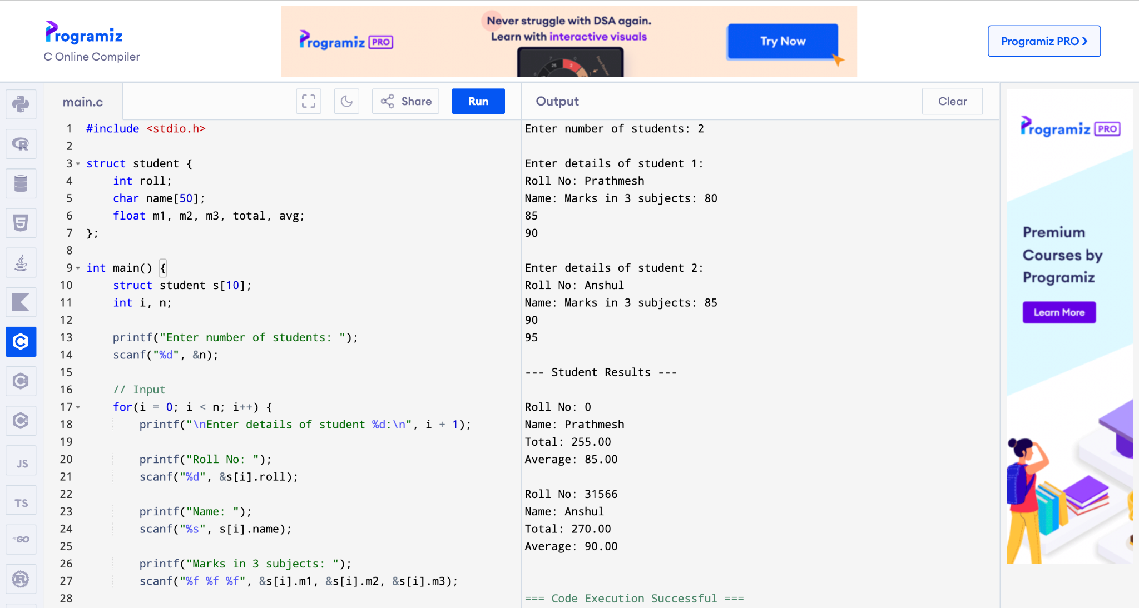
CONCLUSION: Thus, the C program successfully accepts student details using an array of structures and displays the calculated result including total marks and percentage.

FAQs:
- What is a structure in C?
- What is the difference between a structure and a union in C?
- What is an array of structures?
- Why are structures used in C programming?
- What is the advantage of using an array of structures?

