
铒镱光电™ —— 特种光纤光栅高端定制服务专家
ouiyeah™ Photonics · (http://www.ouiyeah.com)
Tel：15000834000·Email: ouiyeah@live.com
中国·上海·电子商城·临夏路208号 · 201803


High-Speed Switches

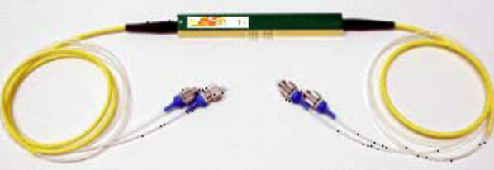

Specifications
Parameters | Values
Principal
Insertion Loss | < 3 dB (for 1x2 switch)
Switching Time | 100 ps
Crosstalk | < 20 dB (for polarization maintaining)
Optical Return Loss | > 45 dB
Operating Wavelength | 1550 nm (C- and L-band)
Polarization | Independent or Maintaining
Physical
Input Fiber | SM or PM
Output Fiber | SM or PM
Optical Connectors | FC/PC standard (FC/APC or others available)
Configurations | 1x2, 2x2, …, 1x8, …
Optional
Structure | Arrays of 2x2 switches
Crosstalk | < 30 dB
Operating Wavelength | 1060 nm or 1550 nm

