E-COMMERCE SALES ANALYSIS

Problem Statement
E-commerce businesses generate large amounts of data from customer purchases, product sales, order fulfilment, and product returns. Without structured analysis, it can be difficult to track sales performance, identify the most profitable products and understand customer purchasing behaviour.
This project uses SQL to analyse e-commerce sales data and transform raw transactional records into meaningful business insights. It helps to identify sales trends, evaluate product and customer performance, and highlight opportunities for improvements in profitability, customer retention, and operational efficiency.
Key Objective
The primary objective is to use SQL (queries, joins, aggregations, subqueries, and window functions) to derive useful insights from raw e-commerce data. These insights can then support better business decisions. The project focuses on the following objectives:
- Customer analysis: Examine customer demographics, geographical distribution, age groups and spending patterns.
- Product performance: Identify best-selling products, compare product prices across categories, and rank products by revenue and profit.
- Sales analysis: Evaluate revenue and profit across product categories and track monthly sales performance over time.
- Order analysis: Examine order volumes, delivery outcomes, and order fulfilment patterns.
- Returns analysis: Identify common return reasons, frequently returned products, refund patterns, and monthly return trends.
Who will use the dashboard
Sales and business analysts can use it to monitor monthly revenue, profit, order volumes, and product-category performance, and identify trends. Product and inventory managers can also utilise the insights to identify popular products, understand product returns, and manage product stock according to project demand. Business managers can assess overall business performance, recognise potential problems, and use evidence from sales, profitability, and returns to guide strategic decisions.
Data Description
Data Size: There are 51 rows in 4 out of the 5 sheets of data (customers, products, orders, returns). The order items sheet contains 127 rows. The number of columns vary with each sheet.
Customers
- Customer id: The unique alpha-numeric ID for every registered customer.
- Customer signup date: The date on which the customer signed up.
- Gender: The gender of the customer.
- Age: The age of the customer (18-54).
- State: The state of residence of the customer.
- City: The city of residence of the customer.
- Pincode prefix: The three numeric digits preceding the pincode.
- Customer segment: The membership status of the customer.
- Preferred payment method: The payment method chosen by the customer.
- Total orders: The total number of orders by a customer.
- Total spend: The total amount of money spent by a customer.
- Last order date: The most recent date a customer placed an order.
- Customer status: The measure of the activity status of a customer.
- Loyalty tier: The tier-sorting mechanism to separate most to least consistent customers.
Products
- Product id: The unique alpha-numeric ID for every registered product.
- Category: The category the product falls under.
- Subcategory: The specific kind of product under the category mentioned.
- Brand: The company selling the product.
- Price: The cost of the product (without any discounts applied).
- Cost price: The marked price of the product on the shelves.
- Discount range: The range of discount provided for the product.
- Rating average: The average rating of the product (out of 5).
- Rating count: The number of people who have rated the product.
- Stock quantity: The quantity of the product available in store.
- Product launch date: The date the product was released in stores.
- Product type: The ranking of the product based on its exclusivity.
Added column- Rating percentage: the weighted average rating of the product (taking into account rating count).
Orders
- Order id: The unique alpha-numeric ID for every recorded order.
- Customer id: The unique alpha-numeric ID for every registered customer
- Order date: The date on which the order was placed.
- Order status: The delivery status of the order.
- Shipping method: The means by which the order was transported.
- Delivery city: The city the order was delivered to.
- Delivery state: The state the order was delivered to.
- Discount percentage: The discount offered on the total order.
- Subtotal: The price of the order before taxes are applied.
- Tax amount: The tax leveraged on the order.
- Final amount: The total amount, considering discount and tax levied.
Order-Items
- Order item id: The unique alpha-numeric ID for every recorded order item.
- Order id: The unique alpha-numeric ID for every recorded order.
- Product id: The unique alpha-numeric ID for every registered product.
- Quantity: The number of items ordered.
- Unit price: The price of a single item.
- Discount percentage: The discount offered on the item ordered.
- Item revenue: The money earned on the sale of the item.
- Item cost: The cost price of the item.
- Profit: The cost subtracted from the revenue (money made after sale).
Added column- Price before discount: The price of the item before the discount was applied.
Returns
- Return id: The unique alpha-numeric ID for every recorded order returned.
- Order id: The unique alpha-numeric ID for every recorded order.
- Customer id: The unique alpha-numeric ID for every registered customer.
- Product id: The unique alpha-numeric ID for every registered product.
- Return date: The date on which the order was returned.
- Refund amount: The amount offered as a refund to the customer.
- Return reason: The reason for the return of the order.
- Return status: The status of the order (whether it has been returned or not).

Data Preprocessing

- Deletion of Rows
In order to facilitate easy import and compilation of data for the project, I deleted a large amount of data from every sheet in order to downsize the number of rows. All the columns (in every sheet) were reduced to 50 rows. The order items table was reduced to 127 rows (corresponding to the repeated entries of the 51 order ids).
- Deletion of Columns
From the original data, I deleted columns that did not seem essential to the project analysis.
- Customers table: age_group, acquisition channel, average_order_value
- Products table: return_rate_baseline
- Orders table: order_time, coupon_code, marketing_channel, shipping_fee, campaign_id
- Null Data
There was null data in multiple columns in every sheet. Using Ms Excel, the blank cells were replaced by “N/A” to be then classified as a different category for the purpose of charts.
- Filters
I applied filters in Ms Excel to isolate the null cells (blanks) in the columns and then label them as “N/A”. I chose to include the null cells in the data instead of deleting them.
- Data Type
Most of the columns contained general/text data type. Using Ms Excel, I changed the format of the columns containing dates into the default date format used in MySQL (YYYY-MM-DD). Within MySQL, the data types include varchar, float, text, int and date.
- Data Manipulation
- In the Orders table, I replaced the values in the customer id column with random values of my own to match the customer ids in the Customers table.
- In the Order Items table, there are multiple order item ids corresponding to the same order id. As most of the order ids are repeated, there are 127 rows in this sheet (compared to the usual 51 rows). I replaced the values in the product id column of the Order Items table with random values of my own to match the product ids in the Product table.
- In the Returns table, I have replaced the order ids column with random values to match the order ids in the Orders table. In the customer id column, I replaced the previous values with the customer ids corresponding to the order ids (referring to the Orders table). Similarly, I replaced the values in the product id column with the product ids that correspond to the order ids. If there are multiple product ids corresponding to a single product id, I have randomly chosen any one of the product ids.
- Foreign Keys
There are 6 foreign keys in the entire schema.
- Orders table: Customer id references customer id in Customers table
- Order items table: Order id references order id in Orders table and product id references product id in Products table
- Returns: Customer id references customer id in Customers table, order id references order id in Orders table and product id references product id in Products table
- Additional Columns
There are additional columns created.
- Products table: Rating percentage
- Order items table: Price before discount (added after unit price column)

Schema
The database follows a normalised relational schema consisting of five interconnected tables: Customers, Products, Orders, Order Items and Returns. The tables are linked through primary and foreign keys, establishing one-to-many and many-to-many relationships. The Order Items table acts as a junction table between Orders and Products, allowing multiple products to be associated with individual orders. In this relational structure, the customer, product, order, order-item, and return information are separated into different tables rather than stored in one enormous table.

One to many/ Many to one Relationship:
- Customers – orders: One customer can place many orders
- Orders - order_items: One order can contain many order items
- Products - order_items: One product can appear in many order items
- Orders - returns : One order can have multiple return records
- Customers – returns: One customer can have multiple return records
- Products – returns: One product can have multiple return records

Many to Many Relationship:
Orders-products (via order items): One order can contain multiple products, and one product can appear in multiple orders.
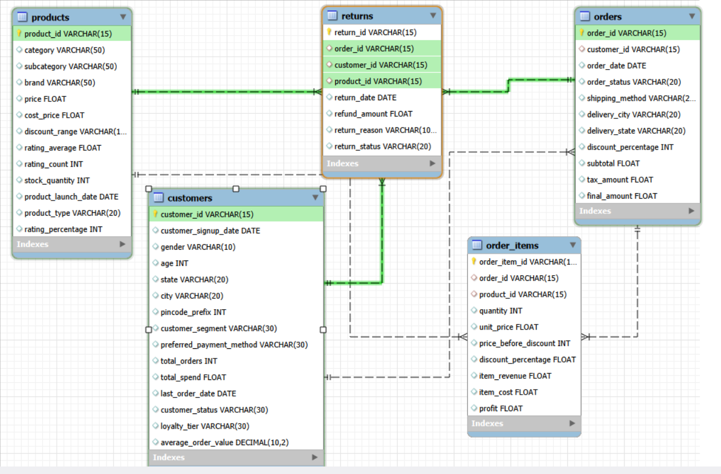

Key Insights

CUSTOMERS TABLE

      - How many customers are registered from each state?

select state, count(customer_id) as customers_in_state
from customers
group by state
order by customers_in_state desc;
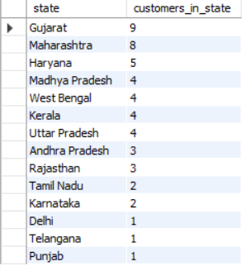

Insights: Out of the 14 states considered, Gujarat (9 customers) and Maharashtra (8 customers) together account for 33.3% of the 51 customers. They are the largest geographic customer groups in this sample.

      - How many customers are male, female or other genders?

select gender, count(*) as total_customers
from customers
group by gender;

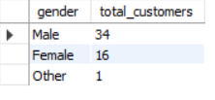

Insights: The customer base is male-dominated, with 66.7% male customers. The number of male customers is more than twice of that of the female customers. The spending by gender can be studied before recommending targeted advertising.

      - What is the age demographic breakdown of the customer base?

select
case
when age between 18 and 24 then "young adult"
when age between 25 and 34 then "millennials"
when age between 35 and 44 then "middle-aged"
when age between 45 and 54 then "older adult"
else "n/a"
end as Age_Group,
count(customer_id) as customer_count
from customers
group by Age_Group;

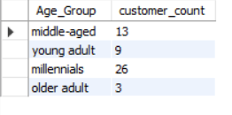

Insights: The 25 to 34 group (millennials) is the largest segment. Together, customers aged 25 to 44 (millennials and middle-aged people) make up 76.5% of the sample. This could encourage more promotion tactics centring ages between 25-33 rather than younger/older demographics.

      - What is the average and total spending of each customer segment?

select customer_segment, count(customer_id) as total_customers,
round(avg(total_orders),0) as average_orders_per_customer,
round(avg(total_spend), 2) as average_customer_spend,
round(sum(total_spend), 2) as total_segment_spend
from customers
group by customer_segment
order by average_customer_spend desc;

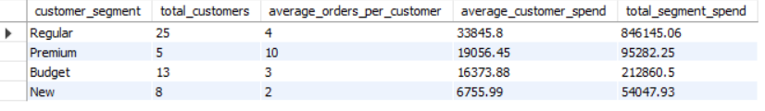

Insights: Regular customers form the backbone of the business's recorded customer spending. Retention campaigns, loyalty rewards and personalised offers could help maintain this segment's contribution. Premium customers appear to purchase more frequently but have lower recorded average spending per customer. The business could investigate opportunities for cross-selling or encouraging higher-value purchases.

PRODUCTS TABLE

            - What products are available, and what are their prices?

select product_id, category, price
from products
order by price desc;

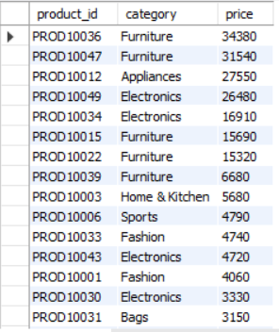

Insights: Furniture includes the top two highest-priced item in the catalogue (PROD10036, priced at ₹34,380 and PROD10047, priced at ₹31,540). This could support more discounts in the furniture category to draw in more customers.

            - How many products are present of each type?

select product_type, count(*) as product_count
from products
group by product_type;

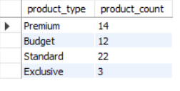

Insights: Standard products make up 43.1% of the catalogue. Exclusive products are relatively scarce, at 5.9%.

            - How many products are present in each category and what is their average price?

select category, count(*) as product_count,
round(avg(price),2) as average_price,
min(price) as min_price, max(price) as max_price
from products
group by category
order by average_price desc;

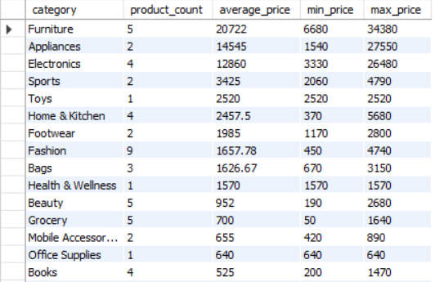

Insights: Furniture has 5 products and an average price of ₹20,722. Appliances has 2 products and an average price of ₹14,545. Furniture has the highest average category price, but this does not automatically mean it is the most profitable.

            - Compare the prices of the most expensive product in each category and the other products in the category.

select product_id, category, brand, price,
max(price) over(partition by category order by price desc) as max_price,
rank() over(partition by category order by price desc) as price_rank
from products
order by max_price desc;
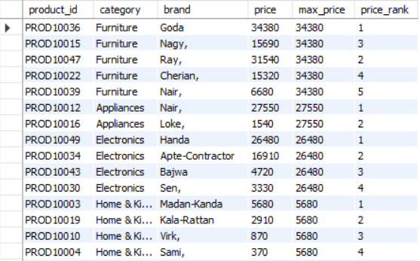

Insights: The query identifies premium-priced products within each category and supports category-level price comparisons. The most expensive product in each category is ranked first. Furniture's maximum is ₹34,380; Appliances' is ₹27,550; Electronics' is ₹26,480.

            - Compare the average ratings of the products (weighted by rating count) as a percentage.

alter table products
add rating_percentage int
generated always as (((rating_average*rating_count/(5*rating_count))*100)) stored;

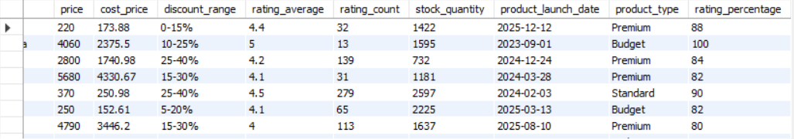

Insights: Fashion has the strongest weighted rating percentage (100) in this dataset and grocery has the lowest weighted rating percentage (62). This is a category-level result, not proof that every fashion product is highly rated or that every grocery product is lowly rated.

ORDERS TABLE

      - What are the order ids and customer ids of the orders that were not delivered? How many are there?

select order_id, customer_id, order_status
from orders
where order_status not in ("Delivered","Returned");
select count(order_status)
from orders
where order_status not in ("Delivered","Returned");

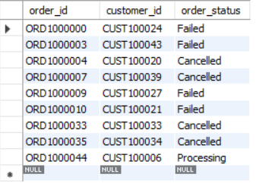

Insights: 17.64% of orders are not marked Delivered/Returned (9 out of 51). This is a useful operational warning and can help guide the delivery team to assess the percentage of failed deliveries.

      - Display all the details of ONLY the orders that were delivered.

create view Delivered_Orders as
select * from orders
where order_status="Delivered";
show create view Delivered_Orders;
select * from Delivered_Orders;
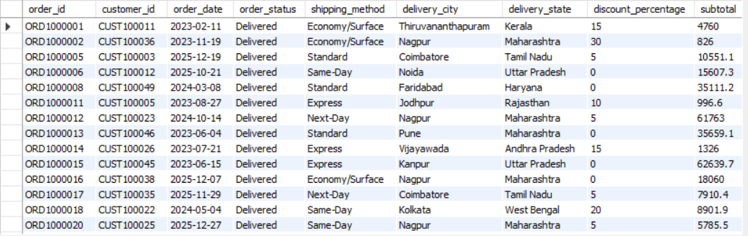

Insights: 82.36% of order records are marked Delivered (42 out of 51). The view is useful for filtering analysis to completed orders.

      - What are the order ids and customer ids of the top 5 value delivered orders?

select order_id, customer_id,final_amount from orders
where order_status="Delivered"
order by final_amount desc
limit 5;

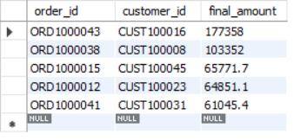

Insights: Highest is ORD1000043 at ₹177,357.60; next is ORD1000038 at ₹103,351.50. Third highest id ORD1000015 at ₹65771.7. This evaluates realised sales. The customers can be noted for special discounts and offers to encourage expenditure.

      - How many orders were delivered from states starting with the letter ""M"?

select delivery_state ,count(delivery_state) from orders
where delivery_state like "M%"
and order_status="Delivered"
group by delivery_state ;

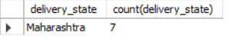

Insights: Maharashtra has 7 delivered orders in the supplied dataset. The query filters state names beginning with M, and Maharashtra is the matching state returned.

ORDER ITEMS TABLE

            - What are the top 10 highest selling products by quantity?

select product_id, sum(quantity) as units_sold
FROM order_items
GROUP BY product_id
ORDER BY units_sold DESC
LIMIT 10;

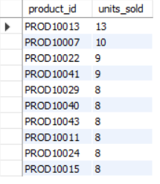

Insights: PROD10013 is the volume leader. A high unit count is a measure of demand, not necessarily profitability.

            - What are the top 10 products that generate the highest profit?

select product_id, round(sum(profit), 2) as total_profit
from order_items
group by product_id
order by total_profit desc
limit 10;
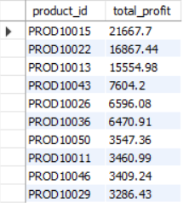
Insights: PROD10015 is the strongest profit contributor among individual products in the supplied records, even though it ranks 10th on the list of products highly ordered in quantity.

            - For each order id, list the different types of items and total number of items purchased.

select order_id, count(order_item_id) as types_of_items, sum(quantity) as total_items
from order_items
group by order_id
order by total_items desc;

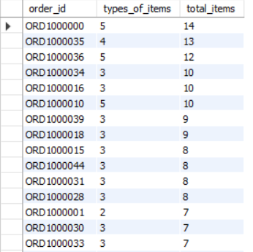

Insights: Some orders contain multiple product lines and quantities. ORD1000000 has 5 distinct order-item records and 14 units; ORD1000035 has 4 records and 13 units; ORD1000036 has 5 records and 12 units. This can support basket-size analysis.

            - What was the price of the item before applying the discount?

alter table order_items
add price_before_discount int
generated always as (quantity*unit_price) stored after unit_price;

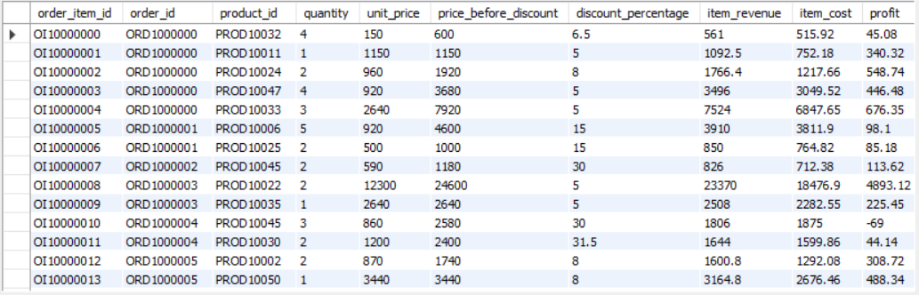

Insights: The price of different products (taking quantity into consideration) can be compared in relation to their discount rates. This helps judge how much the price was discounted for different types of products.

            - Which were the top 5 highest-ordered products? How much profit or loss did they contribute?

select product_id, sum(quantity) as no_of_products, round(sum(profit),2) as total_profit
from order_items
group by product_id
order by no_of_products desc
limit 5;

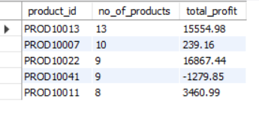

Insights: This comparison reveals that high sales volume does not guarantee high profit. PROD10041 is especially worth investigating because it sold 9 units but has a negative recorded profit.

RETURNS TABLE

- What are the most common reasons for returns?

select return_reason, count(*) as total_returns
from returns
group by return_reason
order by total_returns desc;

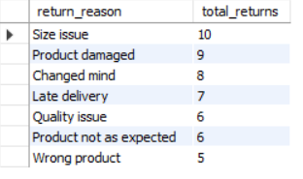

Insights: Size issues and damaged products together account for 19 of 51 returns (37.3%). Product sizing, packaging, and handling deserve investigation.

- Which return reasons cause the highest financial losses?

select return_reason, count(return_id) as total_returns, round(sum(refund_amount), 2) as total_refunds
from returns
group by return_reason
order by total_refunds desc;

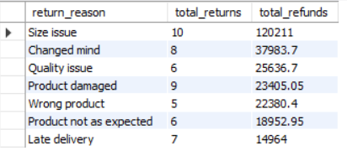

Insights: Size issues account for the highest recorded refund total, making sizing information, product measurements, and fit guidance worth investigating. Changed-mind returns could prompt a review of product descriptions and customer expectations.

- How many customers have not been refunded yet? How many customers have returned their orders in total?

select count(case when return_status not in ("Refunded","Approved") then customer_id end) as unrefunded,
count(customer_id) as total_returns from returns;

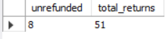

Insights: 15.68% of return records (8 out of 51) are outside the two excluded statuses. The five Pending records may need follow-up; the three rejected returns should be treated separately.

- How many returns occur per month for each year?

select year(return_date) as return_year,
month(return_date) AS return_month,
count(*) as total_returns
from returns
group by return_year, return_month
order by return_year desc, return_month desc;

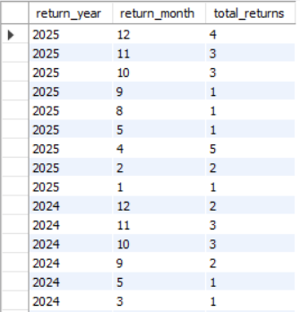

Insights: Recorded returns increased from 15 to 21 between 2024 and 2025, a 40% increase. However, without sales volumes by year, this does not prove the return rate increased.

- What are the product ids of the top three most commonly returned products?

select count(product_id) as products_returned, product_id from returns
group by product_id
order by products_returned desc
limit 3;
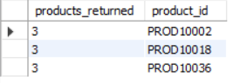

Insights: Three products have the highest return counts (greater than 3). These are candidates for investigation, not confirmed quality problems.

JOINS

- What and how many products were purchased in each order? What are the order ids and product ids?

select o.order_id, p.product_id, oi.quantity
from orders o inner join order_items oi on o.order_id = oi.order_id
inner join products p on oi.product_id = p.product_id
order by oi.quantity desc;

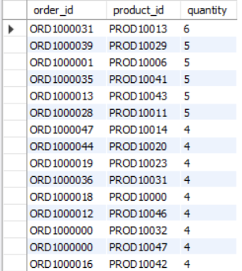

Insights: The join connects order IDs to product IDs and quantities as intended. It provides a useful base for order-level and product-level analysis.

- Which product categories generated the most sales?

select p.category, round(sum(oi.item_revenue),2) as total_revenue
from order_items oi inner join products p on oi.product_id = p.product_id
group by p.category
order by total_revenue desc;

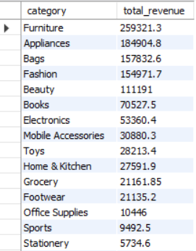

Insights: Furniture leads recorded category revenue, followed by Appliances and Bags. These four categories contribute approximately 65.9% of all recorded item revenue.

- How many products were returned out of all the products purchased?

select count(distinct r.product_id) as products_returned,
count(distinct p.product_id)-count(distinct r.product_id) as products_not_returned
from products p left join returns r on p.product_id=r.product_id;

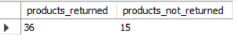

Insights: This measures the number of purchased products returned, which is 36 out of 51 (70.58% of the products purchased).

- Which customers have never placed an order?

select c.customer_id, c.city
from customers c left join orders o
on c.customer_id = o.customer_id
where o.order_id is null;

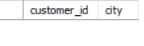

Insights: Every customer has at least one order record in the ordered table, which means that there is no registered customer who has not placed an order.

- Which pairs of customers live in the same city?

select c1.customer_id as customer_1_id, c2.customer_id as customer_2_id, c1.city
from customers c1 inner join customers c2
on c1.city = c2.city
and c1.customer_id < c2.customer_id
order by c1.city;

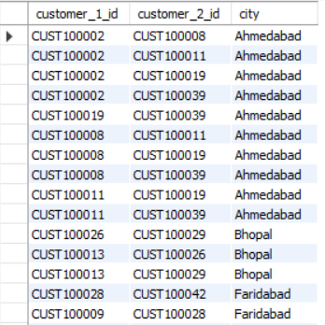

Insights: The dataset contains geographic clusters that could support localised marketing or delivery analysis. Shared city alone does not prove shared preferences or purchasing behaviour.

- Rank products within each category by the revenue they generate.

select p.category, p.product_id, round(sum(oi.item_revenue),2) as total_revenue,
rank() over (partition by p.category order by sum(oi.item_revenue) desc) as revenue_rank,
dense_rank() over (partition by p.category order by sum(oi.item_revenue) desc) as dense_revenue_rank
from products p inner join order_items oi on p.product_id = oi.product_id
group by p.category, p.product_id
order by p.category, total_revenue desc;

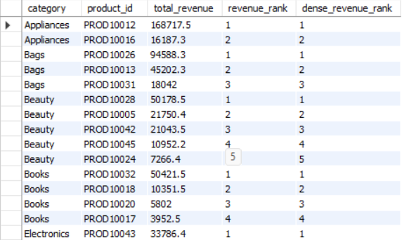

Insights: PROD10012 leads Appliances at ₹168,717.50; PROD10026 leads Bags at ₹94,588.30; PROD10015 leads Furniture at ₹124,159.50. A small number of products contribute a large share of category revenue. These products are worth monitoring for stock availability and profitability.

- What is the month-wise order count, revenue and profit for each year?

select year(o.order_date) as sales_year, month(o.order_date) as sales_month,
count(distinct o.order_id) as total_orders,
round(sum(oi.item_revenue), 2) as revenue,
round(sum(oi.profit), 2) as profit
from orders o join order_items oi on o.order_id = oi.order_id
where o.order_status = 'Delivered'
group by year(o.order_date), month(o.order_date)
order by sales_year desc, sales_month;

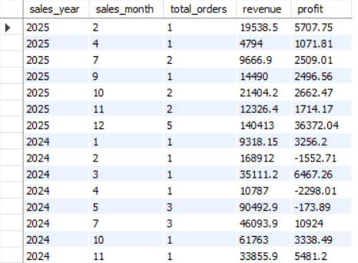

Insights: 2024 had the highest delivered revenue, but its recorded profit was lower than 2023 despite higher revenue. This suggests margins or product mix deserve investigation.

- What is the total revenue and profit generated by each product category?

select p.category,
round(sum(oi.item_revenue), 2) as total_revenue,
round(sum(oi.profit), 2) as total_profit
from products p join order_items oi on p.product_id = oi.product_id
group by p.category
order by total_profit desc;

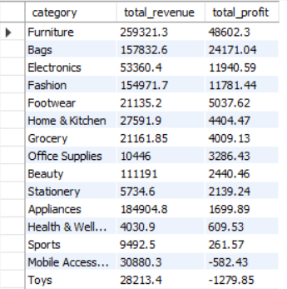

Insights: Furniture is the largest revenue and profit contributor in the current item records. Electronics generates less revenue than Appliances but considerably more profit. Appliances generates substantial revenue but very little profit. The business should investigate costs, discounting, and pricing before trying to grow this category further.

Future Insights
The findings from this analysis provide several opportunities for further investigation. Future analysis could focus on understanding the factors influencing customer retention and repeat purchases, particularly among New and Budget customer segments, while developing strategies to maintain the spending contribution of Regular customers. Product-level analysis could be expanded to investigate the relationship between sales volume, discounting and profitability, especially for products that generate high sales but record low or negative profits. The high refund expenditure associated with size-related returns also presents an opportunity to examine product descriptions, sizing information and customer expectations. Additionally, analysing delivery outcomes alongside shipping methods and geographical regions could help identify potential inefficiencies in order fulfilment.
The project could also be extended by integrating the SQL database with Power BI or Excel to create an interactive dashboard displaying sales trends, customer segmentation, product performance and return patterns. With a larger dataset and more consistent transactional records, further analysis could include customer lifetime value, product return rates, profit margins and customer retention trends. These extensions would provide a more comprehensive basis for evaluating business performance and supporting data-driven decisions.

Conclusion
This project demonstrates the use of SQL to analyse e-commerce data and extract meaningful business insights from interconnected customer, product, order, sales and returns records. Through the application of filtering, aggregation, joins, subqueries, views and window functions, the analysis examines customer demographics and spending patterns, product demand and profitability, order fulfilment, revenue trends and product returns.
The findings highlight several important patterns within the supplied dataset. Regular customers contribute the largest share of recorded customer spending, while Premium customers demonstrate the highest average order frequency. Furniture generates the highest recorded category revenue and profit, whereas certain other categories generate substantial revenue but comparatively low or negative profit. The returns analysis also identifies size-related issues as the largest contributor to recorded refund expenditure. Together, these findings demonstrate how SQL can be used not only to organise and retrieve data but also to identify areas that may require managerial attention.
Overall, the project strengthened the application of relational database concepts and SQL analytical techniques while demonstrating their practical value in evaluating business performance and identifying opportunities for improvement.

Sources
https://www.kaggle.com/code/lalit7881/indian-e-commerce-sales-customer-eda-100/input

