University Name
Project - High Level Design
on
Manufacturing Infrastructure Chatbot for Predictive Maintenance Monitoring

Student Name: ______________________________
Industry Mentor: |  | Guided by:

Document Version: 1.0 Date: 25-04-2026

Table of Contents
1. Introduction
2. Scope of the document
3. Intended Audience
4. System overview
5. System Design
6. Application Design
7. Process Flow
8. Information Flow
9. Components Design
10. Key Design Considerations
11. API Catalogue
12. Data Design
13. Data Model
14. Data Access Mechanism
15. Data Retention Policies
16. Data Migration
17. Interfaces
18. State and Session Management
19. Caching
20. Non-Functional Requirements
21. Security Aspects
22. Performance Aspects
23. Recommended Pictures and Diagrams
24. References

1. Introduction
This High Level Design document describes the architecture, major modules, information flow, interfaces, data design, and non-functional design considerations for the Manufacturing Infrastructure Chatbot, also referred to as InfraChat. The application is a web-based machine monitoring assistant that allows users to ask natural-language questions about manufacturing machine health and view analytics through a dashboard.

2. Scope of the document
This document covers the high-level design of the current project implementation, including Flask routes, frontend screens, chatbot query handling, dashboard analytics, CSV-based data access, and deployment assumptions. It does not cover production cloud deployment, enterprise authentication, real-time IoT ingestion, or machine learning model training because those capabilities are outside the current codebase.

3. Intended Audience
The intended audience includes project reviewers, academic evaluators, developers, system designers, mentors, and stakeholders who need to understand the architecture and design choices of the InfraChat project.

4. System overview
InfraChat provides two main user experiences: a chatbot for plain-English maintenance queries and a dashboard for visual monitoring. The backend loads 10,000 predictive maintenance records from a CSV file and uses pandas for analytics. The chatbot uses rule-based intent handling and RapidFuzz-based fuzzy matching to answer questions about machine counts, failures, averages, machine IDs, and risk status. The dashboard exposes aggregated JSON data for KPI cards, charts, gauges, and a machine table.
Metric | Current Value
Total machines | 10,000
Working machines | 9,661
Failed machines | 339
Failure rate | 3.39%
Average air temperature | 300.0 K
Average process temperature | 310.0 K
Average RPM | 1539
Average torque | 40.0 Nm
Average tool wear | 108.0 min
Machines with tool wear above 200 min | 762

5. System Design
The system follows a simple monolithic web application design. The browser sends page and API requests to the Flask backend. The backend performs command matching, Product ID lookup, risk calculation, and dashboard aggregation using an in-memory pandas DataFrame loaded from the CSV dataset.
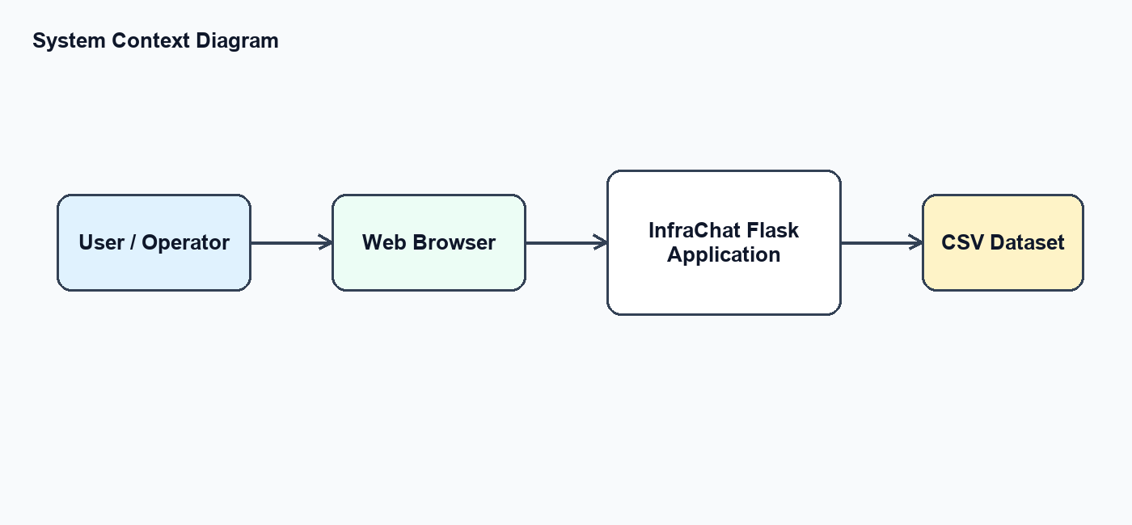
Figure 1: System context diagram
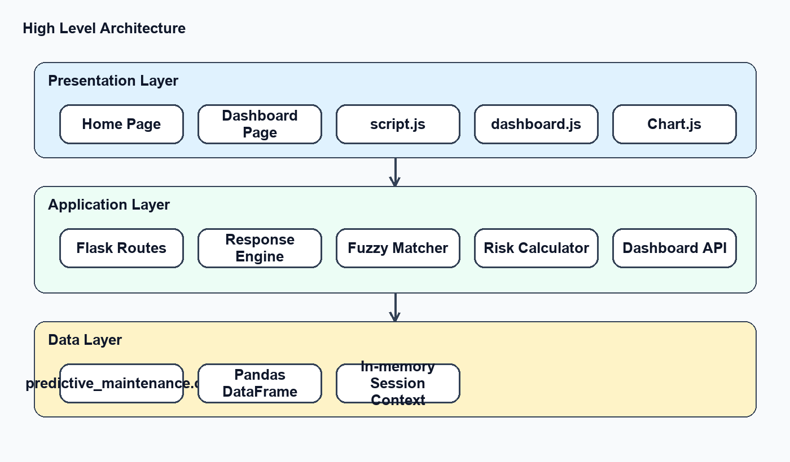
Figure 2: High level architecture diagram

6. Application Design
Layer | Project Files / Components | Responsibility
Presentation Layer | templates/index.html, templates/dashboard.html, static/style.css | Provides home page, dashboard page, navigation, chatbot window, and visual layout.
Client Logic | static/script.js, static/dashboard.js | Sends chat requests, loads dashboard JSON, renders charts, updates KPI cards, and builds machine table.
Application Layer | app.py | Defines Flask routes, loads data, processes queries, calculates risk, and builds API responses.
Data Layer | data/predictive_maintenance.csv | Stores machine records, sensor values, target status, and failure type information.
External Libraries | Flask, pandas, RapidFuzz, Chart.js | Provide web routing, data processing, fuzzy matching, and chart rendering.

7. Process Flow
The main process begins when a user sends a message through the chatbot. The browser posts the message to the Flask /chat route. The backend normalizes the input, searches for a Product ID, applies fuzzy command matching when needed, reads the required values from the DataFrame, and returns a JSON response for display.
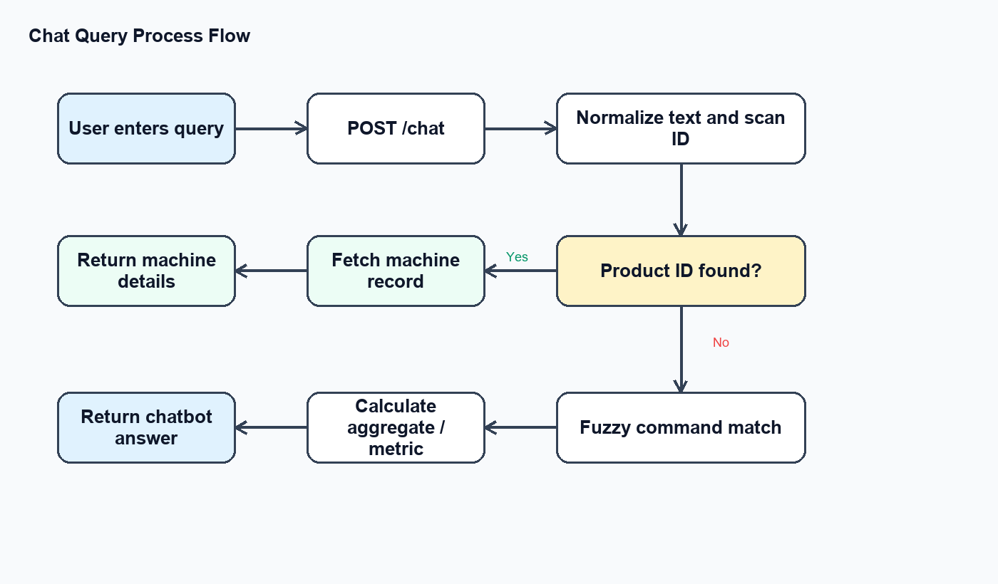
Figure 3: Chat query process flow

8. Information Flow
Machine data flows from the CSV file into an in-memory pandas DataFrame at application startup. Chatbot responses and dashboard analytics both use this shared DataFrame. Dashboard requests return structured JSON, while chatbot requests return formatted response text.
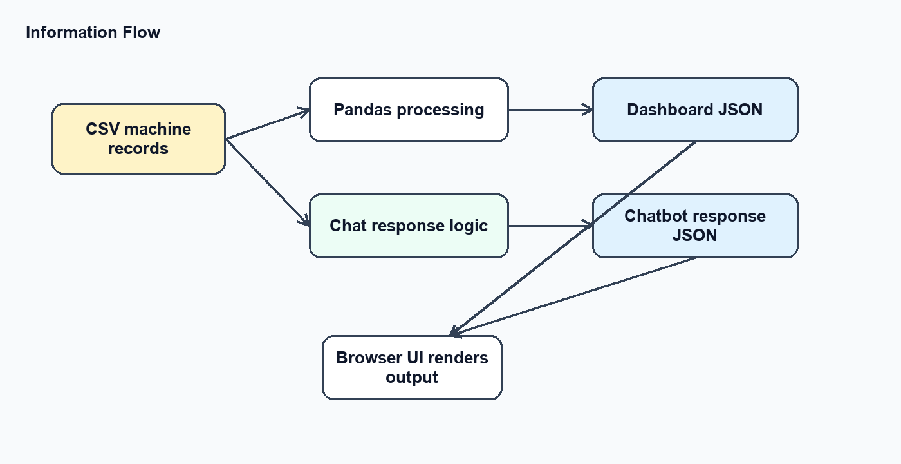
Figure 4: Information flow across data, backend, and browser

9. Components Design
Component | Description | Key Design Notes
Flask Web Server | Hosts pages and APIs. | Runs as a single Python application in the current project.
Chat Response Engine | Handles user queries and returns text responses. | Uses Product ID detection, fuzzy command matching, and context-aware follow-up handling.
Command Dictionary | Maps intents to supported phrases. | Improves usability for non-technical query wording.
Risk Calculator | Classifies machine condition. | Uses Target, tool wear, air temperature, and torque thresholds.
Dashboard API | Builds KPI and chart payloads. | Returns JSON for machine status, failure types, machine types, tool wear, averages, and sample records.
Frontend Dashboard | Renders visual analytics. | Uses Chart.js doughnut, bar, and gauge-like visualizations.
CSV Data Store | Stores machine records. | Loaded once at startup and reused for all requests.

10. Key Design Considerations
- The system is intentionally lightweight and suitable for academic demonstration or local use.
- CSV storage keeps setup simple, but a database should be used for production scale.
- Fuzzy matching improves user experience without requiring a full NLP or generative AI model.
- The current in-memory session context supports simple follow-up queries but is not multi-user safe.
- Dashboard calculations are fast because the dataset is loaded into memory and has limited size.
- The application should be hardened with authentication, logging, exception handling, and HTTPS before production use.

11. API Catalogue
API / Route | Method | Purpose | Response
/ | GET | Loads the home page with chatbot entry point. | HTML page
/dashboard | GET | Loads analytics dashboard page. | HTML page
/api/dashboard-data | GET | Returns KPI, chart, table, and at-risk machine data. | JSON payload
/chat | POST | Accepts a user message and returns chatbot response. | JSON with response field

Example /chat request: { "message": "failed machines" }. Example /chat response: { "response": "Total failed machines: 339" }.

12. Data Design
The project uses a predictive maintenance CSV dataset as its primary data source. Each record represents a machine/product with sensor values and failure classification fields.
Column | Purpose
UDI | Unique row identifier.
Product ID | Machine or product identifier used for lookup.
Type | Machine quality type: L, M, or H.
Air temperature [K] | Air temperature reading.
Process temperature [K] | Process temperature reading.
Rotational speed [rpm] | Machine rotational speed.
Torque [Nm] | Torque/load value.
Tool wear [min] | Tool usage duration.
Target | Failure indicator: 1 means failed, 0 means working.
Failure Type | Specific failure category or No Failure.

13. Data Model
Entity | Attributes | Relationship
MachineRecord | UDI, Product ID, Type, temperatures, RPM, torque, tool wear, Target, Failure Type | One row represents one machine observation used by chatbot and dashboard.
DashboardSummary | total, working, failed, failure_rate, averages, chart labels, chart values | Derived from MachineRecord records at request time.
SessionContext | last_machine_id | Stores the latest referenced Product ID for follow-up chat queries.

14. Data Access Mechanism
The dataset is loaded using pandas.read_csv during application startup. All filtering and aggregation is performed through pandas DataFrame operations such as boolean filters, mean(), sum(), value_counts(), sort_values(), and to_dict().

15. Data Retention Policies
The current application does not create, update, or delete dataset records. The CSV file is retained in the project data folder and remains unchanged during normal application use. Chat session context is temporary and exists only in application memory until the process stops.

16. Data Migration
No automated migration is required for the current CSV-based design. If the solution is upgraded to a relational database, the CSV schema can be mapped to a MachineRecord table and loaded using a one-time import script. Future migrations should preserve Product ID, sensor values, target status, and failure type fields.

17. Interfaces
Interface | Consumer | Provider | Description
Browser UI | User | HTML/CSS/JavaScript | Allows user navigation, chatbot input, dashboard viewing, and data refresh.
Chat API | script.js | Flask /chat route | Sends user message and receives response text.
Dashboard API | dashboard.js | Flask /api/dashboard-data route | Receives analytics payload for charts and tables.
Data Interface | Flask app | CSV file through pandas | Reads machine records for lookup and analytics.

18. State and Session Management
The application stores minimal state in SESSION_CONTEXT with last_machine_id. This supports follow-up questions such as rpm, torque, temperature, or risk after a user has searched for a Product ID. For production, this should be replaced with per-user Flask sessions or database-backed session storage.

19. Caching
The CSV dataset is effectively cached in memory because it is loaded into a pandas DataFrame once when app.py starts. No Redis, browser cache strategy, or external caching layer is currently implemented.

20. Non-Functional Requirements
Area | Requirement / Consideration
Usability | Users should be able to ask simple natural-language queries and view dashboard charts without technical skills.
Reliability | The application depends on the Flask server and availability of the CSV file.
Maintainability | The current single-file backend is easy to inspect; future growth should split routes, services, and utilities.
Scalability | Suitable for local/demo datasets; production scale should use a database and possibly background analytics jobs.
Compatibility | Frontend is browser-based and backend is Python/Flask based.

21. Security Aspects
- The current project assumes trusted local/demo usage.
- No login, authorization, HTTPS enforcement, CSRF protection, or API rate limiting is implemented.
- User input is processed as text and should be validated consistently before production release.
- Production deployment should add authentication, role-based access, secure headers, logging, and protected configuration management.

22. Performance Aspects
- Dataset is loaded once at startup, avoiding repeated disk reads for every query.
- Aggregations over the current 10,000-row dataset are lightweight.
- RapidFuzz command matching is acceptable for the current command dictionary size.
- Dashboard chart data is calculated on request; this is fine for demo use but can be cached for larger datasets.

23. Recommended Pictures and Diagrams
Use the following pictures and diagrams in the final submission. The first five diagrams have already been added to this document. Screenshots should be captured from your running application for the most accurate project evidence.
Picture / Diagram | Where to Use | What It Should Show
System Context Diagram | System Design section | User, browser, Flask application, and CSV dataset.
High Level Architecture Diagram | System Design section | Presentation layer, application layer, and data layer.
Chat Query Process Flow | Process Flow section | Input query, /chat API, Product ID detection, fuzzy matching, and response.
Information Flow Diagram | Information Flow section | CSV to pandas DataFrame to chatbot/dashboard JSON to browser UI.
Deployment View | System Design or References section | Browser, Flask server, and local CSV file running on one host.
Home Page Screenshot | System overview or Application Design | InfraChat landing page with sidebar and chatbot button.
Chatbot Screenshot | Application Design or Interfaces | Chat window showing sample questions and a machine response.
Dashboard Screenshot | Application Design or Information Flow | KPI cards, RPM/torque gauges, failure chart, and machine table.
Dataset Sample Screenshot | Data Design section | CSV columns including Product ID, sensor values, Target, and Failure Type.

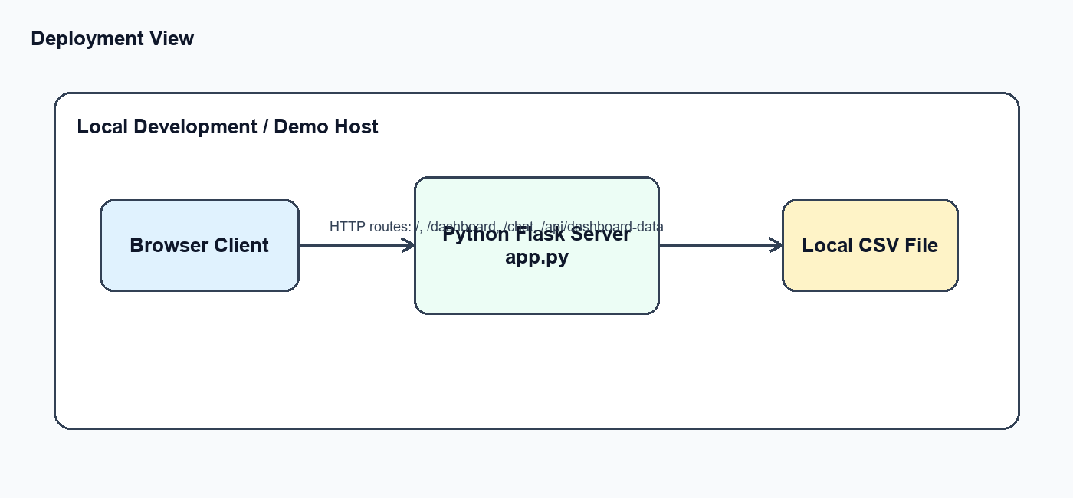
Figure 5: Current deployment view

24. References
- C:\Users\ACER\manufacturing-infrastructure-chatbot\app.py
- C:\Users\ACER\manufacturing-infrastructure-chatbot\templates\index.html
- C:\Users\ACER\manufacturing-infrastructure-chatbot\templates\dashboard.html
- C:\Users\ACER\manufacturing-infrastructure-chatbot\static\script.js
- C:\Users\ACER\manufacturing-infrastructure-chatbot\static\dashboard.js
- C:\Users\ACER\manufacturing-infrastructure-chatbot\data\predictive_maintenance.csv

