**Ansible installation:-**

Sudo apt-get update

**Inventory :-**

We have Ansible Control Sever (ACS) and we have multiple node servers. Ansible to connect to all the nodes we need to keep the details of the nodes in one file which is called inventory.

Default inventory =cd /etc/ansible

Here there will be a file called host. Here we will be having groups and under groups we have host entries. Ex :- suppose we have out UAT server to connect from the ACS machine. So in the host file we will have the entries for UAT server. Here group will be “webservers”,”dbservers” and all and under the group we will add the server IP address.

To make changes to the host file we need to do with sudo (root user).

Suppose you have to restart sshd service then command is =**1**. **sudo service sshd restart**

**2. systemctl restart sshd**

**Module:-**

Ansible –m ping all

Set up authenticaton:-

Create a key.

ssh-keygen

ssh-copy-id

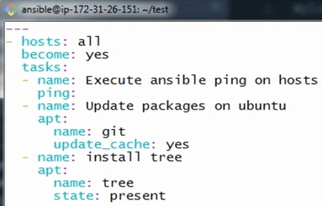

Above is an ansibe playbook.

Suppose we have a task to update one package in all node servers and then install git.

Here the package/module with the help of which we can perform update work is “apt”. we will search ansible module in google and then will search for apt module. There we will find all the commands.

The Linux command to install git is = **sudo apt-get install git**

Here **become = yes**  will do the work of sudo.

Update_cache will install git.

Once we update the package no need to update it again so in next section we will give **state=present** which will install tree.

**Write a yml file:-**

We will be writing a yml file for below task.

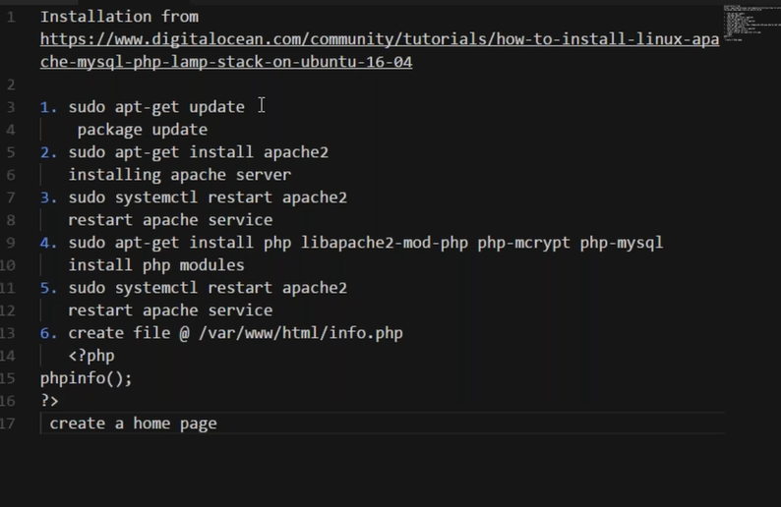

Always start with three hyphen (---) this means you can write multiple playbooks under one yml file.

* Become : yes >> this means become a sudo user.
* All these points are tasks. So we will keep it under task like below and under name we will give the task name.

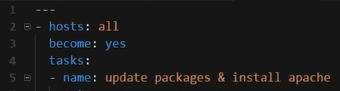

* For point 1 and 2 we have to update the package and install apache. We will be doing this task with the help of module. Here we have choosen apt module. We will google ansible modules and here we will search for apt module and will see using which usage we can install and update.

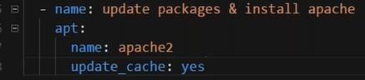

* For 3rd point we have to restart the services. So this is one more task. So we will give it a name , then the module we will use for restart is **service** . under service give the name of the service to be restarted. Then enabled as yes and state as restarted.

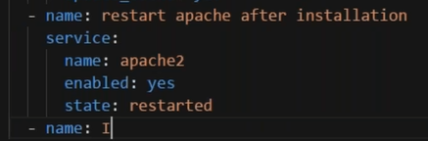

* For 4th point we have to install multiple packages, so we will use loops here. It will be like below.

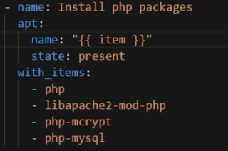

**Ansible Handlers :-**

Suppose I have a situation where I have to restart apache after installing it and 2nd time after installing some more packages. In this situation instead of writing the code 2 times I will use handlers.

We have to write handlers to restart the apache service. We will write as below:-

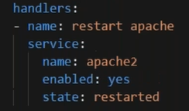

It is exactly same as the way we used to write for service restart as a task. Here we will make it a handler and we will call the handler after the task. This will be done by the command **notify.**

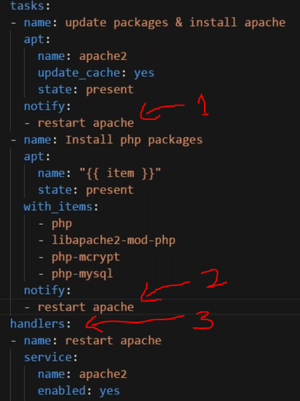

Here in the above picture in point 3 we mentioned the handler to restart apache, and in point 1,2 we called the handler using command **notify** .

**Using When in playbook:-**

Suppose we have a situation that we have to perform some task only when some condition satisfies. That time we can use when in our playbook.

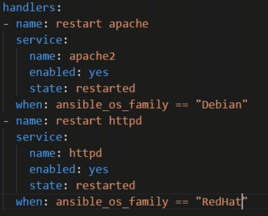

In the above picture we will restart the https service only when the Operating system is Redhat.