**DevOps** is a philosophy of efficient development, deployment and operation of the highest quality software possible. DevOps aims on continuous customer satisfaction. When DevOps is properly adopted then it provides greater quality, faster lead time, greater stability and increased security.

DevOps is a way of thinking, a culture.

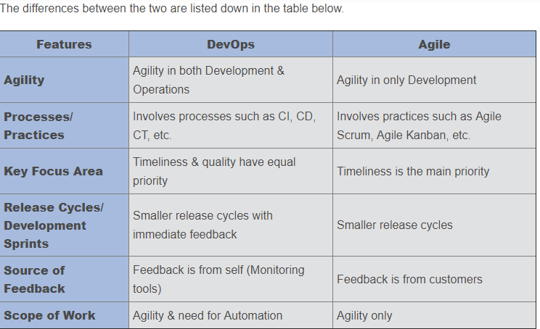

**How is DevOps different from Agile / SDLC?**

Agile is a set of values or principle about how to produce/develop a software. Suppose if you have some ideas and you want to put those in to a working software then you can use Agile values and principle to do that. But that software may be working only in you dev env or test env. You want quick, easy and repetitive way to move the software to Production infrastructure. This is the time DevOps comes in to picture.

Agile focuses in software development but DevOps aims on development and deployment.

### ****What is the most important thing DevOps helps us achieve?****

The most important point where DevOps helps us is to get changes in to production environment as quick as possible while minimizing the risk in software quality. Clear communication and better working relationship between Dev team and Ops team.

### ****What is Version control?****

It is a system that records changes to a file or set of files over time so that you can recall specific versions later.

Version control allows you to:

* Revert files back to a previous state.
* Revert the entire project back to a previous state.
* Compare changes over time.
* See who last modified something that might be causing a problem.
* Who introduced an issue and when

**Types of Branching:-**

Feature Branching :- Feature branching keeps all the changes done to a feature inside a branch. When the feature is fully tested and validated by automated tests the branch is then merged in to master.

Task Branching:-

Release Branching:-

### ****What is Git?****

Git is a distributed Version Control System. It can track changes to file and allows you to revert to any particular changes.

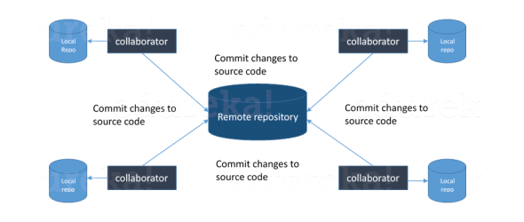

Git provides many advantage over other VCS like SVN because it has a remote repo which can be cloned to the developer’s system, and then the developer can do all kind of changes and commit also. But in SVN you cannot commit the changes until and unless the central server is up.