Link to download mpi: <https://www.microsoft.com/en-us/download/details.aspx?id=57467>

Install mpi on cmd:

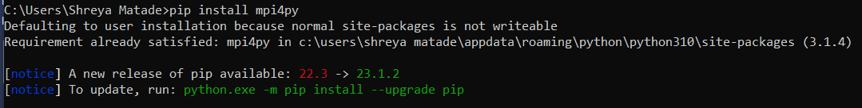

You may need to set up environment variables from bin

To check version:

mpiexec –help

**Mpi Code:**

from mpi4py import MPI

import numpy as np

comm = MPI.COMM_WORLD

rank = comm.rank

send_buf = []

if rank == 0:

 arr = np.array([12,21241,5131,1612251,161,6,161,1613,161363,12616,367,8363])

 arr.shape = (3, 4)

 send_buf = arr

v = comm.scatter(send_buf, root=0)

print("Local sum at rank{0}: {1}".format(comm.rank, np.sum(v)))

recvbuf = comm.reduce(v, root=0)

if comm.rank == 0:

 global_sum = np.sum(recvbuf)

 print("Global sum: "+ str(global_sum))

**Compile using:**

mpiexec –np 3 python sum.py