PROGRAM CYCLE-4

1) PRINTING NAME

echo “What is your name?”
read PERSON
echo “Hello, $PERSON”
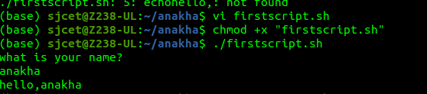

2) ODD OR EVEN

#!/bin/sh

NUMS=[1 2 3 4 5 6 7]

for NUM in $NUMS
do
Q=`expr $NUM % 2`
if [ $Q -eq 0 ]
then
echo “Number is an even number!”
continue
fi
echo “Found odd number”
done
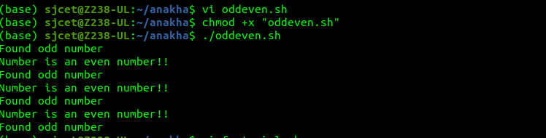
3) FACTORIAL OF A NUMBER

echo "Enter a number"
read num
fact=1

while[ $num -gt 1 ]
do
fact=$((fact * num))
num=$((num - 1))
done

echo $fact
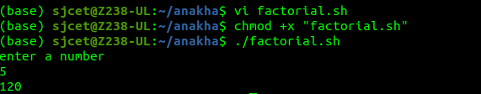

4) SUM OF ALL DIGITS
echo "Enter a number"
read num
sum=0
while [ $num -gt 0 ]
do
mod=$((num % 10))
sum=$((sum + mod))
num=$((num / 10))
done
echo $sum
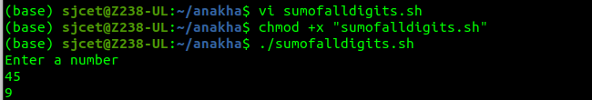
5) SUM OF ALL DIGITS USING EXPR
echo "Enter a number"
read num
sum=0
while [ $num -gt 0 ]
do
mod=`expr $num % 10`
sum=`expr $sum + $mod`
num=`expr $num / 10`
done
echo $sum
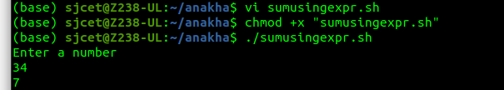
6)print 1 to 100 using while loop

i=1
while [ $i -le 100 ]
do
echo $i
i=$(($i+1))
done
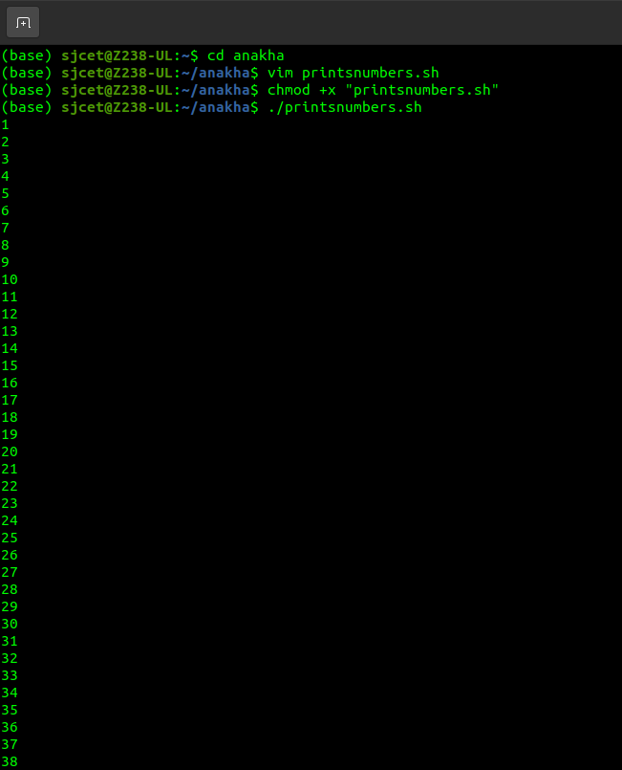

7) print 1 to 100 using expr
# shell script to print numbers 1 to 100
#using while loop and expr
i=1
while [ $i -le 100 ]
do
echo $i
i=`expr $i + 1`
done
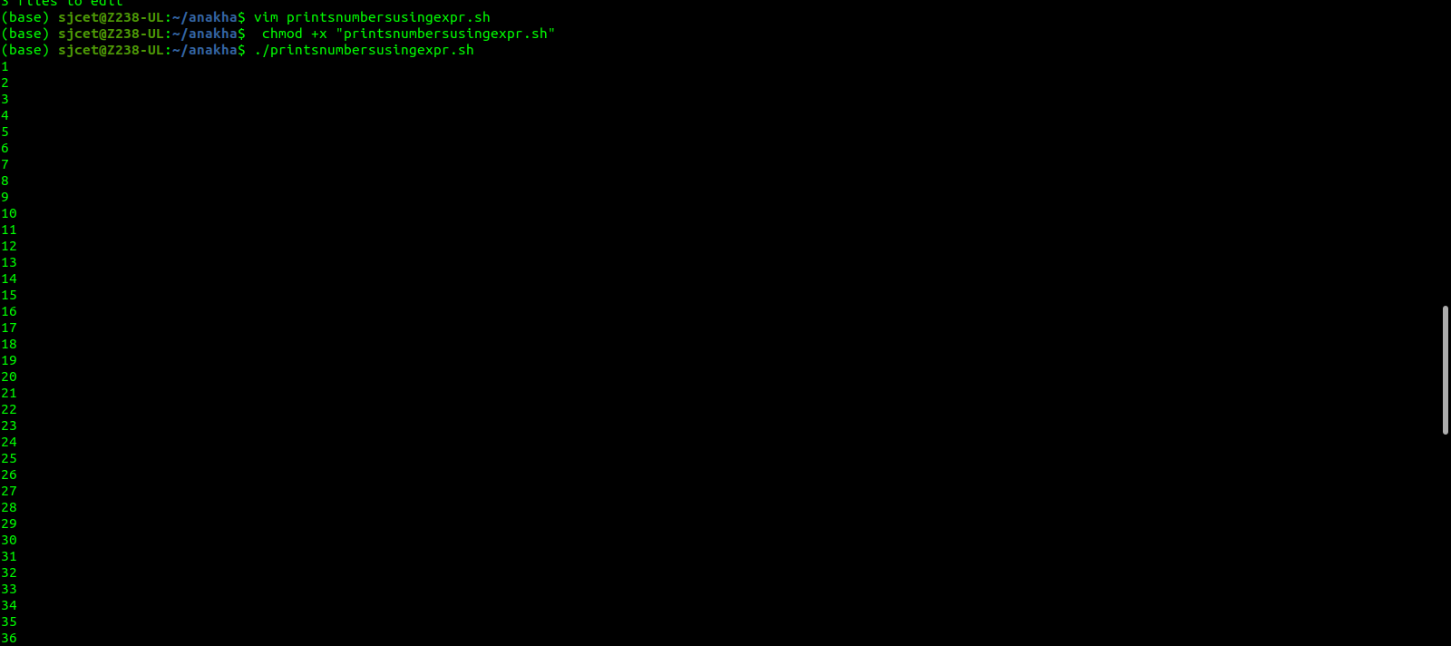
8) print 1 to 100 using for loop
for ((i=1;i<=100;i++))
do
echo $i
done
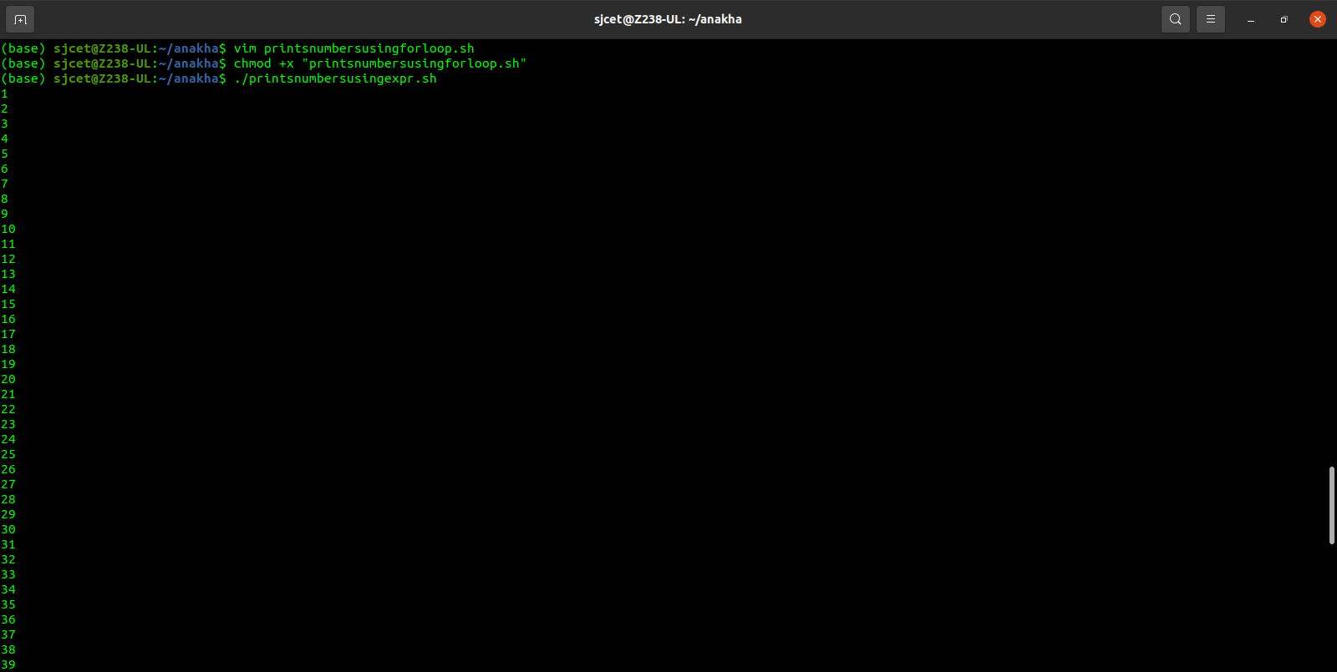
9) largest of n numbers
#shell script for largest of n numbers
echo "Enter Size(N)"
read N
i=1
max=0
echo "Enter Numbers"
while [ $i -le $N ]
do
read num
if [ $i -eq 1 ]
then
max=$num
else
if [ $num -gt $max ]
then
max=$num
fi
fi
i=$((i + 1))
done
echo "largest number, $max"

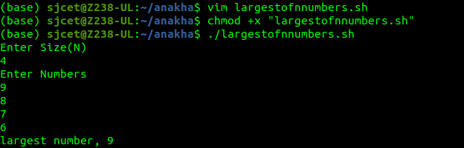
10) Average of n numbers
#shell script to find average of n numbers
echo "Enter Size(N)"
read N
i=1
sum=0
echo "Enter Numbers"
while [ $i -le $N ]
do
read num
sum=$((sum + num))
i=$((i + 1))
done
avg=$(echo $sum / $N | bc -l)
echo “average of $N numbers is $avg”

