Program cycle 3

1. Add two numbers

(base) sjcet@Z238-UL:~/anakha$ nano demo.sh
!/bin/bash
num1=10
num2=20
num3=`expr $num1 + $num2`
echo "Sum is:" $num3
(base) sjcet@Z238-UL:~/anakha$ bash demo.sh
Sum is: 30

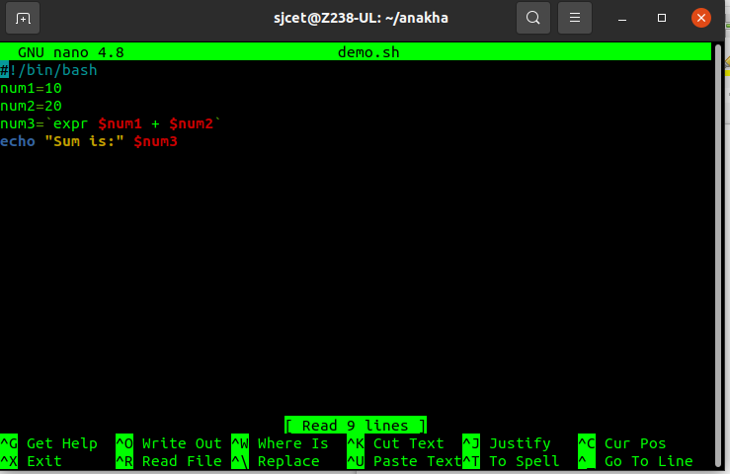
2.swap two numbers

(base) sjcet@Z238-UL:~/anakha$ nano swap.sh
!/bin/bash
first=5
second=10
temp=$first
first=$second
second=$temp
echo"after swapping , numbers are:"
echo "first =" $first," second="$second
(base) sjcet@Z238-UL:~/anakha$ bash swap.sh
after swapping numbers are:
first = 10, second=5
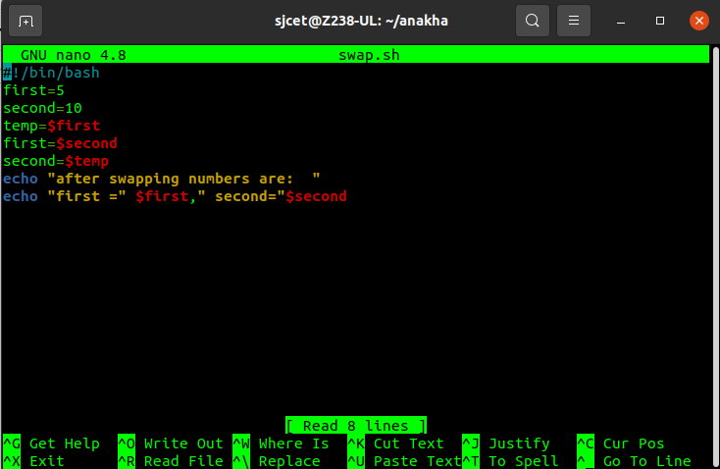

3. current process id ($$)

(base) sjcet@Z238-UL:~/anakha$ nano processid.sh
#!/bin/bash
echo "current process identifier: " $$
(base) sjcet@Z238-UL:~/anakha$ bash processid.sh
current process identifier: 4457
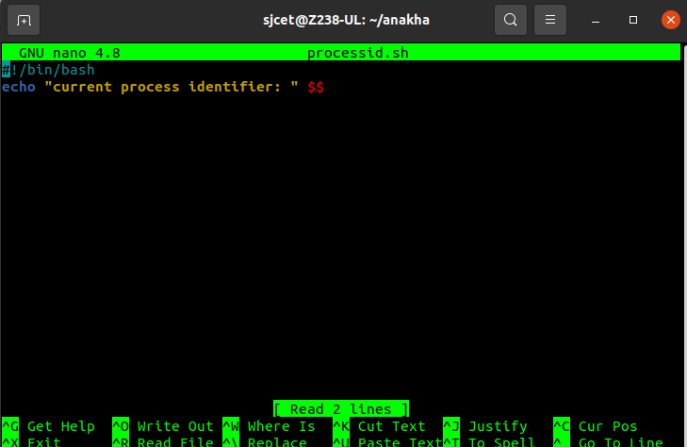

4.To perform ls command
(base) sjcet@Z238-UL:~/anakha$ nano lscommand.sh
#!/bin/bash
echo "here are the list of files: "
ls -l
echo " The number of files: "
ls -l|wc -l
(base) sjcet@Z238-UL:~/anakha$ bash lscommand.sh
here are the list of files:
total 28
----rw-rw- 1 sjcet sjcet 24 Apr 26 14:11 atari.txt
-rw-rw-r-- 1 sjcet sjcet 79 May 17 14:22 demo.sh
-r---w---x 1 sjcet sjcet 96 Apr 26 14:28 file1.txt
-rw-rw-r-- 1 sjcet sjcet 202 Apr 26 14:34 file2.txt
-rw-rw-r-- 1 sjcet sjcet 0 Apr 26 14:21 file3.txt
-rw-rw-r-- 1 sjcet sjcet 0 Apr 26 14:21 file4.txt
-rw-rw-r-- 1 sjcet sjcet 0 Apr 26 14:21 file5.txt
-rw-rw-r-- 1 sjcet sjcet 0 Apr 26 14:21 file6.txt
-rw-rw-r-- 1 sjcet sjcet 0 Apr 26 14:21 file7.txt
-rw-rw-r-- 1 sjcet sjcet 0 Apr 26 14:21 file8.txt
-rw-rw-r-- 1 sjcet sjcet 96 May 17 15:07 lscommand.sh
-rw-rw-r-- 1 sjcet sjcet 51 May 17 14:53 processid.sh
-rw-rw-r-- 1 sjcet sjcet 146 May 17 14:44 swap.sh
The number of files:
14

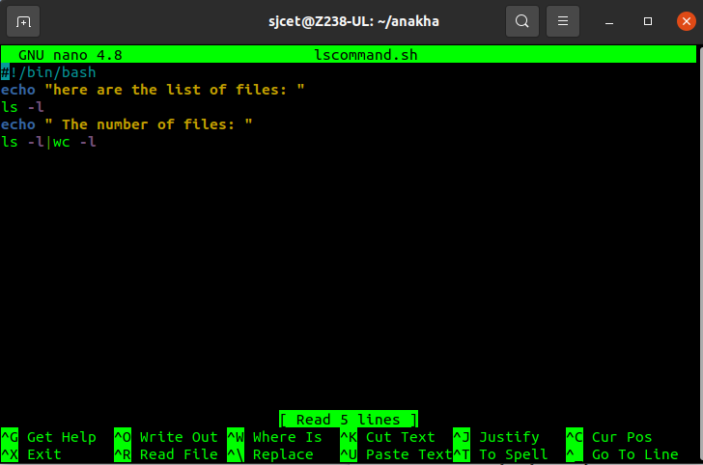
5.area and circumference of circle

(base) sjcet@Z238-UL:~/anakha$ nano circle.sh
#!/bin/bash
echo "enter the radius of circle: "
read r
area=$(echo "3.14*$r*$r" |bc)
circumference=$(echo "2*3.14*$r" |bc)
echo "area of circle = " $area
echo "circumference of circle= " $circumference
(base) sjcet@Z238-UL:~/anakha$ bash circle.sh
enter the radius of circle:
3.5
area of circle = 38.46
circumference of circle= 21.98

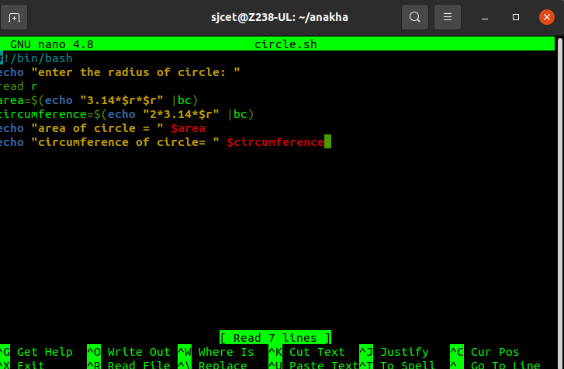
6.even or odd

(base) sjcet@Z238-UL:~/anakha$ nano oddoreven.sh
!/bin/bash
echo "enter a number:"
read n
echo "result: "
if [ `expr $n % 2` == 0 ]
then
echo "$n is even"
else
echo "$n is odd"
fi
(base) sjcet@Z238-UL:~/anakha$ bash oddoreven.sh
enter a number:
2
result:
2 is even

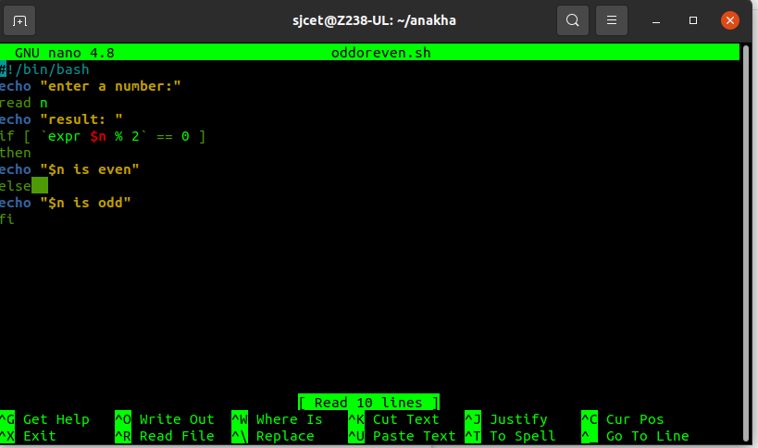
7.prime or not

(base) sjcet@Z238-UL:~/anakha$ nano prime.sh
#!/bin/bash
echo "enter number"
read n
for((i=2; i<=$n/2; i++))
do
ans=$(( n%i ))
if [ $ans == 0 ]
then
echo "$n is not prime"
exit 0
fi
done
echo "$n is prime"
(base) sjcet@Z238-UL:~/anakha$ bash prime.sh
enter number
3
3 is prime

