**Activity_main.xml**

*<LinearLayout xmlns:android="*[*http://schemas.android.com/apk/res/android"*](http://schemas.android.com/apk/res/android)

android:layout_width="match_parent" android:layout_height="match_parent" android:layout_gravity="center">

<Button android:id="@+id/bt"

android:layout_width="match_parent" android:layout_height="wrap_content" android:layout_gravity="center" android:onClick="click" android:text="CHANGE" />

</LinearLayout>

## Main_Activity.java

package com.example.sjcet.background; import android.widget.Button;

import android.view.View;

import android.support.v7.app.AppCompatActivity; import android.os.Bundle;

public class MainActivity extends AppCompatActivity { View v;

Button bt; @Override

protected void onCreate(Bundle savedInstanceState) { super.onCreate(savedInstanceState); setContentView(R.layout.*activity_main*);

v= this.getWindow().getDecorView(); bt=(Button) findViewById(R.id.*bt*);

}

public void click(View view) { v.setBackgroundResource(android.R.color.*holo_orange_light*);

}

}

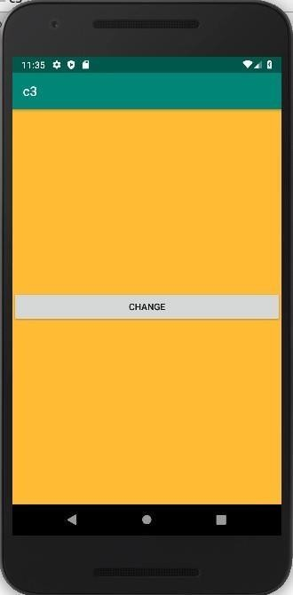**OUTPUT**