**Name:** Sathe Prathamesh Shashank

**Roll no:** 59

# Assignment No: 02

Implement all the functions of a dictionary (ADT) using hashing and handle collisions using chaining with / without replacement.

Data: Set of (key, value) pairs, Keys are mapped to values, Keys must be comparable,

a) Keys must be unique. Standard Operations: Insert(key, value), Find(key), Delete(key)

**Program:**

dictionary = {0:None,1:None,2:None,3:None,4:None,5:None,6:None,7:None,8:None,9:None} i=0 flag=0 val=0

def insert():

no = int(input("Enter number of elements you want to store in a DICTIONARY:"))

for i in range(no): ele = int(input("Enter element:")) chaining(ele)

def chaining(ele):

key = ele%len(dictionary)

if(dictionary[key]==None):

dictionary[key]=ele

else: j=1 while(True): if(dictionary[(key+j)%len(dictionary)] == None):

dictionary[(key+j)%len(dictionary)]=ele break j=j+1

def search(ele): for i in range(len(dictionary)): if(ele == dictionary[i]):

flag=1

if flag==1: print("Element is found at location:",i) return i

else:

print("Element is not present in the dictionary!!!!") return -1

def delete():

val = int(input("Enter the element to delete:")) loc = search(val) if(loc!=-1):

for i in range(len(dictionary)):

dictionary[loc]=None

break else:

print("Element to be deleted is not present!!!")

def display():

print(dictionary)

def main(): serachval=0 while(True):

print("1.INSERT VALUES INTO A DICTIONARY USING CHAINING") print("2.SEARCH FOR AN ELEMENT IN DICTIONARY") print("3.DELETE AN ELEMENT FROM DICTIONARY") print("4.DISPLAY DICTIONARY") print("5.EXIT")

ch = int(input("ENTER YOUR CHOICE:"))

if ch==1: insert()

elif ch==2:

searchval = int(input("Enter element to be searched!!")) search(searchval)

elif ch==3:

delete()

elif ch==4: display()

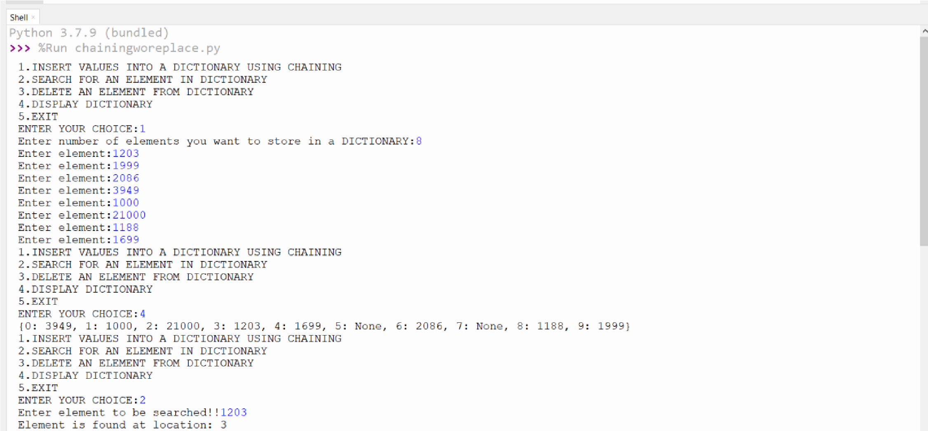 elif ch==5: quit() else:

print("WRONG CHOICE ENTERED!!")

main()

**Output:**

