- Create a line graph interpreting the data and mention the steps one by one. Colum’s considered

- Open the Excel file.
- Select the column "Sl No" and "Number of languages known".
- Go to the Insert tab.
- Click Line Chart → Line with markers.
- The line graph will appear.
- Add labels by clicking:
- Chart Elements → Axis Titles → Add Title
- 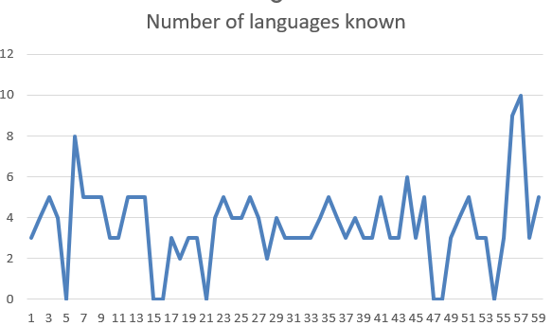

- Create a bar chart and interpret the data and mention the stepwise procedure

Steps:

- Select columns "state" and "Sl No" (or count by category using Pivot Table).
- Go to Insert → Bar Chart → Clustered Bar.
- Add title: "Number of Students by State".
- Add data labels for clarity.

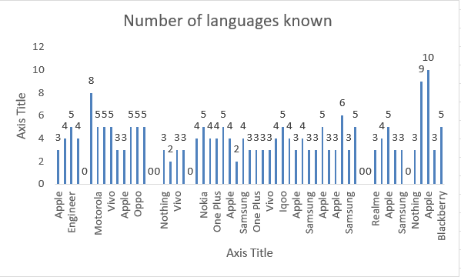
3.Create a pie-chart and interpret the data and mention the stepwise procedure

Steps:

- Select the "Gender" column.
- Go to Insert → Pivot Table → Count entries by gender.
- Select the summary table.
- Insert → Pie Chart → 2-D Pie.
- Add labels (% and Category Names).

4.Mention three excel formulas and method of applying it, and paste the formula along with both input and output.

Formula | Use | Example Input | Output
=AVERAGE(range) | Finds mean value | =AVERAGE() | e.g., 3.2
=COUNTIF(range, condition) | Counts matching values | =COUNTIF() | e.g., 10 males
=MAX(range) | Finds highest value | =MAX() | 5 languages

S Anahith
2462630

