INCIDENT RESPONSE REPORT
Stored Data Manipulation – Modify Registry (T1565.001)

Reported by:
Anakin Palinyot
Cybersecurity Analyst
Organization:
Home SOC Lab
Detection Date:
Jan 19, 2026 @ 19:57:27.583
Classification:
Internal Use / Portfolio Demonstration

Incident Report

Stored Data Manipulation – Modify Registry
Reported by: Anakin Palinyot (Cybersecurity Analyst)

1. Incident Summary
Item | Value
MITRE Technique | Stored Data Manipulation – Modify Registry
MITRE ID | T1565.001
Rule ID | Y1112
Severity Level | 5
Detection Time | Jan 19, 2026 @ 19:57:27.583
Detected By | Wazuh SIEM
A security alert was generated after detecting a Windows Registry modification that may indicate malicious activity such as persistence, defense evasion, or system configuration tampering.

2. Detection Rule Information
rule.id: Y1112
rule.level: 5
rule.mitre.technique: Stored Data Manipulation – Modify Registry
rule.mitre.id: T1565.001

3. Affected Asset Information
Hostname: window10
Agent ID: 001
Operating System: window10
IP Address: 192.168.100.20

4. Registry Modification Details
Registry Key Path: HKEY_LOCAL_MACHINE\System\CurrentControlSet\Services\bam\State\UserSettings\S-1-5-21-4023297114-3169236643-3074174325-1000
Registry Action: modified
Registry Value: \Device\HarddiskVolume1\Windows\System32\cmd.exe

5. Process & Execution Context
This alert was generated from registry monitoring (Wazuh FIM). Process execution details were not available in the current telemetry.
Relevant Decoder: syscheck_registry_value_modified

6. Analysis
Hash values (MD5, SHA1, SHA256) associated with the Background Activity Moderator (BAM) registry key related to cmd.exe were modified. The change was detected during a scheduled scan by Wazuh FIM.
This behavior may indicate file tampering, masquerading, or anti-forensic activity, which aligns with MITRE ATT&CK technique T1565.001.
Analyst Confidence Level: Medium

7. Response Actions
[X] Alert triage performed
[X] Registry change validated
[X] Investigation initiated
[ ] Endpoint isolated
[ ] Malicious process terminated
[ ] Registry value restored

8. Recommendations
- Enable registry integrity monitoring
- Limit registry modification privileges
- Correlate registry events with process creation logs
- Review and tune detection rules for high-risk registry paths

9. Evidence
Wazuh Alert Overview screenshot demonstrating detection confirmation.
Purpose:
ใช้เป็นหลักฐานยืนยันการตรวจพบเหตุการณ์ (Detection Confirmation) ซึ่งแสดงรายละเอียดของ Rule, Severity และ MITRE ATT&CK Mapping จากระบบ Wazuh SIEM
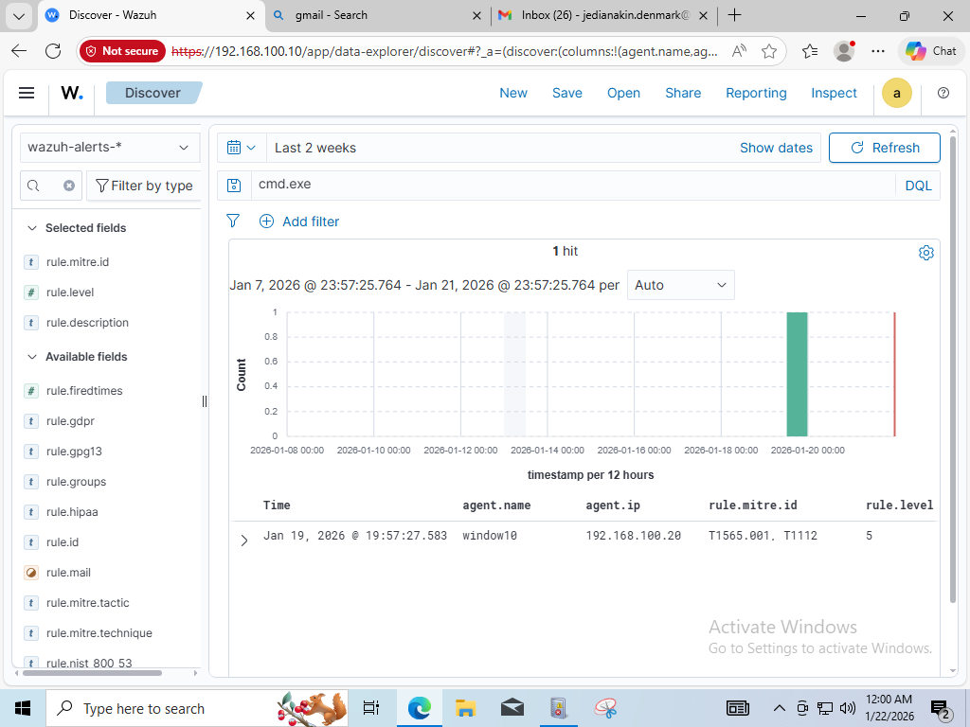
______________________________________________________________________
Evidence Limitation Notice:
หลักฐานในรายงานฉบับนี้อ้างอิงจาก Wazuh Alert Overview เป็นหลัก
เนื่องจากไม่มี Registry raw log หรือ Process execution telemetry เพิ่มเติม
ในช่วงเวลาที่ตรวจพบเหตุการณ์
การขาดข้อมูลดังกล่าวถูกบันทึกเป็นข้อจำกัดของ Telemetry
และจะถูกนำไปพิจารณาในการปรับปรุงการเก็บ Log ในอนาคต

