**ATHLETICISM AND ATTRACTIVENESS OF NFL**

ANASTASIA KOROLEV AND ALEX HEGGE

**ABSTRACT**

The purpose of our algorithm was to create a way to generate the “best” overall NFL fantasy team taking into account not only the players’ athletic ability, but also their physical attractiveness. We then wanted users to be able to customize their team based off their favorable physical characteristics. The team this algorithm generates consists of one quarterback, two running backs, two wide receivers, one tight end, one kicker, one defensive lineman, one linebacker, and one defensive back. The athletic rankings for each position is based off of the NFL Fantasy Football website while appearance rankings were based off of twitter analysis. Through our project we were able to determine the overall “best” NFL fantasy team while also being able to choose various physical characteristics to filter the team by. There were a couple of trends that we noticed especially when it came to common physical characteristics such as brown short hair or between 20 and 30 years old. Overall this program offers a fun and different way to select a fantasy football team.

**INTRODUCTION**

In a typical fantasy football team generator the players are ranked based on their different statistics, but no other system includes the players’ attractiveness with the rankings. A fantasy football team succeeds based off of how well their players perform weekly. We thought it would be a great idea to be able to select a team not only based off of football skills, but physical attractiveness as well. This topic of has grown recently because fantasy football is more popular than ever especially with the rise of weekly fantasy leagues such as Draft Kings and Fan Duel. Our algorithm adds an interesting twist to the typical player selections.

The algorithm starts by giving the user the top overall team based on the ranking system we generated. The user then has the ability to filter their team based on the players’ physical characteristics. The program can be filtered by hair color, hair length, an age range, height, weight, eye color, whether or not they have facial hair and by their skin tone. There can be as many or as few specifications wanted and the team will be updated accordingly.

Our algorithm is essentially a version of gale shapely matching problem. The user has preferences of different characteristics and then based on the users preferences the algorithm finds the highest ranked players with the given characteristics for each position. Each position has their own unique preference list based on the predetermined rankings and then selects the top choice based on the specific characteristics. For the running back and wide receiver positions, the top two players will be selected because of the fantasy football specifications.

**MATERIALS AND METHODS**

For this algorithm we used various programming languages to create a working user interface as well as online resources in order to establish the athletic and attractiveness rankings. The programming languages used include MySQL and Python. SQLAlchemy was necessary to have as the open source SQL toolkit and the object-relational-mapper for Python. In order to generate athletic rankings we took the predicted rankings list of the 2015 season by position off of the NFL Fantasy Football website. Those ranks were all based off of five experts opinions and then averaged together. The attractiveness rankings were a little more complex. The players’ physical appearance was ranked based on the number of times their name was mentioned along with the words “hot”, “good looking”, and “sexy” in tweets. We used the website Topsy to find how many times these words were used for each player in our database. The athletic and attractiveness rankings were then averaged out and an overall ranking list was created for each player within every position. Our program works by filtering all the players in the ‘player’ table in MySQL and creating a new ‘editplayer’ table, which contains all the players that are available to be chosen. The ‘editplayer’ table decreases based on the characteristics the user specifies.

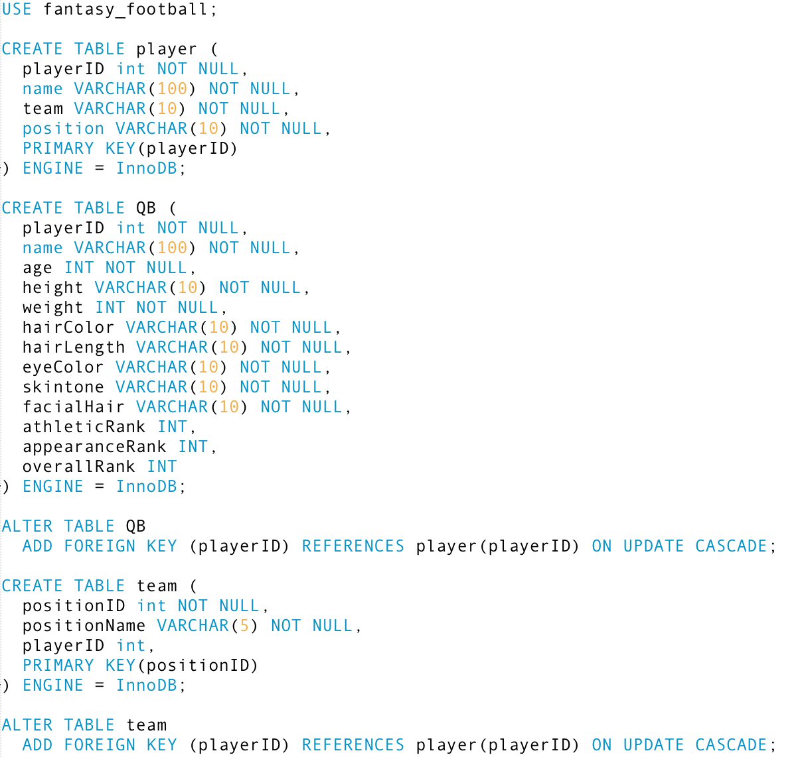MySQL Code

Our MySQL code contains these three tables as well as a table similar to ‘QB’ for each position. The ‘editplayer’ table is deleted and then created every time the program is run.

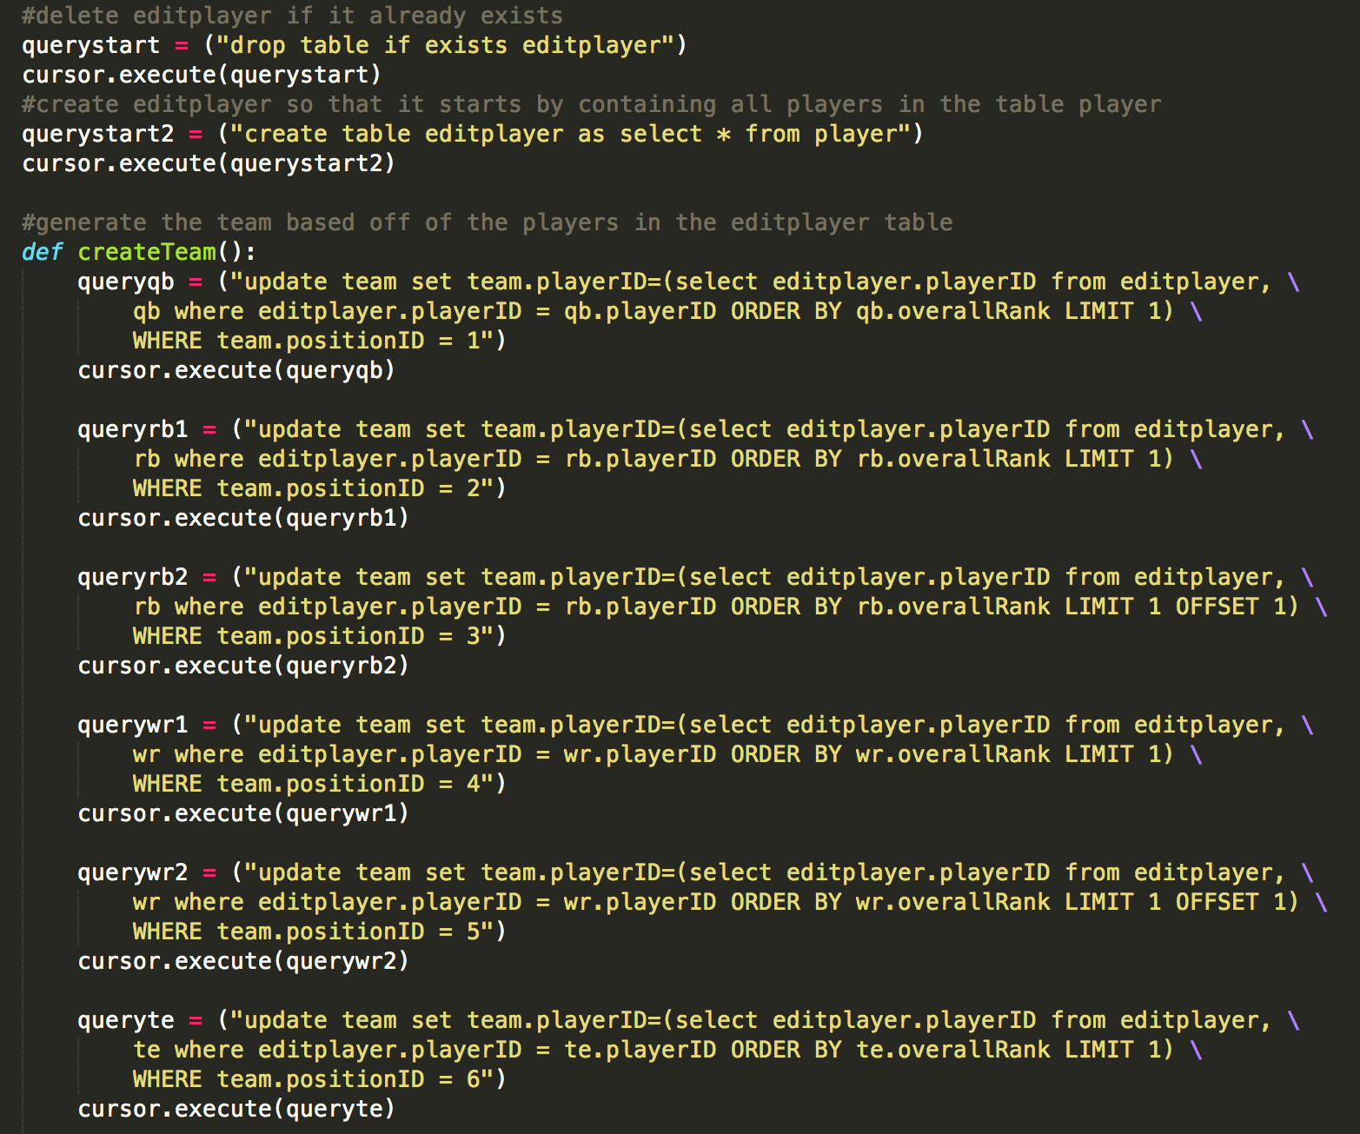Python Code

This excerpt of our Python code contains the piece that generates part of the team based on the ‘editplayer’ table. Every time a new characteristic is given by the user the ‘editplayer’ table updates and therefore the ‘team’ table needs to update as well based off the most recent specifications.

**RESULTS**

This algorithm is a fairly biased on the fact it will always give the user the same team if he or she puts the same characteristics each time. We designed our algorithm to specifically work like this because we wanted it to generate the best athletic and aesthetic team possible with the constraints provided by the user. If the user specifies the want players to be within a certain age range, the program will narrow down the possible players and choose the highest ranked player for each position with the new constraint. The user can also be more complex and choose multiple characteristics. A team can be generated with all blonde hair and blue-eyed players, although the more specific and uncommon features starts to lead to a few problems with the algorithm.

One problem we ran into involves teams with very specific characteristics or with many selected characteristics. For example, if we try to generate a team with blonde hair and blue-eyed players then we will receive a team with only five players on it compared to ten. There is only one running back, one wide receiver, and no defensive line, defensive back, or linebacker players that these specifications apply to. Therefore in some situations, the generated team might be smaller than the expected team size.

Examples

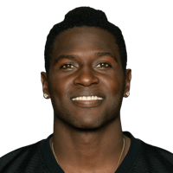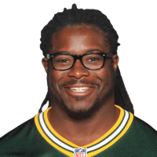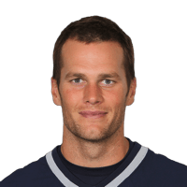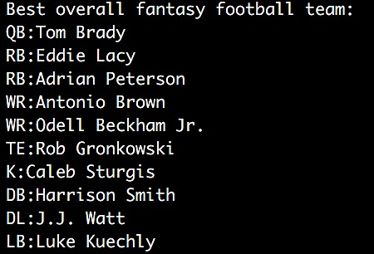This is the best overall fantasy football team that our algorithm generates. Once the program opens this is the first aspect shown to the user before it asks for customizations. (Player images are in order of position)

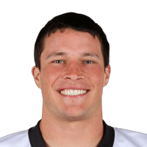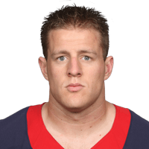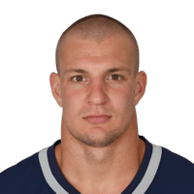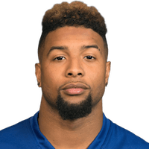

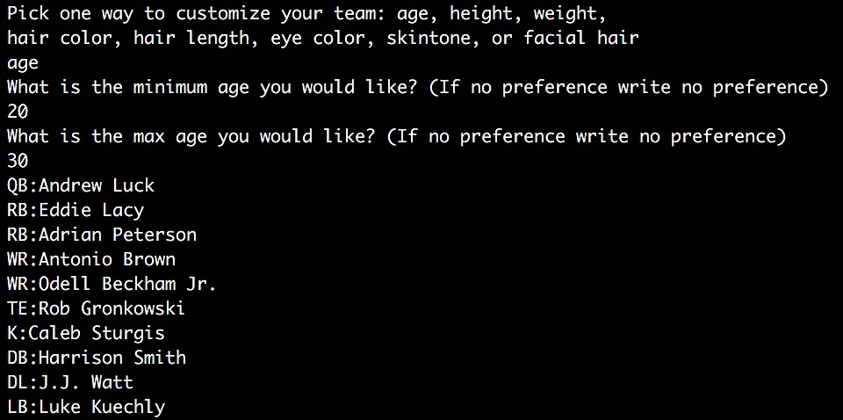

The user’s team can be customized by answering what physical feature he or she would like to specify. This example gives an age range between 20 and 30 and the new team generated applies this age range.

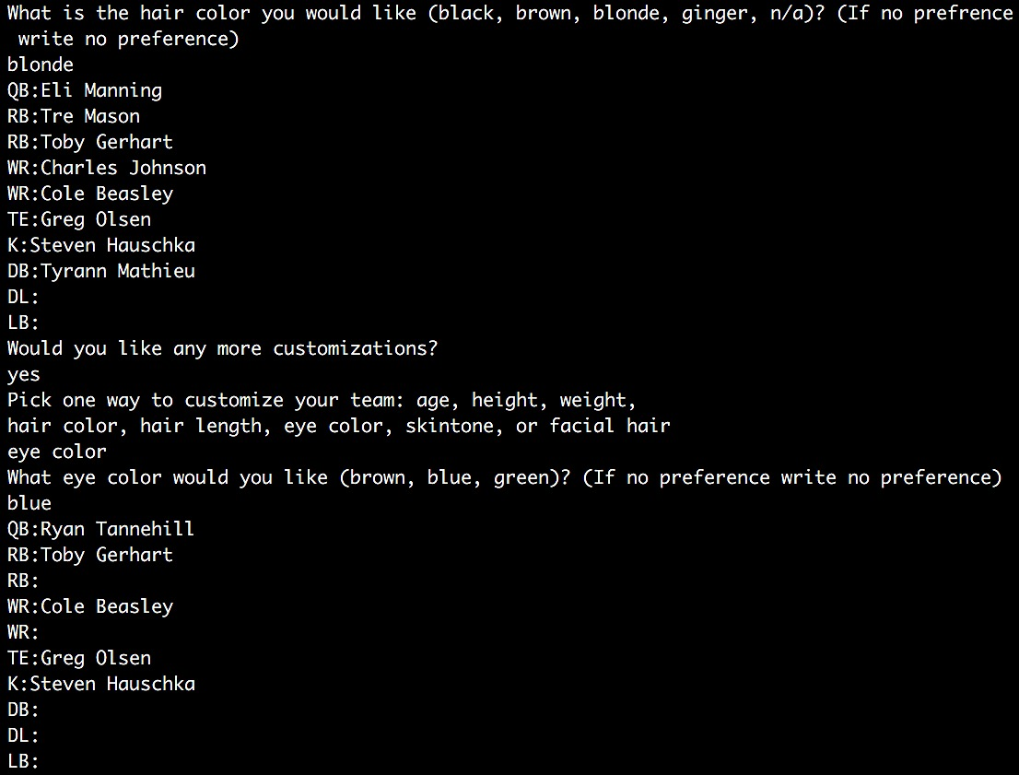

The first team generated only has the blonde hair specification, but the second team has both the blonde hair and blue eye characteristics.

**DISCUSSION**

This algorithm allows individuals who normally are not interested in football see the sport in an interesting and fun way by creating a team based off of looks instead of solely looking at their athletic skills. Individuals who are only interested in their own favorite team or are not interested in football in general, can now be exposed to many athletic and attractive football players based on their own personal preference. The various teams our algorithm can generate could be very different from a team based off of just athletic ability. The team that would be generated based off only the athletic rankings would be: QB: Aaron Rogers, RB: Adrian Peterson, RB: Eddie Lacy, WR: Antonio Brown, WR: Julio Jones, TE: Rob Gronkowski, K: Stephen Gostkowski, DB: Harrison Smith, DL: J.J. Watt, and LB: Luke Kuechly. Therefore four players are different between the athletic and attractive team compared to just the athletic team. This algorithm offers an interesting and different way to create a unique fantasy football team that offers a new way to look at the NFL.

**RESOURCES USED**

*Topsy*. N.p., n.d. Web. 18 Nov. 2015.

* Used for getting a ranking for the players appearance
* The website was recently shut down by Apple

*NFL*. N.p., n.d. Web. 18 Nov. 2015.

* Used to find pictures of players as well as all of the physical characteristics

*Fantasy Football Player Rankings*. N.p., n.d. Web. 18 Nov. 2015.

* Used to find the players overall athletic ranking