**Summary and descriptive statistics of your data**

**Data cleaning steps taken**

Most of our data contained “-“and “D”. According to the instructions for the data, the “-“ means “0” and the “D” means that the data was withheld to limit disclosure. We cleaned dashes and capital D’s by replacing a “0” for all the dashes and “D”s.

We’ve discovered that the Census data is 114 GB and hard to work it. We currently have all the data running on our local machine and have decided to hold off on exploring this data until checkpoint #2.

**Insights and next steps**

Ana is working on the visualization for the world map and U.S. map that we intended to use. She is working on building an HTML5 website as well that displays all of our maps. Here’s what the map interface will look like. We used sample data in the graph below.

We have filters going along with selection of countries and various graphs.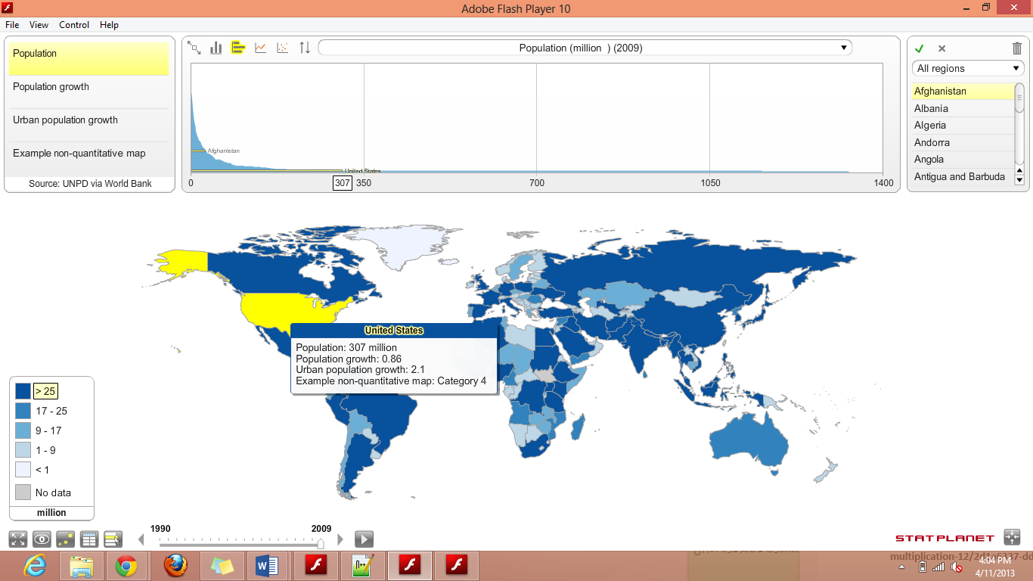 For checkpoint #2 in terms of the visualization, we’re planning on adding relevant data for our filters, discover interesting patterns, change our theme, and edit the graph to have states within the United States clickable.

For our data, we’re going to explore the Census data and see what we can strip from there.