**Team: Immigration Song**

Below we have two graphs. The first one is a detailed map of the United States. You’ll noticed that we labeled all the features that we have incorporated into our visualization. It’s fully interactive and we used a tool called StatPlanet, which can be compared to D3 but specifically for creating maps.

Search Bar

Our Graph Panel

Filter List

Zoom in & out

Map Legend

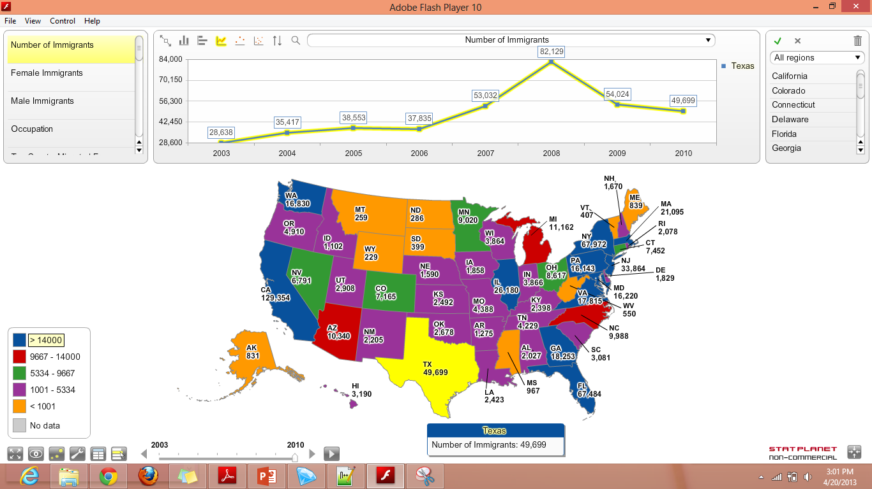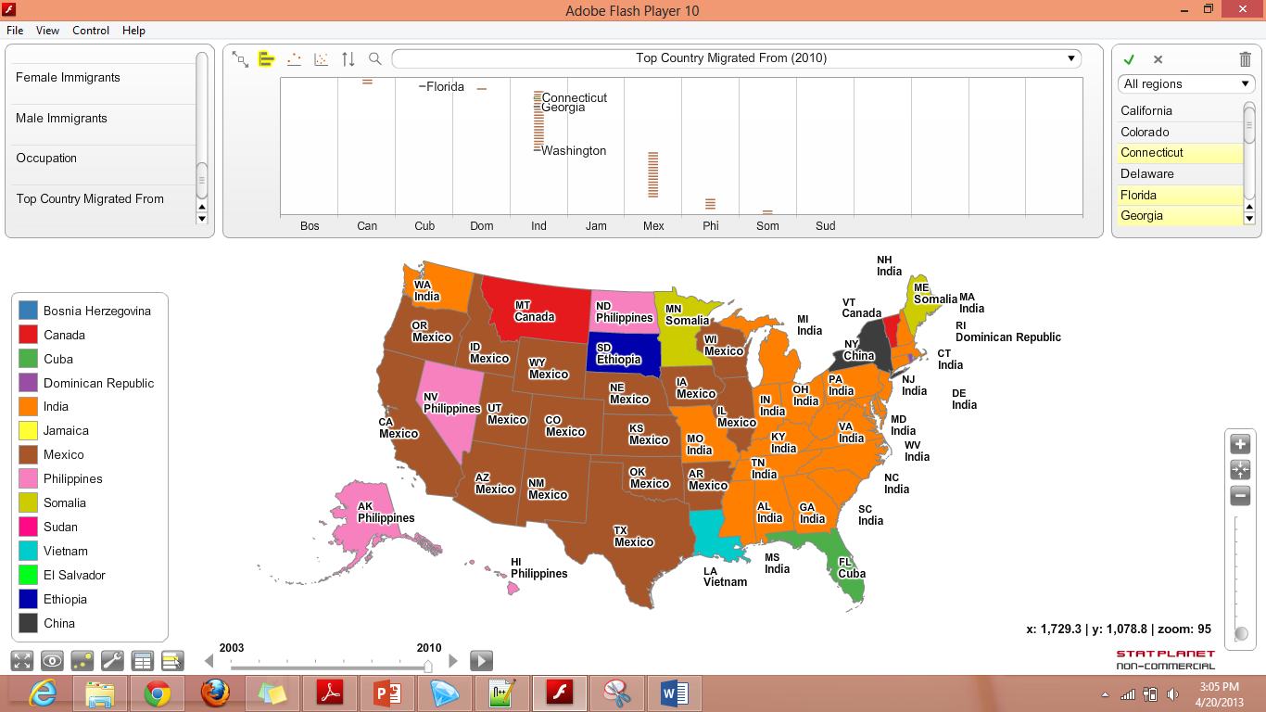



Time Slider

Several other options

Right now the above map is showing us the number of immigrants that reside in each state and are colored accordingly as we specified in our map legend. Notice that we are hovering over Texas and it is highlighted in yellow and it brings up a small text box with more information. We will have 5 different filters to choose from; “Number of Immigrants”, “Female Immigrants”, “Male Immigrants”, “Occupation”, and “Top Country Migrated From”. All you have to do is select a different filter and watch as the data changes. You are also able to zoom in and out of graph. For this type of graph, the zooming features isn’t as helpful as it is for the world map but it’s always a handy feature to have. The search bar allows you to search through different states. Again, for this simple graph the search feature isn’t as helpful but you’ll see how useful it is for the world map. The top middle part of our visualization that we labeled as “Our Graph Panel” instantly creates graphs for you. We can show a column chart, bar chart, time series graph, vertical bubble chart, and a scatter plot. The time slider feature is by far our favorite. Since we have data dating back from 2003, we can select the play button and it will transition through all of the years of data. It’s sort of like a PowerPoint presentation that plays by itself and each slide is a year from 2003-2010 displaying at the same United States map but with different data. Last but not least, we have some other options that are built in to StatPlanet that let us change a couple of the details of our map. We can see the raw data for each filter and change the color scheme.

Although our visualization looks almost done, there’s still a lot of work that has to be done; we are planning on giving the user the ability to select states/country to compare them using the different graphs. The images we have provided give you a good idea of our final product.

Now, let’s move on to the more challenging map, the world map. For this map, we added the same features and filters as the United States map, but instead of having the “Top Country Migrated From”, we have the “Top State Migrated to”.

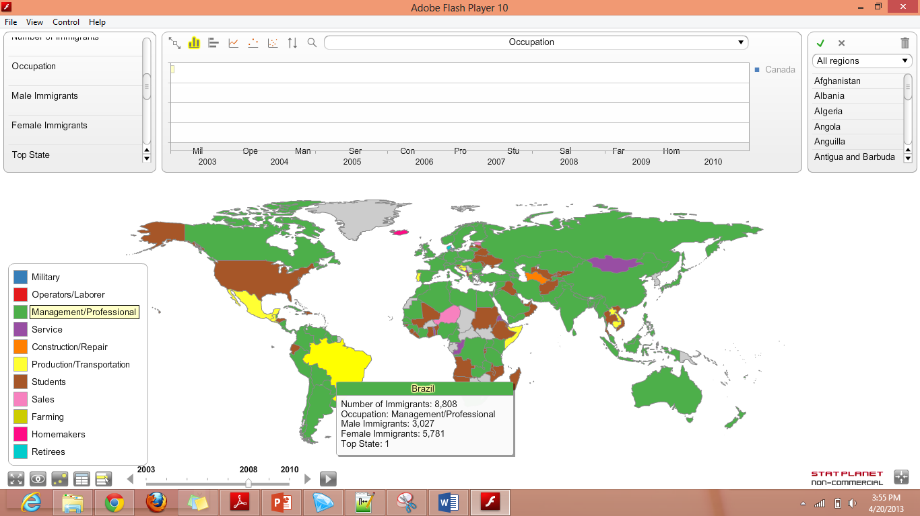

The graph above is showing the top occupation for each country. For some reason, we have a lot of missing data for our world map and there’s not much we can do to fix this (see below). However, we don’t believe this will be an issue for us since we are doing further data mining to try and figure out our initial insight questions we had.

**Data issues**:

While creating the visualizations (particularly the world map), we realized that not all states or countries have all the data for all 8 years (2003-2010). For instance, Zimbabwe only has information for years after 2005. As stated above, there is nothing that we can do about this.

**Next Steps**:

We would like to add functionality to our graph including giving the user the ability to compare different states/countries side by side. The different statistics that we would give the user would be states they went to/countries they came from, number of immigrants (total, female, and male), occupation the immigrants came to the US with, age of the immigrants, and even whether the immigrants were married or not.