DIGITAL TRANSFORMATION: TOOLS AND TECHNIQUES

PROJECT REPORT

Project Title
PropBot AI — Intelligent Real Estate CRM on Microsoft Dynamics 365
Submitted by
Anaksha Janki, Rania Ghazanfar, Marium Arif
Submitted to
Sir Mustajab
Submitted Date
20 June 2026

The Idea
Real estate agencies in Karachi are still running on WhatsApp groups and Excel sheets. Agents miss follow ups, leads go cold, and managers have no visibility into what is happening with their pipeline unless they physically call someone. There is no system, no accountability, and no intelligence.
We built PropBot AI to fix this. It is a complete real estate CRM built on Microsoft Dynamics 365 Sales that manages the full journey of a property deal from the first buyer inquiry all the way to a closed deal and commission payout. On top of the CRM we added an AI powered chatbot called PropBot that lives inside Microsoft Teams. Agents can search properties, check inquiry status, create new leads just by typing a message on their phone. No laptop needed, no browser needed, just Teams.
The system also enforces business rules automatically. A C# plugin running at the server level blocks duplicate inquiries before they are even created. Another plugin fires the moment a deal closes and calculates commission, updates the property status to Sold, and records how many days the property was on the market. All of this happens without anyone pressing a button.
Business Value
The problem we are solving is real and it exists at almost every mid sized agency in Karachi right now. Agents lose leads because nobody follows up. Managers cannot track performance without calling agents individually. Commission calculations happen manually in Excel and errors are common. Properties get listed twice because nobody checks.
Our system solves all of these problems directly.
When a new inquiry comes in it gets automatically assigned to the least busy agent within seconds and they receive a Teams notification immediately. If an agent has not updated a lead in three days the system sends them an alert automatically. When a deal goes above one crore the manager gets an approval request on their phone and can approve or reject with one tap without opening any application.
For the manager the Power BI dashboard gives a live picture of the entire agency. Pipeline stages, agent performance rankings, commission earned, properties sold versus rented, and which areas of Karachi are generating the most business. All of this updates in real time as agents work.
For the agent PropBot means they never have to open a browser to check something. They are sitting with a client . They type it in Teams and get the answer in three seconds. They want to log a new lead on the spot. They tell PropBot and it creates the full inquiry record in D365 automatically.
The technology stack we used covers every layer of the Microsoft Power Platform. Dataverse for the database, D365 Sales for the CRM pipeline, Power Automate for automation, C# plugins for server side business logic, JavaScript for client side form behaviour, Copilot Studio for the AI bot, and Power BI for management reporting. This is not a single feature project. It is a complete enterprise system built the way real consulting projects are built.

ERD
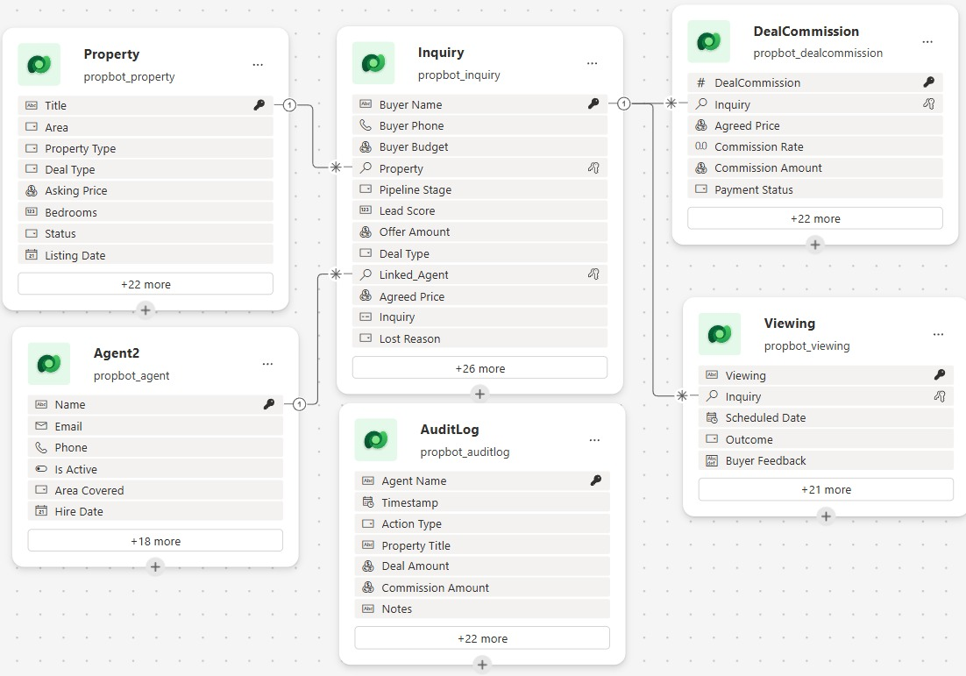

Solution Diagram

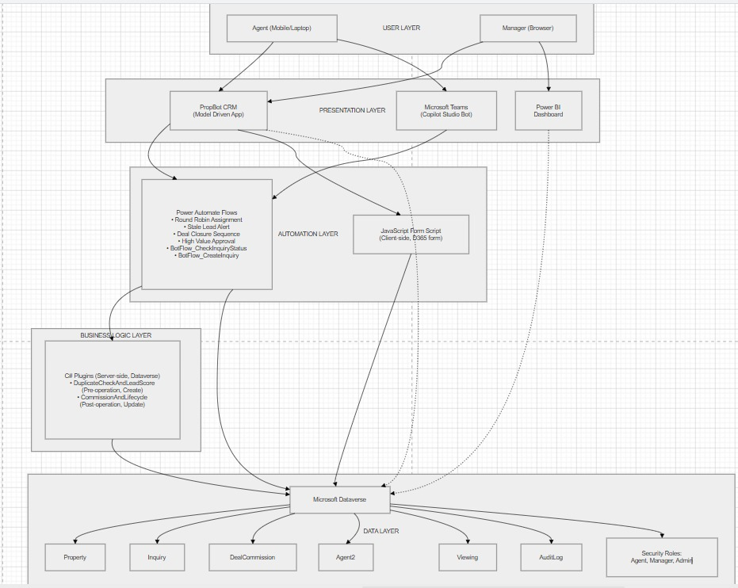

Solution Snapshot

