Invasive lionfish present region-wide variation of allometric growth in the Western Atlantic

Juan Carlos VillaseÃ±or-Derbez ${}^{1}$, Sean Fitzgerald

Lionfish (*Pterois volitans/miles*) are an invasive species in the Western Atlantic and the Caribbean. Improving management of invasive lionfish populations requires accurate estimates of total biomass, which in turn depend on accurate definition of the length-weight relationship. Here, we reviewed published length-weight relationships of lionfish taken from throughout their invasive range and found that lionfish of equal lengths have lower body mass in the Caribbean than in the Atlantic or Gulf of Mexico. . Additionally, we report a new pair of length-weight parameters ($a=3.2056imes{10}^{-6};b=3.235$) for organisms sampled in the central Mexican Caribbean region. The substantial spatial variation in length-weight parameters highlights the importance of using site-specific information when estimating lionfishbiomass using length observations. These findings can have major implications for management in terms of predicting effects on local ecosystems, evaluating the effectiveness of removal programs, or estimating biomass available for harvest..

At least 84% of marine eco-regions have reported the presence of an invasive species , which represent a major threat to local biodiversity and the economic activities that depend on it . Invasive species may threaten native species through predation, competition, or indirect habitat effects . By 2005, the economic cost of invasive species to the United States was estimated at USD $120 billion per year .

Lionfish (*Pterois volitans/miles* complex) are an invasive species in the western Atlantic and the Caribbean, likely introduced through liberation of aquarium-kept organisms . They are the first invasive marine vertebrates established along the North Atlantic Caribbean coasts and their presence has been labeled as a major marine invasion because they threaten local biodiversity, spread rapidly, and are difficult to manage. Invasive lionfish are primarily studied in coral reef ecosystems, where their impacts are far-reaching. For example, an experiment conducted by Albins et al. (2008) showed that lionfish establishment led to reduced recruitment of native fishes by nearly 80% over a five week period in Florida, and increased lionfish biomass coincided with a 65% reduction in the biomass of native prey fishes along Bahamian coral reefs in just two years (Green et al. 2012). Lionfish are also not limited to coral reefs as they have established invasive populations in other habitats such as estuaries , mangroves , hard-bottomed areas , seagrass beds, and mesophotic reefs (Claydon et al. 2012 covers a lot of these). Populations in non-reef habitats are not as well-studied, but they display an opportunistic nature and adaptability to various environments that makes their invasion particularly concerning.

A substantial amount of research describes lionfish feeding ecology in North Carolina , the Bahamas , Northern Gulf of Mexico , Mexican Caribbean , Belize , and Costa Rica . showed that invasive lionfish prey on at least 167 different species across the tropical and temperate North Atlantic. Their feeding behavior and high consumption rates can reduce recruitment and population sizes of native reef-fish species, and can further endanger reef fish . (However, see for a case where there was no evidence that lionfish affected the density, richness, or community composition of prey fishes). Major efforts have been made to understand the possible impacts of the invasion by tracking the spread of established lionfish populations through time and by predicting invasion ranges under future climates . Researchers have been able to predict the trophic impacts of lionfish by combining information from these disciplines, which can then be translated into ecosystem-level and economic impacts.

Governments and non-profit organizations have sought to reduce lionfish densities through removal programs and incentivizing its consumption . In some cases, these have shown to significantly reduce –but not quite eliminate– lionfish abundances at local scales . In addition, culling programs can help stabilize or grow native prey fish populations . Complete eradication of lionfish through fishing is unlikely because of their rapid recovery rates and ongoing recruitment to shallow-water areas from their persistent populations in mesophotic coral ecosystems . However, promoting lionfish consumption might create a level of demand capable of sustaining a stable fishery, which can help control shallow-water populations while providing alternative livelihoods and avoiding further impacts to local reef biota .

The feasibility of establishing fisheries through lionfish removal programs has been extensively evaluated through field observations and empirical modeling . One contributing factor to the success of many removal programs is the sedentary nature of adult lionfish . Culling programs are effective in reducing adult populations largely because lionfish exhibit high levels of site fidelity and rarely leave their home range in most cases . As a result of this sedentary behavior, lionfish are also likely to exhibit high levels of spatial variation in important life history characterstics such as growth or natural mortality rate . The importance of considering spatial heterogeneity is well-documented in terms of assessing and managing sedentary species , and such variation should be accounted for when evaluating the feasibility of establishing lionfish fisheries as well.

Empirical modeling efforts examining the feasibility of establishing fisheries for lionfish involve modeling changes in biomass in response to changes in mortality (*i.e.* culling). A common way to model this is via length-structured population models , where fish lengths are converted to weight in order to calculate total biomass. The length-weight relationship is therefore an essential component of these models, but this relationship can vary across regions as a response to biotic (*e.g.* local food availability) and abiotic (*e.g.* water temperature) conditions . Literature suggests that site-specific parameters are necessary in order to accurately estimate biomass when length-weight relationships are spatially variable, and this variability becomes increasingly important when estimating the potential effectiveness of (and resources needed for) lionfish culling programs or when identifying total biomass available for harvest by fishers . In addition to environmentally-driven spatial variation, genetic analysis of invasive lionfish suggest biological differences due to the existence of two geneticallydistinct subpopulations between the northwest Atlantic and the Caribbean. To date, no studies have examined region-wide differences in length-weight parameters despite the large number of studies reporting this relationship for lionfish.

The objective of this paper is to describe the spatial pattern of length-weight relationships of lionfish in the Caribbean and Western Atlantic and identify whether these differences are trivial. Length-weight relationships for lionfish exist for North Carolina, Northern and Southern Gulf of Mexico, the Southern Mexican Caribbean, Bahamas, Little Cayman, Jamaica, Bonaire, Puerto Rico, and Costa Rica. This study also provides the first length-weight relationship for central Mexican Caribbean.

The main objective of this work was to compare allometric growth of lionfish throughout their invasion range. Allometric parameters were retreived from scientific literature, and an additional pair of parameters were calculated from field observations in the central Mexican Caribbean.

We reviewed 12 published studies and obtained length-weight relationships (n = 17) for the North Atlantic (n = 1), Gulf of Mexico (n = 7,), and Caribbean (n = 10). We collected information on sampling methods, sex differentiation, location, and depth ranges from each study when available, and we assumed both genders were included in a study if gender was unspecified. We also collected data from

Some of the reviewed studies inconsistently defined $a$ as either the ponderal index from Eq. or the y-intercept ($c$) from Eq., and some other studies incorrectly reported parameters as mm-to-g conversions when they were in fact cm-to-g conversions. We standardized each study by converting each equation into Eq. 2 (and 3?) and we report all parameters as TL(mm) to TW(gr) conversions. Locations where allometric studies have been performed are shown in Figure and Table .

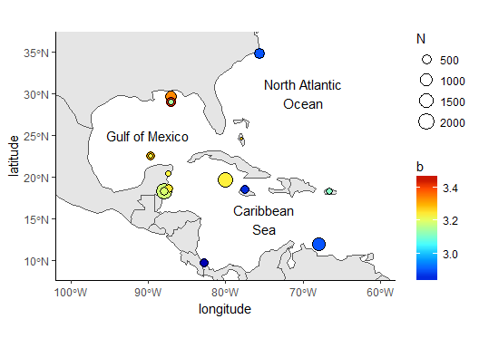

Locations where allometric growth parameters of lionfish (Pterois spp) have been reported. Circle sizes indicate sample size from each study, colors indicate the $b$ coefficient from Eq. .

Combining the length-weight parameters extracted from the literature and the additional pair calculated here, we obtain a total of 18 pairs. We use the central Mexican Caribbean as a case study of how the use of *ex situ* parameters influences the accuracy of weight estimates for lionfish. We estimated TW from the TL observations we collected in the central Mexican Caribbean (n = 109) using each of the 18 parameter pairs and divided predicted weights by known observed weights to obtain a simple measurement of over- or underestimation. Difference in mean weight ratios across the different parameter pairs were tested with a one-way analysis of variance (ANOVA). All analyses were performed in R version 3.4.4 . Raw data and code used in this work are available at dryad.org.

Inserting TL observations for the central Mexican Caribbean into Eq. 2 and converting to Eq. 3 resulted in the coefficient values $b=3.2347391$ and $c=-5.4940866$ ($R^{2}=0.977$, F(df = 1; 107) = 6928.67, $p<0.001$). The significant difference between this allometric factor ($b$) and the isometric growth factor $b=3$ ($t(107)=6.04;p<0.001$) indicated that lionfish do present allometric growth, which is consistent with other studies. Figure 2 shows the relationship between TL and TW for this region, and more information on model fit is presented in TableS2

17 parameters were identified from the 12 peer-reviewed studies that reported length-weight parameters for *P. volitans* and fromthis study in the central Mexican Caribbean (Table , Fig ). Two studies reported gender-level and pooled parameters, while the rest presented pooled results. Reviewed studies presented information for organisms obtained at depths between 0.5 and 57 m. Three studies explicitly stated that their organisms were sampled with pole spears , five studies mentioned that some of their organisms were obtained with pole spears (or other type of harpoon) but also hand-held nets or fish traps , and two studies did not specify how organisms were sampled . use spine-less weight in the length-weight relationship estimation.

Parameters from models fit to males or females exclusively tend to have a higher steepness (*i.e.* higher allometric parameter), with mean $±$ standard deviation values of $b=3.27±0.06$ and $b=3.31±0.23$ for males and females respectively, compared to parameters from models for pooled genders with a mean $±$ standard deviation value of $b=3.14±0.20$. In the case of the ponderal index ($a$) and its $log_{10}$ transformation ($c$), values were higher for parameters for pooled genders. Figure shows the length-weight relationships with parameters from all studies.

There were significant differences in our predicted weights for the central Mexican Caribbean when using the different pairs of parameters (F(df = 15; 1728) = 38.26; p < 0.001). The lowest weight estimates resulted from using the allometric parameters from Banco Chinchorro in the Caribbean (Sabidoitz), and the highest weight estimates came from the Northern Atlantic (Barbour). The calculated ratio of predicted-to-observed weight ranged from 0.80 $±$ 0.19to 1.76 $±$ 0.50 (mean $±$ SD) using these different parameter pairs. As such, using *ex situ* parameters to convert TL to TW could cause weight estimates to vary by well over 100%. Predicted-to-observed weight ratios are presented in Figure .

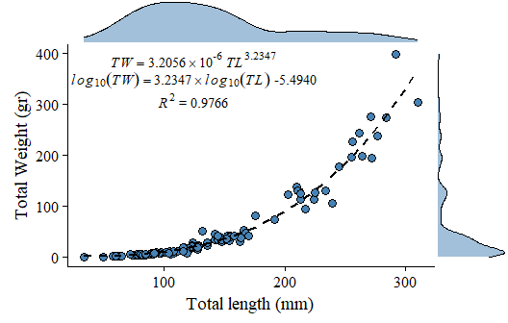

Length-weight relationship for 109 lionfish sampled in the central Mexican Caribbean. Points indicate samples, dashed black line indicates curve of best fit, marginal plots represent the density distribution of each variable.

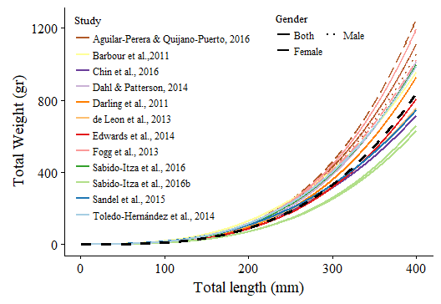

Length-weight relationships (n = 18) for 12 studies and this study. Colors indicate studies from which the parameters were extracted. Solid lines indicate that the fit was performed for males and females pooled together. Dotted lines indicate that the regression was performed on females, and dashed lines indicate it was performed for males. The dashed black line represents the relationship estimated in this study.

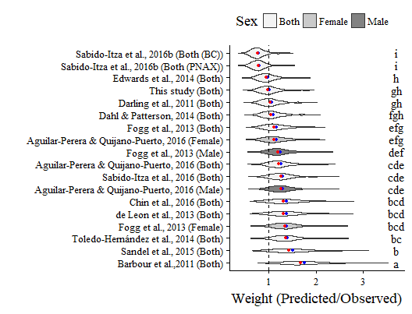

Distribution of predicted to observed weight ratios for 18 pairs of allometric parameters. Red and blue circles indicate median and mean values, respectively. Like letters indicate values that do not differ significantly (Tukey’s HSD; p < 0.05).

The length-weight coefficients estimated for the central Mexican Caribbean in this study were within the range identified in other regions (Table ), but the estimates here resulted in lower weight estimates than parameters from other studies when using similar lengths. Until about TL = 200 mm, there are no appreciable differences between the parameters for organisms from the Mexican Caribbean and those for little Cayman and Jamaica . Yet, for larger organisms (TL > 270 mm) parameters from Costa Rica and Bonaire provide similar estimates to those from this study. Conversely, these same studies tend to estimate higher weights –as compared to the ones reported here– for smaller organisms, likely due to the lack of small organisms in the samples used to estimate their parameters.

We detected substantial differences in weight-at-length between organisms from the Caribbean and Gulf of Mexico / North-Western Atlantic. Weight estimates using parameters from the Gulf of Mexico and North-Western Atlantic were higher on average than those from the Caribbean. The average predicted-to-observed weight ratios from these three regions were **insert Gulf mean +/- SD, NW Atl mean +/- SD, and Caribbean mean _+/- SD,** respectively. These length-weight differences mirror similar findings of regional variability in age-at-length relationships of lionfish acrossboth theirinvaded and native regions.. These differences may be driven by genetic variation or by organisms being exposed to distinct environmental conditions. For example, betancurr_2011 used mitochondrial DNA to demonstrate the existence of two distinct population groups, identified as the “Caribbean group” and “Northern Group”, and fogg_2015 alternatively suggested that age-at-length differences may be driven by climate. Differences in weight-at-length could also reflect differences in energy input (*i.e.* in some regions, lionfish eat more) or differential usage of this energy (*e.g.* regional differences in predator abundances lead to different usage of energy), or a combination of both. Future research is needed to determine which processes are at work here.

Differences in length-weight relationships have traditionally been highlighted as potential pitfalls to fishery management. For example, shows that small-scale variations in other Scorpaeniformes (*Sebastes rastrelliger*) translate to differential landings, effort, and catch per unit effort in the live fish fishery of California, and that these differences must be taken into account in management plans. The lionfish case poses the opposite scenario, where the manager desires to eradicate species. To accurately gauge both the effectiveness of lionfish removal efforts and the resources needed to successfully manage an invasion, we must acknowledge and understand regional biological differences in what?... understand the regional biological difference in important variables such as allometric growth? something like that?.

The results presented here have major implications for management. For example, simulated a lionfish culling program under two scenarios, one using parameters from North Carolina and one using parameters from Little Cayman. They showed that using the different parameters caused up to a four-year difference in the time required for the simulated lionfish population to recover to 90% of its initial biomass after removals ceased. Here, we show that using one set of length-weight parameters versus another for a given length can result in up to a threefold increase in estimated weight. These differences become especially important when estimating the biomass available for harvest, predicting effects on local ecosystems, or evaluating the effectiveness of removal programs. Research efforts focused on invasive lionfish populations need to use parameters calculated for their region to the extent possible, or at least use reasonable sets of different parameters that provide upper and lower bounds in their results. This work additionally highlights the need for more basic research that furthers our understanding of spatially-specific patterns in lionfish biology (?). To better manage the invasion, we must perform research that can describe biologically important information of lionfish throughout its invasion range .

I would like to thank thank Nils Van Der Haar and Michael Doodey from Dive Aventuras as well as Guillermo Lotz-Cador who provided help to collect samples.