**

***Final Project: Traffic Fine Management System***

***Fundamentals of Programming I***

***Software Requirements Specification***

***Document***

*Group Members/Individual:* ***Ana Laze, Group 1***

Approved by: MSc. Klea Çapari

|  |
| --- |
| **Contents** |

1. Introduction 3

2. General Description 3

3. Functional Requirements 4

4. Interface Requirements 5

4.1 User Interfaces 5

4.2 Hardware Interfaces 5

4.3 Communications Interfaces 5

4.4 Software Interfaces 5

5. Analysis of the System 5

6. Design of the System 6

**1. Introduction**

A Traffic Fine Management System is a software application designed to automate the process of managing and tracking traffic violations and the corresponding fines. It streamlines the process of issuing fines, collecting payments, and maintaining records of violators. The system can also generate reports, track payment status, and provide real-time updates on the status of fines. By automating the process, the system can reduce the workload of law enforcement personnel and improve the efficiency of traffic fine management.

## 2. General Description

**2.1 Product Functions**

The product makes input of data and the entire checkout process easier and streamlined for the users (employees) and time efficient for the bidder.

**2.2** **Similar System Information**

The product is being developed with Access, so there are a large number of similar databases or systems and they are used for a wide array of different purposes.

**2.3 User Characteristics**

A traffic fine management system has the following user characteristics:

1. Drivers: The primary users of the system, who receive and pay fines for traffic violations.
2. Law enforcement officers: Officers who issue the fines and input the data into the system.
3. Administrators: System administrators who manage the system, including adding new users and monitoring usage.

**2.4 User Objectives**

Provides a database that will store information on a silent auction. The program faciliatates the speed and ease of input.

## 3. Functional Requirements

1. **Items provided to the IDANRV shall be stored in the Access Database.**
   1. Items shall be stored on the laptop machine and have complete fields.
   2. Very high criticality
   3. Limited network / wi-fi availability could present a technical challenge
   4. The above stated factor is a risk we have encountered. Eliminate it by reducing the dependency of our program on these things.
   5. This requirement is the basis of the project; all other aspects depend on it.
2. **The items shall be accessible via queries and reports.**
   1. Users of the database should be able to run reports on the data that has been put into the database. They should also be able to run queries.
   2. Very high criticality
   3. We do not foresee any technical issues preventing the implementation of this.
   4. Given the capabilities of Access, this requirement is able to be satisfied.
   5. This requirement depends on requirement number one.
3. **The data stored should be able to be manipulated through forms.**
   1. Items and other data should be able to be added and updated through the use of forms.
   2. Very high criticality
   3. We do not foresee any technical risks involved in this requirement.
   4. The only factor we can encounter here is the user of the system not being able to use it correctly. We will overcome this by training those who will be using it.
   5. This requirement is dependent on requirement one.

## 4. Interface Requirements

**4.1 User Interfaces**

* **4.1.1 GUI**  
  The user interface for this program is the interface provided by Microsoft Access 2007. Access includes forms and reports for the users to query and organize data to suit their needs. Forms and reports both have builders that let the user specify which fields they want to use and which constraints they want to define.

**4.2 Hardware Interfaces**

The program (Access) uses the hard disk. Access to the hard drive and other hardware is managed by the operating system and Access.

**4.3 Communications Interfaces**

If we decide to implement an Ad Hoc network for a shared database, the operating system will handle those connections.

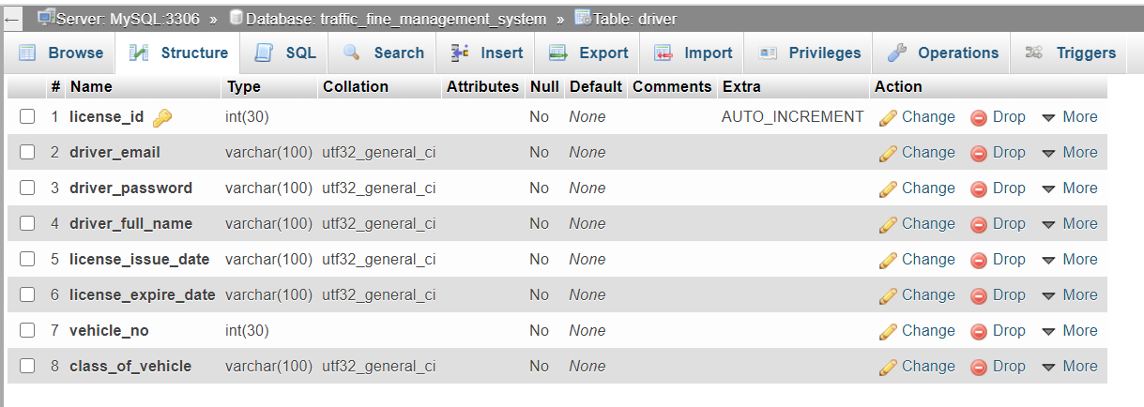

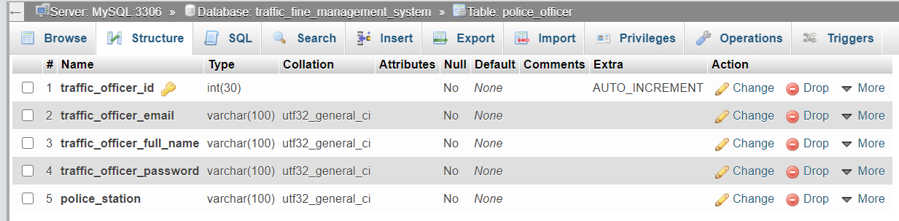

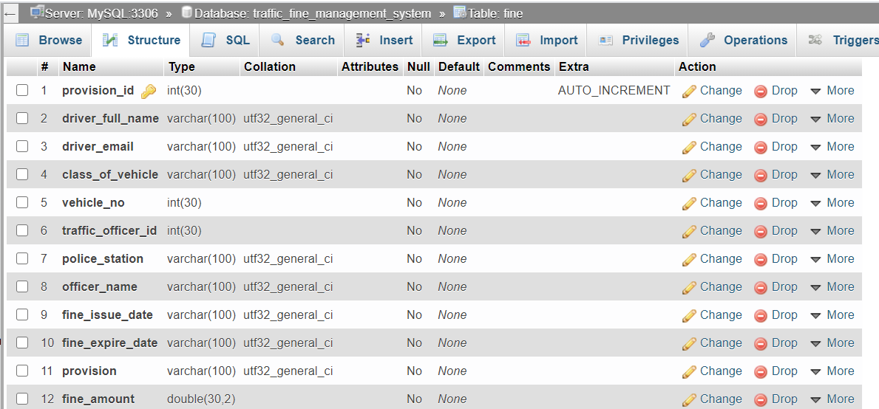

## 5. Analysis of the System (Through UML Diagrams)

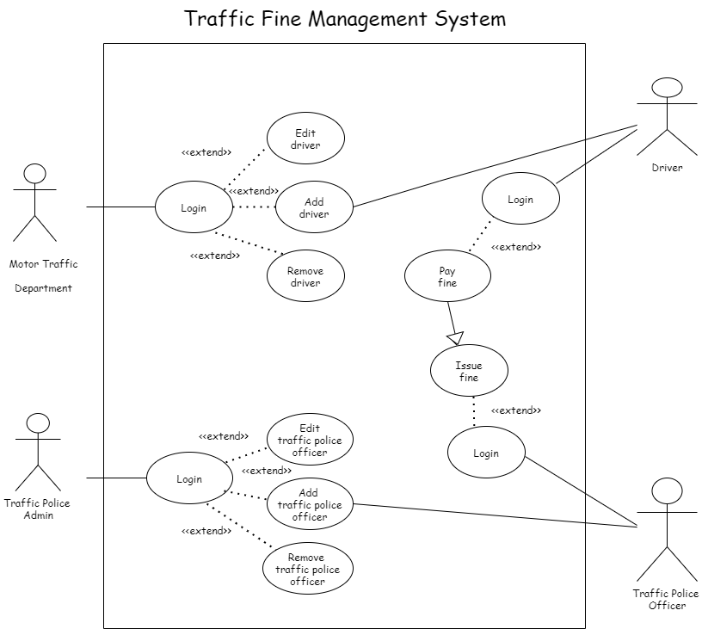

## 6. Design of the System (Through UML Diagrams)

.

