After changing the title to Mexico and clicking the submit button, the page that is shown in the screenshot above is seen, this is happening since we are declaring an HTML form that uses GET to send its data to the process.php file when submitted but this file doesn’t exist/ I haven’t created this file, hence we will get file couldn’t be accessed.

CHANGED TITLE, SELECT EACH OF THE COUNTRIES I ADDED

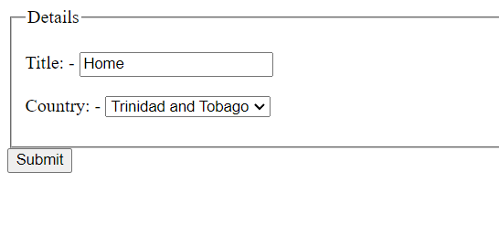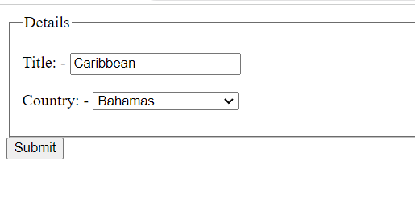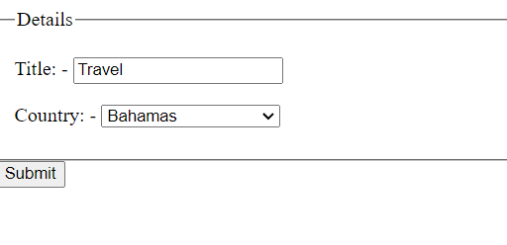

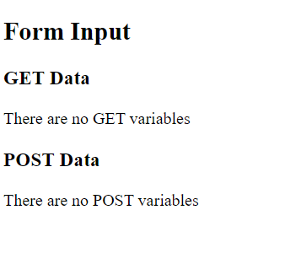After selecting Spain and clicking the submit button, I am directed to the page in the image on the left.

With the use of the action attribute directing the HTML form to a webpage, when we select submit we are directed to that php script.

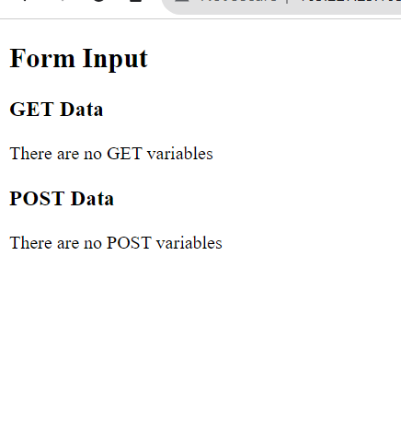Changing the PHP action to post.

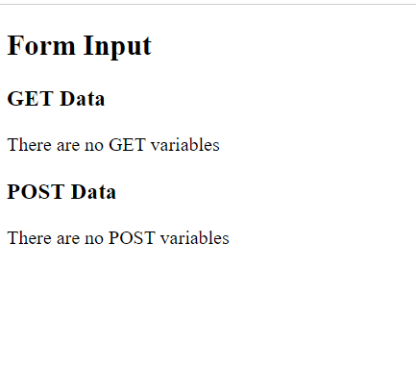After adding a title, selecting Brazil, and clicking submit, the same page appeared since we only assigned one php script despite the action being performed.

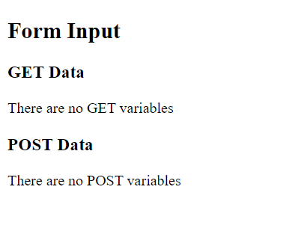After clicking the submit button, for id, password, email and website, no information was get variables were displayed

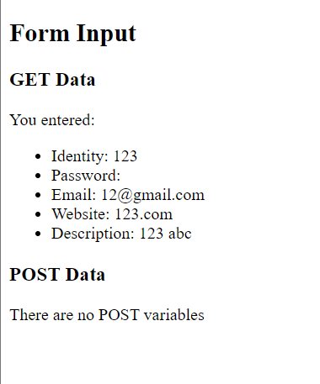

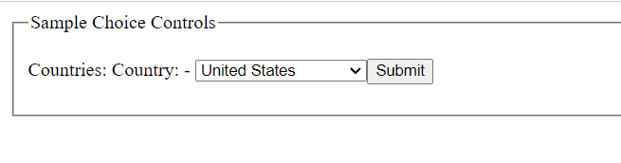

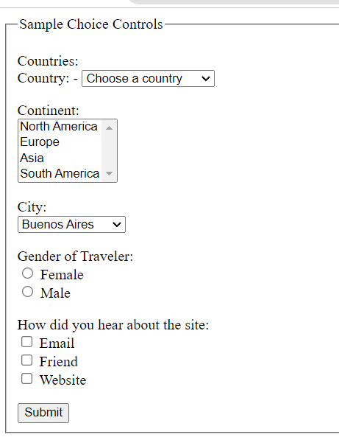

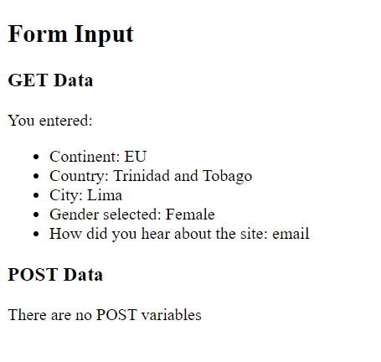

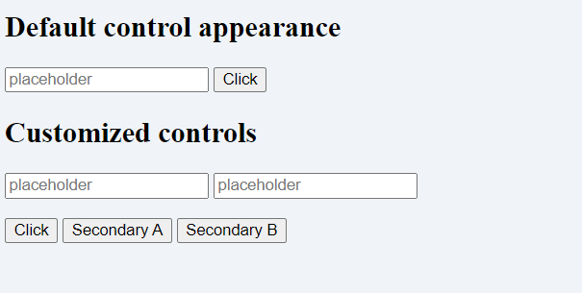 default

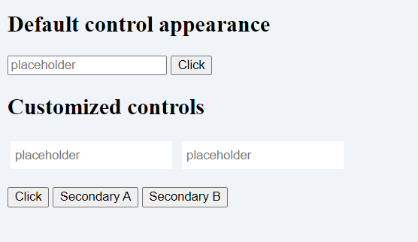new style

Added padding and margin and borders were removed

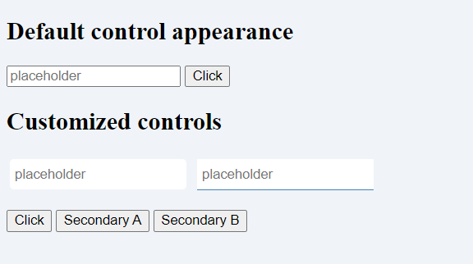bottom border added in steel blue

Yes, both the roundedText and borderedText styles can be combined if both styles are to be added to the same element.

To do so we would create a new class that would include both styles.

.roundedText.borderedText {

border-bottom:;

border-radius: ;

padding: ;

margin: ;

Hexadecimal value for steelblue : #4682B4

It doesn’t matter if hexadecimal or word color values are used, however, hexadecimal values are more precise.

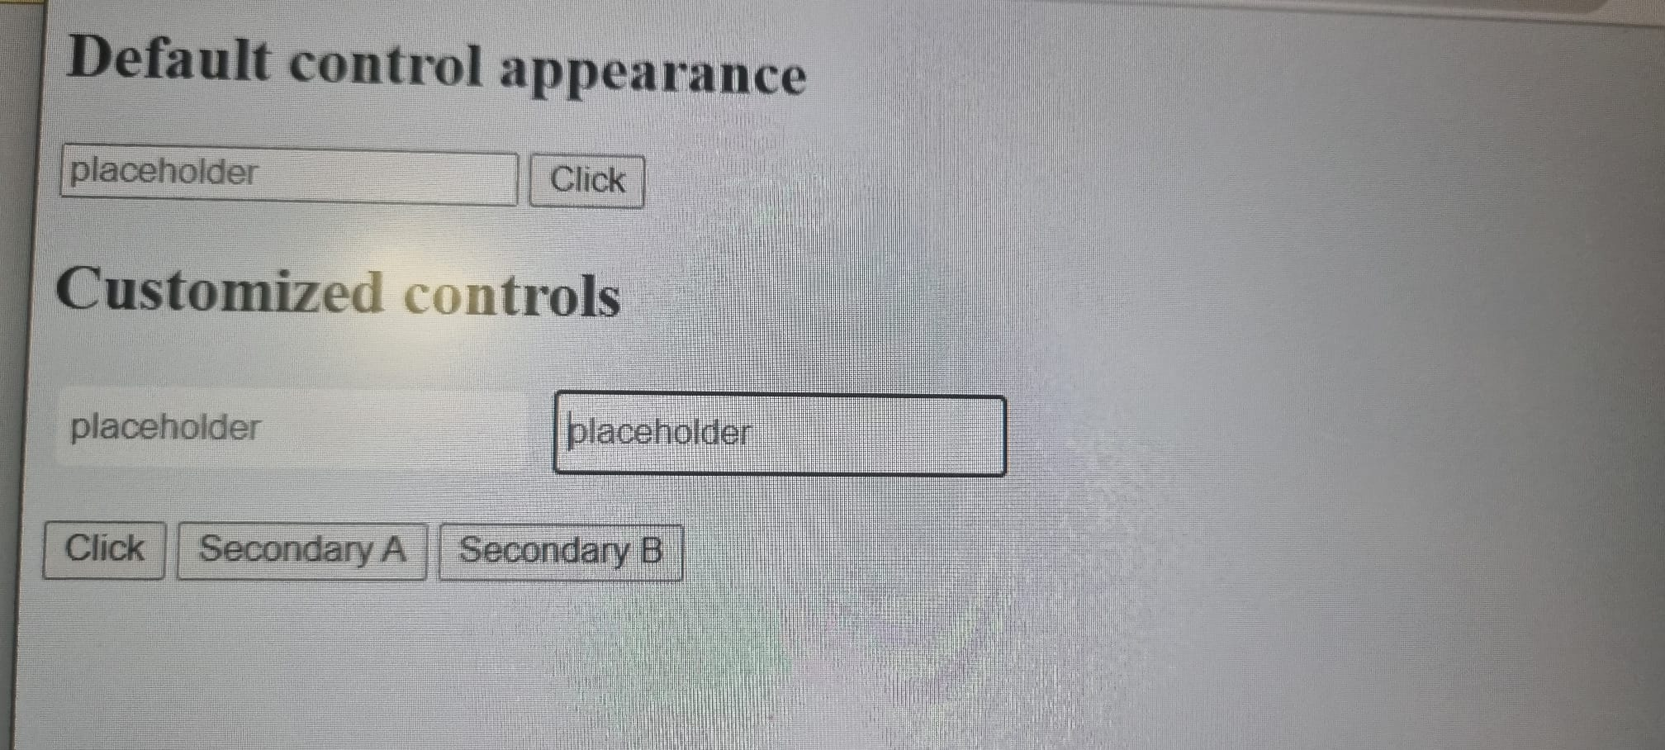

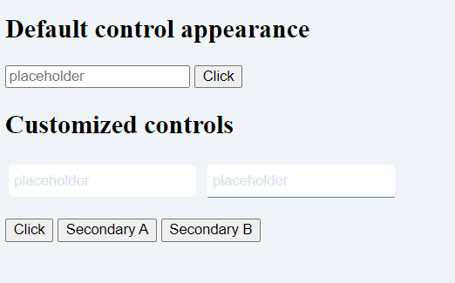placeholder is now written in the color of #D9E2EC

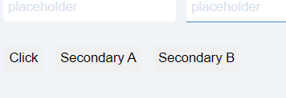

There is no border around buttons and padding and margin changed to 5px and 4px, respectively.



Step 17

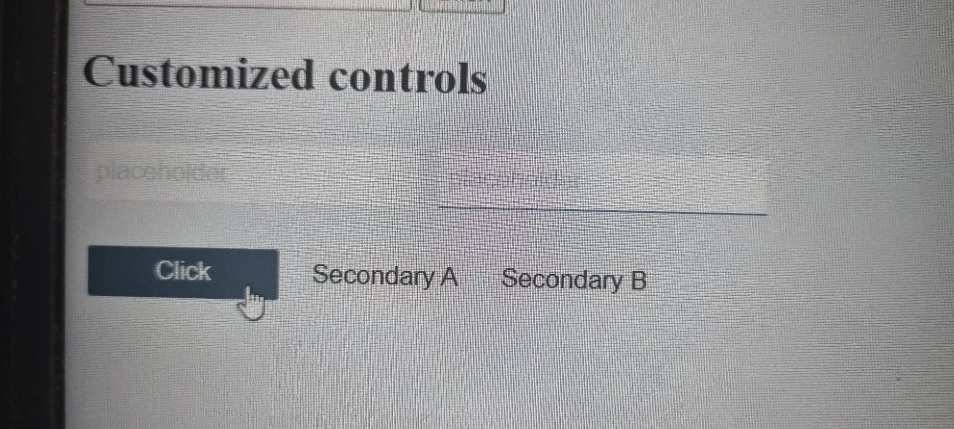

Color changes when hovered

Add border and change the background color

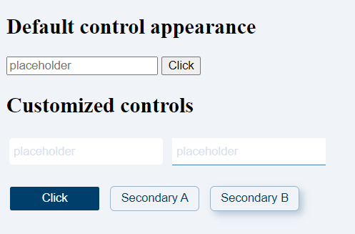

Final product