Readme file-

1. Do the connections as mentioned in below table.

|  |  |  |
| --- | --- | --- |
| **#** | **Source** | **Target** |
|  | **Wifi-Module** | **Relay** |
| 1 | Any I/O pin (I have used PIN 4) | S (SIgnal) |
| 2 | 5V | (+)ve |
| 3 | GND | (-)ve |
|  |  | **LDR** |
| 4 | 3V3 | 1st leg |
| 5 | A/O PIN | 2nd leg |
|  |  | **Resistor** |
| 6 | A/O PIN | 1st leg |
| 7 | GND | 2nd leg |
|  | **Relay** | **Bulb Holder** |
| 8 | COM | 1st pin |
|  |  | **2 Pin Plug** |
| 9 | NO | 1st pin |
|  | **Bulb Holder** | **2 Pin Plug** |
| 10 | 2nd Pin | 2nd Pin |

1. The circuit should look like below.

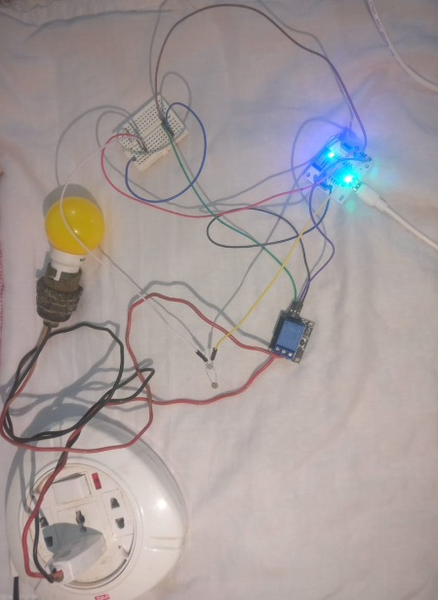

1. I have set the threshold value to switch on the bulb at 350 for this project.

Input = When senor value > threshold value

Output= Light is off

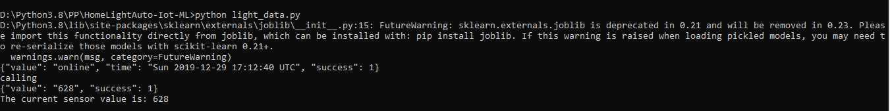

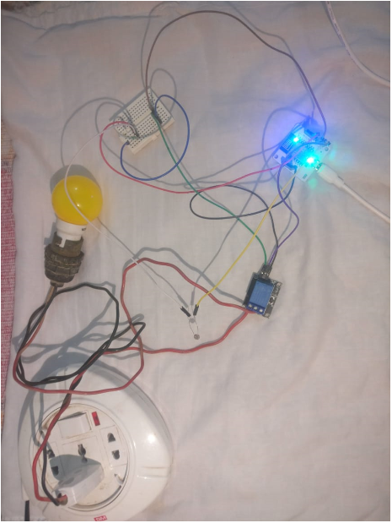

1. Input = When senor value < threshold value

Output= Light is on using the bolt IoT module code

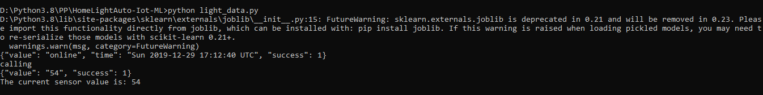

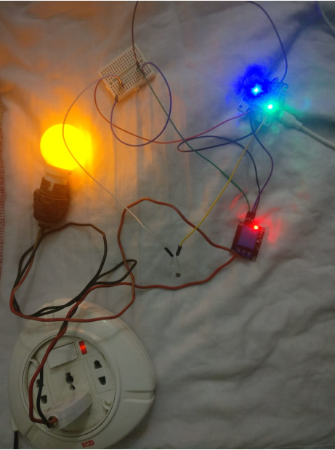

1. Input = LDR not working or the coding is not working or any other breakdown due to which we are unable to get input value from bolt API(In this project, I have changed input function name to something that doesn’t exist, so that the code is unable to get input).

Output= Light is on using the predictions done by Machine Learning coding (used a sample data input file to create ML code).

