CYBERBULLYING DETECTION IN SOCIAL MEDIA

Problem Statement:
Create a program which will detect/ predict the bad comments from a dataset so that the organization can stop them from showing on social media platform.
As a NLP analyst, your task is to
- Clean the dataset.
- Mine and refine the data to uncover its basic attributes and characteristics.
- Determine the independent and dependent variable for this dataset.
- Identify the bad comments from the good ones and create a program which will predict the same.

Steps towards resolution:
Below are the high level steps that we will be preforming.
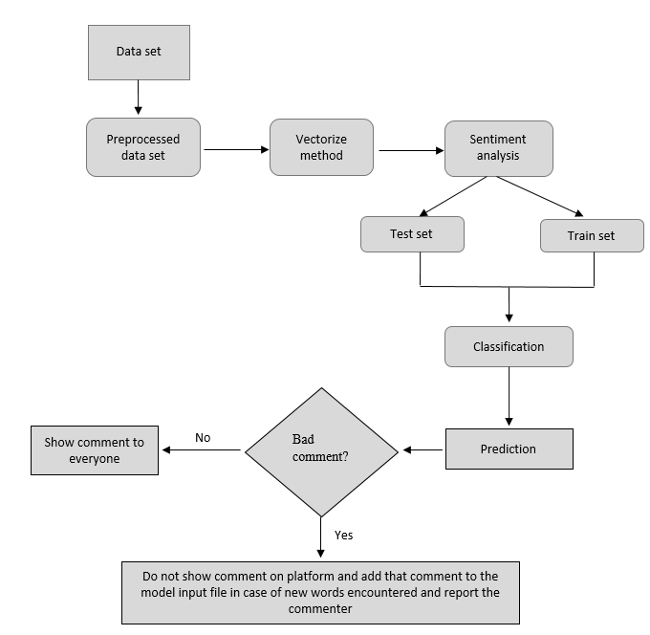

Data Selection and Loading
Let’s load the dataset. The dataset contains the information about annotations, user name and tweets contents.
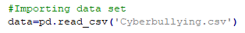
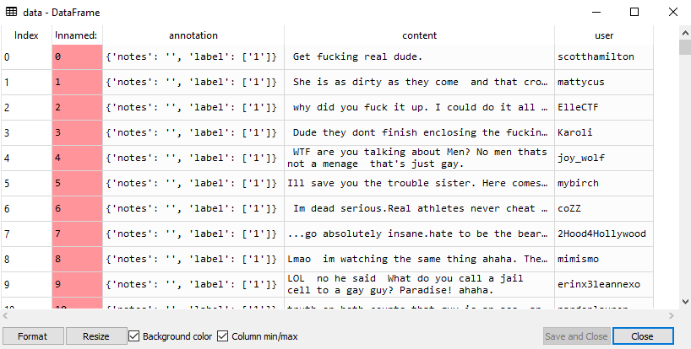

Data Preprocessing
First, the duplicates are removed from the dataset.
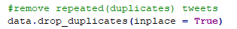
Bag of words is created by removing all characters except for alphabets from the content data, convert it to lower case and append all the words from all the content rows in one array.
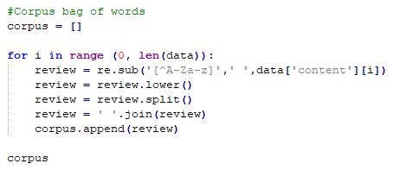

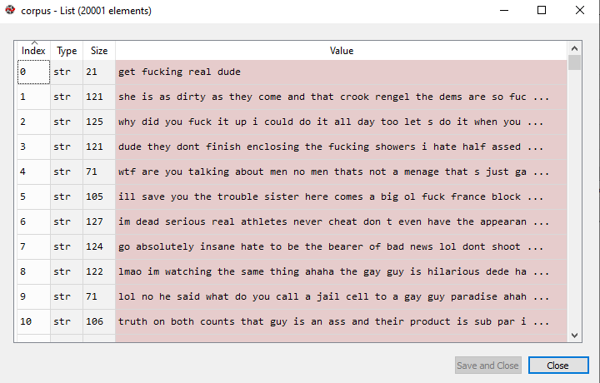
Using CountVectorizer and Tfidf fit-transform, the importance of each word in this input data can be determined.
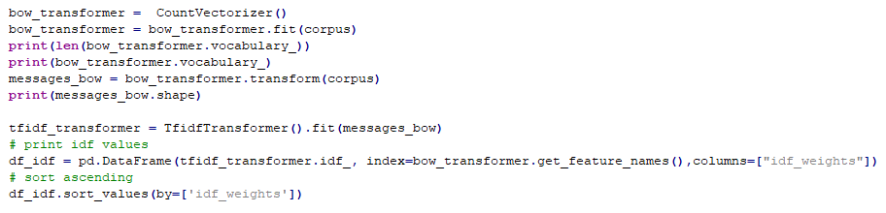
Looking at the idf_weights, we can see that in this dataset the garbage values are mostly repeated and hence they are topping the list.
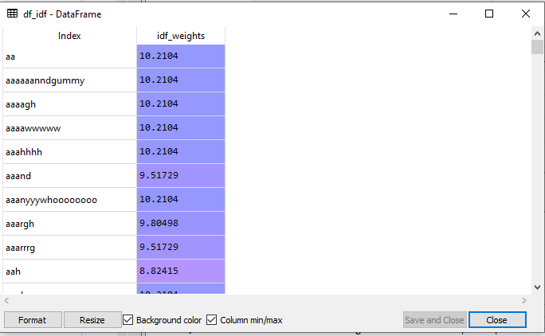

Annotation column does not provide any information for our analysis, we will drop that column.
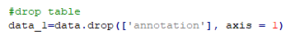
Sentiment Analysis is performed using SentimentIntensityAnalyzer function.
The content data will be passed in this function and score for compound, negative, neutral and positive for each row will be determined.
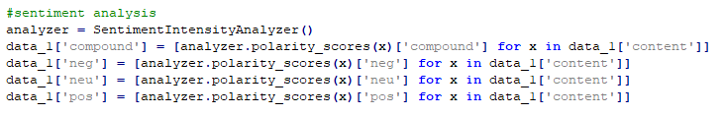

Feature Engineering
A new column called ‘comp_score’ will be created having values as 0 (if compound score >=0; good comment) or 1 (if compound score < 0; bad comment).
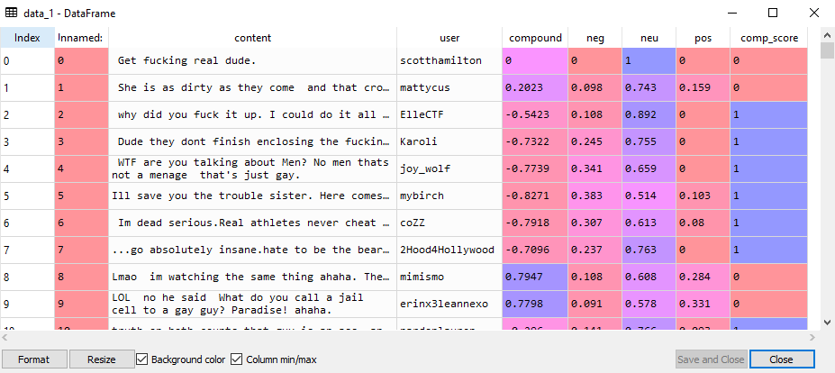
Let’s plot a histogram to analyze the scores.
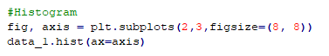
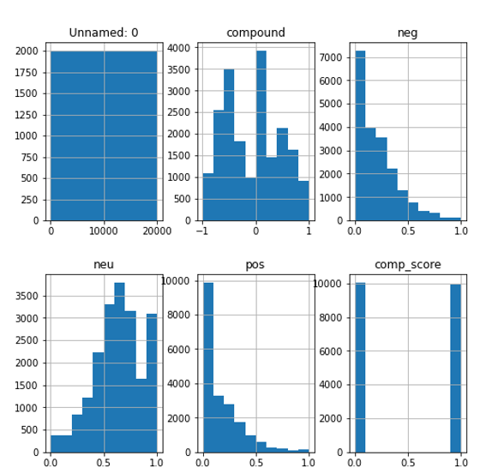
Since compound score is approximate average of negative, neutral and positive score and is normally distributed than other scores, we will use compound score in further analysis.
Let’s check the good and bad comments count using pie chart.
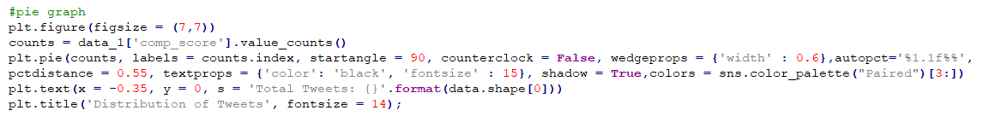
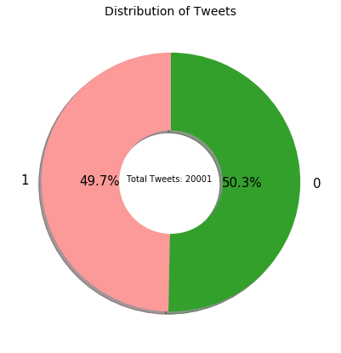

Splitting Dataset into Train and Test Data
From above analysis we can say that the independent variable will the ‘content’ column and the target/dependent variable will be ‘comp_score’.

Let’s start with our data modelling.
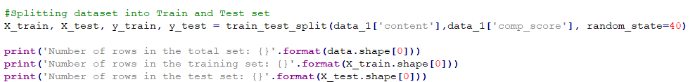
The data is split by default ratio into x-train, x-test, y-train, and y-test data set.
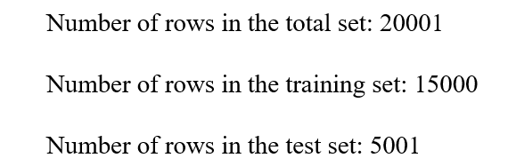
Using CountVectorizer method, the x-train dataset is fit-transformed.
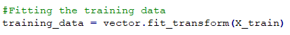

Figure 12: y-train data
Using the same CountVectorizer method, x-test dataset is transformed to numerical format.
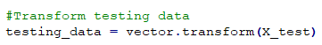

Classification
Multinomial Naïve Bayes classifier is used for modelling this dataset.
This classifier is suitable for classification using discrete features. In this project, comp_score is the discrete feature which is created using feature engineering.
Fit the CountVectorized fit-transformed x-train and the y-train data to the Multinomial Naïve Bayes model.
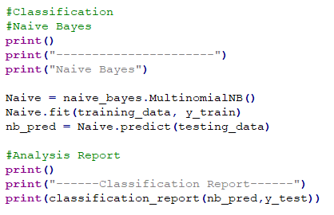

Prediction
Predict data (nb_pred) using the CountVectorized transformed x-test data using the same Multinomial Naïve Bayes model.

Result Generation
Classification report is generated using y-pred and y-test data.
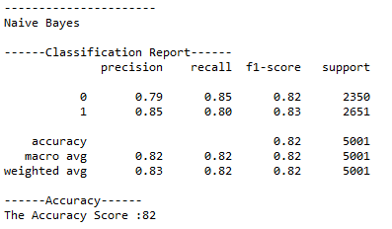
Accuracy score achieved is 82%.
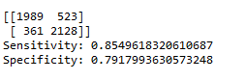
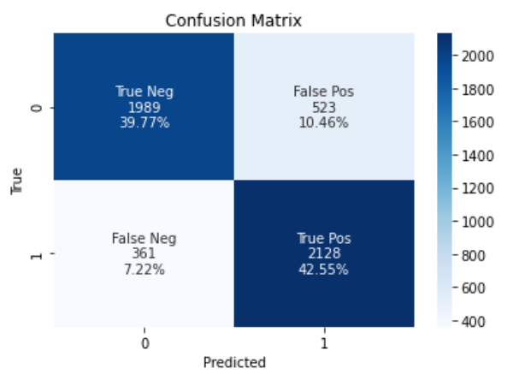
Even though the false positive is 10.5%, means 523 bad comments were gone unrecognized as bad, but 42.6% (2128) bad comments were captured in this initial modelling process.

