# Introduction

This document is the proposed software specifications for a graphical user interface (GUI) software to run under Windows 10 x64, specifically to read and write DS28EC20 eeprom memory devices. There are no .NET examples currently for these chips available for customers.

# Description

The software shall consist of a Microsoft GUI written in C# that allows for reading the entire memory and writing the entire memory of the above-mentioned devices. It will also have an area showing the 1-Wire activity.

# Hardware Setup and Test Fixture Requirements

* 2 DS28EC20 devices in TO92 packages (DS28EC20+).
* DS9120P+ 1-Wire socket board (comes with RJ12 male/male cable).
* DS9490R and/or DS9481-3C7 1-Wire adapter.
* Two alligator-alligator clip cables.
* Connect 1-Wire adapter of choice to the PC on a spare USB port. Plug in RJ12 cable to adapter with the other end plugged into DS9120P+. Attach DS28EC20 to TO92 socket. Use alligator clips to attach to the second DS28EC20, connecting 1-Wire test point to the 1-Wire lead of the chip and connecting the ground test point to the ground lead of the chip.

# Software Development Tools Requirements

* Visual Studio 2017 capable of writing C# programs.

# Software Library Dependencies

* .NET version 4.8 developer pack runtime installed from here: <https://dotnet.microsoft.com/en-us/download/dotnet-framework/net48>.
* Analog Device’s LookAndFeel.dll for ADI-approved GUI components such as a splash screen, icon, buttons, etc.
* It assumes that the 1-Wire Drivers have been installed for USB DS9490R adapter support but should work stand-alone without 1-Wire Drivers for the DS9481R-3C7 PC adapter.

# Operation or Software Flow

When run, the GUI software will do the following before the main Window appears:

1. Automatically discover the first 1-Wire adapter it can. It does this by first looking to see if a DS9490R 1-Wire USB adapter exists on “USB1”. USB1 is mapped as a copy of the first Windows “handle” to the hardware device that was most recently plugged in. If it doesn’t find one there, it will attempt to find a DS9481R-3C7 serial port 1-Wire adapter on COM1 through COM64. If no adapters are found, the GUI will generate a “MessageBox” error message before the main Window appears and before the Splash Screen is visible (see step 2). Figure 1 shows the error message.

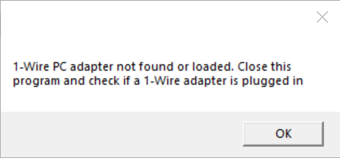

Figure . No Adapter Found Error.

1. The GUI will display a splash screen before the main window appears (using the LookAndFeel.dll). It will appear for 3 seconds and give the name of the software, along with copyright information, version information, and how to contact Analog Devices. It also has a checkbox that a user can check to disable the splash screen as needed. Figure 2 shows the splash screen. To re-enable the splash screen, the user can click the “About” menu item from the main menu of the main GUI window as shown in Figure 3 below. This is the same splash screen but dismisses with a click of the “OK” button.

 

Figure . Splash Screen on Startup Figure . About Screen with OK Button

When the main Window appears, it will contain 3 text edit boxes vertically aligned, along with 2 buttons to go with the read and write events. See Figure 4 below.

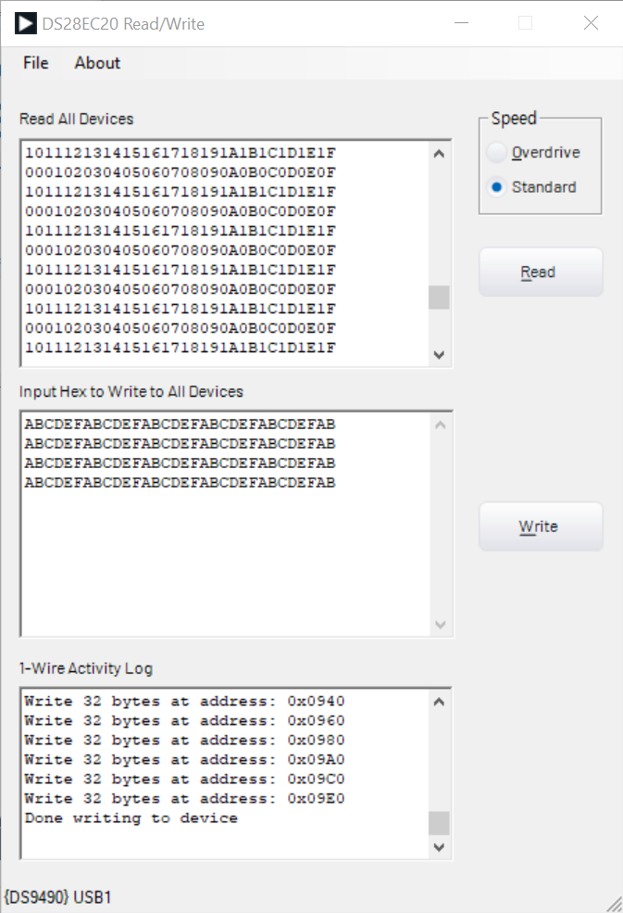

Figure . GUI Main Window

## Reading

The top button is the “read” button. When clicked, the program shall discover all 1-Wire devices connected on the 1-Wire bus, read the entire user memory contents of the devices that are equivalent to the DS28EC20, and display the entire memory contents in hexadecimal form (no spaces) in the topmost text box labeled “Read All Devices”. See Figure 4 for the Main Window, the button labeled “Read” and the “read” text box.

## Writing

The bottom button shall be placed next to the middle text box and is to be labeled “Write”. When clicked the program shall discover all DS28EC20 1-Wire devices and attempt to take the hexadecimal contents that the user places in the middle text box labeled “Input Hex to Write All Devices”, convert it to an array of bytes and write this array to all DS28EC20 devices found. See Figure 4 for the Main Window, the button labeled “Write” and the “write” text box.

## Other GUI Functions

1. 1-Wire Activity text box. The text box labeled “1-Wire Activity Log” shall be the bottom text box. This displays the 1-Wire activity during the read and write events. Specifically, it will show the serial numbers of all 1-Wire devices found. If they are DS28EC20 devices, then they will display a message that reading is occurring or that writing is occurring.
2. The Status Bar. This is at the very bottom of the main Window and shall either display “No Adapter Found” or the adapter and port, such as “{DS9490} USB1” connected as shown in Figure 4.
3. Main Menu. See Figure 4. This is located at the top of the main window and consists of “File” and “About” menu items. When clicking File, it will present a sub menu item called “Exit”. This shall cause the program to exit. Clicking About will cause the “About Screen” to appear as shown in Figure 3.

# Limitations

* Testing will only be done on Windows 10 x64.
* Only DS28EC20 devices will be tested.
* LONG TIME Reads and Writes. Be patient, the DS28EC20 is large memory and at standard 1-Wire speed, it can take over 40 seconds to read a device's full memory. For a write, the program first reads the entire memory and then performs the write, so it can take well over a minute to complete a write.