# Introduction

This document gives a detailed description of the test plan results performed on the DS28EC20 Read/Write Example. This is a GUI software example intended to run on Windows 10 x64 and enables an end customer to read and write the user memory contents of DS28EC20 devices.

# Test Equipment Used

The following is the test equipment used:

* A PC running Windows 10 x64. It needs to have a spare USB port with the 1-Wire Drivers installed. The 1-Wire Drivers package can be downloaded here: <https://www.analog.com/en/design-center/evaluation-hardware-and-software/1-wire-sdks/drivers.html>
* 2 DS28EC20 devices in TO92 packages.
* DS9120P+ 1-Wire socket board (comes with RJ12 male/male cable).
* DS9490R and/or DS9481-3C7 1-Wire adapter.
* Two alligator-alligator clip cables.
* Connect 1-Wire adapter of choice to the PC on a spare USB port. Plug in RJ12 cable to adapter with the other end plugged into DS9120P+. Attach DS28EC20 to TO92 socket. Use alligator clips to attach to the second DS28EC20, connecting 1-Wire test point to the 1-Wire lead of the chip and connecting the ground test point to the ground lead of the chip. See Figure 1 below.

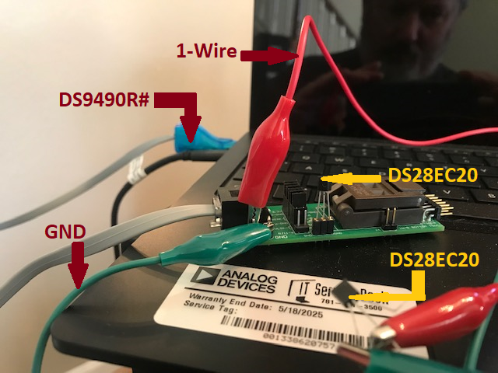

Figure . Test Setup for 2 DS28EC20 devices.

# Tests Conducted

|  |  |  |  |
| --- | --- | --- | --- |
| Case | Description | Test Procedure | Result |
| Splash Screen Disable | The splash screen can be disabled by checking a box on the splash screen. | Upon startup, the splash screen will appear for 3 seconds. On the splash screen is a checkbox labeled “Disable Splash Screen”. Click it to put a check in the checkbox. Exit the program and run it again. The splash screen should not display. | Pass |
| Splash Screen Enable | The splash screen, when disabled, can be re-enabled. | With splash screen disabled, run the program. From the main window, click “About” from the main menu. It will have a check in the check box labeled “Disable Splash Screen”. Click the checkbox to remove the check. Click OK and then exit the program. The splash screen should appear upon the next startup of the program. | Pass |
| No Adapters Found | When program is launched, it automatically detects the first 1-Wire adapter. It should handle the error of no adapters found. | With no adapter plugged in, start the program. It should eventually give an error and show the string “No Adapter” in the main window’s status bar. | Pass |
| File Exit | Clicking File->Exit should close the program. | From the main menu on the main window, click on the “File” menu item, followed by clicking on the Exit sub-menu item. The program should close. | Pass |
| Odd number of characters in “Input Hex” text box. | It takes 2 characters to represent a byte. For example, 2B in hex is a single byte. In the input text box next to the “Write” button, whenever an odd number of digits have been input, it should display an error. | Input an odd number of hexadecimal digits in the text box labeled “Input Hex to Write to All Devices”. Click the “Write” button. The following error message should appear: | Pass |
| Successful Read Multiple Devices | Successful read requires two devices to be on the 1-Wire line at the same time. | Setup two different devices with different data. Use the OneWireViewer to do this. Then run the program and click the “Read” button. The “Read All Devices” text box should be showing 256 bytes of data and the 1-Wire Activity Log should show two serial numbers ending in 2D. | PASS |
| Successful Write Multiple Devices | Whatever hexadecimal characters in the “Input Hex to Write to All Devices” text box should end up in all DS28EC20 devices when the “Write” button is clicked. | With two devices connected to the 1-Wire line, click the “Read” button to read the memory contents of both devices. Copy the entire memory contents of one of them and paste it into the text box labeled “Input Hex to Write to All Devices.” Change a byte and click the “Write” button. Once finished, click the “Read” button. Both devices’ memory contents should be displayed with the single byte change in the “Read All Devices” text box. | PASS |

# Conclusion

The ds28ec20_read_write.exe GUI works as specified.