FSF File Parser Utility
  - High Level Design Document

Project Name | TOF Software
Document Version | 0.1
Document Date | 06-01-2019
Document ID | ADI-HLDD-FSF-PARSER
Development Group | Consumer Software Engineering

Srinivas/Mark - 09/06

Prepared By/ Date | Reviewed By/ Date | Approved By/ Date

Abstract
Storing and retrieving different video and image streams is required across different ToF software components. The unified parser is to provide a library that can be utilized across all components. The parser design initially focuses on the FSF format, but the API shall be easily portable to other formats. This document describes the design details of the FSF parser and API for applications to construct, retrieve video data efficiently.

Document Modification History
Version | Date of Revision | Description of Change | Reason for Change | Affected Sections | Approved By

Affected Groups

Table of Contents
FSF File Parser Utility 1
Abstract 1
Document Modification History 1
Affected Groups 1
Table of Contents 2
1 Introduction 3
1.1 Purpose 3
1.2 Scope 3
1.3 Definitions, Acronyms, and Abbreviations 3
1.4 References 4
1.5 Overview 5
2 High Level Design Overview 6
2.1 FSF Class Diagram 6
2.2 FSF Base Class 6
2.3 FSF Platform Agnostic Class 7
2.4 FSF Definitions Header 8
3 High Level Data Architecture 11
3.1 Enumerated Types 11
3.1.1 FsfMode 11
3.1.2 FsfStatus 11
3.1.3 StreamType 11
3.2 Data Structures 11
3.2.1 FileHeader 13
3.2.2 StreamInfo 13
3.2.3 StreamHeader 13
3.2.4 Stream 13
4 API Definitions 14
4.1 Constructor 14
4.2 CreateFile() 14
4.3 OpenFile() 14
4.4 SaveFile() 14
4.5 CloseFile() 15
4.6 SetFileHeader() 15
4.7 GetFileHeader() 15
4.8 SetStreamInfo() 15
4.9 GetStreamInfo() 16
4.10 SetOptionalFileHeader() 16
4.11 GetOptionalFileHeader() 16
4.12 SetFileComment() 17
4.13 GetFileComment() 17
4.14 SetStream() 17
4.15 GetStream() 18
5 C Wrapper API Definitions 18
5.1 CreateFSFFile() 18
5.2 ReadFSFFile() 18
5.3 ReadFileHeader() 19
5.4 ReadStreamInfo() 19
5.5 WriteOptionalFileHdr() 19
5.6 ReadOptionalFileHdr() 19
5.7 WriteFileComments () 19
5.8 ReadFileComments() 19
5.9 WriteStream() 19
5.10 ReadStream() 20
5.11 IsFileOpen() 20
5.12 Close() 20
5.13 GetWindowsErrorCode() 20
6 C Wrapper Comparison with Microsoft FSF C APIs 20
7 Example 22
7.1 FSF Template Writer 22
8 Limitations 22
9 Traceability to Requirements 22
10 Others 22

Introduction
FSF is a video file format that is used by Microsoft to store various video data such as RAW, DEPTH, AB and XYZ. It supports the concept of streams for each of the data type. This format allows us to capture all video information in a single file or separate files per stream. This document provides the high-level design of the APIs to facilitate access and creation of the FSF files. The goal of the FSF parser is to have a simple interface with compatibility to different platforms yet heavily optimized.

ADI Frame Grabber
ToF Sensor
FSF Parser Utility

Purpose
The purpose of this document is to give the design details of the components that are developed for the FSF utility. The intended audience are the software developers, test development engineers, and application engineers.

Scope
The following software components are produced for windows platform
- FSF library that supports reading and writer functionality

Definitions, Acronyms, and Abbreviations
SDK | Software Development Kit
SPI | Serial Peripheral Interface
ToF or TOF | Time of Flight
MIPI | Mobile Industry Processor Interface
GUI | Graphical User Interface

References

Overview
File Header
Optional File Header
File Comment
Stream Info [ 1..m]
Frames [ 1..n ]
.HeaderSize,
MagicNumber,
FileFormatVersion,
.FileHeaderSize,
StreamInfoSize,
StreamHeaderSize,
OptionalFileHdrSize, FileCommentSize, FrameOffsetInfoLoc, nFrames,
nStreams
.SystemID
Stream Type,
ChannelFormat,
.BytesPerPixel,
nRowsPerStream,
nColumnsPerStream,
OptionalStreamHdrSize, StreamCommentSize,
CompressionScheme
Stream Header
OptionalStreamHdr
Stream Comment
StreamData
Streams [ 1..m ]
Frames [1..n]
Frame Offset

High Level Design Overview

FSF Class Diagram
FSF is an abstract base class which can be extended to have platform-optimized implementations (Windows or Linux) or to use the initial platform-agnostic implementation FSF_Common.
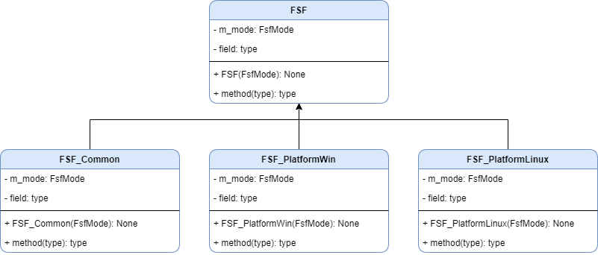

FSF Base Class
The FSF base class contains the following virtual public methods which must implemented in the derived classes.
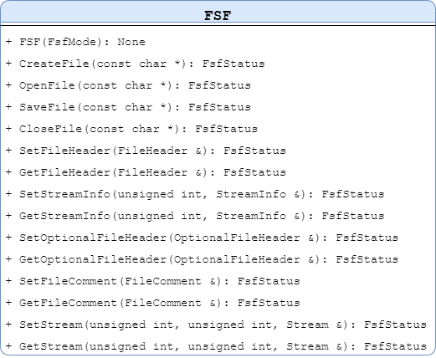

FSF Platform Agnostic Class
The initial platform agnostic implementation of the FSF file parser utility derived from the FSF base class uses the C++ standard file stream library fstream.
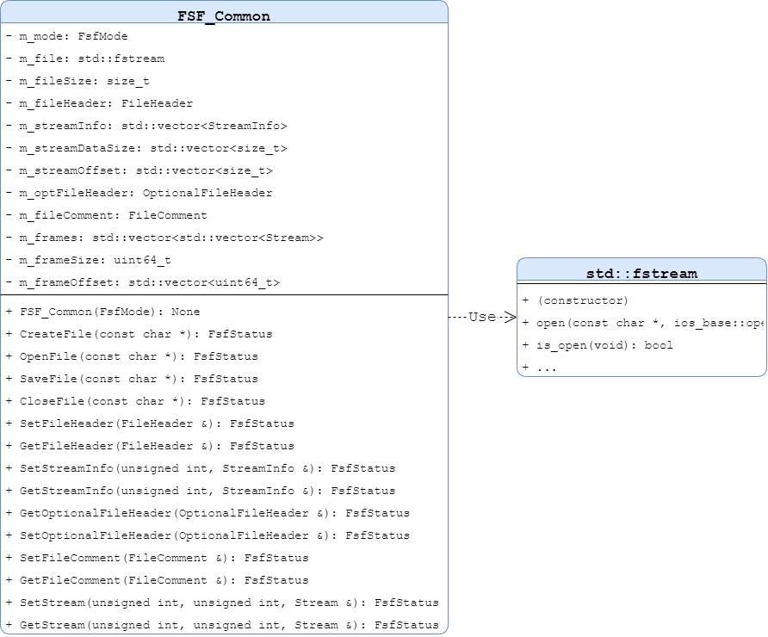

FSF Definitions Header
This section lists down all the macros, enumerated types and structures used throughout the FSF utility.

#ifndef FSF_DEFINITIONS_H
#define FSF_DEFINITIONS_H

#include <cstddef>
#include <cstdint>
#include <string>
#include <vector>

#define FSF_MAGIC_NUMBER 0x00465346 // "FSF"
#define FILE_FORMAT_MAJOR_VERSION 1
#define FILE_FORMAT_MINOR_VERSION 1
#define FILE_HEADER_SIZE sizeof(FileHeader)
#define STREAM_INFO_SIZE sizeof(StreamInfo)
#define STREAM_HEADER_SIZE sizeof(StreamHeader)
#define MAX_NFRAMES 16
#define MAX_NSTREAMS 16

/**
* @brief FSF file mode
*/
enum class FsfMode {
READ,
WRITE
};

/**
* @brief FSF file processing status
*/
enum class FsfStatus {
SUCCESS = 0,
FILE_NOT_OPEN,
FILE_NOT_CREATED,
FILE_DOESNOT_EXIST,
FILE_FORMAT_ERROR,
FILE_HEADER_ERROR,
INVALID_OPERATION,
FAILED = -1
};

/**
* @brief FSF file stream data types
*/
enum class StreamType {
STREAM_TYPE_UNKNOWN,
STREAM_TYPE_RAW,
STREAM_TYPE_ACTIVE_BR,
STREAM_TYPE_PHASE,
STREAM_TYPE_X,
STREAM_TYPE_Y,
STREAM_TYPE_DEPTH,
STREAM_TYPE_RGB,
STREAM_TYPE_RAW_NORM,
STREAM_TYPE_RAW_REAL,
STREAM_TYPE_RAW_IMAG,
STREAM_TYPE_RAW_REAL_FILT,
STREAM_TYPE_RAW_IMAG_FILT,
STREAM_TYPE_RADIAL,
STREAM_TYPE_RADIAL_FILT,
STREAM_TYPE_COMMON_MODE,
STREAM_TYPE_CONF,
STREAM_TYPE_VARIANCE,
STREAM_TYPE_REFLECTIVITY
};

struct FileHeader {
uint32_t HeaderSize;
uint32_t MagicNumber;
uint16_t FileFormatMajorVersion;
uint16_t FileFormatMinorVersion;
uint32_t FileHeaderSize;
uint32_t StreamInfoSize;
uint32_t StreamHeaderSize;
uint32_t OptionalFileHdrSize;
uint32_t FileCommentSize;
uint64_t FrameOffsetInfoLoc;
uint32_t nFrames;
uint32_t nStreams;
};

struct StreamInfo {
uint32_t SystemID;
uint32_t StreamType;
uint32_t ChannelFormat;
uint32_t BytesPerPixel;
uint32_t nRowsPerStream;
uint32_t nColsPerStream;
uint32_t OptionalStreamHdrSize;
uint32_t StreamCommentSize;
uint32_t CompressionScheme;
};

typedef std::string OptionalFileHeader;

typedef std::string FileComment;

struct StreamHeader {
uint32_t TimeStamp;
uint32_t CompressedStreamSize;
};

typedef std::string OptionalStreamHeader;

typedef std::string StreamComment;

typedef std::vector<uint8_t> StreamData;

struct Stream {
StreamHeader streamHeader;
OptionalStreamHeader optionalStreamHeader;
StreamComment streamComment;
StreamData streamData;
};

#endif // FSF_DEFINITIONS_H

High Level Data Architecture

Enumerated Types

FsfMode
The constructor argument type for creating FSF class objects.
Fsfmode | Description
READ | This value must be passed to the FSF class constructor for FSF objects used for reading from FSF files.
WRITE | This value must be passed to the FSF class constructor for FSF objects used for writing to FSF files.

FsfStatus
The return status of FSF API calls.
FsfStatus | Description
SUCCESS | Indicates successful API operation.
FILE_NOT_OPEN | Indicates the FSF file is not opened for reading or writing.
FILE_NOT_CREATED | Indicates the FSF file is not created on WRITE mode.
FILE_DOESNOT_EXIST | Indicates the FSF file to read does not exist.
FILE_FORMAT_ERROR | Indicates the opened file is not a valid FSF file.
FILE_HEADER_ERROR | Indicates an invalid file header is detected which prevents further API operation.
INVALID_OPERATION | Indicates invalid use of the FSF API. See API descriptions.
FAILED | Indicates generic API failure. See API descriptions.

StreamType
<TODO>

Data Structures
The figure below shows the detailed structure of the contents of an FSF file. Such format is stream type agnostic. This means that the format remains the same whether the stored stream data bytes is a stream of float, signed, or raw data byte values. The FSF data structures are patterned closely from this format.
For reference, whenever size is mentioned in this section, it refers to the number of bytes in the referred object.

FileHeader
Data structure for the file header.
FileHeader | Description
HeaderSize | The size of the FileHeader structure plus the size of the StreamInfo structure multiplied by the number of streams.
MagicNumber | The hexadecimal representation of the string “FSF” which is 0x00465346.
FileFormatMajorVersion | File format major revision number.
FileFormatMinorVersion | File format minor revision number.
FileHeaderSize | The size of the FileHeader structure.
StreamInfoSize | The size of the StreamInfo structure.
StreamHeaderSize | The size of the StreamHeader structure.
OptionalFileHdrSize | The size of the optional file header string.
FileCommentSize | The size of the file comment string.
FrameOffsetInfoLoc | The offset of the FrameOffsetInfo structure from the start of file.
nFrames | The number of frames that are contained within the FSF file.
nStreams | The number of streams within each frame in the FSF file.

StreamInfo
Data structure for the stream information.
StreamInfo | Description
SystemID | The combined processor and sensor identification.
StreamType | The types of streams e.g. Active Brightness, Phase, RAW, X, Y, Z.
ChannelFormat
BytesPerPixel
nRowsPerStream
nColsPerStream
OptionalStreamHdrSize
StreamCommentSize
CompressionScheme

StreamHeader
Data structure for stream header information.
StreamHeader | Description
TimeStamp | TODO
CompressedStreamSize | When no compression is applied this would be the actual stream size.

Stream
Stream data structure.
Stream | Description
streamHeader | Stream header time stamp and compressed stream size.
optionalStreamHeader
streamComment
streamData

API Definitions

Constructor
Prototype | FSF_Common(FsfMode mode);
Description | Create an FSF file utility object in the given mode.
Return | Pointer to the class object.

CreateFile()
Prototype | virtual FsfStatus CreateFile(const char *pFilename);
Description | This creates a new file with the specified file name for writing internally allocated FSF data structures. Internal structures are created through the corresponding Setxxx methods.
Return  SUCCESS  FILE_NOT_CREATED  INVALID_OPERATION | If able to successfully create a new file  If the file cannot be created with the given name  If API is invoked with the FSF file utility in READ mode

OpenFile()
Prototype | virtual FsfStatus OpenFile(const char *pFilename);
Description | The specified FSF file is opened for reading. Contents of the file can be read into allocated FSF data structures through the corresponding Getxxx methods.
Return  SUCCESS  FILE_DOESNOT_EXIST  FILE_FORMAT_ERROR  INVALID_OPERATION | If able to successfully open the file  If tried to open a file that does not exist  If the opened file is of invalid format  If API is invoked with the FSF file utility in WRITE mode

SaveFile()
Prototype | virtual FsfStatus SaveFile(const char *pFilename);
Description | This populates the created FSF file with the contents of the internally allocated FSF data structures.
Return  SUCCESS  FILE_HEADER_ERROR  FILE_NOT_OPEN  FAILED  INVALID_OPERATION | If able to successfully save FSF contents to file  If the file header structure is invalid  If file is not created before saving contents to file  If there are errors while saving structures into file  If API is invoked with the FSF file utility in READ mode

CloseFile()
Prototype | virtual FsfStatus CloseFile(void);
Description | Close the created/opened FSF file.
Return | Always returns successfully

SetFileHeader()
Prototype | virtual FsfStatus SetFileHeader(FileHeader &fileHeader);
Description | The internally allocated FileHeader structure is populate with the contents of the referenced FileHeader structure.
Return  SUCCESS  FILE_HEADER_ERROR  INVALID_OPERATION | If internal structures are updated successfully  If the file header structure is invalid  If API is invoked with the FSF file utility in READ mode

GetFileHeader()
Prototype | virtual FsfStatus GetFileHeader(FileHeader &fileHeader);
Description | The referenced FileHeader structure is populated with the file header information from the opened FSF file.
Return  SUCCESS  FILE_NOT_OPEN  FAILED  FILE_HEADER_ERROR  INVALID_OPERATION | If the file header is retrieved successfully  If tried to read file header with the file not open  If there are errors encountered while reading from file  If the retrieved file header is invalid  If API is invoked with the FSF file utility in WRITE mode

SetStreamInfo()
Prototype | virtual FsfStatus SetStreamInfo(const unsigned int streamIndex, StreamInfo &streamInfo);
Description | The internally allocated StreamInfo structure for the selected stream is populated with the contents of the referenced StreamInfo structure. The FileHeader must be set first prior to setting the StreamInfo structures.
Return  SUCCESS  FILE_HEADER_ERROR  FAILED  INVALID_OPERATION | If internal structures are updated successfully  If the file header structure is invalid  If the stream info structure index is invalid  If API is invoked with the FSF file utility in READ mode

GetStreamInfo()
Prototype | virtual FsfStatus GetStreamInfo(const unsigned int streamIndex, StreamInfo &streamInfo);
Description | The referenced StreamInfo structure is populated with the stream information for the selected stream from the opened FSF file. The FileHeader must be retrieved first prior to getting the stream information.
Return  SUCCESS  FILE_HEADER_ERROR  FILE_NOT_OPEN  FAILED  INVALID_OPERATION | If the stream info is retrieved successfully  If the file header structure is invalid  If tried to read stream info with the file not open  If there are errors encountered while reading from file or the stream info structure index is invalid  If API is invoked with the FSF file utility in WRITE mode

SetOptionalFileHeader()
Prototype | virtual FsfStatus SetOptionalFileHeader(OptionalFileHeader &optFileHeader);
Description | If the OptionalStreamHdrSize in the FileHeader is non-zero, a buffer enough to hold the OptionalFileHeader string is internally allocated. The allocated buffer is populated with the contents of the referenced OptionalFileHeader string. The FileHeader must be set first prior to setting the OptionalFileHeader string.
Return  SUCCESS  FILE_HEADER_ERROR  FAILED  INVALID_OPERATION | If internal structures are updated successfully  If the file header structure is invalid  If OptionalFileHdrSize is different with actual string size  If API is invoked with the FSF file utility in READ mode

GetOptionalFileHeader()
Prototype | virtual FsfStatus GetOptionalFileHeader(OptionalFileHeader &optFileHeader);
Description | If the OptionalStreamHdrSize in the FileHeader is non-zero, the referenced OptionalFileHeader string buffer is populated with the contents of the OptionalFileHeader string from the opened FSF file. The FileHeader must be retrieved first prior to getting the OptionalFileHeader string.
Return  SUCCESS  FILE_HEADER_ERROR  FILE_NOT_OPEN  FAILED  INVALID_OPERATION | If the optional file header is retrieved successfully  If the file header structure is invalid  If tried to read optional file header with the file not open  If there are errors encountered while reading from file  If API is invoked with the FSF file utility in WRITE mode

SetFileComment()
Prototype | virtual FsfStatus SetFileComment(FileComment &fileComment);
Description | If the FileCommentSize in the FileHeader is non-zero, a buffer enough to hold the FileComment string is internally allocated. The allocated buffer is populated with the contents of the referenced FileComment string. The FileHeader must be set first prior to setting the FileComment string.
Return  SUCCESS  FILE_HEADER_ERROR  FAILED  INVALID_OPERATION | If internal structures are updated successfully  If the file header structure is invalid  If FileCommentSize is different with actual string size  If API is invoked with the FSF file utility in READ mode

GetFileComment()
Prototype | virtual FsfStatus GetFileComment(FileComment &fileComment);
Description | If the FileCommentSize in the FileHeader is non-zero, the referenced FileComment string buffer is populated with the contents of the FileComment string from the opened FSF file. The FileHeader must be retrieved first prior to getting the FileComment string.
Return  SUCCESS  FILE_HEADER_ERROR  FILE_NOT_OPEN  FAILED  INVALID_OPERATION | If the file comment string is retrieved successfully  If the file header structure is invalid  If tried to read file comment with the file not open  If there are errors encountered while reading from file  If API is invoked with the FSF file utility in WRITE mode

SetStream()
Prototype | virtual FsfStatus SetStream(const unsigned int frameIndex, const unsigned int streamIndex, Stream &stream);
Description | The internally allocated Stream structure for the selected stream is populated with the contents of the referenced Stream structure. Stream structure are structures are internally allocated based on the the number of frames (nFrames) and the number of streams for each frame (nStreams). The FileHeader must be set first prior to setting the Stream structures.
Return  SUCCESS  FILE_HEADER_ERROR  FAILED  INVALID_OPERATION | If internal structures are updated successfully  If the file header structure is invalid  If stream index is invalid or the actual data/string sizes does not match those in the stream info  If API is invoked with the FSF file utility in READ mode

GetStream()
Prototype | virtual FsfStatus GetStream(const unsigned int frameIndex, const unsigned int streamIndex, Stream &stream);
Description | The referenced Stream structure is populated with the contents of the selected stream from the opened FSF file. The FileHeader must be retrieved first prior to retrieving streams.
Return  SUCCESS  FILE_HEADER_ERROR  FILE_NOT_OPEN  FAILED  INVALID_OPERATION | If the stream is retrieved successfully  If the file header structure is invalid  If tried to read stream contents with the file not open  If there are errors encountered while reading from file or the stream index is invalid  If API is invoked with the FSF file utility in WRITE mode

C Wrapper API Definitions
The FSF utility is written primarily in C++. For usability with C-based applications, wrapper APIs are provided. The API return types are Boolean values. Boolean true corresponds to successful API operations, false otherwise.

CreateFSFFile()
Prototype | bool CreateFSFFile(unsigned int *fileHandle, LPCSTR fileName, unsigned int nStreams, FSFSTREAMINFO *streamInfo, unsigned int optFileHdrSize, unsigned int fileCommSize, unsigned int nFrames);
Description | Create a new FSF file for writing stream data. It creates a new file with the given filename if it does not exist otherwise, the existing file contents are overwritten. The number of frames, number of streams within each frame, optional file header strings size, and file comment string size must be known prior to calling this API. Additionally, the stream information structure for all the streams must also be constructed beforehand.  The referenced file handle is updated with the handle to the created FSF file and internal FSF utility object.

ReadFSFFile()
Prototype | bool ReadFSFFile(LPCSTR fileName, unsigned int *fileHandle);
Description | Open an FSF file for reading. The given filename should be an existing file.  The referenced file handle is updated with the handle to the opened FSF file and internal FSF utility object.

ReadFileHeader()
Prototype | bool ReadFileHeader(unsigned int fileHandle, FSFFILEHEADER *fileHeader);
Description | Read the FSF file header. The referenced file header structure is updated with the file header information coming from the opened FSF file.

ReadStreamInfo()
Prototype | bool ReadStreamInfo(unsigned int fileHandle, unsigned int streamID, FSFSTREAMINFO *streamInfo);
Description | Read the FSF stream information. The referenced stream information structure is updated with the information for the given stream index coming from the opened FSF file.

WriteOptionalFileHdr()
Prototype | WriteOptionalFileHdr(unsigned int fileHandle, void *optionalFileHeader);
Description | Set the optional file header string for writing into an FSF file. The internal optional file header string buffer is updated with the contents of the referenced string.

ReadOptionalFileHdr()
Prototype | ReadOptionalFileHdr(unsigned int fileHandle, void *optionalFileHeader);
Description | Read the optional file header string from the opened FSF file. The referenced optional file header string buffer is updated with the optional file header information from the opened FSF file.

WriteFileComments ()
Prototype | WriteFileComments(unsigned int fileHandle, void *fileComments);
Description | Set the file comment string for writing into an FSF file. The internal file comment string buffer is updated with the contents of the referenced string.

ReadFileComments()
Prototype | ReadFileComments(unsigned int fileHandle, void *fileComments);
Description | Read the file comment string from the opened FSF file. The referenced file comment string buffer is updated with the file comment information from the opened FSF file.

WriteStream()
Prototype | bool WriteStream(unsigned int fileHandle, unsigned int frameID, unsigned int streamID, unsigned int timeStampInmsecs, void *optStreamHdr, void *comments, void *frameData);
Description | Set the stream information for the given frame and stream ID. The internal stream structure along with the buffer for the stream data, optional stream header information, and stream comment are updated with the contents of the respective referenced buffers.

ReadStream()
Prototype | bool ReadStream(unsigned int fileHandle, unsigned int frameID, unsigned int streamID, unsigned int *timeStampInmsecs, void *optStreamHdr, void *comments, void *frameData);
Description | Read the stream information for the given frame and stream ID. The referenced stream structure along with the referenced buffer for the stream data, optional stream header information, and stream comment are updated with the contents coming from the opened FSF file.

IsFileOpen()
Prototype | bool IsFileOpen(unsigned int fileHandle);
Description | Returns true if the file for a given file handle was created/opened successfully. False, otherwise.

Close()
Prototype | bool Close(unsigned int fileHandle);
Description | Closes the file (and the FSF utility object) referenced by the given file handle. If the filehandle is for an FSF file opened for writing, the buffers are saved into the file prior to closing the file.

GetWindowsErrorCode()
Prototype | unsigned int GetWindowsErrorCode(void);
Description | This API returns the error code (0 means SUCCESS) of the last API call that was made.

C Wrapper Comparison with Microsoft FSF C APIs
The following table summarizes the comparison of the FSF utility’s C wrappers with the existing Microsoft FSF utility APIs which was distributed as a windows library.

API | Microsoft C API Parameters | FSF - C Interface Parameters
CreateFSFFile | unsigned int* fileHandle | unsigned int *fileHandle
 | LPCSTR fileName | LPCSTR fileName
 | unsigned int nStreams | unsigned int nStreams
 | FSFSTREAMINFO* streamInfo | FSFSTREAMINFO *streamInfo
 | unsigned int optFileHdrSize | unsigned int optFileHdrSize
 | unsigned int fileCommSize | unsigned int fileCommSize
 | FILE_CREATION_FLAGS mode | unsigned int nFrames
ReadFSFFile | LPCSTR fileName | LPCSTR fileName
 | unsigned int* fileHandle | unsigned int *fileHandle
ReadFileHeader | unsigned int fileHandle | unsigned int fileHandle
 | FSFFILEHEADER* fileHeader | FSFFILEHEADER *fileHeader
ReadStreamInfo | unsigned int fileHandle | unsigned int fileHandle
 | unsigned int streamID | unsigned int streamID
 | FSFSTREAMINFO* streamInfo | FSFSTREAMINFO *streamInfo
WriteOptionalFileHdr | unsigned int fileHandle | unsigned int fileHandle
 | void* optionalFileHeader | void *optionalFileHeader
ReadOptionalFileHdr | unsigned int fileHandle | unsigned int fileHandle
 | void* optionalFileHeader | void *optionalFileHeader
WriteFileComments | unsigned int fileHandle | unsigned int fileHandle
 | void* fileComments | void *fileComments
ReadFileComments | unsigned int fileHandle | unsigned int fileHandle
 | void* fileComments | void *fileComments
WriteStream | unsigned int fileHandle | unsigned int fileHandle
 | unsigned int frameID | unsigned int frameID
 | unsigned int streamID | unsigned int streamID
 | unsigned int timeStampInmsecs | unsigned int timeStampInmsecs
 | void* optStreamHdr | void *optStreamHdr
 | void* comments | void *comments
 | void* frameData | void *frameData
ReadStream | unsigned int fileHandle | unsigned int fileHandle
 | unsigned int frameID | unsigned int frameID
 | unsigned int streamID | unsigned int streamID
 | unsigned int* timeStampInmsecs | unsigned int *timeStampInmsecs
 | void* optStreamHdr | void *optStreamHdr
 | void* comments | void *comments
 | void* frameData | void *frameData
IsFileOpen | unsigned int fileHandle | unsigned int fileHandle
Close | unsigned int fileHandle | unsigned int fileHandle
GetWindowsErrorCode | void | void

Example

FSF Template Writer
The following example shows how to use the FSF utility in writing stream data from the sensor.

...

void main(int argc, char *argv[])
{
FSF *pFSF = new FSF_Common { FsfMode::WRITE };

if (pFSF != NULL)
{
pFSF->CreateFile(“Write.fsf”);
pFSF->SetFileHeader(...);
pFSF->SetStreamInfo(...);
pFSF->SetStreamInfo(...);
pFSF-> SetOptionalFileHeader(...);
pFSF-> SetFileComment(...);
pFSF->SetStream(...);
pFSF->SetStream(...);
pFSF->SaveFile(...);
pFSF->CloseFile(...);
}
}

Limitations

Traceability to Requirements
Document reference ID & Description: <Typically requirement specification document.>

Serial No. | Reference document  Requirement (Section ID/Name) | Design document  (Section ID/Name)

Others

