# Study Watch Firmware Upgrade using Android App

This document lists down the steps to do Firmware Upgrade on Study Watch via BLE using Android App.

## Firmware Binary Download (ADI_project.zip)

Download the Firmware Binary (**ADI_project.zip**) from the below link and proceed to the next step.

<https://github.com/analogdevicesinc/study-watch-sdk/blob/main/bin_Firmware/ADI_project.zip>

## Firmware Upgrade with BLE Transport

1. For doing firmware upgrade via BLE using Android mobile application, press two buttons on DVT1 watch for 5 seconds. This takes it to the bootloader stage, and it waits for DFU with “an arrow icon”, as shown in Figure 1

Figure 1 DVT1 Watch in bootloader mode

1. The Watch will remain in Bootloader stage for 2 minutes, after which it gets auto cancelled and loads the application image, if present.
2. Move the ADI_project.zip file in package to your Android phone and open the “nRF connect” mobile application.

( For details, refer to <https://www.nordicsemi.com/Software-and-Tools/Development-Tools/nRF-Connect-for-mobile> to find out how to install the APP)

1. Scan for the BLE advertisement from the nRF Connect APP. When the APP finds the ADI_dfu, select the CONNECT button to establish the connection as in Figure 2

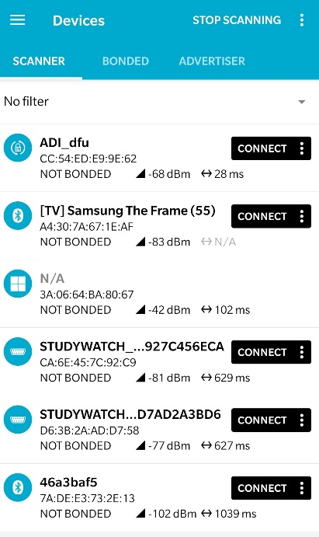

Figure 2 nRF Connect app Scan Results showing "ADI_dfu" device name

1. After connected to the DVT1 board, click the “DFU” icon as marked in Figure 3

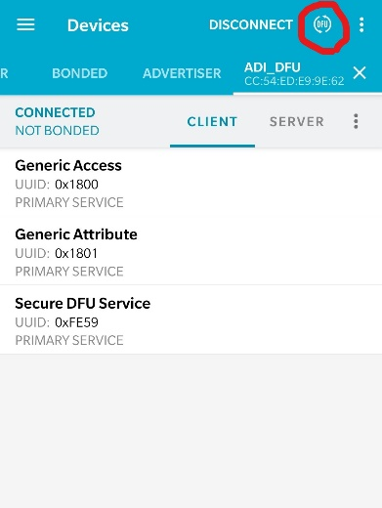

Figure 3 nRF Connect app DFU icon marked

1. A dialog box “Select file type” will pop up, make no change and click “OK” to find the upgrade .zip file from your phone. After the ADI_project.zip file is found, select it and then start the BLE upgrade starts

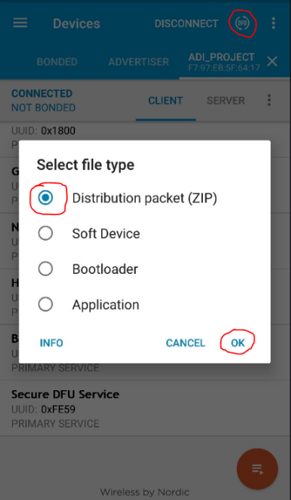

Figure 4 nRF Connect Upgrade zip package selection

1. The Graph showing the transfer details will appear. It is to be noted that, it will take a while to start and complete the transfer – 2-4 minutes. Please wait for the update to complete.

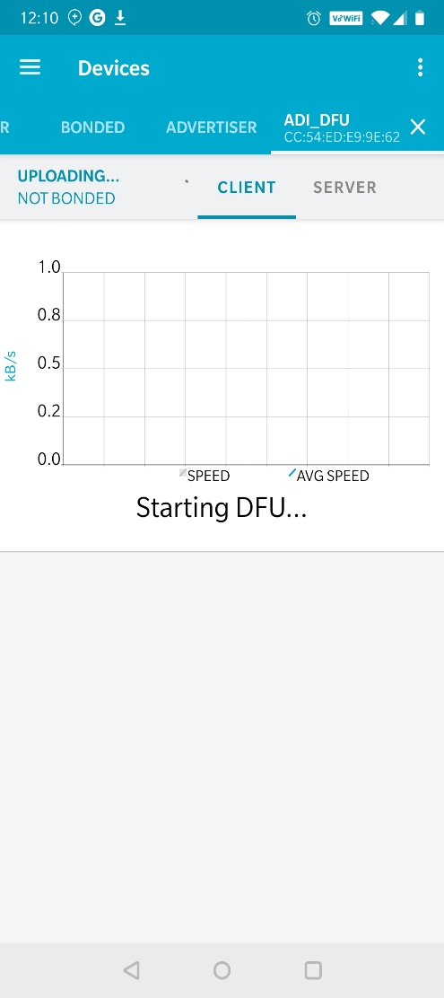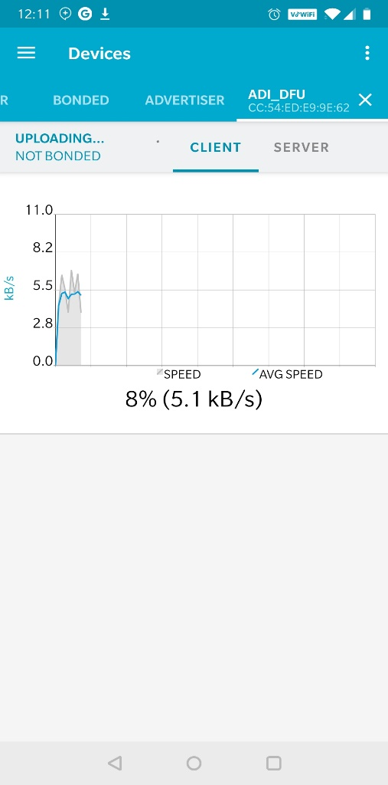

Figure 5 nRF Connect package upgrade status graph

1. After the upgrade process is completed, the APP will automatically close the window and go back to the previous Tab with “ADI_DFU” showing its not connected. This happens because the Watch isn’t in bootloader stage and has a different device name.

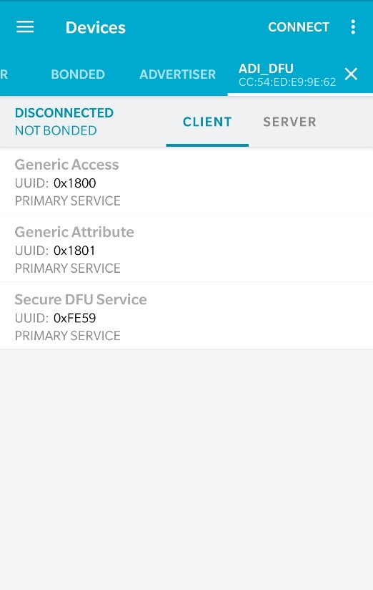

Figure 6 nRF Connect app, after upgrade is completed

1. If you want to test the firmware upgrade via BLE upgrade again, please return to step 1 above and repeat the process.