Python Script for PLL analysis

pll_tf.py

This script runs analysis on a dual loop PLL [it can also be used to analyse a PLL without any dual loop. Make gm <1e-12] whose parameters are defined in the script as shown in the snapshot shown below:
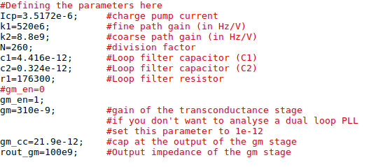

One you run the script, two windows will open up (the one on left hand side is the open loop response and the one on the right is the closed loop response)
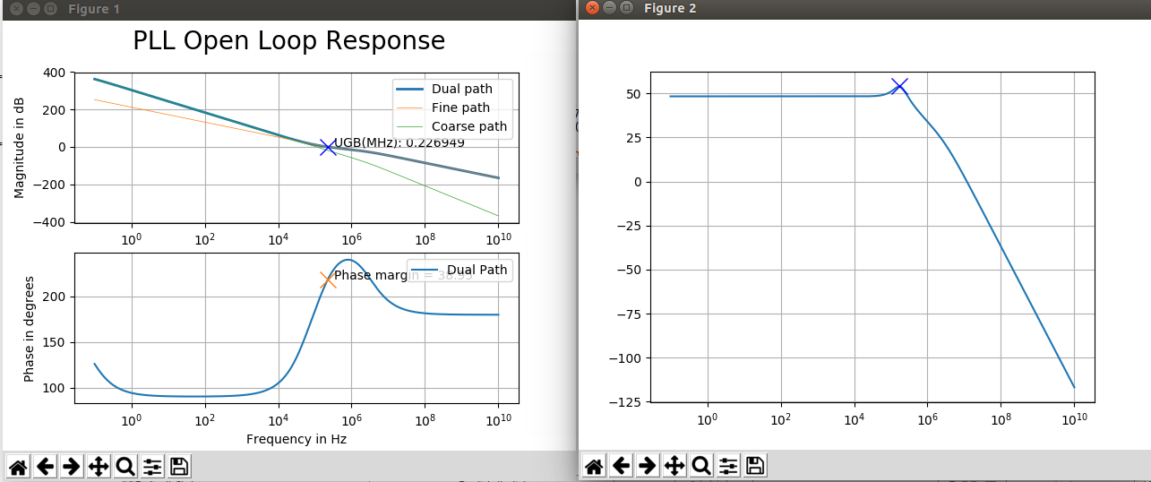
Also, in the terminal, you will find details about the phase margin (Note that phase margin will be in DEGREES)
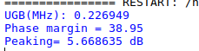

Code for pll_tf.py

from scipy import signal
import numpy as np
import matplotlib.pyplot as plt
from scipy.interpolate import interp1d
import math
#the function below adds two transfer fucntions
def add_tr(tf1,tf2):
len_tf1=len(tf1);
len_tf2=len(tf2);
sum_tf=np.zeros(max(len_tf1,len_tf2));
if len_tf1>len_tf2:
for i in range(0,len_tf1-len_tf2):
sum_tf[i]=tf1[i];
for i in range(len_tf1-len_tf2,len_tf1):
sum_tf[i]=tf1[i]+tf2[i-(len_tf1-len_tf2)]
elif len_tf2 > len_tf1:
for i in range(0,len_tf2-len_tf1):
sum_tf[i]=tf2[i];
for i in range(len_tf2-len_tf1,len_tf2):
sum_tf[i]=tf2[i]+tf1[i-(len_tf2-len_tf1)]
else:
for i in range(0,len_tf1):
sum_tf[i]=tf1[i]+tf2[i];
return sum_tf;

#Defining the parameters here
Icp=3.5172e-6; #charge pump current
k1=520e6; #fine path gain (in Hz/V)
k2=8.8e9; #coarse path gain (in Hz/V)
N=260; #division factor
c1=4.416e-12; #Loop filter capacitor (C1)
c2=0.324e-12; #Loop filter capacitor (C2)
r1=176300; #Loop filter resistor
#gm_en=0
gm_en=1;
gm=310e-9; #gain of the transconductance stage
#if you don't want to analyse a dual loop PLL
#set this parameter to 1e-12
gm_cc=21.9e-12; #cap at the output of the gm stage
rout_gm=100e9; #Output impedance of the gm stage

pi=3.141592653589793
f_vec=np.logspace(-1,10,1000); #run the sweep from 0.1Hz to 10GHz
w_vec=2*pi*f_vec; #convert the corresponding f_vec into its w_vec equivalent
#convert the VCO gains into rads/s-V
k1=k1*2*pi;
k2=k2*2*pi;

#calculaye the various time constants
tau3=gm_cc*rout_gm;
tau1=r1*c1;
tau2=tau1*(c2/(c1+c2));

#define the low gain path transfer fucntion
num_fine=np.array([tau1,1])*Icp*k1;
den_fine=np.array([tau2,1,0,0])*2*pi*N*(c1+c2)

#define the numerator and denominator of GH(s)
num_gh=np.array([tau1*tau3*k1,(tau1+tau3)*k1,k1+(gm*rout_gm*k2)])*Icp;
den_gh=np.array([tau2*tau3,tau2+tau3,1,0,0])*2*pi*(c1+c2)*N;

#define the numerator and denomiantor of the fine loop
num_gh_fine=np.array([tau1,1])*Icp*k1;
den_gh_fine=np.array([tau2,1,0,0])*2*pi*(c1+c2)*N;
pll_fine_loop=signal.lti(num_gh_fine,den_gh_fine)

#define the numerator and denominator of the coarse loop
num_gh_coarse=gm*rout_gm*k2*Icp;
den_gh_coarse=np.array([tau2*tau3,tau2+tau3,1,0,0])*2*pi*(c1+c2)*N;
pll_coarse_loop=signal.lti(num_gh_coarse,den_gh_coarse);

#Create the PLL open loop transfer function using signal.lti
#signal.lti returns a continious time system object
pll_open_loop=signal.lti(num_gh,den_gh);

#Find the magnitude and phase response of the PLL
w,mag,phase=signal.bode(pll_open_loop,w_vec);
w,mag_fine,phase_fine=signal.bode(pll_fine_loop,w_vec);
w,mag_coarse,phase_coarse=signal.bode(pll_coarse_loop,w_vec)
#Use the intepolate function to make a function w_mag(p) which returns the frequency (in rads/s) corresponding to the point in the
#PLL open loop magnitude curve whose value is 'p' in dB
w_mag=interp1d(mag,w);
w_UGB=w_mag(0); #this finds the frequency(in rads/s) corresponding to UGB

#create two subplots corresponding to magnitude and phase
fig,ax=plt.subplots(nrows=2,ncols=1);
fig.suptitle('PLL Open Loop Response',fontsize=20)
#plot the magnitude response in the first sub-plot
ax_magPlot=plt.subplot(2,1,1);
plt.semilogx(f_vec,mag,linewidth=2,label='Dual path');
plt.legend(['Dual path response'])
plt.semilogx(f_vec,mag_fine,'-',label='Fine path',linewidth=0.5);
plt.legend(['Fine loop response']);
plt.semilogx(f_vec,mag_coarse,'-',label='Coarse path',linewidth=0.5);
plt.legend(['Coarse loop response'])
plt.grid()
plt.legend()
#add a 'x' marker at the UGB point
plt.semilogx(w_UGB/(2*pi),0,'bx',ms=12.5)
ax_magPlot.set_xlabel('Frequency in Hz')
ax_magPlot.set_ylabel('Magnitude in dB')
string_UGB='UGB(MHz): %f'%(w_UGB/(2*pi*1e6))
ax_magPlot.annotate(string_UGB,xy=(w_UGB/(2*pi),0),xytext=(1.5*w_UGB/(2*pi),0))
print string_UGB

ax_phasePlot=plt.subplot(2,1,2,sharex=ax_magPlot);
plt.semilogx(f_vec,phase,label='Dual Path');
ax_phasePlot.set_xlabel('Frequency in Hz')
ax_phasePlot.set_ylabel('Phase in degrees')
w_phase=interp1d(w,phase)
phase_at_UGB=w_phase(w_UGB)
plt.semilogx(w_UGB/(2*pi),phase_at_UGB,'x',ms=12.5)
plt.grid()
plt.legend()

if phase_at_UGB >=0 and phase_at_UGB <180:
phase_margin=180-phase_at_UGB
elif phase_at_UGB >=180 and phase_at_UGB < 360:
phase_margin=phase_at_UGB-180;
elif phase_at_UGB >=360 and phase_at_UGB <540:
phase_margin=540-phase_at_UGB
elif phase_at_UGB < 0:
phase_margin=phase_at_UGB+180
string_pm="Phase margin = %2.2f"%phase_margin
print string_pm
ax_phasePlot.annotate(string_pm,xy=(w_UGB/(2*pi),phase_at_UGB),xytext=(w_UGB*1.5/(2*pi),phase_at_UGB))

#now the closed loop part.
#forward path transfer function
num_g=num_gh;
den_g=den_gh/N; #den_gh is the denominator of the open loop transfer fucntion, which includes the multiplication by N
#feedback path transfer function
num_h=np.array([1.0])
den_h=np.array([N*1.0])
#the closed loop transfer function
num_pll_cltf=np.convolve(num_g,den_h);
den_pll_cltf=add_tr(np.convolve(den_h,den_g),np.convolve(num_g,num_h));
pll_cltf=signal.lti(num_pll_cltf,den_pll_cltf);
w,mag_cltf,phase_cltf=signal.bode(pll_cltf,w_vec)
plt.figure() #lets create a new plot
plt.semilogx(w/(2*pi),mag_cltf)
dc_value=20*(math.log(N,10));
peaking_in_dB=np.max(mag_cltf)-dc_value;
string_peaking="Peaking= %f dB"% peaking_in_dB
print(string_peaking)
w_peak=np.argmax(mag_cltf);
plt.plot(w[w_peak]/(2*pi),np.max(mag_cltf),'bx',ms=12.5)
#cltf_plot_ax.annotate(string_peaking,xy=(w_peak/(2*pi),np.max(mag_cltf)),xytext=((w_peak/(2*pi))*1.5,np.max(mag_cltf)))
plt.grid()
plt.show()

