eta



Tutorial TWIST MMC

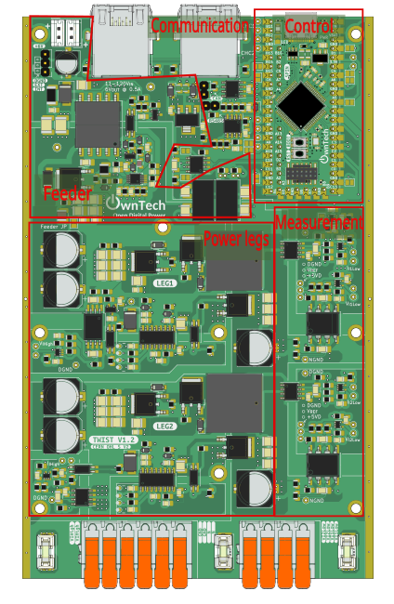

Table of contents
Introduction 3
Additional environment setup 3
MMC structure 3
Blinky MMC arm 4
Objectives 4
Expected results 10
Sorting algorithm 11
Individual MMC module test 11

Introduction
The goal of this tutorial is to use the OnwTech TWIST boards to build an MMC progressively. Please refer to the “Tutorial_Twist_Board” for learning how to use the Twist board before starting this new series of tutorials.

Additional environment setup

After the basic environment setup on “Tutorial_Twist_Board”, you will also need to:
- Install Git graph in VScode.



- Follow this tutorial to create a SSH key and add it to your GitHub account: https://medium.com/@techworldthink/a-beginners-guide-to-adding-ssh-key-to-github-windows-6a5de5396ba6

- If your PC user is not administrator, you will need to modify the file in which you will save the SSH key in Step1:

Enter file in which to save the key (C:\Users\admin/.ssh/id_rsa): C:\Users\your-user-name/.ssh/id_rsa

Then, you will probably have this warning when trying to follow Step 3 in the tutorial:
@@@@@@@@@@@@@@@@@@@@@@@@@@@@@@@@@@@@@@@@@@@@@@@@@@@@@@@@@@@
@ WARNING: UNPROTECTED PRIVATE KEY FILE! @
@@@@@@@@@@@@@@@@@@@@@@@@@@@@@@@@@@@@@@@@@@@@@@@@@@@@@@@@@@@
Permissions for 'C:\\Users\\your-user-name/.ssh/id_rsa' are too open.
It is required that your private key files are NOT accessible by others.

This should concern you if you share your PC with other people, if it is the case, you should get in touch with the IT team of the lab.

MMC structure

Write here about difference between the classical MMC structure and what we want to do in the CARROTS project.

Using Scope Mimicry library

Blinky MMC arm

Objectives
The goal of this tutorial is to do a first MMC arm without using power with the following structure:
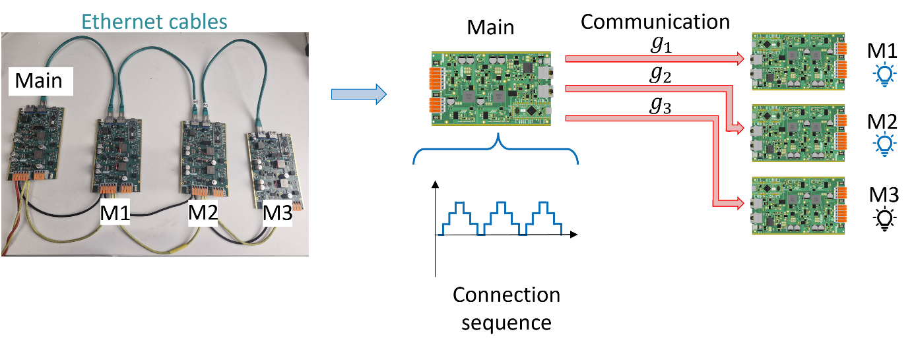
The main board serves as the central controller in the classical structure of the MMC. It will generate a connection sequence going from 0 to 3 that indicates how many modules should be connected. Then, it choses which modules to connect according to the preset preference order M1 → M2 → M3.
Then, the main board sends the connection commands g1, g2 and g3 via the Ethernet cables to the M1, M2 and M3 boards. If the board receives the command to be connected, it turns ON its SPIN board LED. If the board receives the command to be disconnected, it turns OFF its SPIN board LED.

Required Hardware

- 4 TWIST boards with SPIN
- DC Power Supply (48 V, 2 A)
- 3 Ethernet cables (RJ45)
- PC 64-bits (windows or linux)

Required Software

- Git
- Visual Studio Code with PlatformIO

Pull the project in VScode from GitHub

First, we need to load the Blinky MMC arm code from the “MMC_merged” branch in https://github.com/Ayoub-Farah/Hackathon_toulouse/ .
- Open Git graph window in VScode by clicking in the button marked in red:
- In the Git graph window, select the icon and to set the Remote Configurations compatible to the remote repository you want to pull from.
- Click on Add Remote and add a new remote repository called hackathon with Fetch URL and Push URL equal to https://github.com/Ayoub-Farah/Hackathon_toulouse
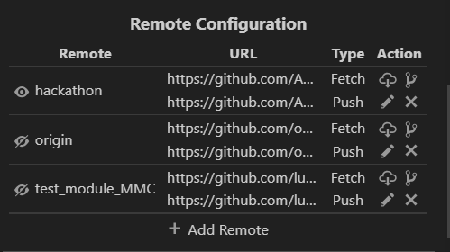
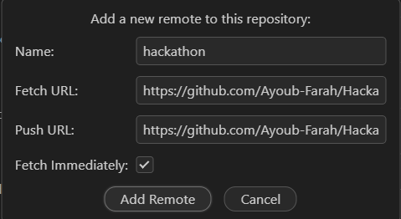
- In Git Graph window, click right on the branch and checkout to this branch keeping the same name for the local branch. In this tutorial it is the MMC_merged branch.
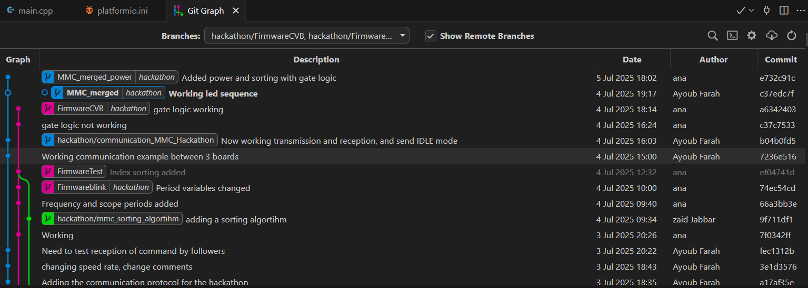
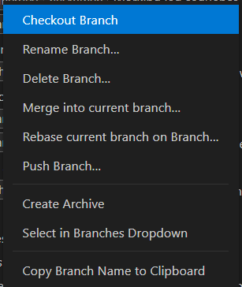
- Now you have the good code to execute the Blinky MMC arm in your VScode.

Code explanation
- Starting by the setup_routine function, it configures the peripherals and main loop_functions:
It first configures the SPIN LED by using a function coded in Low Level.
config_led_LL(); // Configure the LED pin in Low Level
Then, it sets the TWIST board to Buck mode, declares the background, communication and critical tasks and starts them. The critical task has a frequency of 10 kHz.
After that, it configures the communication protocol used by informing the transmitted and reception buffer variables, the function that gives the actions of the board when it receives a message and the transmission speed.
communication.rs485.configure(buffer_tx, buffer_rx, sizeof(buffer_rx),
reception_function,
SPEED_20M); // custom configuration for RS485
Finally, it configures a some scope channels for the master to acquire the connection sequence generated “N_u” and the connection signal for each module “g1”, “g2” and “g3”.
- Continuing to the loop_communication_task function, it makes the main board change between the IDLE and POWER modes, and enables scope data triggering and recording according to the pressed key in the keyboard.
IDLE mode is equivalent to key “i” and POWER mode is equivalent to key “p”.
Data trigger becomes equal to true when the key ‘a’ is pressed, setting the starting time of data acquisition. It should be pressed during POWER mode.
bool a_trigger()
{
return enable_acq;
}
The data recording function dump_scope_datas stores the acquired data in both csv and text format in the folder “Data_records” within “src” when the key “r” is pressed. It happens only in IDLE mode.
void dump_scope_datas(ScopeMimicry &scope)
{
uint8_t *buffer = scope.get_buffer();
/* We divide by 4 (4 bytes per float data) */
uint16_t buffer_size = scope.get_buffer_size() >> 2;
printk("begin record\n");
printk("#");
for (uint16_t k = 0; k < scope.get_nb_channel(); k++)
{
printk("%s,", scope.get_channel_name(k));
}
printk("\n");
printk("# %d\n", scope.get_final_idx());
for (uint16_t k = 0; k < buffer_size; k++)
{
printk("%08x\n", *((uint32_t *)buffer + k));
task.suspendBackgroundUs(100);
}
printk("end record\n");
}
- Next, the loop_background_task function makes the LED toggle or turn off according if it is in IDLE or POWER mode and it prints some variables values from the control part.
- Finally, the loop_critical_task function contains the whole communication and control logic.
If the board is the Main (module_ID == MMC_LEAD):
In POWER mode, the control part generates the connection sequence using the order of variable seq_u = {1, 2, 3, 2, 1, 0}. The sequence has a certain period sw_period that regulates the width of the staircase step.
if (sw_timer == sw_period)
{
if (counter_seq >= 6)
{
counter_seq = 0;
}
number_of_connected_submodules_upper_arm = (float)seq_u[counter_seq]; // recuperate as float for scope
counter_seq++;
sw_timer = 0;
}
sw_timer++;

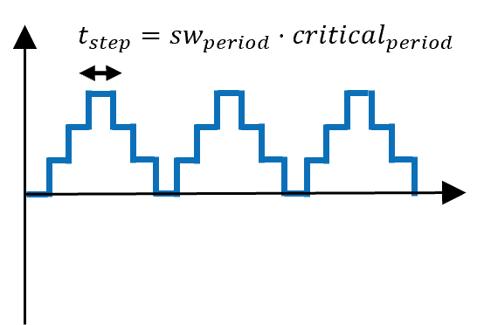
After that, the connection variables are modified to 0 or 1 according to the connection priority M1→M2→M3.
if (number_of_connected_submodules_upper_arm == 0)
{
g[0] = 0; // g[0] -> M1
g[1] = 0; // g[1] -> M2
g[2] = 0; // g[2] -> M3
}
if (number_of_connected_submodules_upper_arm == 1)
{
g[0] = 1;
g[1] = 0;
g[2] = 0;
}
if (number_of_connected_submodules_upper_arm == 2)
{
g[0] = 1;
g[1] = 1;
g[2] = 0;
}
if (number_of_connected_submodules_upper_arm == 3)
{
g[0] = 1;
g[1] = 1;
g[2] = 1;
}

g_u_1 = (float)g[0]; // recuperate as float for scope
g_u_2 = (float)g[1]; // recuperate as float for scope
g_u_3 = (float)g[2]; // recuperate as float for scope

And the scope acquires data according to a certain period equal to $t_{acq}=scope_{period}⋅critical_{period}$.
if (scope_timer == scope_period)
{
scope.acquire();
scope_timer = 0;
}
scope_timer++;
In terms of communication, the main board saves in the structure dataTX_mmc:
- The commands corresponding to each module.
- Its own ID to identify from who the message is coming.
- Status saying if it is in POWER mode = 1 or in IDLE mode = 0.
And then starts the communication to send these information to the modules boards.
SET_SIGNAL(dataTX_mmc.command, MMC_SM1, g[0]);
SET_SIGNAL(dataTX_mmc.command, MMC_SM2, g[1]);
SET_SIGNAL(dataTX_mmc.command, MMC_SM3, g[2]);

dataTX_mmc.ID = module_ID;
memcpy(buffer_tx, &dataTX_mmc, sizeof(dataTX_mmc));
dataTX_mmc.status = 1;
communication.rs485.startTransmission();
We can see that the dataTX_mmc and dataRX_mmc structures have in its definition one more information to store the capacitor voltage of the modules.

struct MMC_frame
{
uint8_t command;
float32_t Capacitor_Voltage;
uint8_t status;
uint8_t ID;
} __packed;

If it enter IDLE mode, the Main sends an IDLE flag to all modules to enter IDLE mode as well via the status information.
else if (mode == IDLEMODE)
{
/* Made to send IDLE flag only once */
if (!send_idle)
{
dataTX_mmc.ID = module_ID;
dataTX_mmc.status = 0;
memcpy(buffer_tx, &dataTX_mmc, sizeof(dataTX_mmc));
communication.rs485.startTransmission();
send_idle = true; // Set the flag to send idle command
}
}
In the reception_function we can see that the main board receives an artificial information of capacitor_voltage from the modules and stores it in a the vector MMC_capacitor_voltage. The capacitor_voltage information will be later substituted by the measure of the capacitor voltage acquired by the board.
If the board is a module (module_ID == MMC_SMx):
Analysing reception_function, it receives the information from the other boards and:
- Verify if the sender is the main if (dataRX_mmc.ID == MMC_LEAD):
  - Stores the command signal in module_comand.
  - Changes to POWER mode or IDLE mode according to the main board status.
- Verify if it is the next one in line to send the next message if ((dataRX_mmc.ID == module_ID - 1)):
  - Updates the transmission data structure for its own values of ID and capacitor voltage.
  - And then starts the communication to send these information to the other boards only if in POWER mode.
if (dataRX_mmc.ID == MMC_LEAD)
{
/* retrievig command from lead message*/
module_comand = GET_SIGNAL(dataRX_mmc.command, module_ID);
/* retrieving status */
if (dataRX_mmc.status == 1)
{
mode = POWERMODE;
}
else
{
mode = IDLEMODE;
}
}

/* The board following the ID of the one who sent will start sending
the next message */
if ((dataRX_mmc.ID == module_ID - 1))
{
dataTX_mmc = dataRX_mmc; // Copy the received data to the transmission data
dataTX_mmc.ID = module_ID;
dataTX_mmc.Capacitor_Voltage = MMC_voltage; /* TODO :uncomment when we get the voltage */
if (mode == POWERMODE)
{
memcpy(buffer_tx, &dataTX_mmc, sizeof(dataTX_mmc));
communication.rs485.startTransmission();
}
}
Observe that the sending order goes as follows:

- Main
- SM3
- SM2
- SM1

This happens since the IDs are defined as:
#define MMC_LEAD 0
#define MMC_SM1 1
#define MMC_SM2 2
#define MMC_SM3 3

In the critical function, while in POWER mode a module board:
- Turns ON its SPIN LED if it is commanded to be connected by the Main (module_command = 1)
- Turns OFF its SPIN LED if it is commanded to be disconnected (module_command =0).
else
{
if (module_comand != module_command_past)
{
change_state_command = true; // Set the flag to change the state
}

if (module_comand)
{
if (change_state_command)
{
Led_turnON_LL();
change_state_command = false; // Reset the flag
}
}
else
{
if (change_state_command)
{
Led_turnOFF_LL();
change_state_command = false; // Reset the flag
}
}
}
module_command_past = module_comand; // Update the past command

Hardware setup
In terms of hardware, you will connect the 4 boards as in the image:
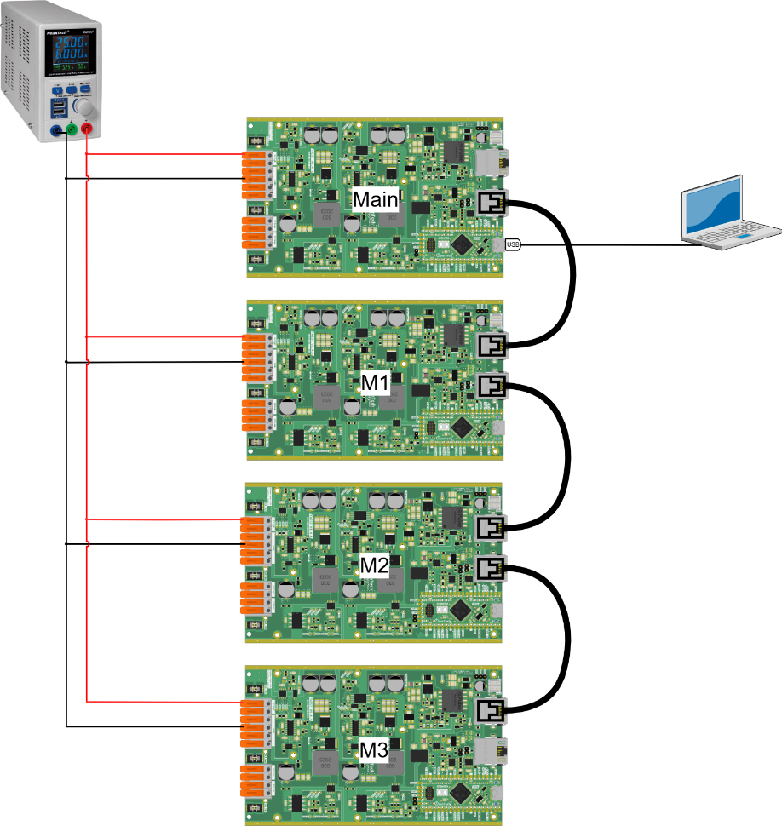
You have to upload in each board the main.ccp code changing the variable module_ID to MMC_LEAD, MMC_SM1, MMC_SM2 or MMC_SM3 according to the module function.

/* --------------USER VARIABLES DECLARATIONS------------------- */

/* TODO : Define module_ID depending on the ID of the board */
uint8_t module_ID = MMC_SM1; // The ID of the module, can be set to MMC_LEAD or any other SMx

After making the connections and connecting the PC to the main with the USB-C cable, you should have something like this:

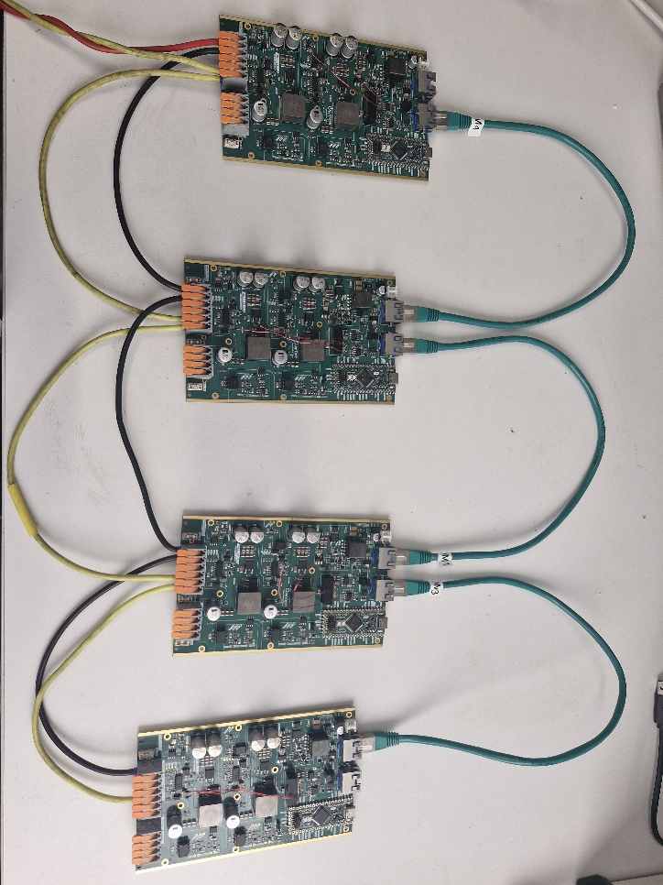
We connect the boards in series to and set the power supply to 15 V in order to power their SPIN boards.

Executing the tutorial
After uploading the code to all three boards, open the serial monitor using the icon while connected with the master, as shown in the hardware setup.
- Press h to display the help menu.
- The main and M1, M2 and M3 boards starts in IDLE mode.
- Turn on the power supply around 15 V to power the 4 SPIN boards.
- Press p to switch to POWER mode and the modules LEDs will start to light up and off according to the connection sequence.
Return to step 3 to execute it again
- Turn off the power supply.
- Press i to switch to IDLE mode and stop the arm operation.
While in POWER mode, you should expect a result like this:
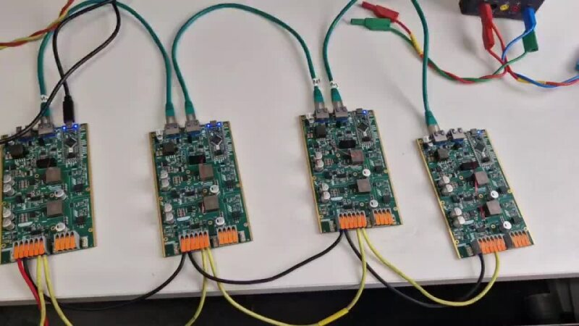

Sorting algorithm

Individual MMC module test

