eta



Tutorial TWIST-SPIN board

Communications

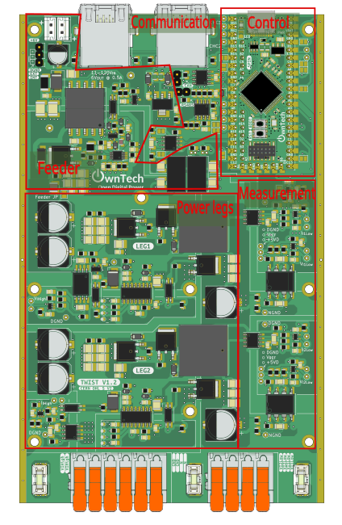

Table of contents
Introduction 3
Additional environment setup 3
Communication test 4
Objectives 4
Introduction to RS485 4
Introduction to CAN 6
Introduction to Analog 6
Required Hardware 6
Required Software 7
Get tutorial code from VScode 7
Code explanation 7
CAN communication 8
Analog communication 8
Sync communication 9
RS485 communication 9
Hardware setup 12
Executing the tutorial 12

Introduction
The goal of this tutorial is to start using the OnwTech TWIST boards with communication protocols. Please refer to the “Tutorial_Twist_Board” for learning how to use the Twist board before starting this new series of tutorials.

Additional environment setup

This is not mandatory but it will help you to push or pull from a remote repository if you need to modify anything in these tutorials.

After the basic environment setup on “Tutorial_Twist_Board”, you will also need to:
- Install Git graph in VScode.

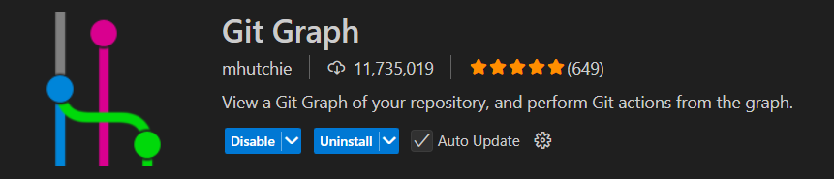

- Follow this tutorial to create a SSH key and add it to your GitHub account: https://medium.com/@techworldthink/a-beginners-guide-to-adding-ssh-key-to-github-windows-6a5de5396ba6

- If your PC user is not administrator, you will need to modify the file in which you will save the SSH key in Step1:

Enter file in which to save the key (C:\Users\admin/.ssh/id_rsa): C:\Users\your-user-name/.ssh/id_rsa

Then, you will probably have this warning when trying to follow Step 3 in the tutorial:
@@@@@@@@@@@@@@@@@@@@@@@@@@@@@@@@@@@@@@@@@@@@@@@@@@@@@@@@@@@
@ WARNING: UNPROTECTED PRIVATE KEY FILE! @
@@@@@@@@@@@@@@@@@@@@@@@@@@@@@@@@@@@@@@@@@@@@@@@@@@@@@@@@@@@
Permissions for 'C:\\Users\\your-user-name/.ssh/id_rsa' are too open.
It is required that your private key files are NOT accessible by others.

This should concern you if you share your PC with other people, if it is the case, you should get in touch with the IT team of the lab.

Communication test

Objectives
The goal of this tutorial is to do a first communication test using two boards to understand how the different communications types are used in the Twist board:
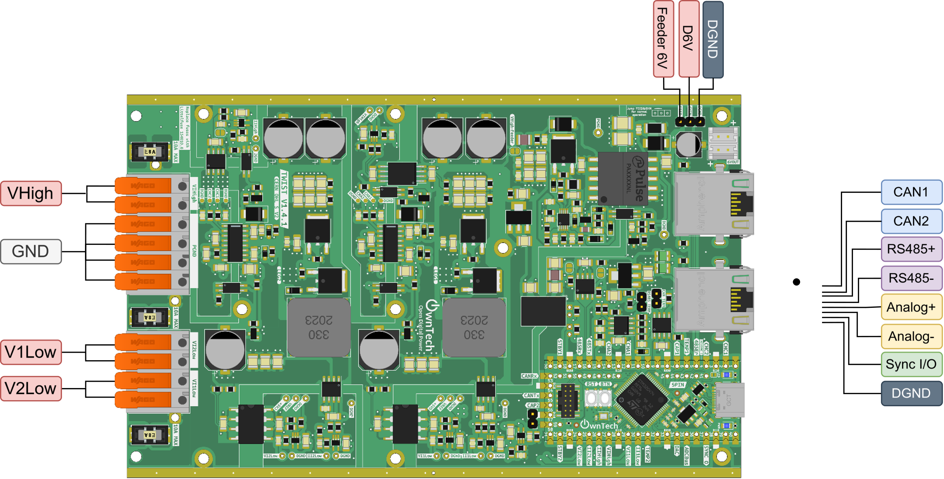
The different communications are:
- RS485
- CAN
- Analog
- Sync
In this first tutorial, two boards communicates via all three communication types plus Sync to verify if all communications are successful.

Introduction to RS485

RS-485 is a standard for serial communication that allows multiple devices to communicate over long distances using differential signaling on a twisted pair of wires.

In terms of speed, RS485 can go up to 20Mbits/s. This means that it would take 800 microseconds for 200 modules to exchange 10 bytes (80 bits) each at 20 Mbps
- A voltage or a current measurement takes about 12 bits for example

But what is a serial communication? And a differential signaling?

In serial communications a bit is sent every clocks period, such as in the schematic:
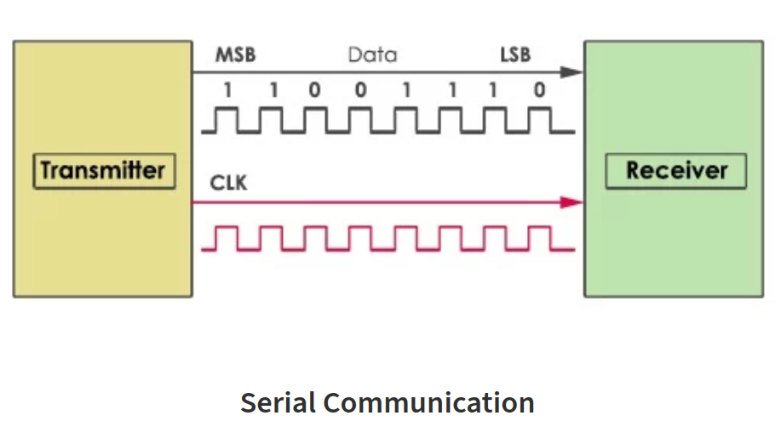
In opposition, in parallel communications a Data is sent multiple bits at once, each on its own wire, such as in the schematic:
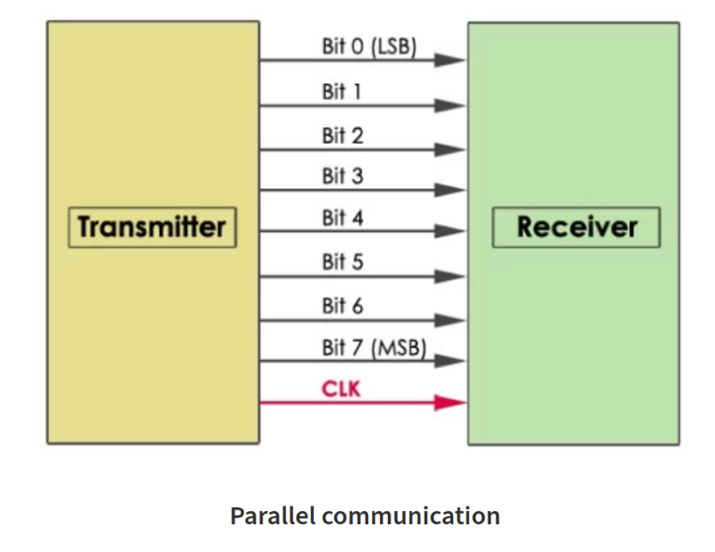

A single-ended signal is sent on one wire, measured against ground. In the other hand, a differential signal is sent on two wires, measured as the voltage difference between them. This makes it more resistant to noise.

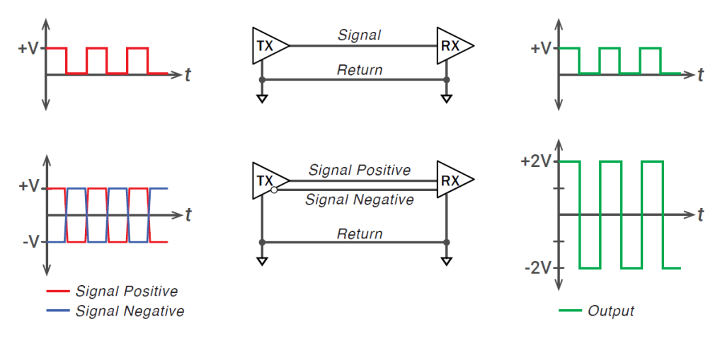

Introduction to CAN

CAN (Controller Area Network) is a robust serial communication protocol designed for reliable data exchange between microcontrollers and devices, especially in automotive and industrial systems.

In CAN protocol, all the modules (refered as nodes) are connected to a single communication bus.

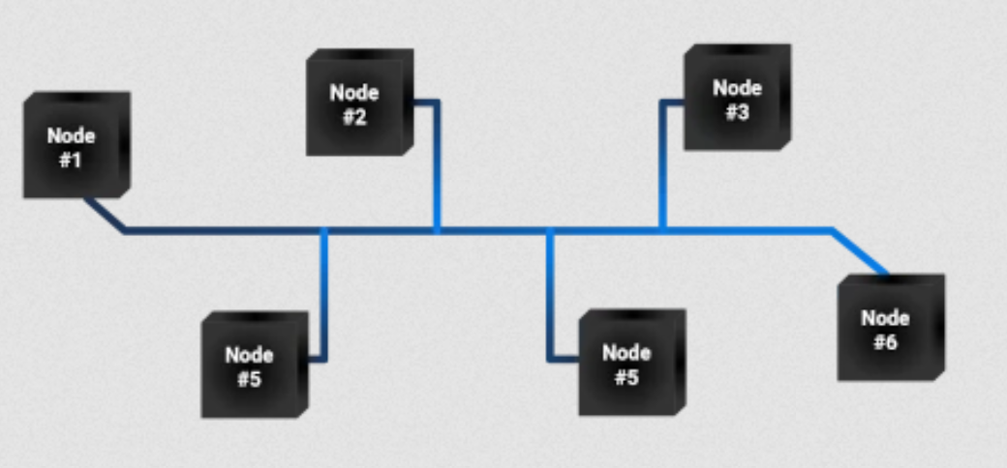

The difference between can and RS-485 is that in CAN there is no risk of data collision (i.e. multiples nodes communicating at the same time). The data collision is avoided by setting a communication priority: if two nodes talk at the same time, the one with the smallest ID (identifier) has the priority.

In terms of speed, CAN go up to 1Mbits/s but there has been an improved version of the CAN called the FD-CAN that can go to 8Mbits/s. So we can say that RS-485 communication is faster but in counterpart has a risk of data collision if compared to CAN communication.

Introduction to Analog

Analog (analogical communication) is a method of communication that sends or receives data using continuous signals, differently from RS485 and CAN signals that deals with digital discrete binary signals.

These continuous signals vary in amplitude, frequency and phase to represent data and can be, for example, currents, voltages, sound waves, etc. They are also well-defined at every time.

When we want to send a measurement via analog communication, the physical signal is converted into an analog signal by a transducer, such as the conversion of an acoustic wave into an electrical signal. The analog signal is going to be proportional to the physical signal it represents.

Analog communication depends of ADC analog-to-digital and DAC digital-to-analog converters to interface with digital systems.

Required Hardware

- 2 TWIST boards with SPIN
- 1 Ethernet cables (RJ45)
- 2 Electronic jumpers
- 2 Isolated alligator clips
- 2 Small banana cables
- PC 64-bits (windows or linux)

Required Software

- Git
- Visual Studio Code with PlatformIO

Get tutorial code from VScode

First, we need to load the Basic communication code from the OwnTech example repository version in https://github.com/analuhaas/examples
- In VScode, open the folder where you previously cloned OwnTech’s github.
- In platformio.ini file, substitute the owntech_examples variable link by https://github.com/analuhaas/examples.git
- Go to platform.io icon , go to Examples Twist under the Project Tasks tab and click on “Basic Communication”.
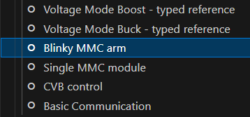
- Now you have the good code to execute the tutorial in your VScode.

Code explanation

First, in the variable setup the structure that is going to test is the communication is successful for all RS485, CAN, Analog and Sync is defined:
* This structure holds variables for testing RS485, Sync, analog measurements, and status information.
*/
typedef struct {
uint8_t test_RS485; /**< Variable for testing RS485 */
uint8_t test_Sync; /**< Variable for testing Sync */
uint16_t test_CAN; /**< Variable for testing the CAN Bus */
bool test_bool_CAN; /**< Boolean variable for testing the CAN Bus */
uint16_t analog_value_measure; /**< Analog measurement */
uint8_t id_and_status; /**< Status information */
} ConsigneStruct_t;

The explanation of the code will be separated according to the communication protocol.

CAN communication

The CAN communication is handled in the background loop. First its enables the CAN control and Broadcasting.

communication.can.setCtrlEnable(true);
communication.can.setBroadcastEnable(true);

Then, the master board will store the control reference sent by the slave via CAN and sends a start order to the slave device so it continues to communicate with the master via CAN.

if(master){
/* Use the following function receives a control reference over CAN */
CAN_received_value = communication.can.getCtrlReference();
/* Use the following functions to send a start or stop order over CAN */
communication.can.startSlaveDevice();
// communication.can.stopSlaveDevice();
spin.led.toggle();

The slave board verifies if it received a start or a stop order from the master. If it continues to receive a start order, it keeps sending its control reference to the master over CAN communication. The ctrl_slave_counter is updated each time the background loop is executed.

} else{
/* The following functions retrieve any start stop order sent over CAN */
CAN_received_start_stop = communication.can.getStartStopState();
if(CAN_received_start_stop){
spin.led.turnOn();
/* The following functions sends reference over CAN */
communication.can.setCtrlReference(CAN_control_reference);;
}
ctrl_slave_counter++;

}

Analog communication

In the setup_routine() function, the master board analog communication is initialized and configured to send the analog_value_ref value continuously.
communication.analog.init(); /* Initializes the analog communication */
communication.analog.setAnalogCommValue(analog_value_ref); /* Sends an analog value by default from the master at initialization */

And the analog communication is also started for the slave board.

communication.analog.init(); /* Initializes the analog communication */

The slave board measures the received message sent via analog communication and stores in the variable analog_value_receive that is latter sent back to the master via RS485 communication for successfulness verification.

meas_data = shield.sensors.getLatestValue(ANALOG_COMM);
if (meas_data != NO_VALUE)
analog_value_receive = (uint16_t)meas_data;

Sync communication

The communication synchronization is initialized in the setup_routine for both master and slave. With this configuration, the master sends a synchronization pulse to the slave in order to synchronize the boards timers.

communication.sync.initMaster(); /* start the synchronisation as master */

communication.sync.initSlave(); /* sets the sync as slave */

RS485 communication

The RS485 communication is used to check on all communications protocols by checking if the values on the structure ConsigneStruct_t sent by the slave to the master are equal to expected.

Its configuration for the master board shows that the communication structure sent and receives respectively is of type ConsigneStruct_t.

communication.rs485.configure(buffer_tx,
buffer_rx,
sizeof(ConsigneStruct_t),
master_reception_function,
SPEED_20M); // custom configuration for RS485

Its configuration for the slave board shows that the reception function is different than the one for the master.

communication.rs485.configure(buffer_tx,
buffer_rx,
sizeof(ConsigneStruct_t),
slave_reception_function,
SPEED_20M); // custom configuration for RS485

In RS485 communication, buffer_tx and buffer_rx are pointers to the transmitted buffer (tx_consigne) and pointer to the received buffer (rx_consigne), respectively.

uint8_t* buffer_tx = (uint8_t*)&tx_consigne;
uint8_t* buffer_rx =(uint8_t*)&rx_consigne;

The sent and received buffers tx_consigne and rx_consigne are of type ConsigneStruct_t.

ConsigneStruct_t tx_consigne;
ConsigneStruct_t rx_consigne;

The communication is first configured and then turned on in the setup_routine using the function:

communication.rs485.turnOnCommunication();

Then, the master defines the reference value to be sent to the slave in the transmission buffer tx_consigne and starts communication in the critical_loop. It sets the test of successfulness to start after 50 master critical periods (5 ms).

if(master){
/* writting rs485 value */
tx_consigne.test_RS485 = rs485_send;

counter_time++; /* Counts time to not start immediately */
if (counter_time > 50){
test_start = true; /* Starts the test after 50 periods */
}
communication.rs485.startTransmission();

When the slave receives the transmitted message, its reception function slave_reception_function() is activated. It configures its transmission buffer according to the received messages from each communication:
- CAN: it sends if the CAN communication is maintained
- RS485: it sends back the received reference value of 125 + a step of 25
- Sync: it sends the critical function periods counter
- Analog: it sends the measured received value from analog communication

and starts communication to send these back to the master.

void slave_reception_function(void)
{
tx_consigne = rx_consigne; /* Matches the buffers to send back information */
tx_consigne.test_bool_CAN = CAN_received_start_stop; /* Sends the CAN start-stop state */
tx_consigne.test_RS485 = rx_consigne.test_RS485 + slave_rs485_step; /* Sends the RS485 reference plus a certain value */
tx_consigne.test_Sync = ctrl_slave_counter; /* Sends the counter of the critical function*/
tx_consigne.analog_value_measure = analog_value_receive; /* Sends the analog value measured */

communication.rs485.startTransmission();
}

When the master receives the message, its reception function master_reception_function() is activated. It performs the tests to verify if the communications were successful:
- CAN: successful if the control reference sent by the master via CAN communication (CAN_control_reference) was sent back by the slave to the master via CAN communication (CAN_received_value).
- RS485: successful if the master receives the test_RS485 value it sent (125) + a step (25) added by the slave.
- Sync: sucessful if the control counter of the slave is sent to the master more than 5 times
- Analog: successful if the slave analog measure received by the master via RS485 is within 50 quantum of the original value sent by the master via analog communication.

void master_reception_function(void)
{
/* Receives the data from the slave converter */
analog_value_receive = rx_consigne.analog_value_measure; /* receives the analog value from slave */
rs485_receive = rx_consigne.test_RS485; /* receives the rs485 reference value from slave */
sync_receive = rx_consigne.test_Sync; /* Receives the counter of the critical task from the slave*/

if(test_start){
if (rs485_receive == rs485_send + slave_rs485_step){ /* The RS485 is good is the master receives its reference value plus the step of the slave */
RS485_success = true;
}
if (analog_value_receive - analog_value_ref > 50 || analog_value_receive - analog_value_ref > -50){ /* The analog is good if the value received by the master is within 50 quantum of the value sent by the master */
Analog_success = true;
}
if(CAN_received_value == CAN_control_reference){ /* The CAN is good if the master has received the expected reference value from the slave via the control */
Can_success = true;
}
if(sync_master_counter < 5 && rx_consigne.test_Sync > 10){ /* The sync is good if the master has received a counter of the slave critical function more than 5 times */
sync_master_counter++;
if(sync_master_counter == 5){
Sync_success = true;
}
}
}
}

Hardware setup

In terms of hardware, you will connect the 2 boards as in the image using Ethernet cables. You will also connect the second board to a 6 V power supply to feed the SPIN board during the tutorial.

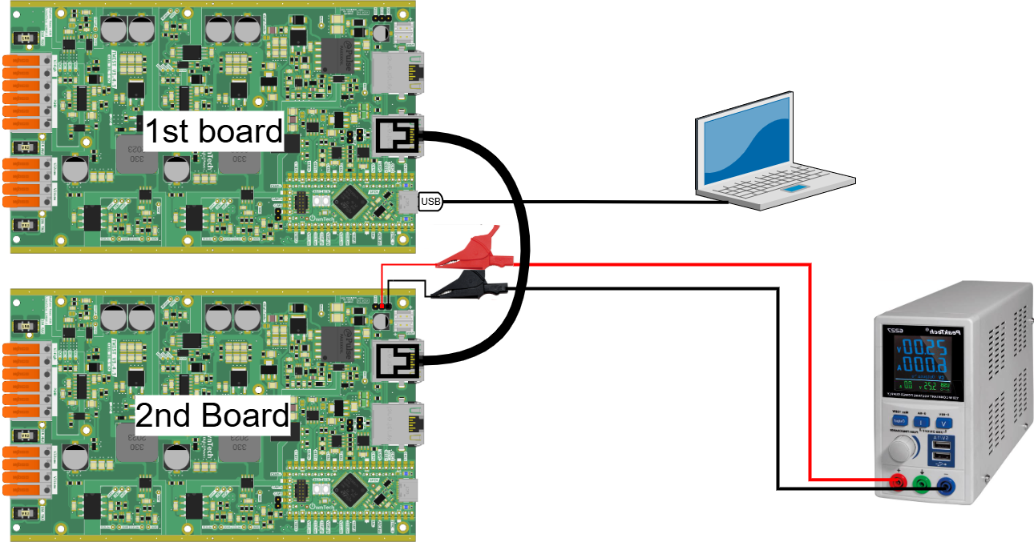

Executing the tutorial

First, you have to build and upload in each board the main.ccp code by changing the master variable to true before building and uploading to the first board and false before building and uploading to the second board.
After uploading the code to the two boards, execute the following steps to perform the tutorial:
- Turn on the power supply of the second board at 6 V.
- Open the serial monitor using the icon while connected with the first board via the USB-C cable.
- When finished, turn off the 6 V power supply and disconnect the USB-C cable.
If the tutorial is executed properly and the communication cables are well connected, you will have all communications to be succeeded as in the print:
