eta



Tutorial TWIST MMC

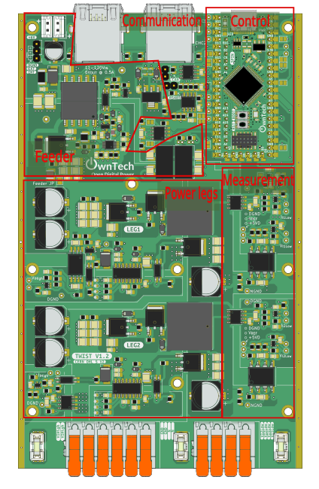

Table of contents
Introduction 3
Additional environment setup 3
MMC structure 3
MMC principle of operation 5
MMC control 7
Using Scope Mimicry library 9
Blinky MMC arm 10
Objectives 10
Required Hardware 10
Required Software 10
Pull the project in VScode from GitHub 10
Code explanation 12
Hardware setup 18
Executing the tutorial 19
Sorting algorithm (CVB) 21
Objectives 21
Required Hardware 22
Required Software 22
Pull the project in VScode from GitHub 22
Code explanation 24
Hardware setup 27
Executing the tutorial 28
Individual MMC module test 29
Objectives 29
Required Hardware 31
Required Software 31
Pull the project in VScode from GitHub 31
Code explanation 33
Hardware setup 35
Executing the tutorial 38

Introduction
The goal of this tutorial is to use the OnwTech TWIST boards to build an MMC progressively. Please refer to the “Tutorial_Twist_Board” for learning how to use the Twist board before starting this new series of tutorials.

Additional environment setup

After the basic environment setup on “Tutorial_Twist_Board”, you will also need to:
- Install Git graph in VScode.



- Follow this tutorial to create a SSH key and add it to your GitHub account: https://medium.com/@techworldthink/a-beginners-guide-to-adding-ssh-key-to-github-windows-6a5de5396ba6

- If your PC user is not administrator, you will need to modify the file in which you will save the SSH key in Step1:

Enter file in which to save the key (C:\Users\admin/.ssh/id_rsa): C:\Users\your-user-name/.ssh/id_rsa

Then, you will probably have this warning when trying to follow Step 3 in the tutorial:
@@@@@@@@@@@@@@@@@@@@@@@@@@@@@@@@@@@@@@@@@@@@@@@@@@@@@@@@@@@
@ WARNING: UNPROTECTED PRIVATE KEY FILE! @
@@@@@@@@@@@@@@@@@@@@@@@@@@@@@@@@@@@@@@@@@@@@@@@@@@@@@@@@@@@
Permissions for 'C:\\Users\\your-user-name/.ssh/id_rsa' are too open.
It is required that your private key files are NOT accessible by others.

This should concern you if you share your PC with other people, if it is the case, you should get in touch with the IT team of the lab.

MMC structure

The Modular Multilevel Converter structure is shown in the image below.
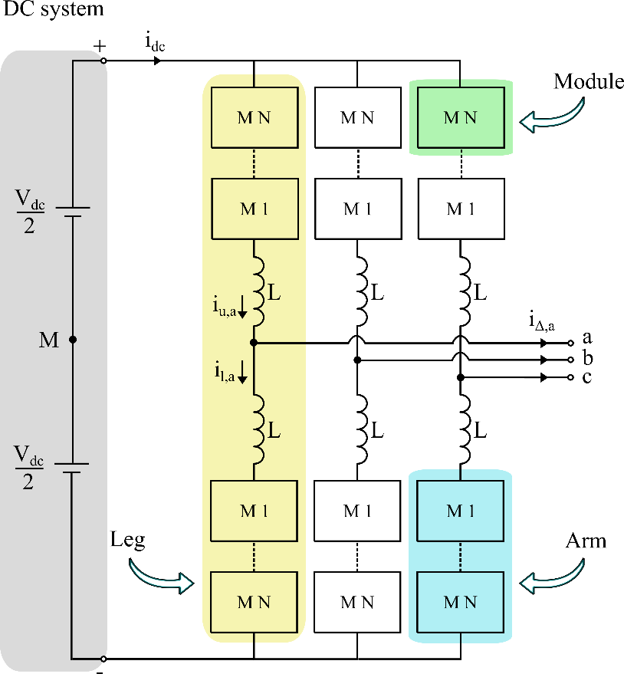

The DC-side of an MMC is composed of a DC-bus connected to the positive and negative terminals of the converter legs. The MMC is a three-phase converter topology and its AC-side is connected to the AC network or AC system using the terminals of each leg (a,b,c).

Each leg is composed two arms and the arms connected to the positive DC-side terminal are called upper arms (u), and the arms connected to the negative DC-side terminal are called lower arms (l). Each arm itself is composed of N modules (M) and an inductor (L). The arm inductor is connected in series with the modules to limit the circulating current that appears due to the instantaneous voltage difference between the arms.

A module is a basic DC–AC power conversion unit composed of low-voltage semiconductor devices, usually IGBTs or MOSFETs. The most commonly used submodule configurations are the Half-Bridge and Full-Bridge.

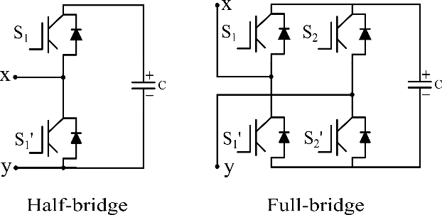

Depending on which of the switches are turned on, the module can be either connected to the arm or bypassed. When the module is connected to the arm, it inserts a $v_{SM}=v_{c}$ voltage into the arm equivalent to its internal capacitor voltage. When bypassed, it does not contribute to the arm voltage having $v_{SM}=0$. Additionally, in cases of fault, the module assumes a blocked state where both of its switches are turned off.

When connected to the arm, the arm current ($i_{u,a}, i_{l,a}$) passes into the module, charging or discharging its internal capacitor according to the current sign.

The modules states can be summarized with the image and table below.

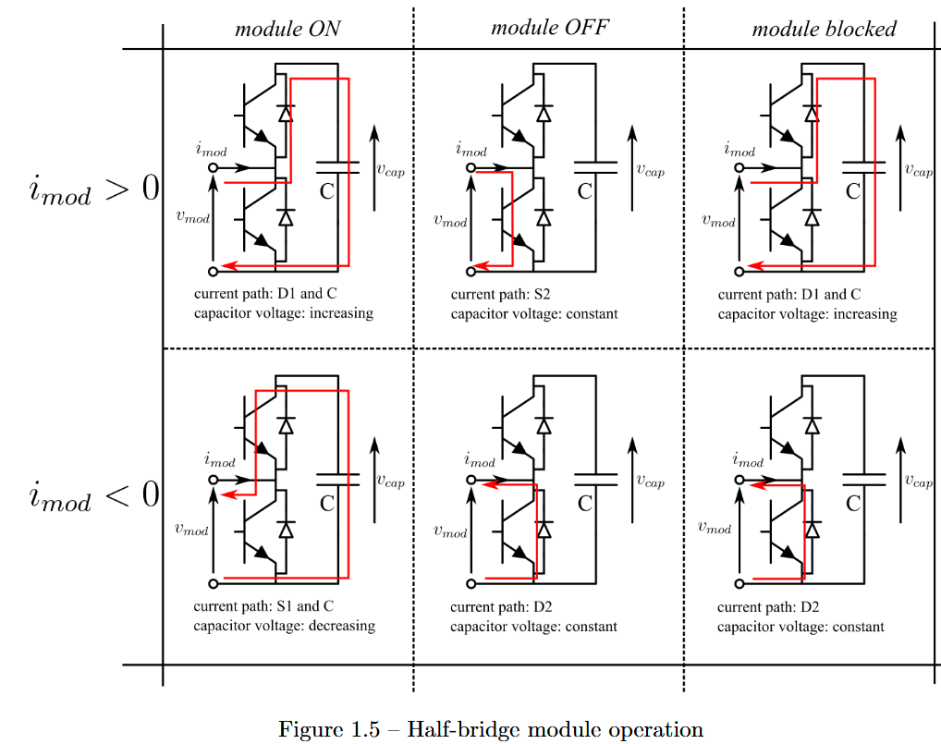

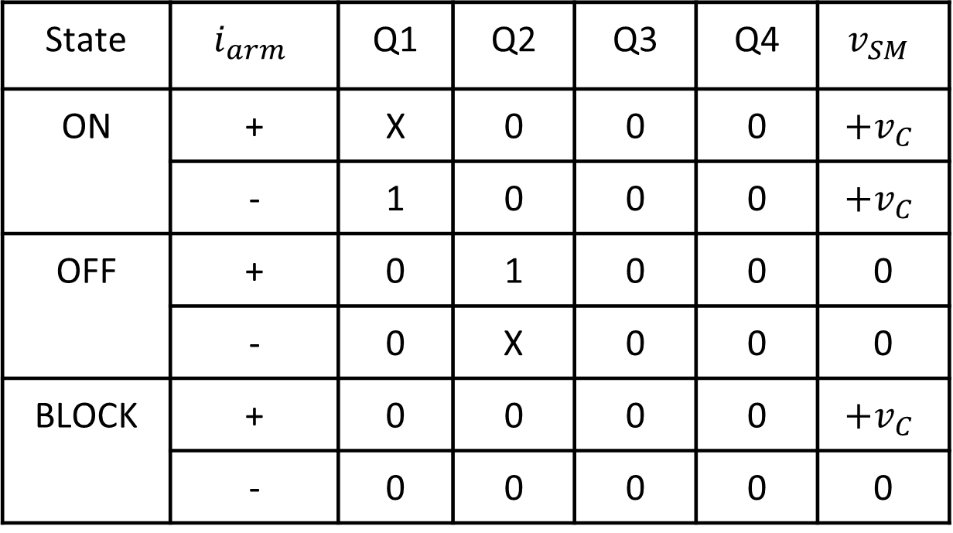

MMC principle of operation

In the MMC ideal operation, the DC-bus voltage is distributed between the modules capacitors. Therefore, all modules are ideally the same with identical capacitor voltage with a $v_{c}=\frac{V_{DC}}{N}$ mean level.

From this assumption, we can understand the MMC operation principle more easily analyzing the phase a upper arm taking $N=4$, i.e. the arms are composed of 4 modules.

The MMC arm works as a group of modules that you stack to build a certain wave form. Each module is a block that can be connected or disconnected to sum a voltage to the arm.
- All modules disconnected will lead to an arm voltage of $v_{u,a}=0$ .
- Connecting 1 module will lead to an arm voltage of $v_{u,a}=v_{c}$ .
- Connecting 2 modules will lead to an arm voltage of $v_{u,a}=2v_{c}$.
- Connecting 3 modules will lead to an arm voltage of $v_{u,a}=3v_{c}$.
- Connecting 4 modules will lead to an arm voltage of $v_{u,a}=4v_{c}$.

More generically, taking $N_{u,a}$ to be the number of modules connected at each time:

$$v_{u,a}=N_{u,a}v_{c}$$

So, stacking up the modules, we can build a multilevel stepped waveform in the arm output. In the case of a MMC with 4 modules per arm, we can get a stepped waveform voltage output in the arm with 5 voltage levels:

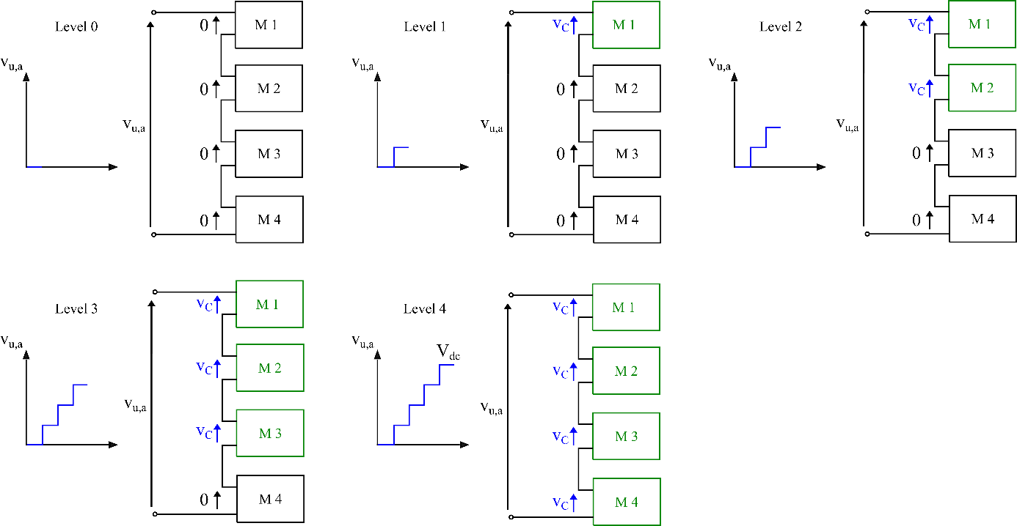

To ensure the leg voltage to match with the DC-bus voltage $V_{DC}$, the leg operates such that, at each time, N modules are always connected to the leg. In our example, this means that we will always have 4 modules connected to leg.

Using this rule and combining the upper arm and lower arm operation, the phase a voltage output will follow the formula if the voltage drop on the arm inductor is neglected:

$$v_{a}=\frac{v_{l,a}-v_{u,a}}{2}$$

Using that $v_{u,a}=N_{u,a}v_{c}$and the modules capacitors voltages are all equal to $v_{c}=\frac{V_{DC}}{N}$.

$$v_{a}=\frac{N_{l,a}-N_{u,a}}{2}⋅\frac{V_{DC}}{N}$$

Combining the different upper and lower arm modules connections, with $N=4$, the phase a voltage output will also have a stepped waveform with 5 levels going from $+\frac{V_{DC}}{2}$ and $-\frac{V_{DC}}{2}$.

The MMC operation in time is represented by the gif below.



The above principle is extended to any number of modules per arm and, by stacking more modules we will have a waveform with more levels closer to a sinus waveform.

The main advantages of the MMC converter are:
- As a modular converter, it is easily scalable in voltage an power.
- The structure can have redundant modules to increase its resiliency to faults and perform maintenance.
- The generated AC output voltages and currents waveforms have small ripple and are close to a sinusoidal waveform. So the AC output has very little harmonics and reducing or eliminating the need for filters.
- The modules can operate in very low switching frequency, leading to smaller losses.

MMC control

Traditionally, the MMC is controlled by a central controller that has to communicate with all the modules to acquire its capacitor voltage measurements and to send the command to be in connected or bypass mode.

With that logic, the MMC architecture becomes even more complex with a high computational control and big communication network.
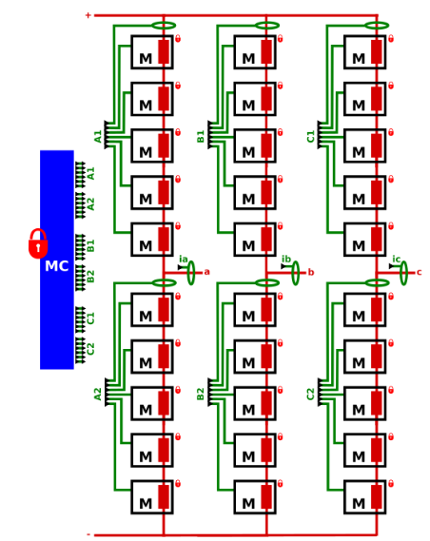

The classic control of the MMC with central controller is composed mainly of 4 blocks:

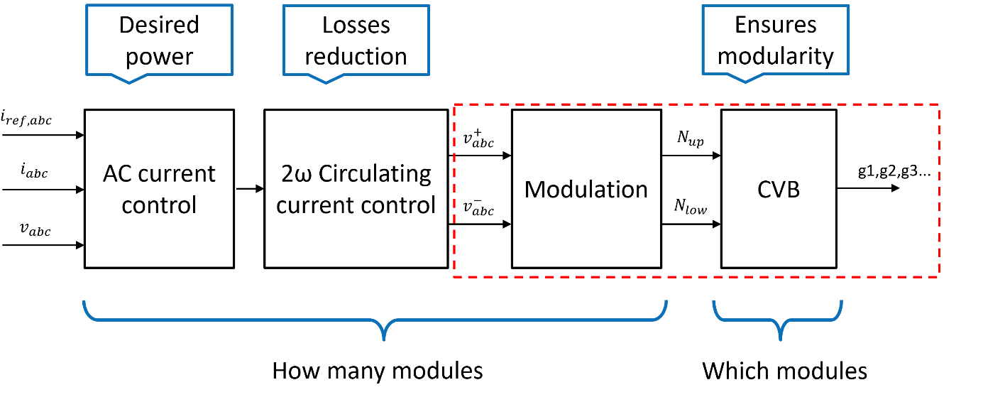
- AC current control: the AC current control ensures the delivery of the desired power on the converter output.
- Circulating current control: regulates the circulating current to reduce the associated losses.
- Modulation: usually a multiple carrier PWM or NLM strategy, uses the upper and lower arms voltages references from the inter-arm control to chose how many modules should be connected to the arms.
- Capacitor voltage balancing (CVB): it is an algorithm that choses the modules to connect/bypass in the arm ensuring that their voltage is balanced, having the same mean value. This ensures the modularity principle of the MMC.

In this tutorial, we will work to build an open-loop MMC, i.e. the voltage reference of the arms will be generated as arbitrary sinusoidal waves with the desired amplitude and only the modulation and CVB algorithm will be implemented.

Using Scope Mimicry library

The Scope Mimicry library allows to capture live data and variables within the main.cpp code. Its configuration consists of defining its sample length and number of channels.

ScopeMimicry scope(sample_lenght, number_of_channels);

That are:
- Sample length = how many points are acquired (e.g. 512, 1024, 2048)
- Number of channels = how many variables we measuring

The channels are configured by setting the variable we want to track and a string for the variable legends in the scope. For example:
scope.connectChannel(I1_low_value, "I1_low");

We also use a trigger function that returns a bool value, that will trigger the scope when returning 1. For example:

bool a_trigger()
return (myVariable == 1)

The trigger is set using:
scope.set_trigger(&a_trigger);

We can also set a delay to acquire some data before the trigger moment with:
scope.set_delay(0.0F);

The scope is started with:
scope.start();

But it only launch the acquisition when using:
scope.acquire();

Blinky MMC arm

Objectives
The goal of this tutorial is to do a first MMC arm without using power with the following structure:
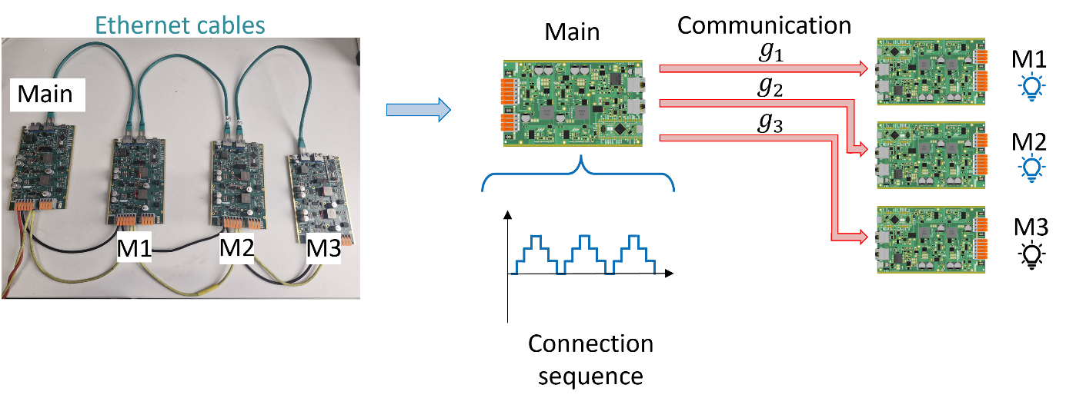
The main board serves as the central controller in the classical structure of the MMC. It will generate a connection sequence going from 0 to 3 that indicates how many modules should be connected. Then, it choses which modules to connect according to the preset preference order M1 → M2 → M3.
Then, the main board sends the connection commands g1, g2 and g3 via the Ethernet cables to the M1, M2 and M3 boards. If the board receives the command to be connected, it turns ON its SPIN board LED. If the board receives the command to be disconnected, it turns OFF its SPIN board LED.

Required Hardware

- 4 TWIST boards with SPIN
- DC Power Supply (48 V, 2 A)
- 3 Ethernet cables (RJ45)
- Cables to connect with the power supply
- PC 64-bits (windows or linux)

Required Software

- Git
- Visual Studio Code with PlatformIO

Get tutorial code from VScode

First, we need to load the Blinky MMC arm code from the OwnTech example repository version in https://github.com/analuhaas/examples
- In VScode, open the folder where you previously cloned OwnTech’s github.
- In platformio.ini file, substitute the owntech_examples variable link by https://github.com/analuhaas/examples.git
- Go to platform.io icon , go to Examples Twist under the Project Tasks tab and click on “Blinky MMC arm”.
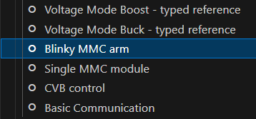
- Now you have the good code to execute the tutorial in your VScode.

Code explanation
- Starting by the setup_routine function, it configures the peripherals and main loop_functions:
It first configures the SPIN LED by using a function coded in Low Level.
config_led_LL(); // Configure the LED pin in Low Level
Then, it sets the TWIST board to Buck mode, declares the background, communication and critical tasks and starts them. The critical task has a frequency of 10 kHz.
After that, it configures the communication protocol used by informing the transmitted and reception buffer variables, the function that gives the actions of the board when it receives a message and the transmission speed.
communication.rs485.configure(buffer_tx, buffer_rx, sizeof(buffer_rx),
reception_function,
SPEED_20M); // custom configuration for RS485
Finally, it configures a some scope channels for the master to acquire the connection sequence generated “N_u” and the connection signal for each module “g1”, “g2” and “g3”.
- Continuing to the loop_communication_task function, it makes the main board change between the IDLE and POWER modes, and enables scope data triggering and recording according to the pressed key in the keyboard.
IDLE mode is equivalent to key “i” and POWER mode is equivalent to key “p”.
Data trigger becomes equal to true when the key ‘a’ is pressed, setting the starting time of data acquisition. It should be pressed during POWER mode.
bool a_trigger()
{
return enable_acq;
}
The data recording function dump_scope_datas stores the acquired data in both csv and text format in the folder “Data_records” within “src” when the key “r” is pressed. It happens only in IDLE mode.
void dump_scope_datas(ScopeMimicry &scope)
{
uint8_t *buffer = scope.get_buffer();
/* We divide by 4 (4 bytes per float data) */
uint16_t buffer_size = scope.get_buffer_size() >> 2;
printk("begin record\n");
printk("#");
for (uint16_t k = 0; k < scope.get_nb_channel(); k++)
{
printk("%s,", scope.get_channel_name(k));
}
printk("\n");
printk("# %d\n", scope.get_final_idx());
for (uint16_t k = 0; k < buffer_size; k++)
{
printk("%08x\n", *((uint32_t *)buffer + k));
task.suspendBackgroundUs(100);
}
printk("end record\n");
}
- Next, the loop_background_task function makes the LED toggle or turn off according if it is in IDLE or POWER mode and it prints some variables values from the control part.
- Finally, the loop_critical_task function contains the whole communication and control logic.
If the board is the Main (module_ID == MMC_LEAD):
In POWER mode, the control part generates the connection sequence using the order of variable seq_u = {1, 2, 3, 2, 1, 0}. The sequence has a certain period sw_period that regulates the width of the staircase step.
if (sw_timer == sw_period)
{
if (counter_seq >= 6)
{
counter_seq = 0;
}
number_of_connected_submodules_upper_arm = (float)seq_u[counter_seq]; // recuperate as float for scope
counter_seq++;
sw_timer = 0;
}
sw_timer++;

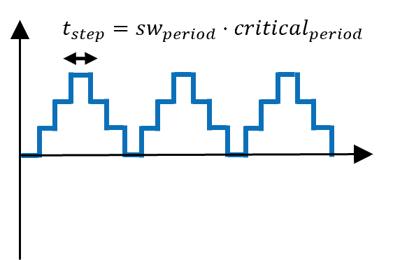
After that, the connection variables are modified to 0 or 1 according to the connection priority M1→M2→M3.
if (number_of_connected_submodules_upper_arm == 0)
{
g[0] = 0; // g[0] -> M1
g[1] = 0; // g[1] -> M2
g[2] = 0; // g[2] -> M3
}
if (number_of_connected_submodules_upper_arm == 1)
{
g[0] = 1;
g[1] = 0;
g[2] = 0;
}
if (number_of_connected_submodules_upper_arm == 2)
{
g[0] = 1;
g[1] = 1;
g[2] = 0;
}
if (number_of_connected_submodules_upper_arm == 3)
{
g[0] = 1;
g[1] = 1;
g[2] = 1;
}

g_u_1 = (float)g[0]; // recuperate as float for scope
g_u_2 = (float)g[1]; // recuperate as float for scope
g_u_3 = (float)g[2]; // recuperate as float for scope

And the scope acquires data according to a certain period equal to $t_{acq}=scope_{period}⋅critical_{period}$.
if (scope_timer == scope_period)
{
scope.acquire();
scope_timer = 0;
}
scope_timer++;
In terms of communication, the main board saves in the structure dataTX_mmc:
- The commands corresponding to each module.
- Its own ID to identify from who the message is coming.
- Status saying if it is in POWER mode = 1 or in IDLE mode = 0.
And then starts the communication to send these information to the modules boards.
SET_SIGNAL(dataTX_mmc.command, MMC_SM1, g[0]);
SET_SIGNAL(dataTX_mmc.command, MMC_SM2, g[1]);
SET_SIGNAL(dataTX_mmc.command, MMC_SM3, g[2]);

dataTX_mmc.ID = module_ID;
memcpy(buffer_tx, &dataTX_mmc, sizeof(dataTX_mmc));
dataTX_mmc.status = 1;
communication.rs485.startTransmission();
We can see that the dataTX_mmc and dataRX_mmc structures have in its definition one more information to store the capacitor voltage of the modules.

struct MMC_frame
{
uint8_t command;
float32_t Capacitor_Voltage;
uint8_t status;
uint8_t ID;
} __packed;

If it enter IDLE mode, the Main sends an IDLE flag to all modules to enter IDLE mode as well via the status information.
else if (mode == IDLEMODE)
{
/* Made to send IDLE flag only once */
if (!send_idle)
{
dataTX_mmc.ID = module_ID;
dataTX_mmc.status = 0;
memcpy(buffer_tx, &dataTX_mmc, sizeof(dataTX_mmc));
communication.rs485.startTransmission();
send_idle = true; // Set the flag to send idle command
}
}
In the reception_function we can see that the main board receives an artificial information of capacitor_voltage from the modules and stores it in a the vector MMC_capacitor_voltage. The capacitor_voltage information will be later substituted by the measure of the capacitor voltage acquired by the board.
If the board is a module (module_ID == MMC_SMx):
Analysing reception_function, it receives the information from the other boards and:
- Verify if the sender is the main if (dataRX_mmc.ID == MMC_LEAD):
  - Stores the command signal in module_comand.
  - Changes to POWER mode or IDLE mode according to the main board status.
- Verify if it is the next one in line to send the next message if ((dataRX_mmc.ID == module_ID - 1)):
  - Updates the transmission data structure for its own values of ID and capacitor voltage.
  - And then starts the communication to send these information to the other boards only if in POWER mode.
if (dataRX_mmc.ID == MMC_LEAD)
{
/* retrievig command from lead message*/
module_comand = GET_SIGNAL(dataRX_mmc.command, module_ID);
/* retrieving status */
if (dataRX_mmc.status == 1)
{
mode = POWERMODE;
}
else
{
mode = IDLEMODE;
}
}

/* The board following the ID of the one who sent will start sending
the next message */
if ((dataRX_mmc.ID == module_ID - 1))
{
dataTX_mmc = dataRX_mmc; // Copy the received data to the transmission data
dataTX_mmc.ID = module_ID;
dataTX_mmc.Capacitor_Voltage = MMC_voltage; /* TODO :uncomment when we get the voltage */
if (mode == POWERMODE)
{
memcpy(buffer_tx, &dataTX_mmc, sizeof(dataTX_mmc));
communication.rs485.startTransmission();
}
}
Observe that the sending order goes as follows:

- Main
- SM3
- SM2
- SM1

This happens since the IDs are defined as:
#define MMC_LEAD 0
#define MMC_SM1 1
#define MMC_SM2 2
#define MMC_SM3 3

In the critical function, while in POWER mode a module board:
- Turns ON its SPIN LED if it is commanded to be connected by the Main (module_command = 1)
- Turns OFF its SPIN LED if it is commanded to be disconnected (module_command =0).
else
{
if (module_comand != module_command_past)
{
change_state_command = true; // Set the flag to change the state
}

if (module_comand)
{
if (change_state_command)
{
Led_turnON_LL();
change_state_command = false; // Reset the flag
}
}
else
{
if (change_state_command)
{
Led_turnOFF_LL();
change_state_command = false; // Reset the flag
}
}
}
module_command_past = module_comand; // Update the past command

Hardware setup
In terms of hardware, you will connect the 4 boards as in the image:
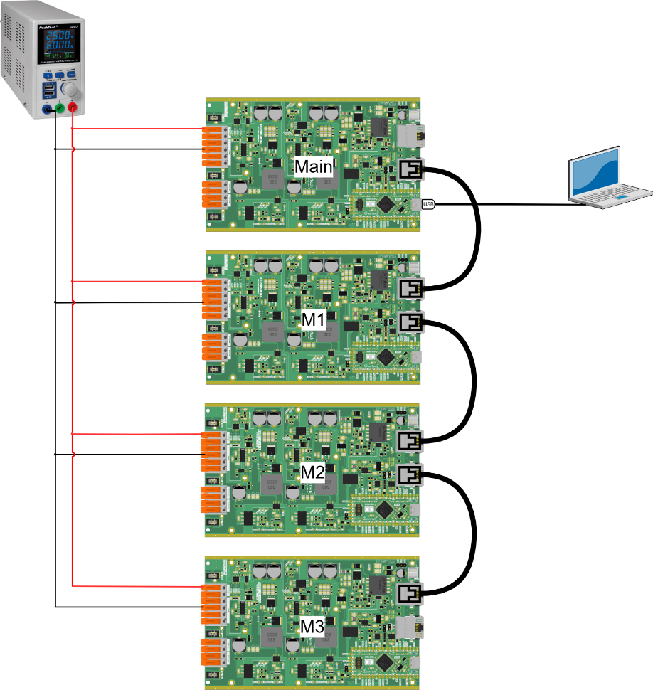

After making the connections and connecting the PC to the main with the USB-C cable, you should have something like this:

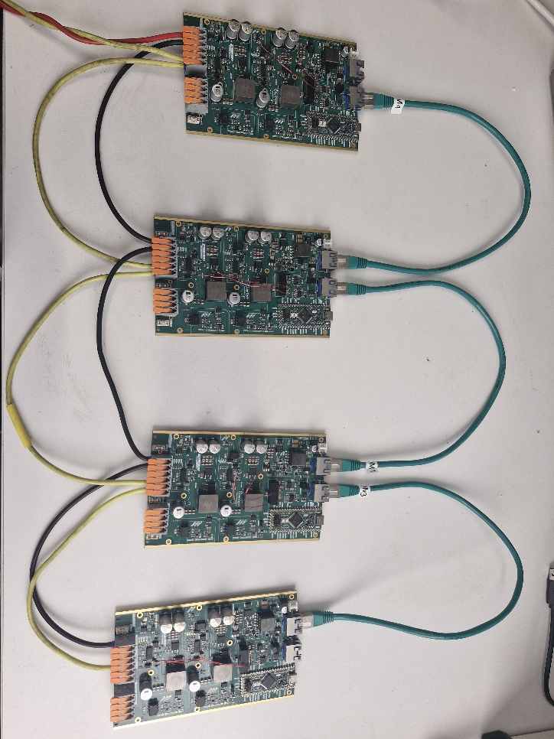
We connect the boards in series to and set the power supply to 15 V in order to power their SPIN boards.

Executing the tutorial

You have to build and upload in each board the main.ccp code changing the variable module_ID to MMC_LEAD, MMC_SM1, MMC_SM2 or MMC_SM3 according to the module function.

/* --------------USER VARIABLES DECLARATIONS------------------- */

/* TODO : Define module_ID depending on the ID of the board */
uint8_t module_ID = MMC_SM1; // The ID of the module, can be set to MMC_LEAD or any other SMx
After uploading the code to all four boards, open the serial monitor using the icon while connected with the master, as shown in the hardware setup.
- Press h to display the help menu.
- The main and M1, M2 and M3 boards starts in IDLE mode.
- Turn on the power supply around 15 V to power the 4 SPIN boards.
- Press p to switch to POWER mode and the modules LEDs will start to light up and off according to the connection sequence.
Return to step 3 to execute it again
- Press i to switch to IDLE mode and stop the arm operation.
- Turn off the power supply.
While in POWER mode, you should expect a result like this:
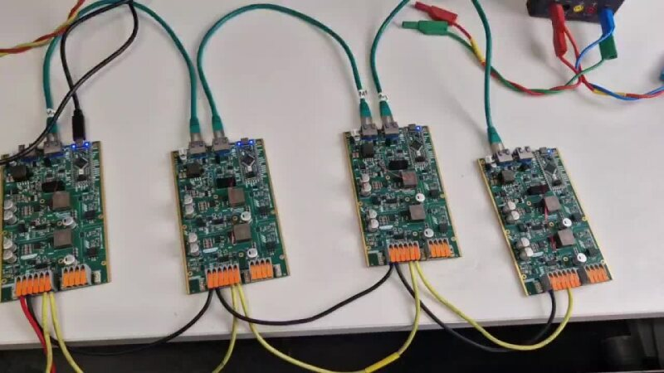

Sorting algorithm (CVB)

Objectives
The goal of this tutorial is test the logic of the Capacitor Voltage Balancing (CVB) algorithm. The CVB algorithm is used in the MMC in order to create a preference order for the connection of modules into the arm.
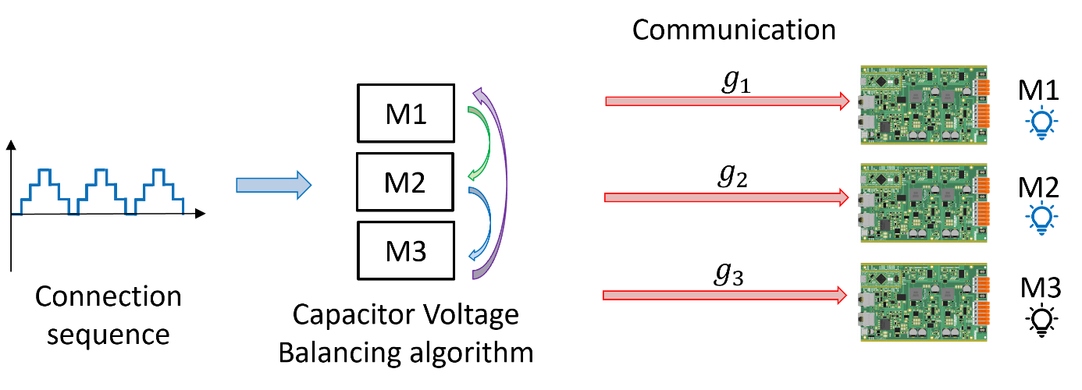
This algorithm is extremely important since the module main element, the capacitor charges and discharges according to the current as seen in the figure:

Therefore, if the connection order is random, the voltage of the modules in one arm are going to have different values every time, which is not good for the converter operation. So, we use the CVB algorithm with the objective of maintaining the capacitors voltages of all modules within one arm in the same mean level.
The algorithm works as follows:
- The algorithm receives the number of modules to be connected $N$ from the modulation block.
- It verifies if this number is different from 0.
- If the arm current $i_{arm}$ is positive, the capacitors are going to be charged. Then, the modules with smaller voltage are connected such that their voltage will increase.
- If the arm current $i_{arm}$ is negative, the capacitors are going to be discharged. Then, the modules with higher voltage are connected such that their voltage will decrease.
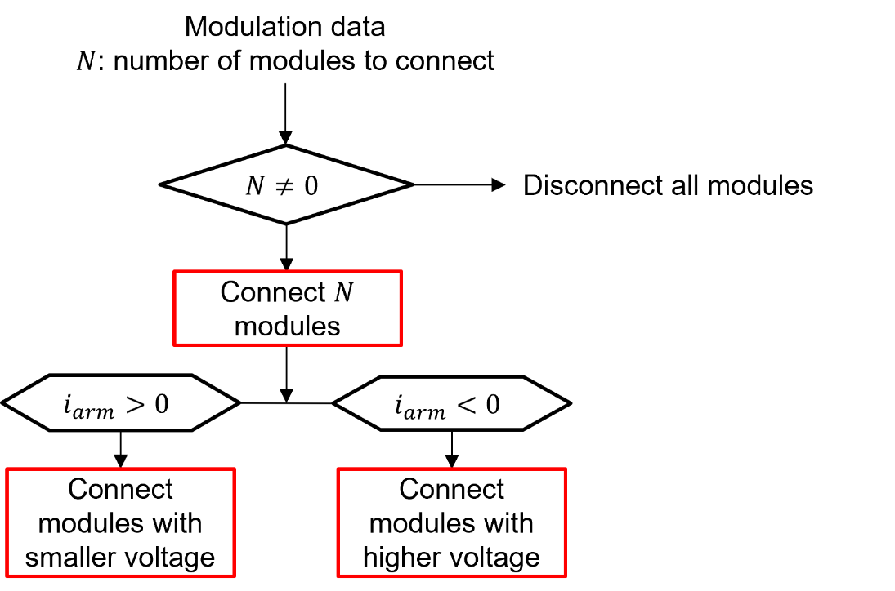
To do this, we need to first sort the modules according to their capacitor voltages and then pass through the algorithm that will generate the switching signals indicating if they are connected or not.

Required Hardware

- 1 TWIST boards with SPIN
- PC 64-bits (windows or linux)

Required Software

- Git
- Visual Studio Code with PlatformIO

Get tutorial code from VScode

First, we need to load the CVB control code from the OwnTech example repository version in https://github.com/analuhaas/examples
- In VScode, open the folder where you previously cloned OwnTech’s github.
- In platformio.ini file, substitute the owntech_examples variable link by https://github.com/analuhaas/examples.git
- Go to platform.io icon , go to Examples Twist under the Project Tasks tab and click on “CVB control”.

- Now you have the good code to execute the tutorial in your VScode.

Code explanation
- Starting by the setup_routine function, it configures the peripherals and main loop_functions:
It sets the TWIST board legs to Buck mode, declares the background, communication and critical tasks and starts them. The critical task has a frequency of 10 kHz.
Finally, it configures a some scope channels for the master to acquire the connection sequence generated “N_u” and the connection signal for each module “g1”, “g2” and “g3”.
- Continuing to the loop_communication_task function, it makes the main board change between the IDLE and POWER modes, and enables scope data triggering and recording according to the pressed key in the keyboard. If you have already seen it in Blinky MMC arm tutorial, skip directly to step 4 that describes the critical_task function.
IDLE mode is equivalent to key “i” and POWER mode is equivalent to key “p”.
Data trigger becomes equal to true when the key ‘a’ is pressed, setting the starting time of data acquisition. It should be pressed during POWER mode.
bool a_trigger()
{
return enable_acq;
}
The data recording function dump_scope_datas stores the acquired data in both csv and text format in the folder “Data_records” within “src” when the key “r” is pressed. It happens only in IDLE mode.
void dump_scope_datas(ScopeMimicry &scope)
{
uint8_t *buffer = scope.get_buffer();
/* We divide by 4 (4 bytes per float data) */
uint16_t buffer_size = scope.get_buffer_size() >> 2;
printk("begin record\n");
printk("#");
for (uint16_t k = 0; k < scope.get_nb_channel(); k++)
{
printk("%s,", scope.get_channel_name(k));
}
printk("\n");
printk("# %d\n", scope.get_final_idx());
for (uint16_t k = 0; k < buffer_size; k++)
{
printk("%08x\n", *((uint32_t *)buffer + k));
task.suspendBackgroundUs(100);
}
printk("end record\n");
}
- Next, the loop_application_task function makes the LED toggle or turn off according if it is in IDLE or POWER mode and it prints some variables values from the control part in the serial monitor terminal.
- Finally, the loop_critical_task function contains the whole CVB algorithm logic.
In IDLE mode, we ensure that its PWM deactivated.
In POWER mode, the connection sequence logic is generated as in the Blinky MMC arm. But we add an additional sequence for the lower arm that is complementary from the upper arm sequence.
if (sw_timer == sw_period)
{
if (counter_seq >= 6) {
counter_seq = 0;
}
number_of_connected_submodules_upper_arm = (float)seq_u[counter_seq]; // recuperate as float for scope
number_of_connected_submodules_lower_arm = (float)seq_l[counter_seq]; // recuperate as float for scope
counter_seq++;
sw_timer = 0;
}
Then the sorting algorithm function is executed:
It firsts sorts the modules indexes according to capacitor voltage for both arms. This is done in a while loop within 10 times because this was the necessary amount of loops to sort up to 6 modules.
void sorting()
{
uint8_t counter_loops_sorting = 0;
while(counter_loops_sorting < 10){ // Sorts modules indexes according to capacitor voltage
for(uint8_t counter = 0; counter < total_number_of_modules_arm-1; counter++)
{
if(modules_capacitor_voltages_upper_arm[counter] > modules_capacitor_voltages_upper_arm[counter + 1])
{
float32_t temp = modules_capacitor_voltages_upper_arm[counter];
modules_capacitor_voltages_upper_arm[counter] = modules_capacitor_voltages_upper_arm[counter + 1];
modules_capacitor_voltages_upper_arm[counter + 1] = temp;
float32_t temp2 = modules_indexes_upper_arm[counter];
modules_indexes_upper_arm[counter] = modules_indexes_upper_arm[counter + 1];
modules_indexes_upper_arm[counter + 1] = temp2;
}

if(modules_capacitor_voltages_lower_arm[counter] > modules_capacitor_voltages_lower_arm[counter + 1])
{
float32_t temp = modules_capacitor_voltages_lower_arm[counter];
modules_capacitor_voltages_lower_arm[counter] = modules_capacitor_voltages_lower_arm[counter + 1];
modules_capacitor_voltages_lower_arm[counter + 1] = temp;
float32_t temp2 = modules_indexes_lower_arm[counter];
modules_indexes_lower_arm[counter] = modules_indexes_lower_arm[counter + 1];
modules_indexes_lower_arm[counter + 1] = temp2;
}
}

counter_loops_sorting++;
}
Then, a for loop choses the modules to connect according to the input current and generates the connection switching signal for all modules within the upper and lower arms.
if(counter < number_of_connected_submodules_lower_arm)
{
if(i_lower_arm>=0)
{
uint8_t index_smallest_voltage_capacitor_lower_arm = modules_indexes_lower_arm[counter];
g_l[index_smallest_voltage_capacitor_lower_arm] = 1;
}
else{
uint8_t higher_index = total_number_of_modules_arm-1-counter;
uint8_t index_highest_voltage_capacitor_lower_arm = modules_indexes_lower_arm[higher_index];
g_l[index_highest_voltage_capacitor_lower_arm] = 1;
}
}

Returning to the critical function, it retrives the switching signals for the scope and the scope acquires data according to a certain period equal to $t_{acq}=scope_{period}⋅critical_{period}$.
if (scope_timer == scope_period)
{
scope.acquire();
scope_timer = 0;
}
scope_timer++;

Hardware setup
In terms of hardware, you will connect the board with the PC using a USB to USB-C cable.
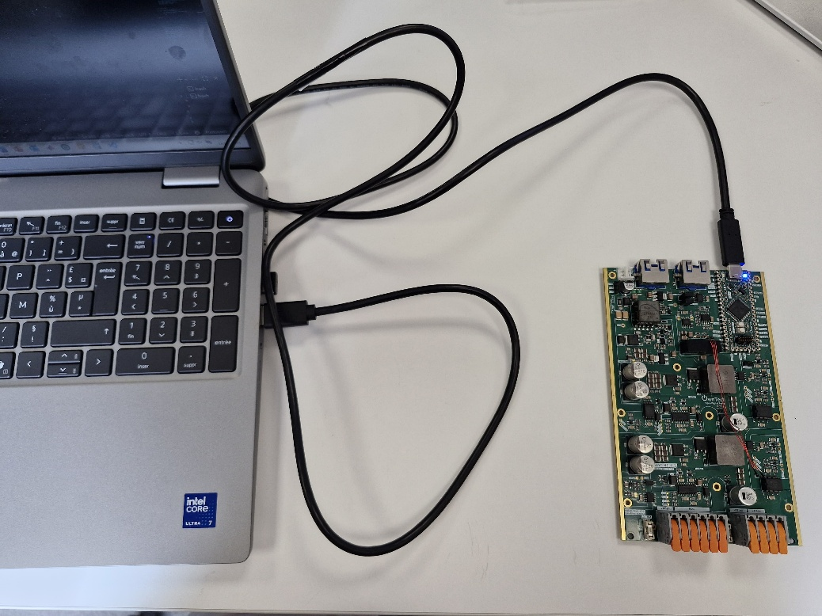

Executing the tutorial
Build  and Upload  the code into the board and open the serial monitor using the icon.
- Press h to display the help menu.
- The board starts in IDLE mode.
- Press p to switch to POWER mode and the CVB starts to choose the connected modules according to the connection sequence.
Return to step 3 to execute it again
- Press a to set the start of acquired data.
- Press r when you think you have sufficient data to record.
- Press i to switch to IDLE mode and stop the CVB operation.
- Data will be recorded in src>>Data_records folder.
By plotting the recorded data, expect seeing something like this:
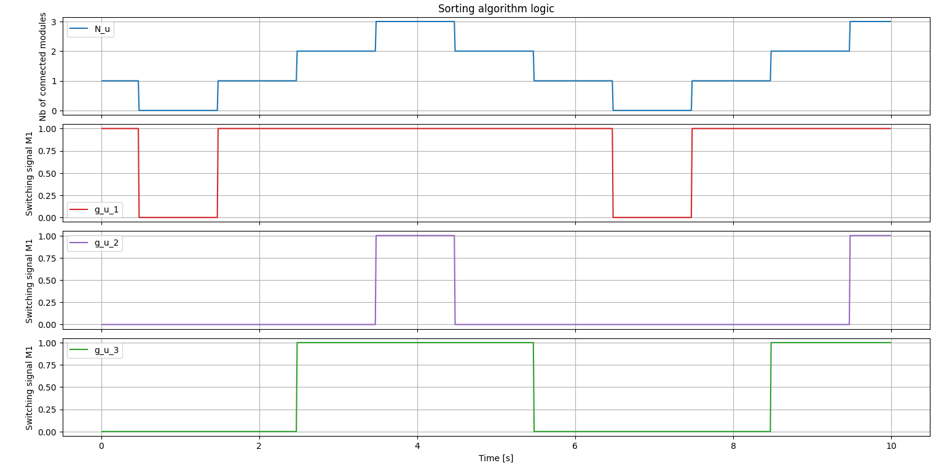
To have this kind of plot, you can use the python code plot_CVB in src>>Data_records folder.
These results were obtained using modules_capacitor_voltages_upper_arm[3] = {3.0,5.0,4.0} and i_upper_arm = 1 ($i≥0$) for the upper arm to test the algorithm, so the preference of connection should be $g_{u1}→g_{u3}→g_{u2}$.
You can plot the same for the lower arm using modules_capacitor_voltages_lower_arm[3] = {3.0,5.0,4.0} and i_lower_arm = -1 ($i<0$), so the preference of connection should be $g_{u2}→g_{u3}→g_{u1}$.
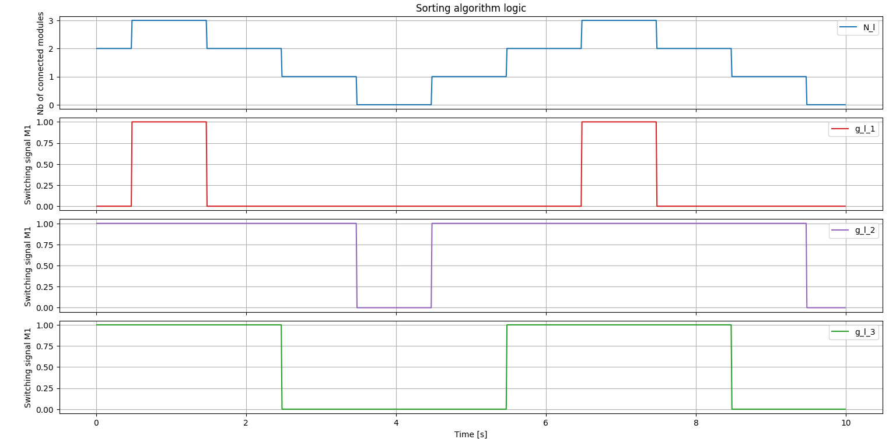
You can play with the scope and connection sequence steps frequency or try to modify the number of modules, current signal and capacitor voltages to fully understand the code.

Individual MMC module test

Objectives
The goal of this tutorial is to test a individual MMC module operation following the structure:
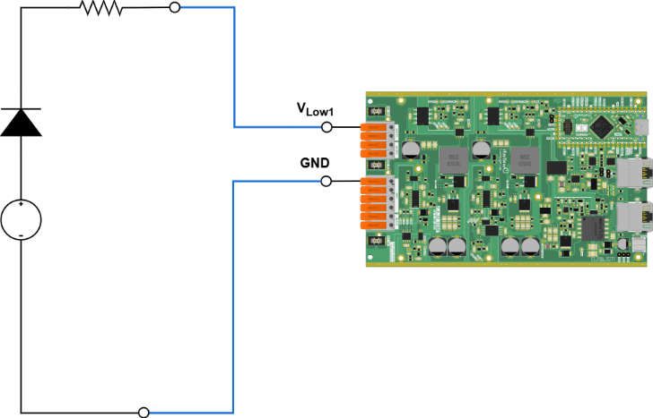
The board serves as a HB module of the MMC by programming its second leg (LEG2) to be deactivated, having the following circuit. Observe that the HIGH terminals are open (Vhigh to GND).
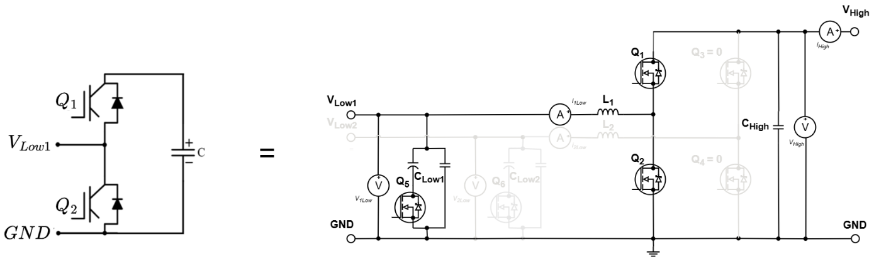
The tutorial will consist of putting the module in OFF and latter ON state according to the correspondence table:

- ON state: the module is considered to be connected to the circuit and the current pass through its capacitor.
- OFF state: the module is considered to be bypassed from the circuit and the current does not pass through its capacitor.
- BLOCK state: will not be used during the tutorial.
Observe that the module state will basically be controlled using the board first leg (LEG1) switches Q1 and Q2.
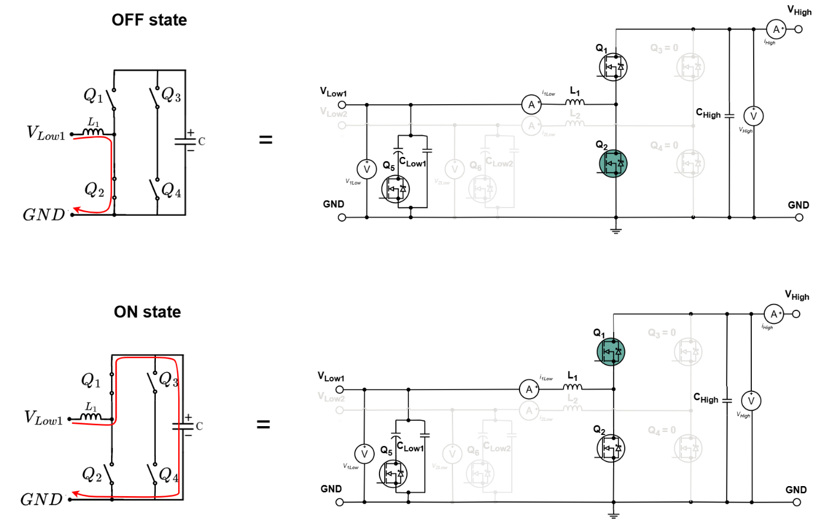
A diode will be used for protecting the power supply from currents in the opposite sense. Because of that, the current passing through the module will be always positive and its behavior will be only tested in the condition when the module capacitor is charged. Also, the resistor used is high in order to reduce the current flowing into the module.

Required Hardware

- 1 TWIST boards with SPIN
- DC Power Supply (48 V, 2 A)
- Cables to connect with the power supply
- PC 64-bits (windows or linux)

Required Software

- Git
- Visual Studio Code with PlatformIO

Get tutorial code from VScode

First, we need to load the Single module test code from the OwnTech example repository version in https://github.com/analuhaas/examples
- In VScode, open the folder where you previously cloned OwnTech’s github.
- In platformio.ini file, substitute the owntech_examples variable link by https://github.com/analuhaas/examples.git
- Go to platform.io icon , go to Examples Twist under the Project Tasks tab and click on “Single MMC module”.

- Now you have the good code to execute the tutorial in your VScode.

Code explanation
- Starting by the setup_routine function, it configures the peripherals and main loop_functions:
It sets the TWIST board legs to Buck and Boost mode and changes the duty cycle maximum and minimum limits to 1 and 0, respectively. This is necessary to fully control the module switches.
It declares the background, communication and critical tasks and starts them. The critical task has a frequency of 10 kHz.
Finally, it configures a some scope channels.
- Continuing to the loop_communication_task function, it makes the board do the following functions according to the pressed key in the keyboard:
  - Change between the IDLE (i) and POWER (p) modes
  - Increases (u) or decreases (d) the duty cycle if in POWER mode
  - Change to SWITCH mode (s), that is the mode we are using during the tutorial
  - Changes the module state to ON (o), OFF (f), BLOCK (b), only works in SWITCH mode
  - Enables scope recording (r)
The data recording function dump_scope_datas stores the acquired data in both csv and text format in the folder “Data_records” within “src” when the key “r” is pressed. It happens only in IDLE mode.
void dump_scope_datas(ScopeMimicry &scope)
{
uint8_t *buffer = scope.get_buffer();
/* We divide by 4 (4 bytes per float data) */
uint16_t buffer_size = scope.get_buffer_size() >> 2;
printk("begin record\n");
printk("#");
for (uint16_t k = 0; k < scope.get_nb_channel(); k++)
{
printk("%s,", scope.get_channel_name(k));
}
printk("\n");
printk("# %d\n", scope.get_final_idx());
for (uint16_t k = 0; k < buffer_size; k++)
{
printk("%08x\n", *((uint32_t *)buffer + k));
task.suspendBackgroundUs(100);
}
printk("end record\n");
}
- Next, the loop_application_task function makes the LED toggle, turn on or turn off according if it is in IDLE, POWER or SWITCH mode and it prints the measured currents and voltages Ilow1, Vlow1 and Vhigh in the serial monitor terminal.
- Finally, the loop_critical_task function contains the module states logic.
First, the measurements from the boards sensors are used to update the measurement variables.
In the different modes:
- If the board is in IDLE mode, we ensure that its PWM deactivated.
- If the board is in POWER mode, the board LEG1 will work as a Buck with a duty cycle initially equal to 0,3. We will not use this mode.
- If the board is in SWITCH mode, the board will work as a MMC module having the following states:
  - g=0 (OFF): as LEG1 is in buck convention, the duty cycle is set to 0 to open Q1 and close Q2 and enables the PWM.
shield.power.setDutyCycle(LEG1,0.0);
  - g=1 (ON): as LEG1 is in buck convention, the duty cycle is set to 1 to close Q1 and open Q2 and enables the PWM.
shield.power.setDutyCycle(LEG1,1.0);
  - g=2 (ON): opens both MOSFETS Q1 and Q2.
if (pwm_enable == true)
{
shield.power.stop(ALL);
}
pwm_enable = false;
According to documentation, the buck convention uses the PWM channel to control the HIGH switch (Q1) and the boost convention uses the PWM channel to control the LOW switch (Q2).

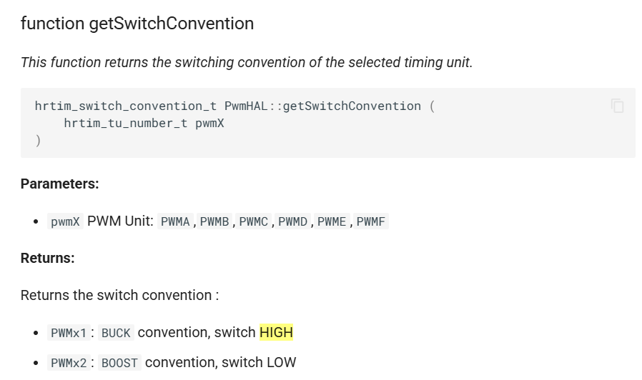

Finally, the scope acquires the data at each critical loop cycle.

Hardware setup
- In terms of hardware, you will connect the board with the power supply and oscilloscope as in the image: 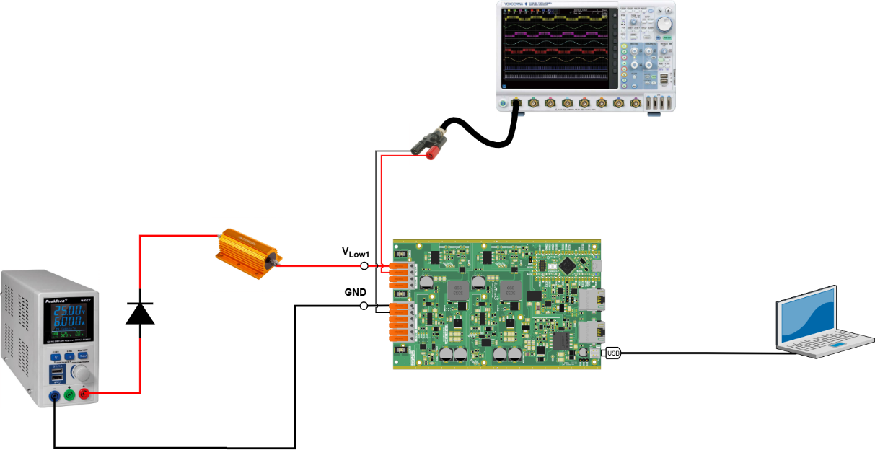
More specifically for the Oscilloscope connection, you will need to use a BNC adaptor to the differential voltage you want to measure (VLOW1 to GND)
- Connect the board to the PC via a USB-C cable
- Build and upload the main.ccp code into the board SPIN.
- Configure Ownplot following these steps:
  - Open the Serial Monitor and check the Port Name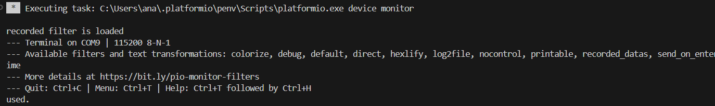
  - Close the serial monitor and Launch OwnPlot
  - In the Port tab, select the port connected to your PC (e.g., if the port is COM9, select COM9.)
  - Click the Open Port button 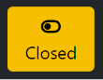 to open the port. It should change to "Open."
  - Set the Number of Channels in the Settings tab to 3. 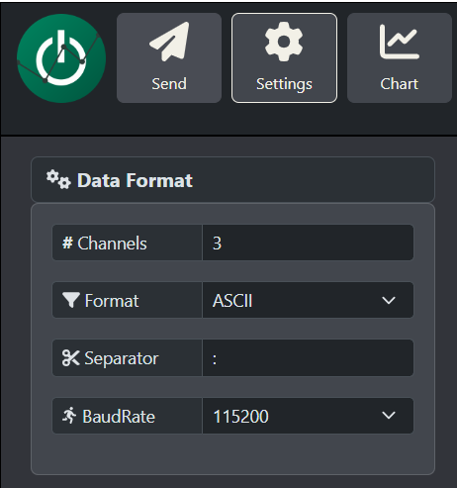

  - Customize Legends in the Graph tab to Ilow1, Vlow1, Vhigh, in this order. 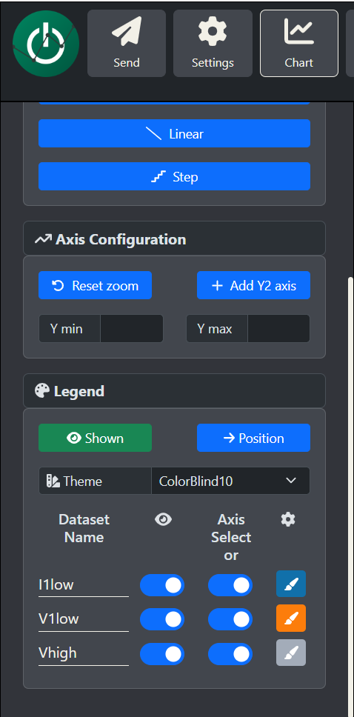

  - Configure the Commands in the Send tab as in the application task:
    - Idle mode = i
    - Power mode = p
    - Switch mode = s
    - Module ON = o
    - Module off = f
    - Module block = b
    - Download scope data = r
    - Duty_cycle Up = u
    - Duty_cycle Down = d 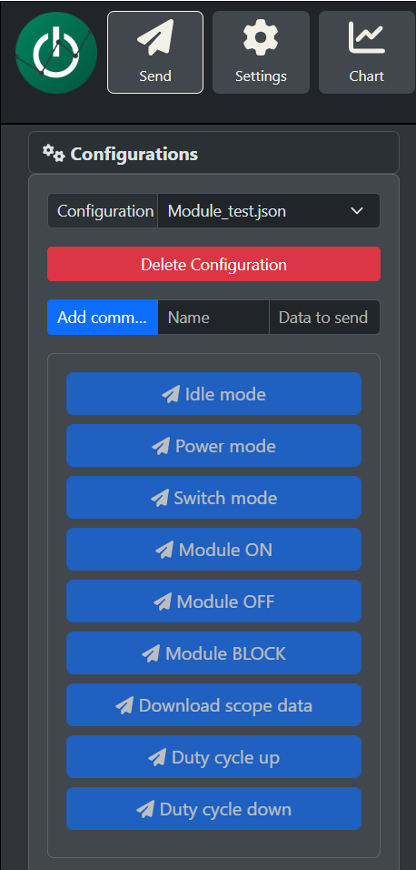
- Configure your Oscilloscope:
  - Make sure it acquires the output voltage of the module (V1low to GND)
  - Use a 20 ms/div or 10 ms/div configuration.
  - Configure it to trigger when the voltage rises up to 7 V to see how the module voltage changes during the transition from state OFF to ON in the oscilloscope.
  - You can also add a current probe if you would like to measure the circuit current.

In my setup, I used PicoScope 4444 as oscilloscope for voltage measurement.

After making the connections and connecting the PC to board the USB-C cable, you should have something like this:

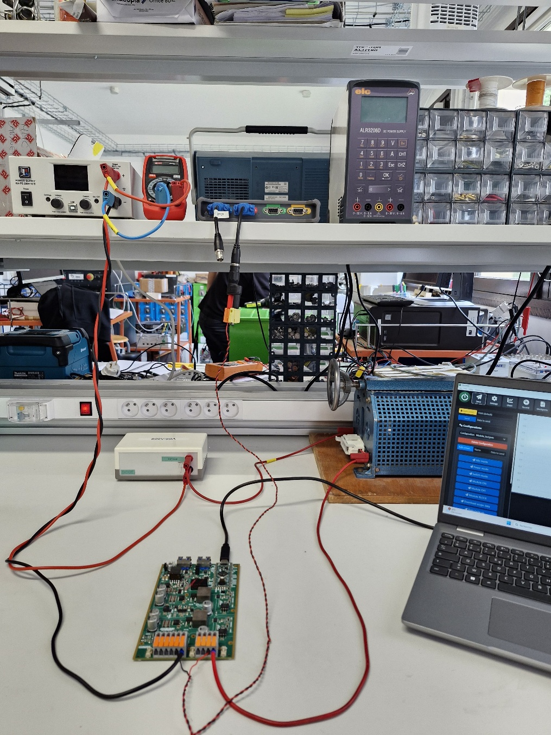
PC
Resistor
Diode
Oscilloscope
Power supply

Executing the tutorial
After uploading the code to the board and setting up OwnPlot.
Return to step 2 to execute it again
- The board starts in IDLE mode (board disactivated).
- Turn on the power supply around 10 V to power the circuit.
- Press the button “SWITCH mode” and the module will start already in ON module.
- Press the button “Module OFF” to put the module in OFF state.
- Press the button “Module ON” to put the module in ON state to see the transition.
- Press the button “Module OFF” to put the module in OFF state.
- Turn off the power supply.
- Press the button "IDLE mode" and stop the arm operation.
If you acquire the transition in the oscilloscope using the trigger, you should expect a result like this:
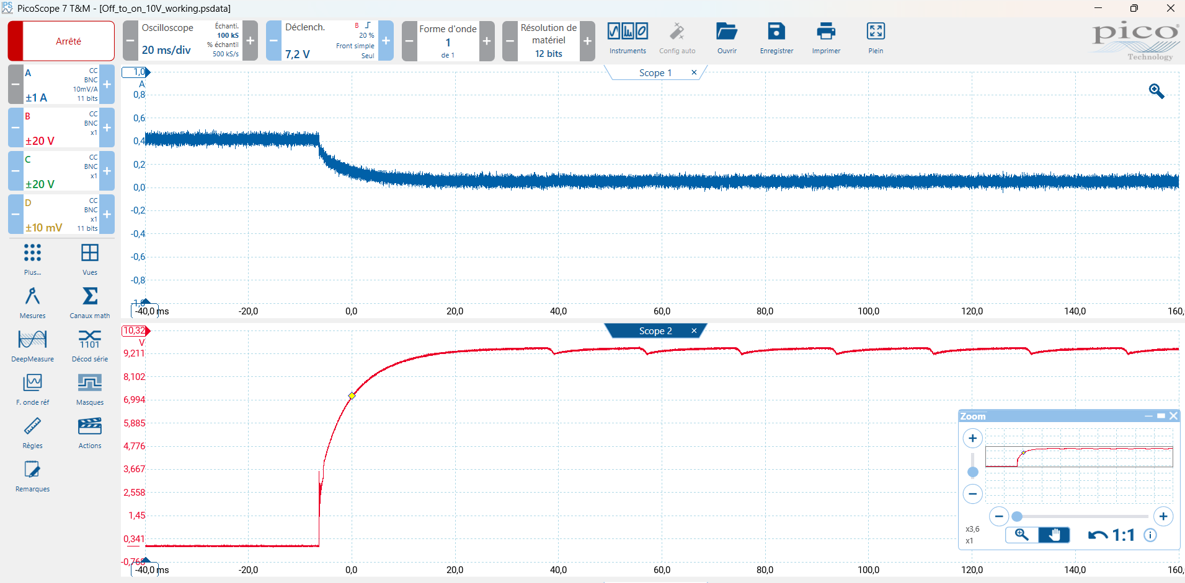
In my case, Scope 1 measures the current entering the resistor and Scope 2 measures the voltage between the board terminals Vlow1 and GND, that are the modules terminals. This means that Scope 2 measures the output voltage of the half-bridge module.
The module starts at OFF and, at this moment, the module is bypassed having its voltage $V_{SM}=0 V$. Therefore, all the power supply voltage is in the resistor and a current of $I≈0,4 A$ circulates into the circuit.
Then, the module transitions from OFF to ON state. Its capacitor $C_{high}$ starts to charge until it achieves a voltage of $V_{SM}=9,3 V$. We would expect it to have is voltage around 10 V during this phase, however, there are additional voltage drops on the resistor and on the board inductor. The current also goes down near to zero.
We also observe a unexpected behavior of the voltage at ON state. It goes up and down repeatedly. This can be explained by the antiparallel diode in the board Q1 switch. At first, when the capacitor is charging with $V_{SM}<9,3 V$, the current passes by the antiparallel diode.

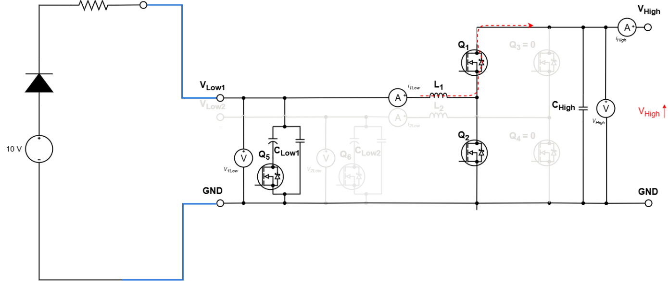
When it achieves 9,3 V, the voltage in the capacitor $C_{high}$ becomes higher than the voltage on the antiparallel diode anode because the low-side filter capacitor does not charge anymore in the same rate as $C_{high}$. Then, the diode starts to open and $C_{high}$ discharges rapidly until it achieves a voltage that allows the antiparallel diode to conduct again.
This creates the up and down cycle that we see:
