eta



Tutorial TWIST-SPIN board

Communications

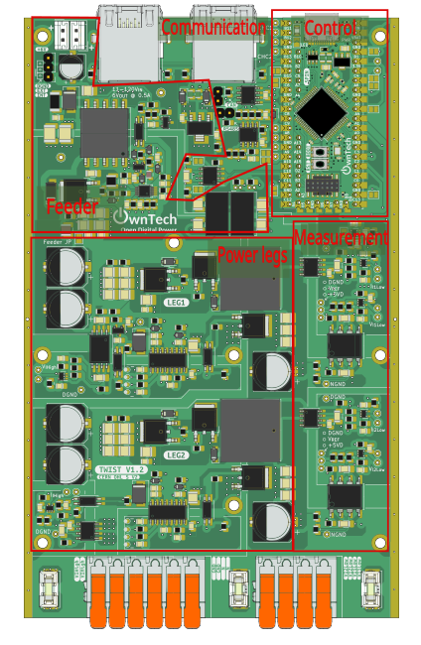

Table of contents
Introduction 3
AC peer-to-peer 4
Required hardware 4
Required Software 4
Create the Project 4
Step-by-Step Implementation 5
Code explanation 6
Connect hardware and Power up 10
Expected Results 10

Introduction
The goal of this tutorial is to start using the OnwTech TWIST boards with communication protocols. Please refer to the “Tutorial_Twist_Board” for learning how to use the Twist board before starting this new series of tutorials.

The tutorials are built using the TWIST Microgrid examples in https://docs.owntech.org/latest/ .

AC peer-to-peer
The purpose of this tutorial is to implement a system with two power electronics converters: a DC/AC converter producing a certain power and informing an AC/DC converter that it can consume this reference power.
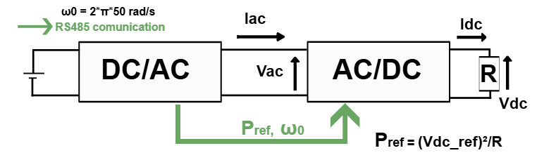
The DC/AC converter's task is to generate AC power for use in the electrical network, being connected to a DC generation like a solar panel for example (in our case the generation is going to be the DC power supply). The DC/AC converter is also called the SERVER converter in this tutorial.
The AC/DC converter’s task is to convert AC power back into DC power when the electrical network requires DC power for various applications, such as charging batteries or powering DC devices. The AC/DC converter is also called the SERVER converter in this tutorial.
In this tutorial, the DC/AC converter informs the AC/DC converter of the available power it can deliver. This information includes details like the power's magnitude and frequency.
A control loop composed of PI and PR controllers is used such that the DC/AC converter maintains an alternating current in phase opposition (180 degrees phase shift) with the input alternating voltage. This phase opposition ensures that power is effectively delivered to the load.
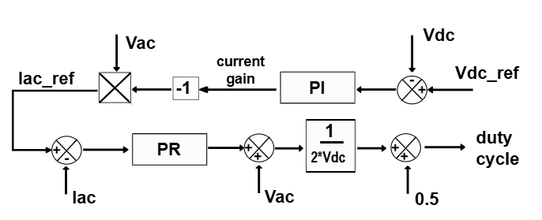

Required hardware
- 2 boards TWIST v_1_3 or later
- 64-bit PC (Windows or Linux)
- 50 V DC Power Supply
- 115 Ω Resistive Load
- Ethernet cable
- Oscilloscope or OnwPlot

Required Software
- Git
- Visual studio code

Create the Project
- First, we need to load the AC peer to peer base example.
In PlatformIO , go to Examples Twist under the Project Tasks tab and click on “AC peer to peer”.
The main.cpp file will be updated automatically. This is the file we will modify to implement the example.
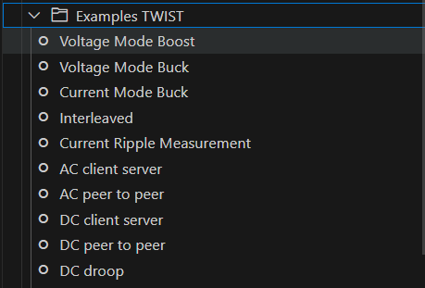
Next, create a new branch dedicated to the AC peer to peer example.
To learn how to create a new branch, refer to the tutorial "Saving Modifications to the Board Code."

Step-by-Step Implementation

- You need to first add the following lines to the platformio.ini file:
lib_deps=
control_pid = https://gitlab.laas.fr/owntech/power-api/opalib-control-pid.git
control_library = https://github.com/owntech-foundation/control_library.git
owntech_examples = https://github.com/owntech-foundation/examples.git
scope = https://github.com/owntech-foundation/scopemimicry.git

- Update the main.cpp code with the complete set of correction factors you calculated during the “Board Sensors Calibration” tutorial in the setup_routine() function

Your need to add the correction factors for the two boards you are using, for that you can use the structure:

#ifdef SERVER
data.setParameters(V_HIGH, 0.030031,-0.017898);
data.setParameters(V1_LOW, 0.044972283,-91.43827945);
data.setParameters(V2_LOW, 0.045018053,-91.8567704);
data.setParameters(I1_LOW, 0.004725748,-9.782756806);
data.setParameters(I2_LOW, 0.004402295,-9.021969522);
data.setParameters(I_HIGH, 0.004235355,-8.624550514);
#endif

#ifndef SERVER
data.setParameters(V_HIGH, 0.030031,-0.017898);
data.setParameters(V1_LOW, 0.044972283,-91.43827945);
data.setParameters(V2_LOW, 0.045018053,-91.8567704);
data.setParameters(I1_LOW, 0.004725748,-9.782756806);
data.setParameters(I2_LOW, 0.004402295,-9.021969522);
data.setParameters(I_HIGH, 0.004235355,-8.624550514);
#endif

Code explanation
- Drivers
- Owntech drivers let you use the power API and all other libraries.
- Zephyr libraries uses the RTOS (real-time OS) API that we use to manage tasks on the microcontroller.
- ScopeMimicry Library allows to capture live data and variables.
- Role definition
- Need to be modified according to the board role in the example before build and upload to the board
- #define SERVER // Role : SERVER or CLIENT
- User Variables declaration
In this section multiple variables used during the code are declared.
- f0: is the converter frequency.
- Udc: sets the voltage of the DC power supply used
- Ts: sets the sample time of the controllers.
- I_ac_ref: sets the AC side current reference that changes to the available power.
- P_ref: sets the power available reference communicated from the SERVER to the CLIENT.
- Rdc: sets the resistance of the load connected to the AC/DC converter output terminals.
- v_dc_ref: sets the DC output voltage reference for the AC/DC converter as sqrt(P_ref*Rdc)
- duty_cycle: stores the duty cycle of the converter.
- pwm_enable: it is a boolean flag indicates whether PWM is enabled or not (ON or OFF)
- control_task_period: defines the period of the control task.
- received_serial_char: stores the received command via serial monitor.
- meas_data: stores the last voltage and current measurements of the sensors.
- is_downloading: indicates ??
- Measurement variables are used to monitor voltage and current values.
  - The suffix "high" refers to input voltage or current.
  - The suffix "low" refers to output voltage or current.
- ScopeMimicry scope is created with 9 channels with 1024 data points per channel.
- The PR resonant control parameter are also defined
Communication variables:
- tx_consigne, rx_consigne: Two structures, one for Transmitter (server) and one for Receiver (client), composed of Power reference information and its status.
- buffer_tx, buffer_rx: Pointer to the transmitted buffer and pointer to the received buffer, respectively.
- record_counter: stores the duration of the signal recording by the scope.
Board operation modes:
- enum lists the different that can be activated by the serial monitor commands:
enum serial_interface_menu_mode // LIST OF POSSIBLE MODES FOR THE OWNTECH CONVERTER
{
IDLEMODE = 0,
POWERMODE
};

Variables declared only if the board is SERVER:
- angle: stores the operation angle of the converter.
- Vac_ref: sets the AC side voltage reference.
Variables declared only if the board is CLIENT:
- V_ac_meas: stores the AC side voltage measured.
- gain_current: stores the output of the PI controller.
- PID related variables are also defined (only PI used, Td = 0).

- Auxiliary functions

The trigger function return true all the time, meaning that all data is recorded and there is actually no trigger. It is used as input for the scope used to record the measured data.
bool a_trigger() {
return true;
}
The dump_scope_datas function gets the scope measurements and records it by printing the measured values in the serial monitor screen.
void dump_scope_datas(ScopeMimicry &scope) {
uint8_t *buffer = scope.get_buffer();
uint16_t buffer_size = scope.get_buffer_size() >> 2; // we divide by 4 (4 bytes per float data)
printk("begin record\n");
printk("#");
for (uint16_t k=0;k < scope.get_nb_channel(); k++) {
printk("%s,", scope.get_channel_name(k));
}
printk("\n");
for (uint16_t k=0;k < buffer_size; k++) {
printk("%08x\n", *((uint32_t *)buffer + k));
task.suspendBackgroundUs(100);
}
printk("end record\n");
}
The reception_function is used to start the client reception of the data if the receiver id_status 6th bit is 1. If yes, the status flag is updated and the scope starts to acquire data if the receiver id_status is 00100010 (2nd bit is 1). The P_ref value is also set to the value sent by the SERVER converter.

This gives us two different states of rx_consigne.id_and_status:
- 00100000 identifies the intended receiver board to communicate these informations
- 00100010 the same and also states that the scope function can be started.
void reception_function(void)
{

#ifdef CLIENT
if (rx_consigne.id_and_status >> 6 == 1)
{
status = rx_consigne.id_and_status;

if ((rx_consigne.id_and_status & 2) == 1)
scope.start();

P_ref = rx_consigne.P_ref_fromSERVER;
}
#endif

}

- Hardware Setup Functions
In the function setup_routine(), first we setup the hardware
- spin.version.setBoardVersion(SPIN_v_1_0); configures the SPIN board version.
- twist.setVersion(shield_TWIST_V1_3); sets the TWIST board version.
Then, we set the twist operation mode (Buck, Boost or Inverter)
- twist.initLegBuck(LEG1) and twist.initLegBoost(LEG2): configures the power leg1 in Buck mode and power leg2 in Boost mode to obtain a inverter.
- data.enableTwistDefaultChannels()
Then, we configure the communication
- communication.rs485.configure(...): configures the communication between the two boards with the protocol RS485
- communication.sync.initMaster() and communication.sync.initSlave(TWIST_v_1_1_4) configures the PWM clock synchronization between the two Boards.
Then we set the correction factors for the measure voltages and currents.
- data.setParameters(...) sets the gain and offset for each onboard measurement.
Then it declare and initialize the application, communication and critical tasks.
If the board is the SERVER:
- pid.init(pid_params): initializes the pid controller with the pid_params parameters defined in the User variables declaration section.
- pid_current_control.reset(-gain_current): resets the pid output.
Finally, it starts the PR control and sets the scope configurations:
- scope.connectChannel(I1_low_value, "I1_low"): sets a scope channel name and associated variable.
- scope.set_trigger(a_trigger): sets the function used as trigger.
- scope.set_delay(0.0F): sets the delay to acquire a given amount of data before the trigger instant.
- scope.start(): initializes the scope.
- Loop functions and Closed-loop buck implementation
In the communication task, the SPIN listens to the serial port and, depending on the received character, it switches the converter operation between IDLEMODE and POWERMODE.
- In IDLEMODE and SERIALMODE, PWM is disabled and there is no power conversion.
- In POWERMODE, PWM is enabled, activating power conversion.
By using case “r”, the user can also do an individual scope acquisition.
In the application task:
- SPIN led is turned on if in POWERMODE
- A scope recording is performed if is_downloading == 1 (when “r” is pressed”)
- If the board is the CLIENT, it prints some information on the serial monitor while in POWERMODE.
- task.suspendBackgroundMs(100) suspends the application task for 100 µs.
In the critical task, the converter operation and communication is controlled.
- The measurements are stored within the measurement variables defined in the User variables declaration.
- In IDLEMODE, there is no power conversion since the pwm is disabled and the SERVER converter id_status is set to 00100000 (64), meaning that no scope acquisition should be made in the inactive mode.
- In POWERMODE for the SERVER board, the pwm is enabled and there is power conversion. The duty cycle is computed using a sinus with Vac_ref amplitude. The id_status is updated according to the record counter and P_ref to be sent is also updated. The communication transmission is started and during the whole time in POWERMODE, the scope acquires the measured data.
- The CLIENT board derives from the id_status if it should be in POWERMODE or in IDLEMODE. It is in POWERMODE if the last three bits gives a 1 or a 2, where the v_dc_ref is calculared and the PID and PR controllers are used to control the converter power output. The scope acquisition is also done every 4 critical task cycles as indicated in.
if (critical_task_counter % 4 == 0)

Connect hardware and Power up
- For initial hardware setup, connect your TWIST boards in the image configuration:
- Connect Vhigh and GND of the SERVER TWIST board to the DC power supply (set current limit to 1 A).
- Connvect Vhigh and GND of the CLIENT TWIST board to a resistive load.
- Connect VLow1 and VLow2 terminals of the two TWIST boards
- Connect the USB-C port of the SPIN of the SERVER board to your PC via a USB cable.
- Turn on the DC power supply. Choose a voltage between 0 and 48 V.
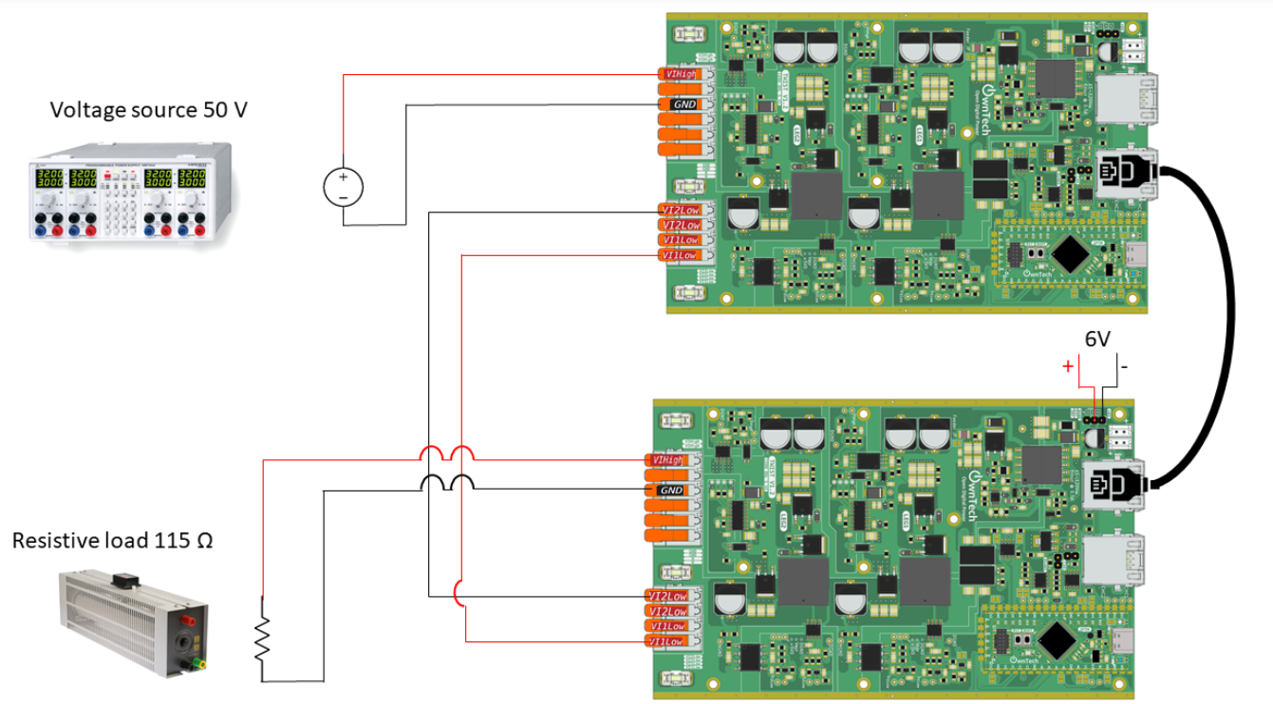
- Build  and Upload 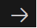
- Use OwnPlot or other oscilloscope to visualize your data and control the converter.
Voilà !

Expected Results

