eta



Tutorial TWIST-SPIN board

Communications

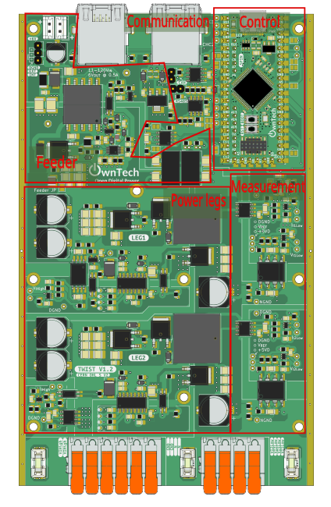

Table of contents
Introduction 4
Additional environment setup 4
Communication test 5
Objectives 5
Required Hardware 5
Required Software 5
Pull the project in VScode from GitHub 5
Code explanation 7
AC peer-to-peer 8
Required hardware 9
Required Software 9
Create the Project 9
Step-by-Step Implementation 9
Code explanation 10
Connect hardware and Power up 15
Expected Results 15

Introduction
The goal of this tutorial is to start using the OnwTech TWIST boards with communication protocols. Please refer to the “Tutorial_Twist_Board” for learning how to use the Twist board before starting this new series of tutorials.

Some tutorials are built using the TWIST Microgrid examples in https://docs.owntech.org/latest/ .

Additional environment setup

After the basic environment setup on “Tutorial_Twist_Board”, you will also need to:
- Install Git graph in VScode.

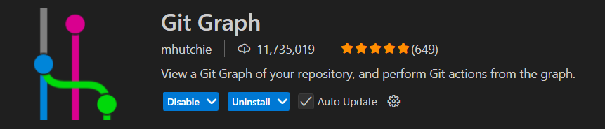

- Follow this tutorial to create a SSH key and add it to your GitHub account: https://medium.com/@techworldthink/a-beginners-guide-to-adding-ssh-key-to-github-windows-6a5de5396ba6

- If your PC user is not administrator, you will need to modify the file in which you will save the SSH key in Step1:

Enter file in which to save the key (C:\Users\admin/.ssh/id_rsa): C:\Users\your-user-name/.ssh/id_rsa

Then, you will probably have this warning when trying to follow Step 3 in the tutorial:
@@@@@@@@@@@@@@@@@@@@@@@@@@@@@@@@@@@@@@@@@@@@@@@@@@@@@@@@@@@
@ WARNING: UNPROTECTED PRIVATE KEY FILE! @
@@@@@@@@@@@@@@@@@@@@@@@@@@@@@@@@@@@@@@@@@@@@@@@@@@@@@@@@@@@
Permissions for 'C:\\Users\\your-user-name/.ssh/id_rsa' are too open.
It is required that your private key files are NOT accessible by others.

This should concern you if you share your PC with other people, if it is the case, you should get in touch with the IT team of the lab.

Communication test

Objectives
The goal of this tutorial is to do a first communication test using two boards to understand how the different communications types are used in the Twist board:
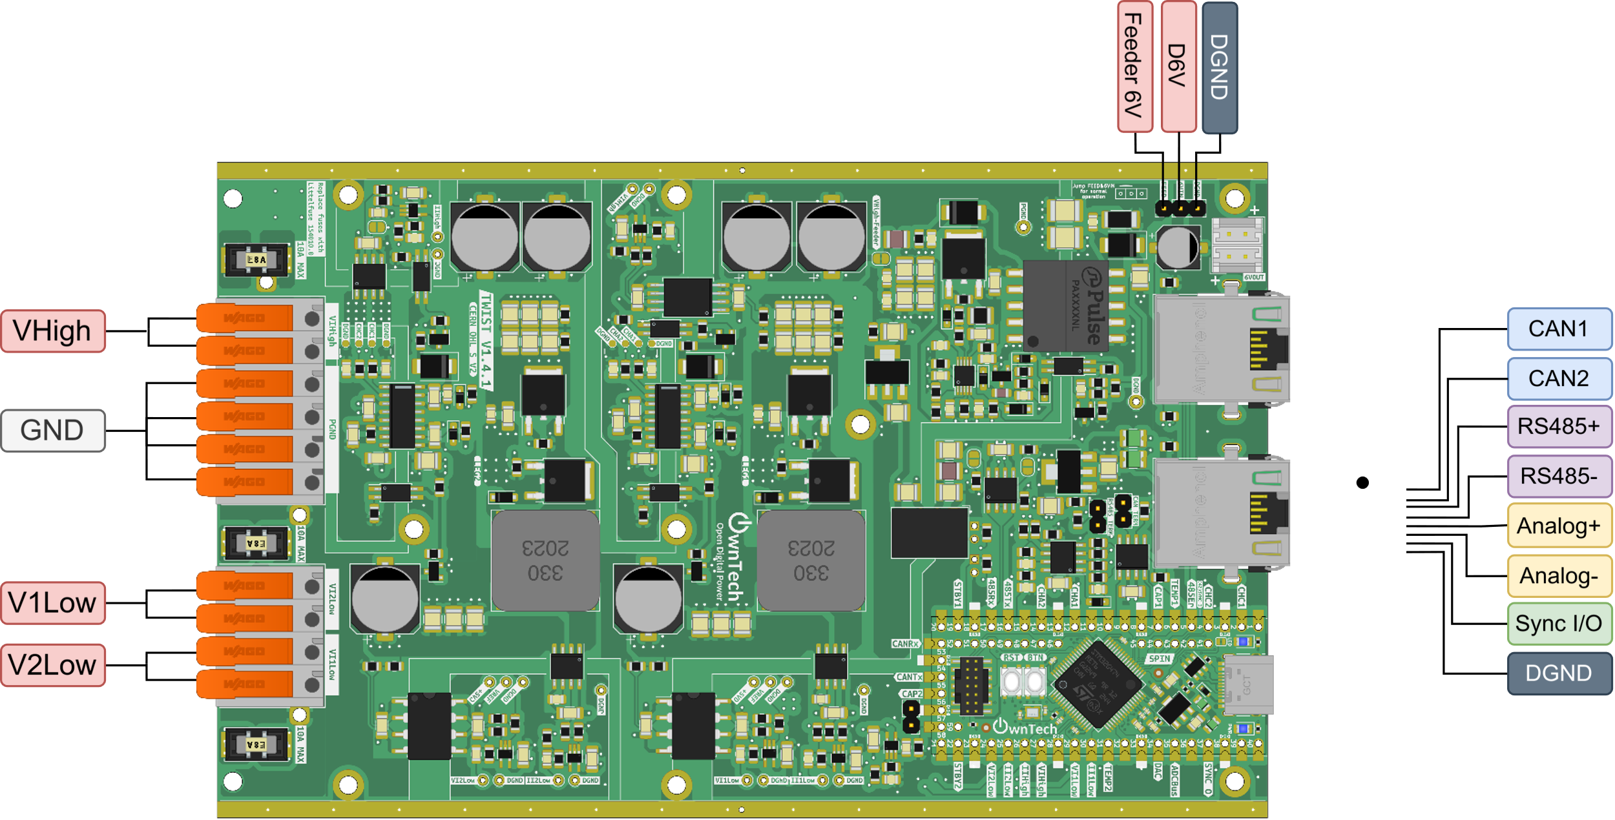
The different communications are:
- RS485
- CAN
- Analog
- Sync
In this first tutorial, two boards communicates via all three communication types plus Sync to verify if all communications are successful.

Introduction to RS485

RS-485 is a standard for serial communication that allows multiple devices to communicate over long distances using differential signaling on a twisted pair of wires.

In terms of speed, RS485 can go up to 20Mbits/s. This means that it would take 800 microseconds for 200 modules to exchange 10 bytes (80 bits) each at 20 Mbps
- A voltage or a current measurement takes about 12 bits for example

But what is a serial communication? And a differential signaling?

In serial communications a bit is sent every clocks period, such as in the schematic:
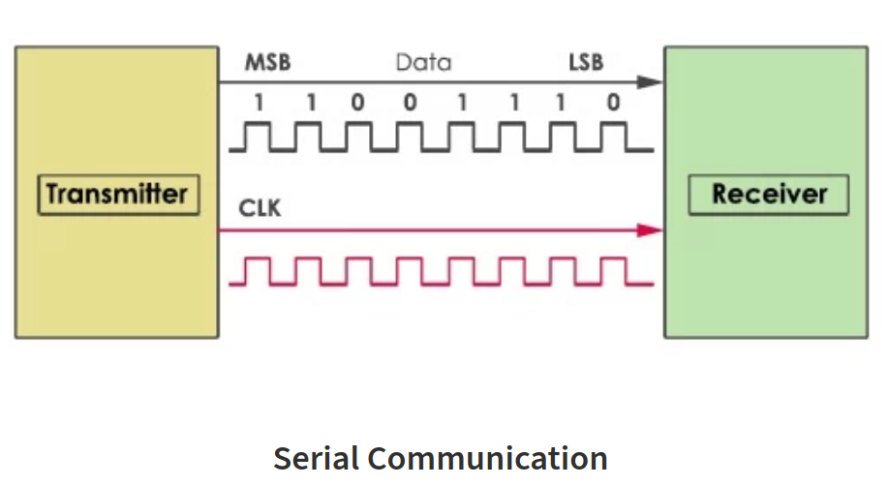
In opposition, in parallel communications a Data is sent multiple bits at once, each on its own wire, such as in the schematic:
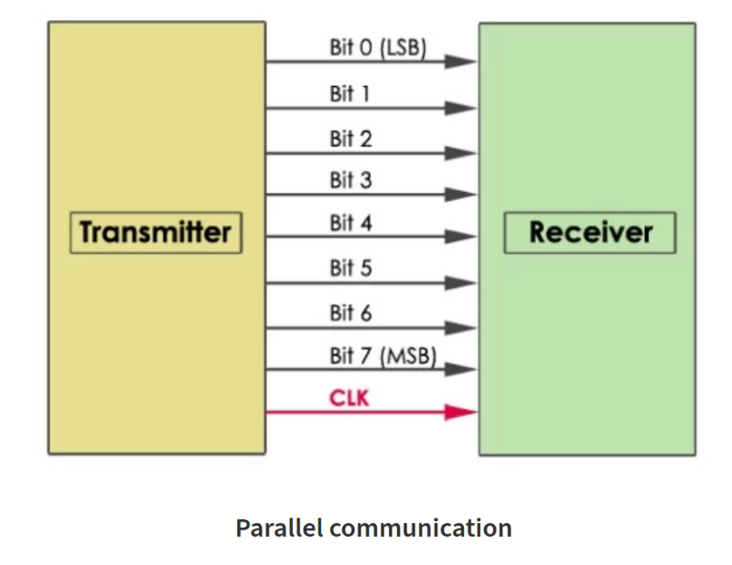

A single-ended signal is sent on one wire, measured against ground. In the other hand, a differential signal is sent on two wires, measured as the voltage difference between them. This makes it more resistant to noise.

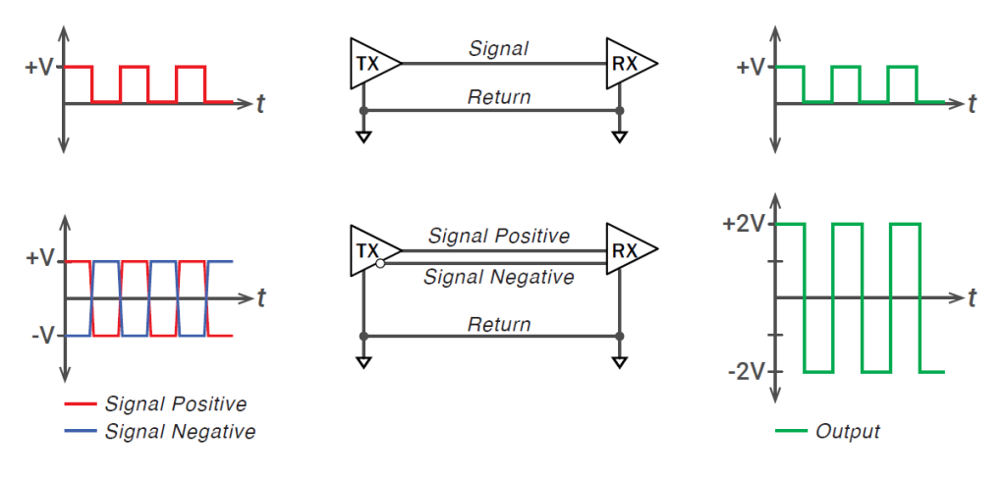

Introduction to CAN

CAN (Controller Area Network) is a robust serial communication protocol designed for reliable data exchange between microcontrollers and devices, especially in automotive and industrial systems.

In CAN protocol, all the modules (refered as nodes) are connected to a single communication bus.

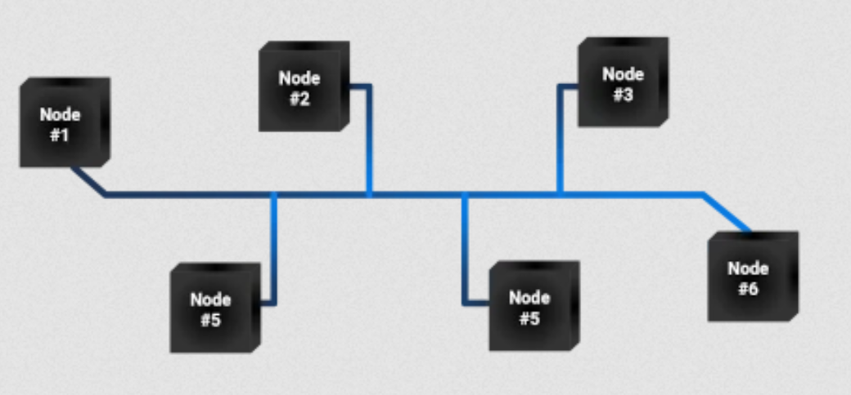

The difference between can and RS-485 is that in CAN there is no risk of data collision (i.e. multiples nodes communicating at the same time). The data collision is avoided by setting a communication priority: if two nodes talk at the same time, the one with the smallest ID (identifier) has the priority.

In terms of speed, CAN go up to 1Mbits/s but there has been an improved version of the CAN called the FD-CAN that can go to 8Mbits/s. So we can say that RS-485 communication is faster but in counterpart has a risk of data collision if compared to CAN communication.

Introduction to Analog

Analog (analogical communication) is a method of communication that sends or receives data using continuous signals, differently from RS485 and CAN signals that deals with digital discrete binary signals.

These continuous signals vary in amplitude, frequency and phase to represent data and can be, for example, currents, voltages, sound waves, etc. They are also well-defined at every time.

When we want to send a measurement via analog communication, the physical signal is converted into an analog signal by a transducer, such as the conversion of an acoustic wave into an electrical signal. The analog signal is going to be proportional to the physical signal it represents.

Analog communication depends of ADC analog-to-digital and DAC digital-to-analog converters to interface with digital systems.

Required Hardware

- 2 TWIST boards with SPIN
- 1 Ethernet cables (RJ45)
- 2 Electronic jumpers
- 2 Isolated alligator clips
- 2 Small banana cables
- PC 64-bits (windows or linux)

Required Software

- Git
- Visual Studio Code with PlatformIO

Pull the project in VScode from GitHub

First, we need to load the Blinky MMC arm code from the “Comm_tutorial_01” branch in https://github.com/analuhaas/tutorial-codes .
- Create a folder where you want the code to be pulled to and initialize git in the source control tab:
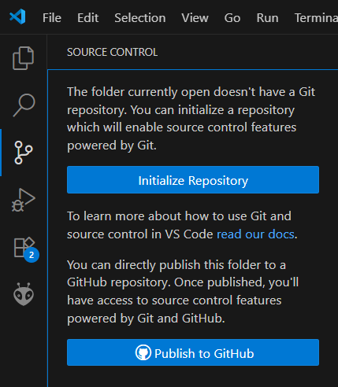
- Open Git graph window in VScode by clicking in the button marked in red:
- In the Git graph window, select the icon and to set the Remote Configurations compatible to the remote repository you want to pull from.
- Click on Add Remote and add a new remote repository with Fetch URL equal to https://github.com/analuhaas/tutorial-codes
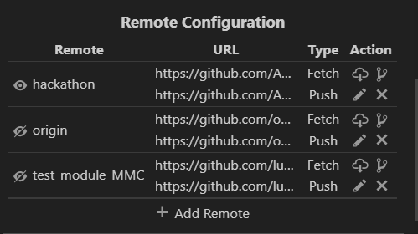
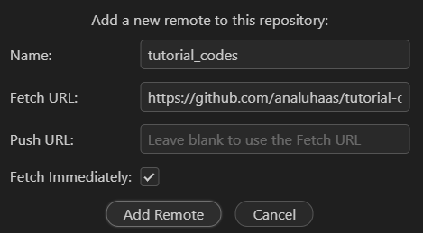
- In Git Graph window, click right on the branch and checkout to this branch keeping the same name for the local branch. In this tutorial it is the Comm_tutorial_01 branch.
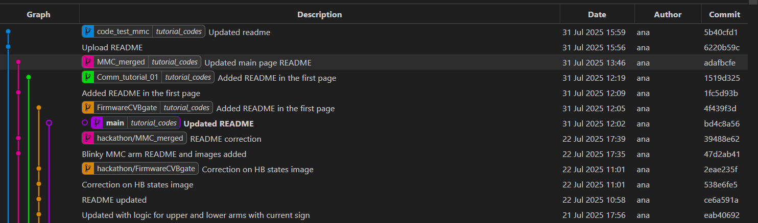
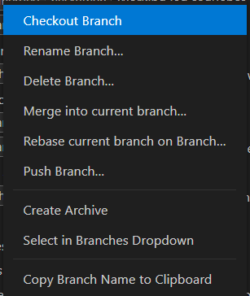
- Now you have the good code to execute the communication test in your VScode.

Code explanation

First, in the variable setup the structure that is going to test is the communication is successful for all RS485, CAN, Analog and Sync is defined:
* This structure holds variables for testing RS485, Sync, analog measurements, and status information.
*/
typedef struct {
uint8_t test_RS485; /**< Variable for testing RS485 */
uint8_t test_Sync; /**< Variable for testing Sync */
uint16_t test_CAN; /**< Variable for testing the CAN Bus */
bool test_bool_CAN; /**< Boolean variable for testing the CAN Bus */
uint16_t analog_value_measure; /**< Analog measurement */
uint8_t id_and_status; /**< Status information */
} ConsigneStruct_t;

The explanation of the code will be separated according to the communication protocol.

CAN communication

The CAN communication is handled in the background loop. First its enables the CAN control and Broadcasting.

communication.can.setCtrlEnable(true);
communication.can.setBroadcastEnable(true);

Then, the master board will store the control reference sent by the slave via CAN and sends a start order to the slave device so it continues to communicate with the master via CAN.

if(master){
/* Use the following function receives a control reference over CAN */
CAN_received_value = communication.can.getCtrlReference();
/* Use the following functions to send a start or stop order over CAN */
communication.can.startSlaveDevice();
// communication.can.stopSlaveDevice();
spin.led.toggle();

The slave board verifies if it received a start or a stop order from the master. If it continues to receive a start order, it keeps sending its control reference to the master over CAN communication. The ctrl_slave_counter is updated each time the background loop is executed.

} else{
/* The following functions retrieve any start stop order sent over CAN */
CAN_received_start_stop = communication.can.getStartStopState();
if(CAN_received_start_stop){
spin.led.turnOn();
/* The following functions sends reference over CAN */
communication.can.setCtrlReference(CAN_control_reference);;
}
ctrl_slave_counter++;

}

Analog communication

In the setup_routine() function, the master board analog communication is initialized and configured to send the analog_value_ref value continuously.
communication.analog.init(); /* Initializes the analog communication */
communication.analog.setAnalogCommValue(analog_value_ref); /* Sends an analog value by default from the master at initialization */

And the analog communication is also started for the slave board.

communication.analog.init(); /* Initializes the analog communication */

The slave board measures the received message sent via analog communication and stores in the variable analog_value_receive that is latter sent back to the master via RS485 communication for successfulness verification.

meas_data = shield.sensors.getLatestValue(ANALOG_COMM);
if (meas_data != NO_VALUE)
analog_value_receive = (uint16_t)meas_data;

Sync communication

The communication synchronization is initialized in the setup_routine for both master and slave. With this configuration, the master sends a synchronization pulse to the slave in order to synchronize the boards timers.

communication.sync.initMaster(); /* start the synchronisation as master */

communication.sync.initSlave(); /* sets the sync as slave */

RS485 communication

The RS485 communication is used to check on all communications protocols by checking if the values on the structure ConsigneStruct_t sent by the slave to the master are equal to expected.

Its configuration for the master board shows that the communication structure sent and receives respectively is of type ConsigneStruct_t.

communication.rs485.configure(buffer_tx,
buffer_rx,
sizeof(ConsigneStruct_t),
master_reception_function,
SPEED_20M); // custom configuration for RS485

Its configuration for the slave board shows that the reception function is different than the one for the master.

communication.rs485.configure(buffer_tx,
buffer_rx,
sizeof(ConsigneStruct_t),
slave_reception_function,
SPEED_20M); // custom configuration for RS485

In RS485 communication, buffer_tx and buffer_rx are pointers to the transmitted buffer (tx_consigne) and pointer to the received buffer (rx_consigne), respectively.

uint8_t* buffer_tx = (uint8_t*)&tx_consigne;
uint8_t* buffer_rx =(uint8_t*)&rx_consigne;

The sent and received buffers tx_consigne and rx_consigne are of type ConsigneStruct_t.

ConsigneStruct_t tx_consigne;
ConsigneStruct_t rx_consigne;

The communication is first configured and then turned on in the setup_routine using the function:

communication.rs485.turnOnCommunication();

Then, the master defines the reference value to be sent to the slave in the transmission buffer tx_consigne and starts communication in the critical_loop. It sets the test of successfulness to start after 50 master critical periods (5 ms).

if(master){
/* writting rs485 value */
tx_consigne.test_RS485 = rs485_send;

counter_time++; /* Counts time to not start immediately */
if (counter_time > 50){
test_start = true; /* Starts the test after 50 periods */
}
communication.rs485.startTransmission();

When the slave receives the transmitted message, its reception function slave_reception_function() is activated. It configures its transmission buffer according to the received messages from each communication:
- CAN: it sends if the CAN communication is maintained
- RS485: it sends back the received reference value of 125 + a step of 25
- Sync: it sends the critical function periods counter
- Analog: it sends the measured received value from analog communication

and starts communication to send these back to the master.

void slave_reception_function(void)
{
tx_consigne = rx_consigne; /* Matches the buffers to send back information */
tx_consigne.test_bool_CAN = CAN_received_start_stop; /* Sends the CAN start-stop state */
tx_consigne.test_RS485 = rx_consigne.test_RS485 + slave_rs485_step; /* Sends the RS485 reference plus a certain value */
tx_consigne.test_Sync = ctrl_slave_counter; /* Sends the counter of the critical function*/
tx_consigne.analog_value_measure = analog_value_receive; /* Sends the analog value measured */

communication.rs485.startTransmission();
}

When the master receives the message, its reception function master_reception_function() is activated. It performs the tests to verify if the communications were successful:
- CAN: successful if the control reference sent by the master via CAN communication (CAN_control_reference) was sent back by the slave to the master via CAN communication (CAN_received_value).
- RS485: successful if the master receives the test_RS485 value it sent (125) + a step (25) added by the slave.
- Sync: sucessful if the control counter of the slave is sent to the master more than 5 times
- Analog: successful if the slave analog measure received by the master via RS485 is within 50 quantum of the original value sent by the master via analog communication.

void master_reception_function(void)
{
/* Receives the data from the slave converter */
analog_value_receive = rx_consigne.analog_value_measure; /* receives the analog value from slave */
rs485_receive = rx_consigne.test_RS485; /* receives the rs485 reference value from slave */
sync_receive = rx_consigne.test_Sync; /* Receives the counter of the critical task from the slave*/

if(test_start){
if (rs485_receive == rs485_send + slave_rs485_step){ /* The RS485 is good is the master receives its reference value plus the step of the slave */
RS485_success = true;
}
if (analog_value_receive - analog_value_ref > 50 || analog_value_receive - analog_value_ref > -50){ /* The analog is good if the value received by the master is within 50 quantum of the value sent by the master */
Analog_success = true;
}
if(CAN_received_value == CAN_control_reference){ /* The CAN is good if the master has received the expected reference value from the slave via the control */
Can_success = true;
}
if(sync_master_counter < 5 && rx_consigne.test_Sync > 10){ /* The sync is good if the master has received a counter of the slave critical function more than 5 times */
sync_master_counter++;
if(sync_master_counter == 5){
Sync_success = true;
}
}
}
}

Hardware setup

In terms of hardware, you will connect the 2 boards as in the image using Ethernet cables. You will also connect the second board to a 6 V power supply to feed the SPIN board during the tutorial.

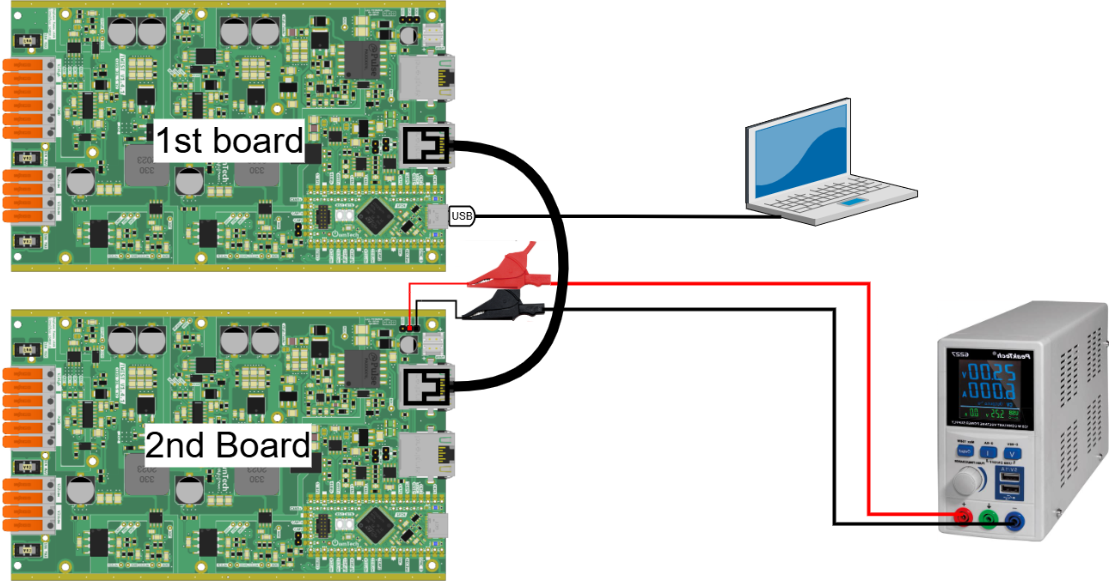

Executing the tutorial

First, you have to build and upload in each board the main.ccp code by changing the master variable to true before building and uploading to the first board and false before building and uploading to the second board.
After uploading the code to the two boards, execute the following steps to perform the tutorial:
- Turn on the power supply of the second board at 6 V.
- Open the serial monitor using the icon while connected with the first board via the USB-C cable.
- When finished, turn off the 6 V power supply and disconnect the USB-C cable.
If the tutorial is executed properly and the communication cables are well connected, you will have all communications to be succeeded as in the print:
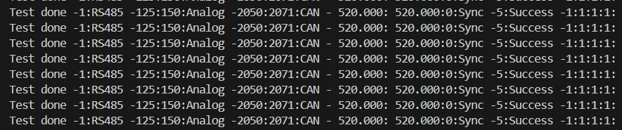

AC peer-to-peer
The purpose of this tutorial is to implement a system with two power electronics converters: a DC/AC converter producing a certain power and informing an AC/DC converter that it can consume this reference power.
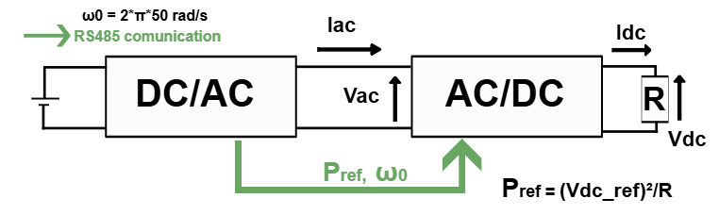
The DC/AC converter's task is to generate AC power for use in the electrical network, being connected to a DC generation like a solar panel for example (in our case the generation is going to be the DC power supply). The DC/AC converter is also called the SERVER converter in this tutorial.
The AC/DC converter’s task is to convert AC power back into DC power when the electrical network requires DC power for various applications, such as charging batteries or powering DC devices. The AC/DC converter is also called the SERVER converter in this tutorial.
In this tutorial, the DC/AC converter informs the AC/DC converter of the available power it can deliver. This information includes details like the power's magnitude and frequency.
A control loop composed of PI and PR controllers is used such that the DC/AC converter maintains an alternating current in phase opposition (180 degrees phase shift) with the input alternating voltage. This phase opposition ensures that power is effectively delivered to the load.
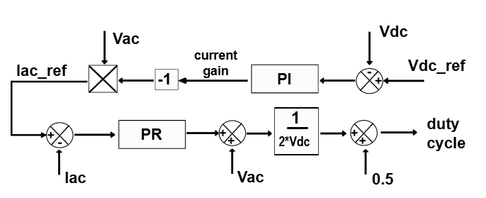

Required hardware
- 2 boards TWIST v_1_3 or later
- 64-bit PC (Windows or Linux)
- 50 V DC Power Supply
- 115 Ω Resistive Load
- Ethernet cable
- Oscilloscope or OnwPlot

Required Software
- Git
- Visual studio code

Create the Project
- First, we need to load the AC peer to peer base example.
In PlatformIO , go to Examples Twist under the Project Tasks tab and click on “AC peer to peer”.
The main.cpp file will be updated automatically. This is the file we will modify to implement the example.
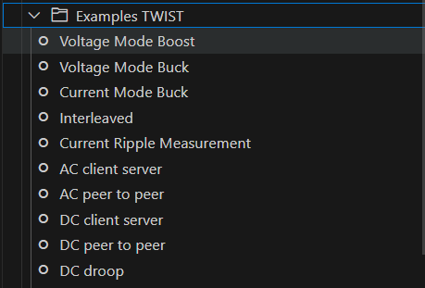
Next, create a new branch dedicated to the AC peer to peer example.
To learn how to create a new branch, refer to the tutorial "Saving Modifications to the Board Code."

Step-by-Step Implementation

- You need to first add the following lines to the platformio.ini file:
lib_deps=
control_pid = https://gitlab.laas.fr/owntech/power-api/opalib-control-pid.git
control_library = https://github.com/owntech-foundation/control_library.git
owntech_examples = https://github.com/owntech-foundation/examples.git
scope = https://github.com/owntech-foundation/scopemimicry.git

- Update the main.cpp code with the complete set of correction factors you calculated during the “Board Sensors Calibration” tutorial in the setup_routine() function

Your need to add the correction factors for the two boards you are using, for that you can use the structure:

#ifdef SERVER
data.setParameters(V_HIGH, 0.030031,-0.017898);
data.setParameters(V1_LOW, 0.044972283,-91.43827945);
data.setParameters(V2_LOW, 0.045018053,-91.8567704);
data.setParameters(I1_LOW, 0.004725748,-9.782756806);
data.setParameters(I2_LOW, 0.004402295,-9.021969522);
data.setParameters(I_HIGH, 0.004235355,-8.624550514);
#endif

#ifndef SERVER
data.setParameters(V_HIGH, 0.030031,-0.017898);
data.setParameters(V1_LOW, 0.044972283,-91.43827945);
data.setParameters(V2_LOW, 0.045018053,-91.8567704);
data.setParameters(I1_LOW, 0.004725748,-9.782756806);
data.setParameters(I2_LOW, 0.004402295,-9.021969522);
data.setParameters(I_HIGH, 0.004235355,-8.624550514);
#endif

Code explanation
- Drivers
- Owntech drivers let you use the power API and all other libraries.
- Zephyr libraries uses the RTOS (real-time OS) API that we use to manage tasks on the microcontroller.
- ScopeMimicry Library allows to capture live data and variables.
- Role definition
- Need to be modified according to the board role in the example before build and upload to the board
- #define SERVER // Role : SERVER or CLIENT
- User Variables declaration
In this section multiple variables used during the code are declared.
- f0: is the converter frequency.
- Udc: sets the voltage of the DC power supply used
- Ts: sets the sample time of the controllers.
- I_ac_ref: sets the AC side current reference that changes to the available power.
- P_ref: sets the power available reference communicated from the SERVER to the CLIENT.
- Rdc: sets the resistance of the load connected to the AC/DC converter output terminals.
- v_dc_ref: sets the DC output voltage reference for the AC/DC converter as sqrt(P_ref*Rdc)
- duty_cycle: stores the duty cycle of the converter.
- pwm_enable: it is a boolean flag indicates whether PWM is enabled or not (ON or OFF)
- control_task_period: defines the period of the control task.
- received_serial_char: stores the received command via serial monitor.
- meas_data: stores the last voltage and current measurements of the sensors.
- is_downloading: indicates ??
- Measurement variables are used to monitor voltage and current values.
  - The suffix "high" refers to input voltage or current.
  - The suffix "low" refers to output voltage or current.
- ScopeMimicry scope is created with 9 channels with 1024 data points per channel.
- The PR resonant control parameter are also defined
Communication variables:
- tx_consigne, rx_consigne: Two structures, one for Transmitter and one for Receiver, composed of Power reference information and its status.
- buffer_tx, buffer_rx: Pointer to the transmitted buffer and pointer to the received buffer, respectively.
- record_counter: stores the duration of the signal recording by the scope.
Board operation modes:
- enum lists the different that can be activated by the serial monitor commands:
enum serial_interface_menu_mode // LIST OF POSSIBLE MODES FOR THE OWNTECH CONVERTER
{
IDLEMODE = 0,
POWERMODE
};

Variables declared only if the board is SERVER:
- angle: stores the operation angle of the converter.
- Vac_ref: sets the AC side voltage reference.
Variables declared only if the board is CLIENT:
- V_ac_meas: stores the AC side voltage measured.
- gain_current: stores the output of the PI controller.
- PID related variables are also defined (only PI used, Td = 0).

- Auxiliary functions

The trigger function return true all the time, meaning that all data is recorded and there is actually no trigger. It is used as input for the scope used to record the measured data.
bool a_trigger() {
return true;
}
The dump_scope_datas function gets the scope measurements and records it by printing the measured values in the serial monitor screen.
void dump_scope_datas(ScopeMimicry &scope) {
uint8_t *buffer = scope.get_buffer();
uint16_t buffer_size = scope.get_buffer_size() >> 2; // we divide by 4 (4 bytes per float data)
printk("begin record\n");
printk("#");
for (uint16_t k=0;k < scope.get_nb_channel(); k++) {
printk("%s,", scope.get_channel_name(k));
}
printk("\n");
for (uint16_t k=0;k < buffer_size; k++) {
printk("%08x\n", *((uint32_t *)buffer + k));
task.suspendBackgroundUs(100);
}
printk("end record\n");
}
The reception_function is used to start the client reception of the data if the receiver id_status 6th bit is 1.
if (rx_consigne.id_and_status >> 6 == 1)
If yes, the status flag is updated and the scope starts to acquire data if the receiver id_status is 00100010 (2nd bit is 1).
if ((rx_consigne.id_and_status & 2) == 1)
This gives us two different states of id_and_status for the CLIENT:
- 00100000 identifies the intended receiver board to communicate these informations
- 00100010 the same and also states that the scope function can be started.
The P_ref value is also set to the value sent by the SERVER converter.
void reception_function(void)
{

#ifdef CLIENT
if (rx_consigne.id_and_status >> 6 == 1)
{
status = rx_consigne.id_and_status;

if ((rx_consigne.id_and_status & 2) == 1)
scope.start();

P_ref = rx_consigne.P_ref_fromSERVER;
}
#endif

}

- Hardware Setup Functions
In the function setup_routine(), first we setup the hardware
- spin.version.setBoardVersion(SPIN_v_1_0); configures the SPIN board version.
- twist.setVersion(shield_TWIST_V1_3); sets the TWIST board version.
Then, we set the twist operation mode (Buck, Boost or Inverter)
- twist.initLegBuck(LEG1) and twist.initLegBoost(LEG2): configures the power leg1 in Buck mode and power leg2 in Boost mode to obtain a inverter.
- data.enableTwistDefaultChannels()
Then, we configure the communication
- communication.rs485.configure(...): configures the communication between the two boards with the protocol RS485
- communication.sync.initMaster() and communication.sync.initSlave(TWIST_v_1_1_4) configures the PWM clock synchronization between the two Boards.
Then we set the correction factors for the measure voltages and currents.
- data.setParameters(...) sets the gain and offset for each onboard measurement.
Then it declare and initialize the application, communication and critical tasks.
If the board is the SERVER:
- pid.init(pid_params): initializes the pid controller with the pid_params parameters defined in the User variables declaration section.
- pid_current_control.reset(-gain_current): resets the pid output.
Finally, it starts the PR control and sets the scope configurations:
- scope.connectChannel(I1_low_value, "I1_low"): sets a scope channel name and associated variable.
- scope.set_trigger(a_trigger): sets the function used as trigger.
- scope.set_delay(0.0F): sets the delay to acquire a given amount of data before the trigger instant.
- scope.start(): initializes the scope.

- Loop functions
In the communication task, the SPIN listens to the serial port and, depending on the received character, it switches the converter operation between IDLEMODE and POWERMODE.
- In IDLEMODE and SERIALMODE, PWM is disabled and there is no power conversion.
- In POWERMODE, PWM is enabled, activating power conversion.
By using case “r”, the user can also do an individual scope acquisition.
In the application task:
- SPIN led is turned on if in POWERMODE
- A scope recording is performed if is_downloading == 1 (when “r” is pressed”)
- If the board is the CLIENT, it prints some information on the serial monitor while in POWERMODE.
- task.suspendBackgroundMs(100) suspends the application task for 100 µs.
In the critical task, the converter operation and communication is controlled.
- The measurements are stored within the measurement variables defined in the User variables declaration.
- In IDLEMODE, there is no power conversion since the pwm is disabled and the SERVER converter id_status is set to 00100000 (64), meaning that no scope acquisition should be made in the inactive mode.
- In POWERMODE for the SERVER board:
  - The pwm is enabled and there is power conversion.
  - The duty cycle is computed using a sinus with Vac_ref amplitude.
  - The id_status is updated according to the record counter and P_ref to be sent is also updated.
  - The communication transmission is started
  - At every critical task cycle, the scope acquires the measured data.
- The CLIENT board derives from the id_status if it should be in POWERMODE or in IDLEMODE. It is in POWERMODE if the last three bits gives a 1 or a 2.
if (record_counter == 0)
tx_consigne.id_and_status = (1 << 6) + 2;
else
tx_consigne.id_and_status = (1 << 6) + 1;

- During POWERMODE for the CLIENT:
  - The v_dc_ref is calculared
  - The PID and PR controllers are used to control the converter power output.
  - The scope acquisition is also done every 4 critical task cycles as indicated in.
if (critical_task_counter % 4 == 0)

Connect hardware and Power up
- For initial hardware setup, connect your TWIST boards in the image configuration:
- Connect Vhigh and GND of the SERVER TWIST board to the DC power supply (set current limit to 2 A).
- Connvect Vhigh and GND of the CLIENT TWIST board to a resistive load.
- Connect VLow1 and VLow2 terminals of the two TWIST boards
- Connect the USB-C port of the SPIN of the SERVER board to your PC via a USB cable.
- Turn on the DC power supply at 50 V.
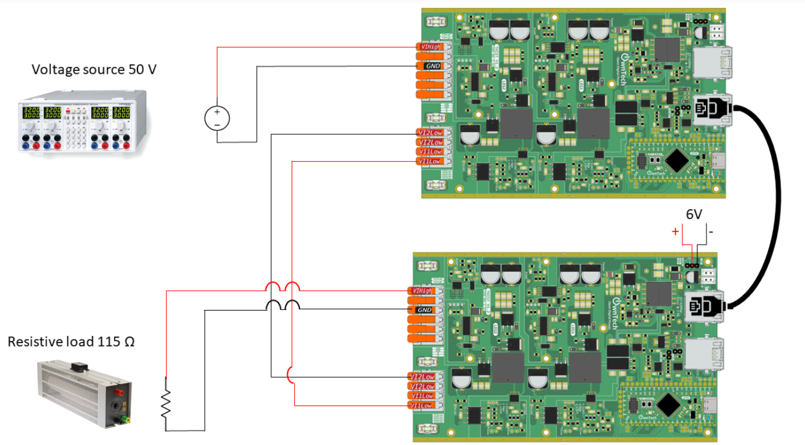
- Build  and Upload 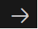
- Use OwnPlot or other oscilloscope to visualize your data and control the converter.
Voilà !

Expected Results

