eta



Tutorial TWIST-SPIN board

Hardware

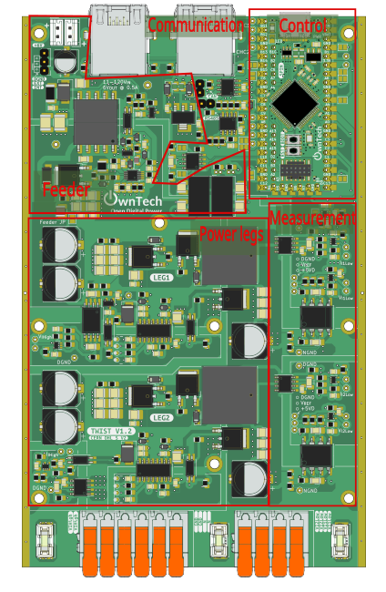

Table of contents
Introduction 4
Additional environment setup 4
Communication test 5
Objectives 5
Required Hardware 5
Required Software 5
Pull the project in VScode from GitHub 5
Code explanation 7
AC peer-to-peer 8
Required hardware 9
Required Software 9
Create the Project 9
Step-by-Step Implementation 9
Code explanation 10
Connect hardware and Power up 15
Expected Results 15

Introduction
The goal of this tutorial is to understand the hardware basics of the OnwTech TWIST boards . You can also refer to the “Tutorial_Twist_Board” for learning how to use the Twist board.

Composition of a power electronics converter

Power block

Power block main elements

A simplified schematic of the power electronics part of the Twist board is provided in the image below. It consists of an H-bridge converter.
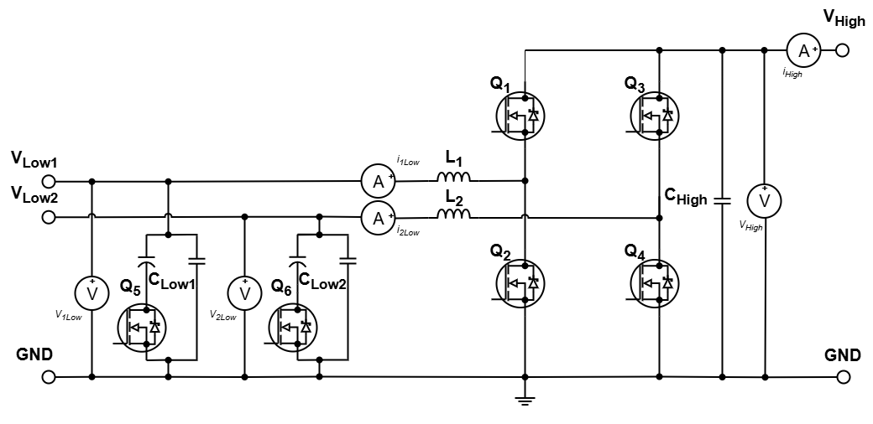

From the KICAD circuit of 1 H-bridge converter leg as really implemented in the Twist board in the image below, we can easily identify the equivalence of the marked elements with the simplified circuit.

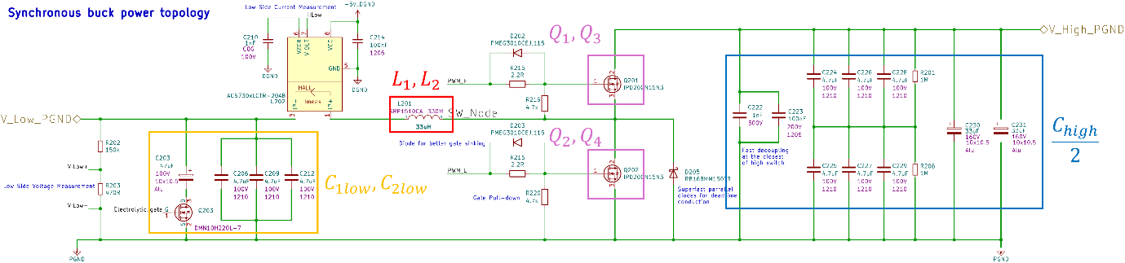

Passive elements

By comparing the KICAD for the Twist Board and the base circuit for the Power block, we identify the values of the inductors and capacitors:

Component | Value | Description
L1 | 33 µH | SRP1510CA Series - Shielded Power Inductors
L2 | 33 µH | Same as L1
CLow1 | 61,1 µF | 47 µF electrolytic capacitor and 3 ceramic capacitors of 4,7 µF in parallel. Only 47 µF electrolytic capacitor in series with Q5/Q6 MOSFET.
CLow2 | 61,1 µF | Same as CLow1
CHigh | 188,6 µF | For each leg: 2 ceramic capacitors of 100 nF and 1 nF in parallel for Fast Decoupling.  6 ceramic capacitors of 4,7 µF in parallel.  2 electrolytic capacitor of 33 µF in parallel.
Ceramic capacitors filter transient of higher frequency (switching) and electrolytic capacitors filter transient of lower frequency (ripple) and are used to store energy.
On the High side capacitor back, two ceramic capacitors are placed physically closer to the MOSFET terminal for Fast decoupling. They delete transients and noises generated locally and serves the fast current peaks, avoiding EMI problems.

MOSFETS

We identify in the OnwTech board circuit different MOSFETs.

The Q1 and Q2 forms the first half-bridge leg connected to the V1low terminal while Q3 and Q4 forms the second half-bridge leg connected to the V2low terminal. These are the most important elements on the board since they allow its reprogrammability.

The 2 half-bridge legs are identical such that it is only necessary to describe the Q1 and Q2 control. The MOSFETs used are NMOS having the symbol

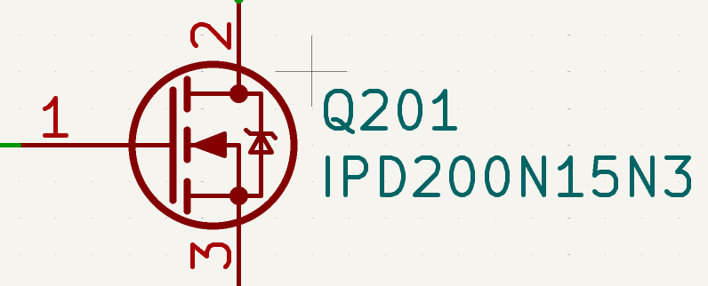

where 1 = Gate (G), 2 = Drain (D) and 3 = Source (S).

A NMOS has three main regions:
- Cut-off region (OFF state): Vgs < Vth, the switch doesn’t conduct (Id ≈ 0).
- Linear or ohmic region (ON state): Vgs > Vth e Vds < (Vgs - Vth), the switch behaves like a resistor.
- Saturation region (ON state): Vgs > Vth e Vds > (Vgs - Vth), the current Id is constant.

For applications in power electronics converters where the MOSFET is used as a switch, it operates only in the two first regions. The MOSFET regions are summarized in the figure:
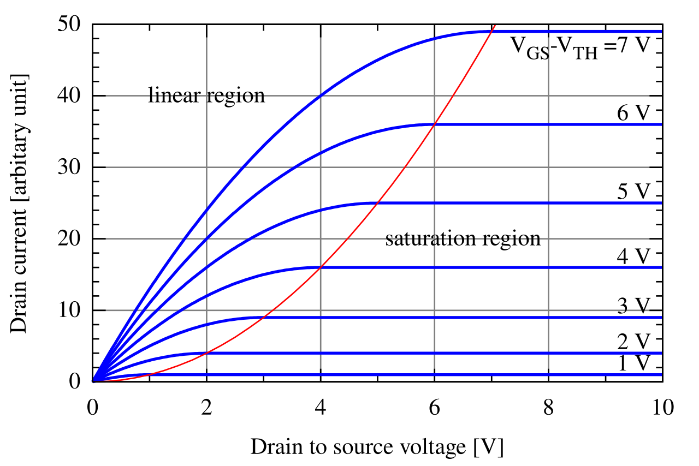

The Linear region is better for these applications since the MOSFET resistance Rdson during this region is small, reducing losses during conduction since Vds is kept low. Also, the drain current adapts itself to the load connected do the source terminal.

If the MOSFET would be used in the saturation region, the Vds voltage is higher and the drain current is almost constant no matter what Vds voltage is applied, having no adaptability on the current output with respect to the load. Therefore, using the saturation region is not interesting and we must ensure that Vg is set to keep the NMOS in the Linear region with the designed Rdson.

The MOSFET switching is controlled by a driver that adjusts the PWM sent by the microcontroller to be applied on the gate terminal. The driver PWM output is connected to the gate controlling switching such that:

- For ON state, conduction:
  - The gate driver applies a voltage Vg such that Vgs > Vth
  - The current Id goes up while Vds goes down, having on switching losses
- For OFF state, open:
  - The gate driver applies a voltage Vg=0V such that Vgs < Vth
  - Id goes to zero and Vds goes up quickly, having off switching losses

More specifically, these switches are controlled with the interface of a gate drive, which will be further explained afterwards.
The specific MOSFET used is IPD200N15N3 G is ideal for high frequency applications.

In the Twist board datasheet, we see that its switching frequency is 200 kHz.

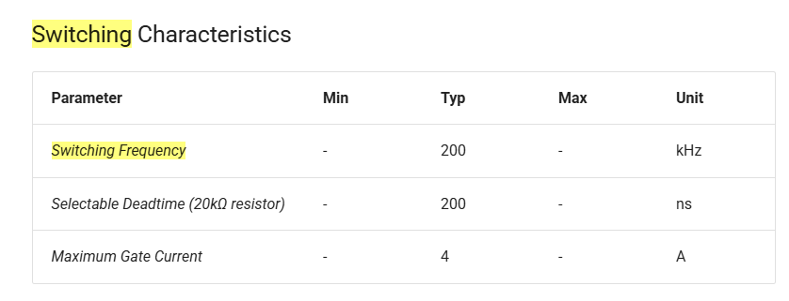

The Q5 and Q6 MOSFETs activated when the converter topology demands a extra capacitor in the low terminals, such as the Boost.

The gate of these switches is controlled by a input from the SPIN board “LEG_CAPA_DRIVE_DGND” that indicates if the capacitor should be connected or disconnected according to the converter topology. This connection indicator is interfaced with a optocoupler to isolate the digital and the power without propagation of noises or overvoltage to digital control (noise tolerance is low) that could be generated by the switching.

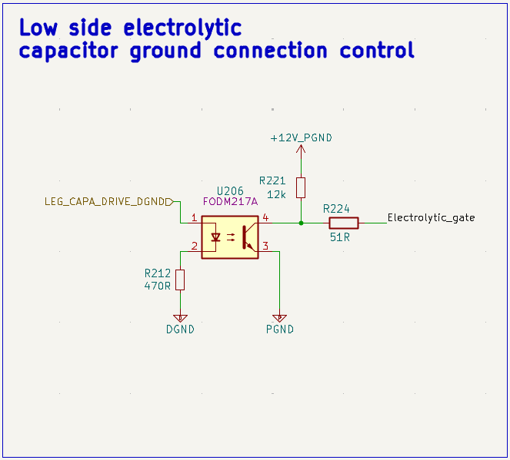

Dead time diodes

In a structure that have two complementary switches such as in the OnwTech board, there is a intermediary state called the dead time where both switches are OFF to avoid short-circuit between the source and the ground.

Ideally the switches don’t conduct during this period but the inductor current needs to keep flowing and, since the switch is off, the current is going to force its way into the body diode of the switch.
To avoid conduction losses on the body diode during the deadtime, an external fast Schottky diode that have lower voltage drop and faster switching is usually used.

Dead time diode working principal on a Buck:
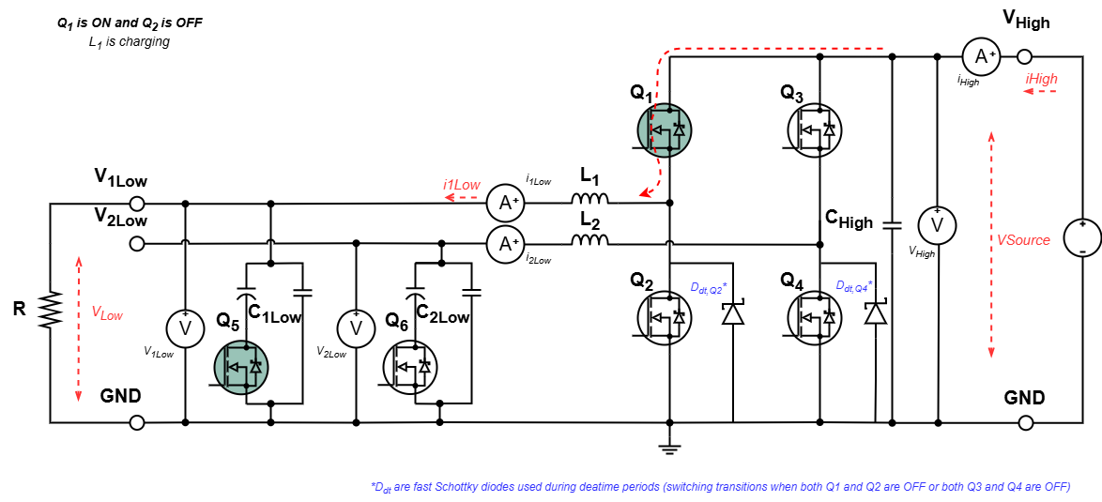
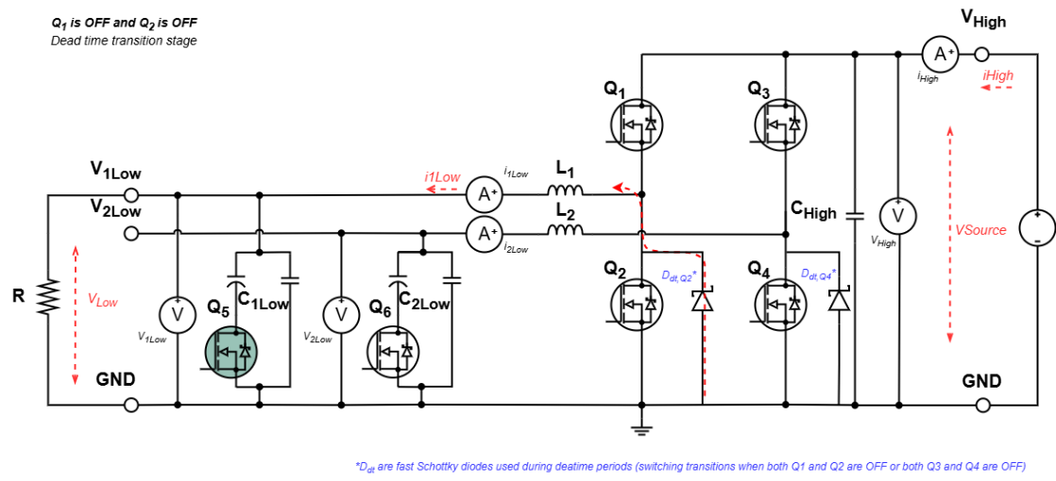
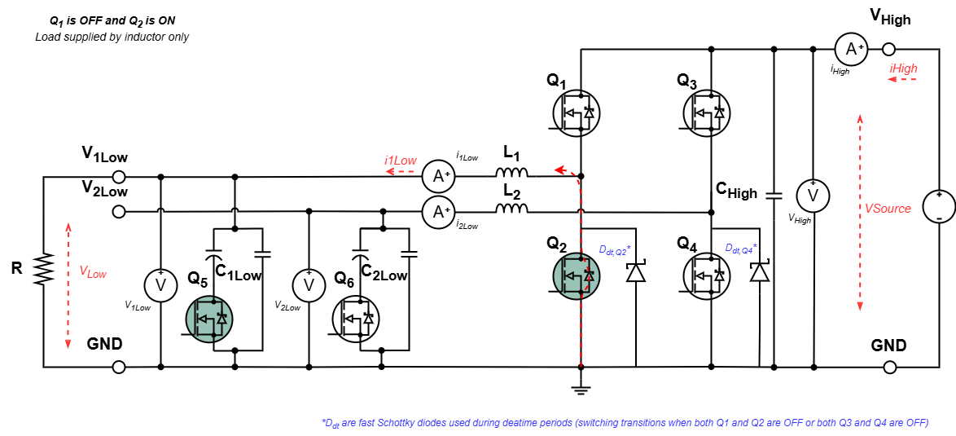

Dead time diode working principle on a Boost:
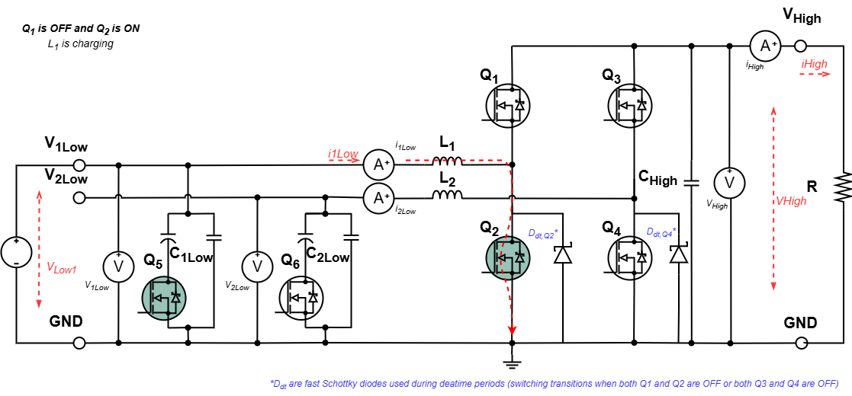
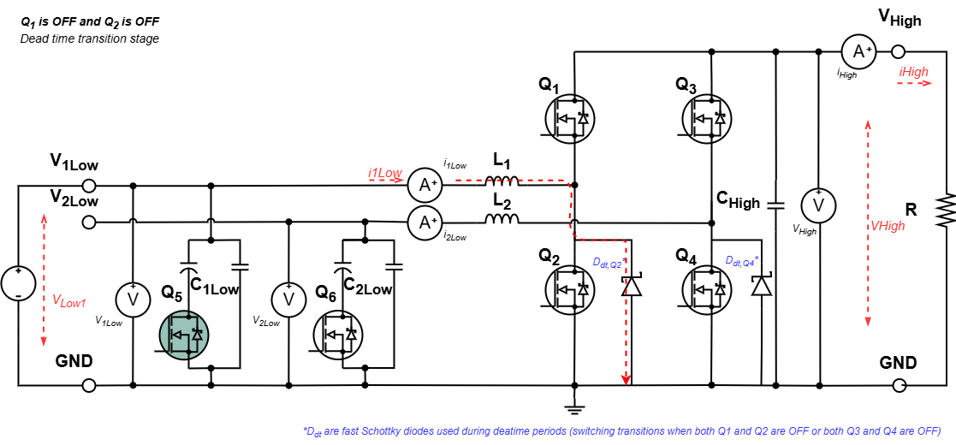
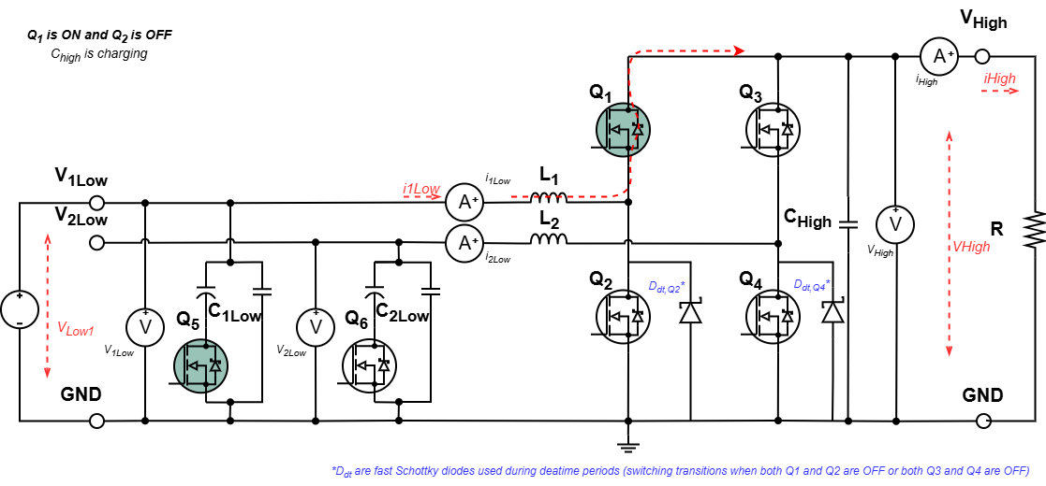

Dead time diode working principle on the inverter operation:
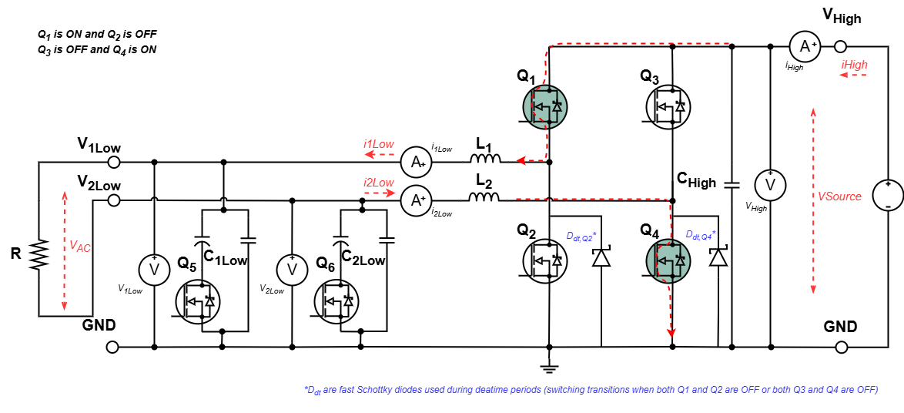
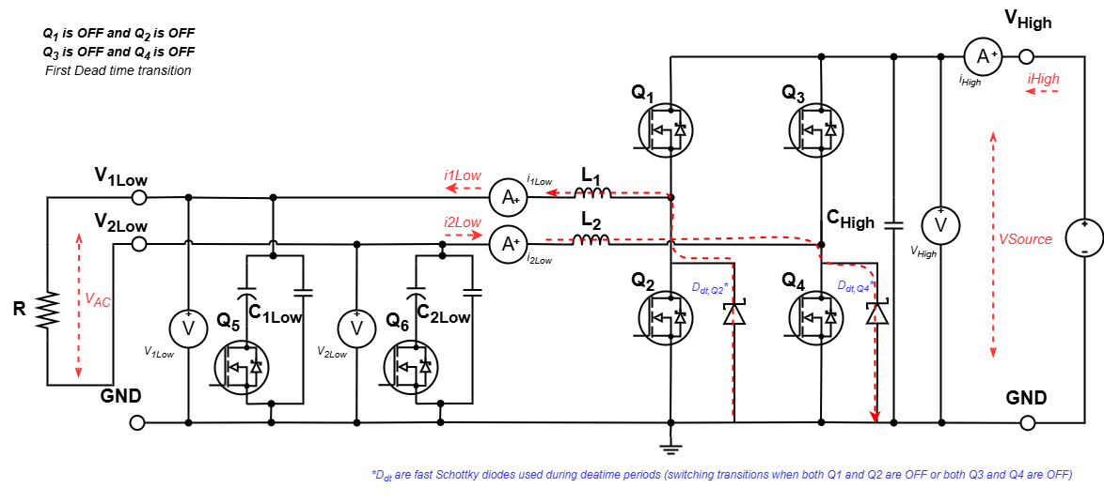
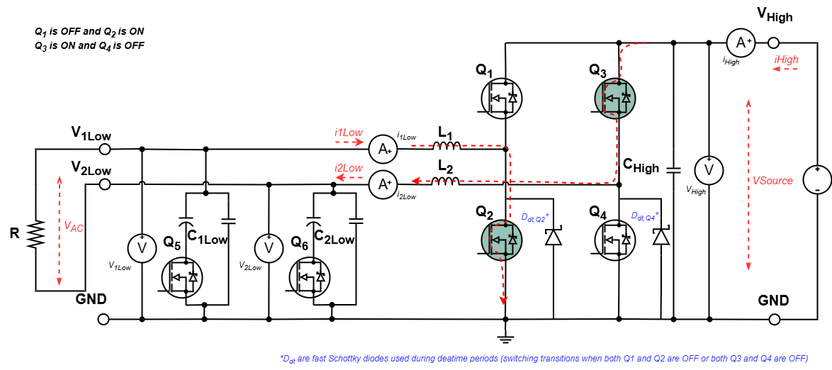
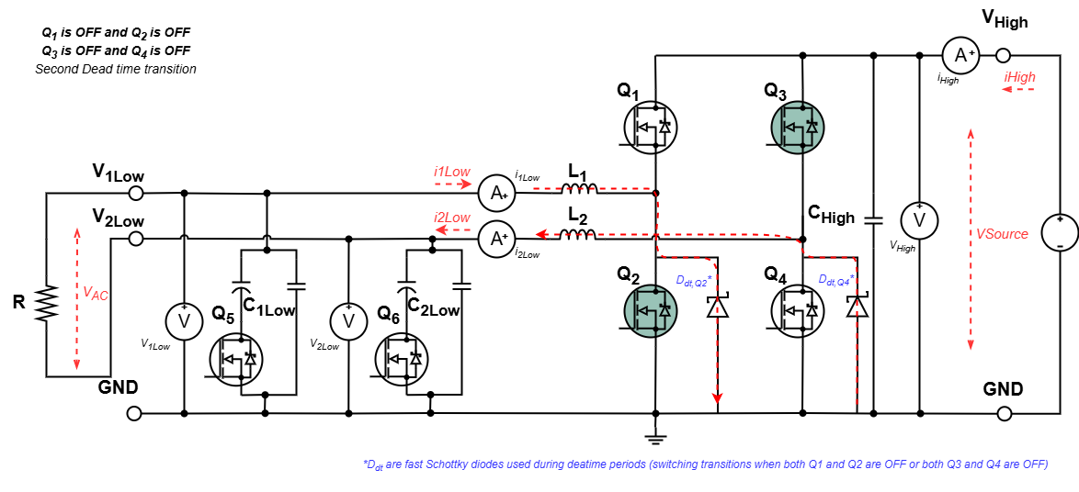

Driver block

Gate driver

The switches Q1, Q2, Q3 and Q4 are controlled by a PWM input from the microcontroller. Due to its complementarity, Q1 and Q2 are controlled by a single PWM, the same occurs for Q3 and Q4. The PWM input and the switch gate are interfaced by a driver to isolate the digital PWM from the power PWM and to adapt it to the gate voltage levels.

The IPD200N15N3 G MOSFET Vgs goes up to +/- 20 V and the Vgs threshold voltage typical value is 3 V.

The used driver is the UCC21222 from Texas Instruments.

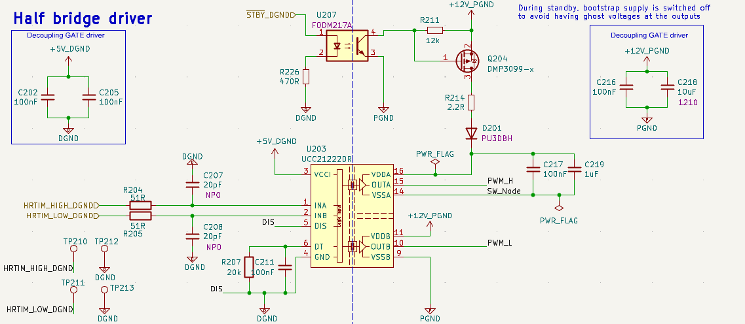

The driver PINs schematic is:
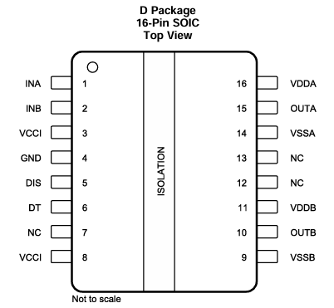
Inputs:
- INA receives the input signal for channel A. In the case of OnwTech Board, it receives the “digital PWM” for the upper switch.
- INB receives the input signal for channel B. In the case of OnwTech Board, it receives the “digital PWM” for the lower switch.
Outputs:
- OUTA is the output for channel A and gives the “power PWM” adapted to the gate of the upper MOSFET (Q1 in HB leg 1 or Q3 in HB leg 2).
- OUTB is the output for channel B and gives the “power PWM” adapted to the gate of the lower MOSFET (Q2 in HB leg 1 or Q4 in HB leg 2).
Power PINS:
- GND is the primary-side reference connected to the digital ground. It is the reference used for all digital inputs.
- VCCI is the primary-side supply voltage. In the case of OnwTech Board, this digital supply VCCI-GND is set to +5V.
- VDDA is the secondary-side power supply for channel A driver.
- VDDB is the secondary-side power supply for channel B driver. We can see more easily for channel B that VDD-VSS is set to 12 V.
- VSSA is the secondary-side ground reference for channel A driver.
- VSSB is the secondary-side ground reference for channel B driver.

Each output driver is independently supplied with a driver power supply (VDDA/B). The driver translates the input signal (INx) to the output side using the corresponding output supply voltage (VDDA/B) that defines the output logic voltage level going to the gate of the power device.

For example, in channel B, if VDDB-VSSB = 12V the driver output to turn on the MOSFET is going to be ~12V (HIGH level) and ~0V (= VSSB, LOW level) to turn it off.

For the input logic levels, if VCCI = 3,3V, the INA and INB PINs considers a signal above ~2V as "HIGH" and below ~0,8V as "LOW". The input values are referenced to VCCI, such that these HIGH and LOW ranges changes proportionally to VCCI.

If we configure the PINs of the GPIO activating the switches directly (not using embedded the PWM OnwTech function), we can see from the Logic Table of the driver that it is protected from short-circuit if both switches are set to HIGH at the same time. But using PWM is preferable !

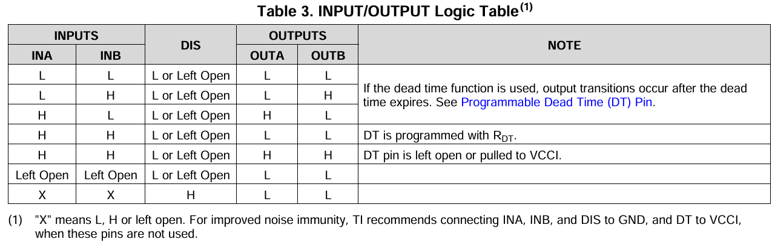

In the OwnTech board, the channels A and B output are treated differently. For channel B, the source terminal is connected to the ground such that the VDDB and VSSB references are directly imposed. But for channel A, the source terminal is connected to SW_node that is a floating reference. Because of that, a bootstrap circuit is needed to set VDDA and VSSA references.

Bootstrap circuit

The Bootstrap circuit ensures that the Vgs value are appropriate to turn on or off the MOSFET even if SW_node voltage is variable. For that, while the lower half-bridge MOSFET (Q2) conducts, the MOSFET Qbt is turned making that a current passes through diode D201 charging the bootstrap capacitor up to 12 V. This bootstrap capacitor is a parallel association of C217 and C219.

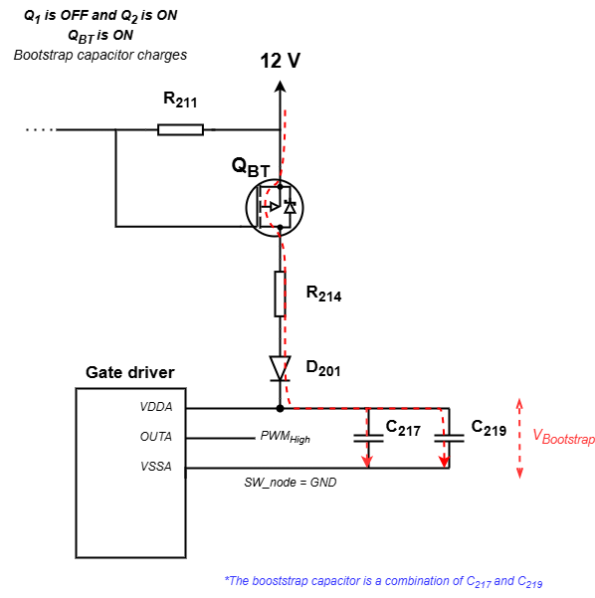

When the upper half-bridge MOSFET (Q1) is turned on, the MOSFET Qbt is turned off and a current no longer passes through the diode D201. Since the Bootstrap capacitor is charged, the VDDA supply is adapted to have +12 V over SW_node voltage. This ensures that the MOSFET is turned on when the digital PWM input for Q1 (INA) is in HIGH state.

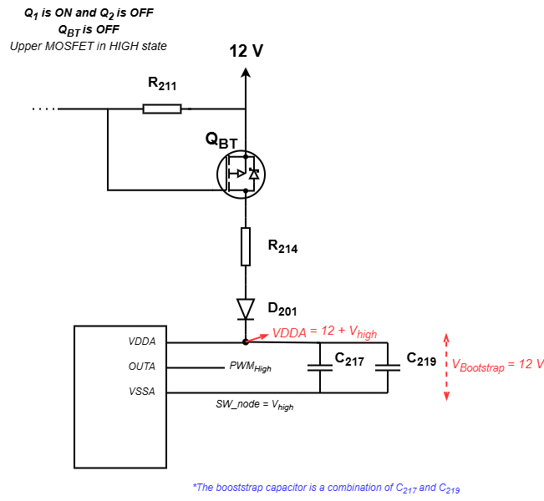

PWM

PWM channels
The spin has a total of 5 PWM channels with 2 complementary output each:
- PWMA
- PWMC
- PWMD
- PWME
- PWMF
The complementary outputs are used to control the switch pairs Q1-Q2 and Q3-Q4 in a complementary manner.

Modulation type and PWM strategies

The modulation types can be either Left aligned (CHA) or Center aligned (CHC) with respect to the Master counter, which is equal to have a sawtooth or a triangle wave form, respectively.
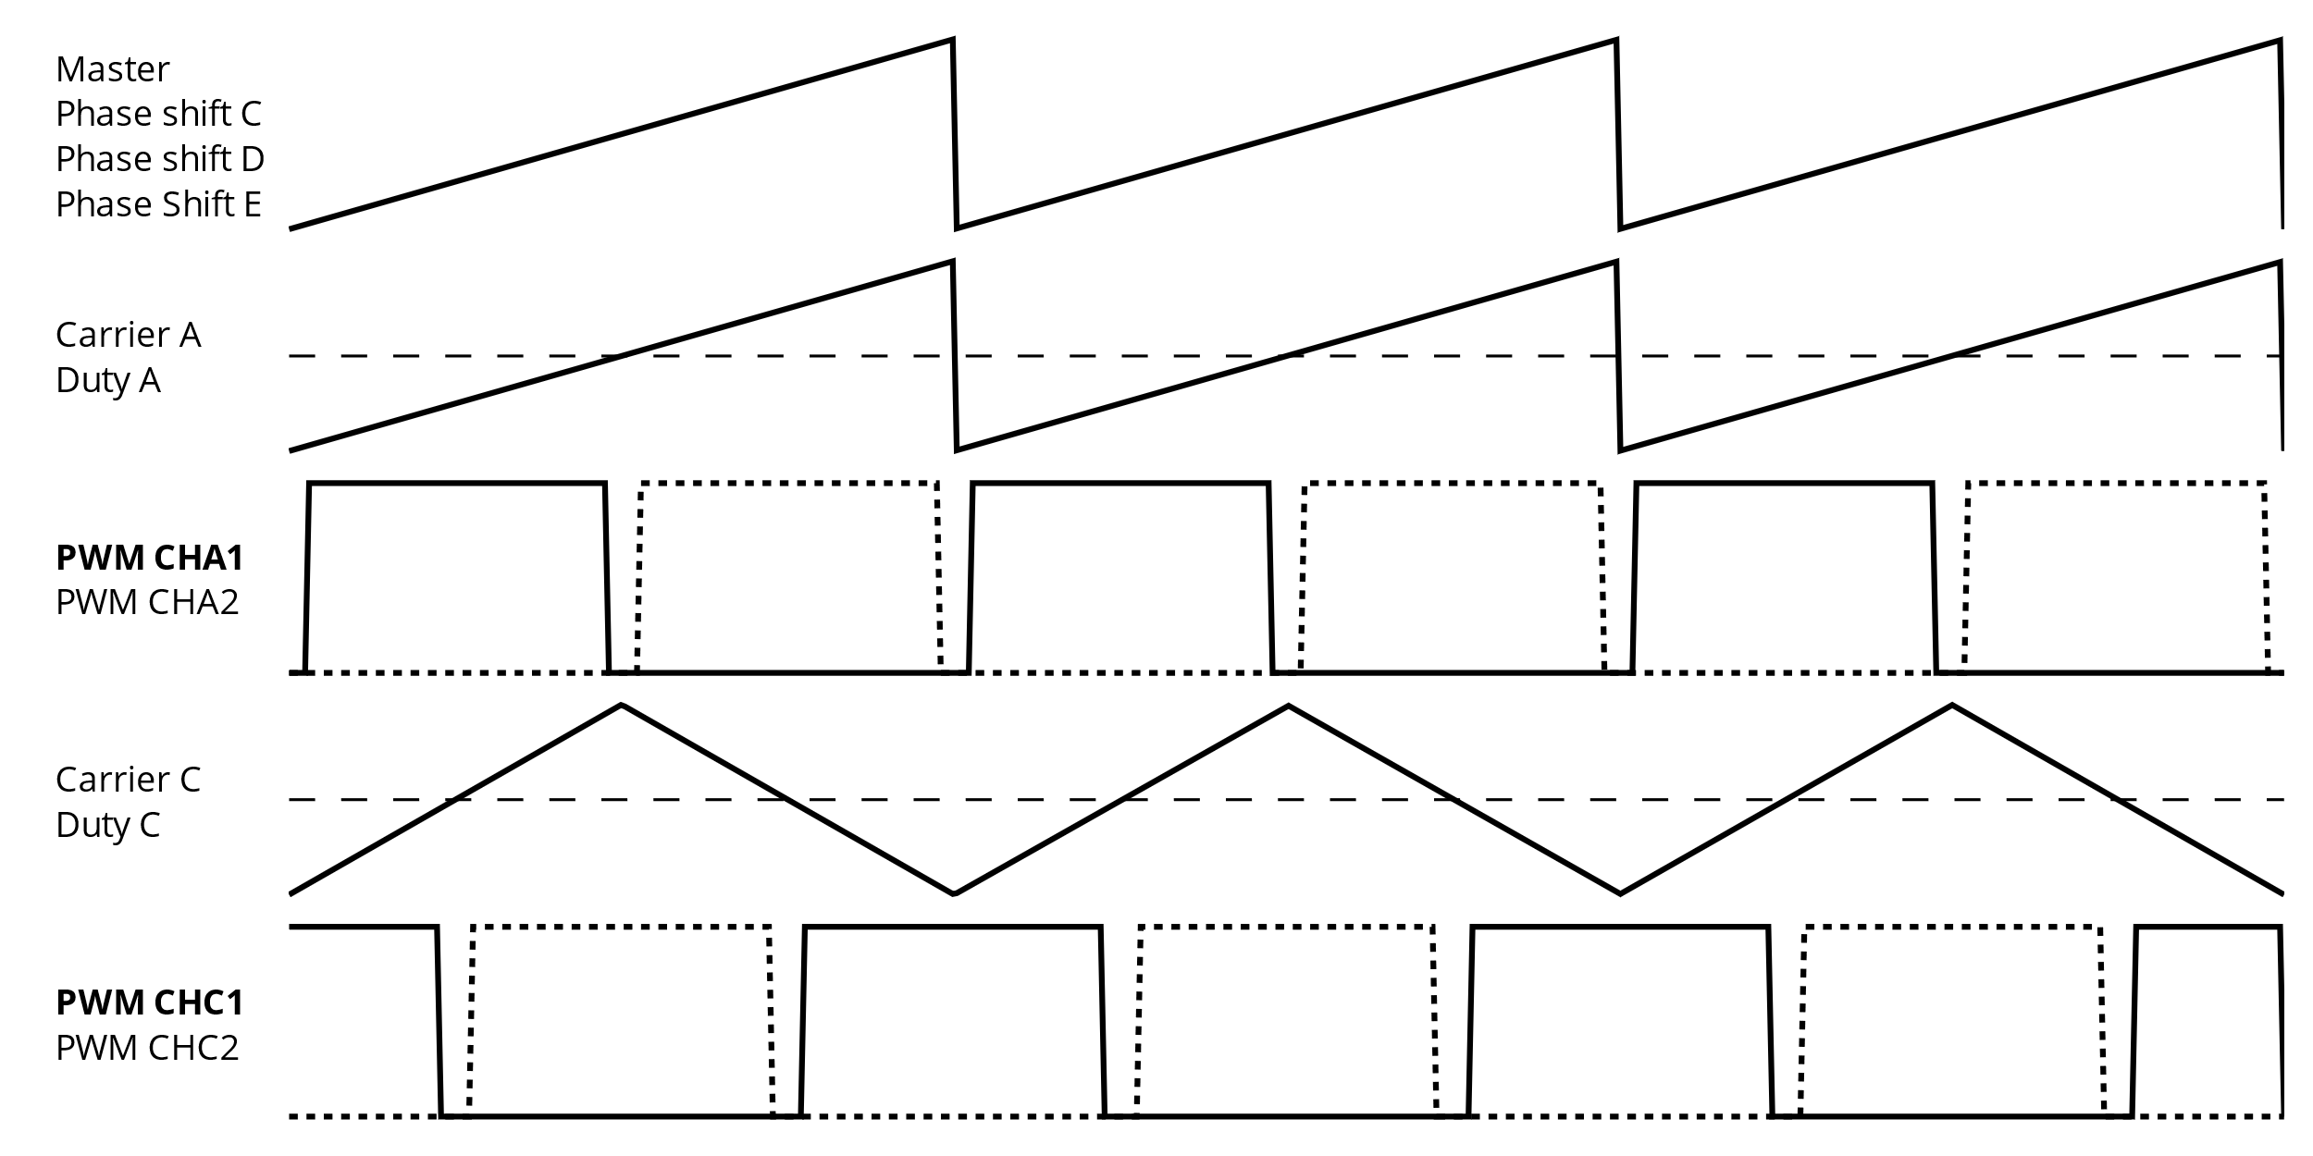

Different PWM strategies such as PS-PWM and LS-PWM can be created by manipulating the 5 PWM channels. For PS-PWM, we can phase-shifting the N used carriers (limited to N <= 5 in 1 board).

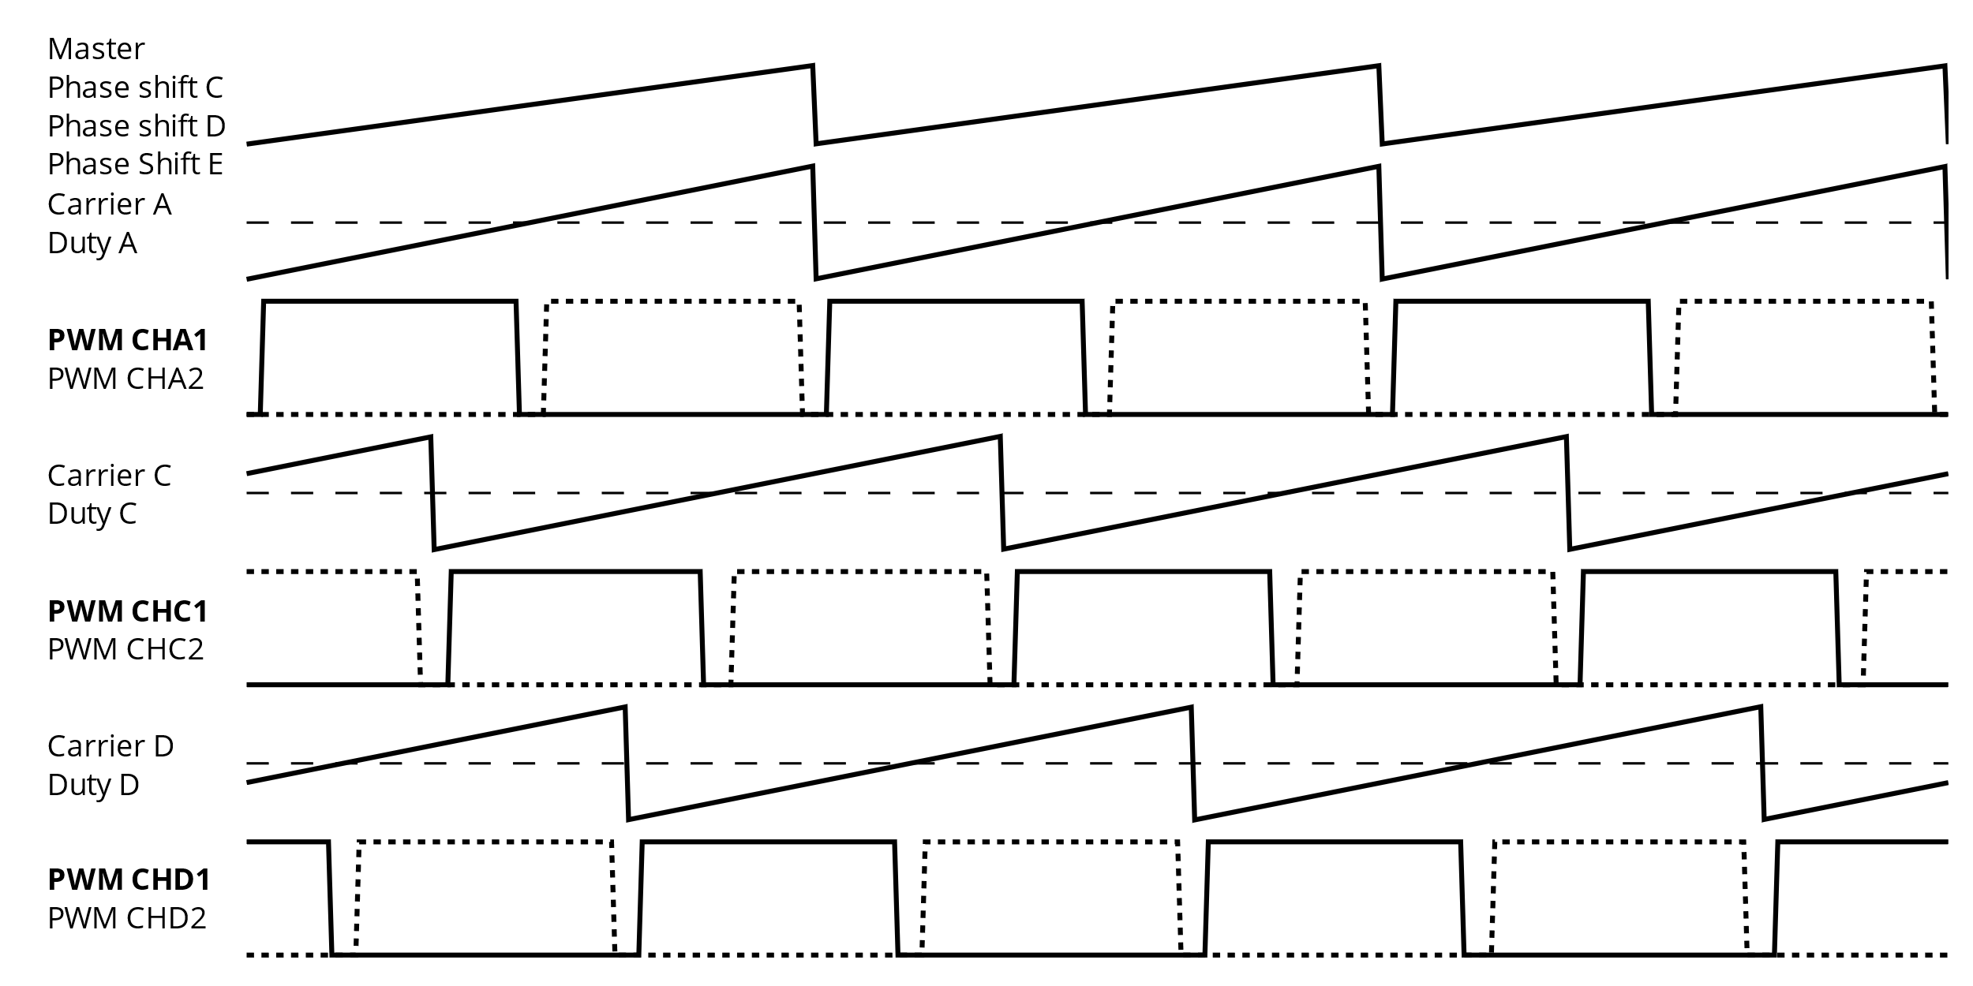

To phase shift the PWM carriers, we use:

spin.pwm.setPhaseShift(PWMA, 0);
spin.pwm.setPhaseShift(PWMC, 120);
spin.pwm.setPhaseShift(PWMD, 240);
A SPIN tutorial learns how to generate PS-PWM for a 2 leg interleaved configuration https://docs.owntech.org/latest/examples/SPIN/PWM/multiple_pwm/

Carrier frequency

The carriers frequency of the PWM can be modified with the function:

spin.pwm.setFrequency(200000); // Set frequency of pwm
Apparently only one switching frequency can be used for all PWM generated, which is not really a limitation thinking of topologies such as the MMC considering its traditional central controller configuration.

In OnwTech TWIST datasheet, the typical switching frequency is said to be 200 kHz but no upper or lower limitation are defined, which was confirmed with Jean. The maximum limitation could be set by the MOSFET characteristics cause $T_{sw} =\frac{1}{f_{sw}}$ shoudn’t be smaller than$t_{rise} + t_{fall} = 17 ns$.

This gives us $f_{sw} max \sim 58 MHz$for the IPD200N15N3 G MOSFET.

Duty cycle

The duty cycle for each PWM channel can be set individually with the function:

spin.pwm.setDutyCycle(PWMA, 0.8);

The duty cycle is set to a constant value in the DC/DC examples but in the DC/AC or DC/AC converter topologies it is set to a sinusoidal shape as follows and the same could be used for the case of the MMC:

static uint32_t control_task_period = 100; //[us] period of the control task

/* Sinewave settings */
static const float f0 = 50.F;
static const float w0 = 2 * PI * f0;
#ifdef GENERATOR
static float angle = 0;
static float Vac_ref;
#endif
static const float Udc = 25.0;
static const float32_t Ts = control_task_period * 1e-6F;

angle += w0 * Ts;
angle = ot_modulo_2pi(angle);
Vac_ref = 10.0F;
duty_cycle = 0.5 + Vac_ref * ot_sin(angle) / (2.0 * Udc);
shield.power.setDutyCycle(ALL,duty_cycle);

The duty cycle in this example is a sinusoidal wave centered at 0.5 with amplitude equal to $\frac{V_{ac,ref}}{2U_{dc}}$.

Dead time

The dead time configuration, as explained before, serves to avoid to short-circuit the H-Bridge leg switches. The dead time can be configured symmetrically, having the same dead time for leading and trailing edge:

spin.pwm.setDeadtime(PWMA, 100, 100);
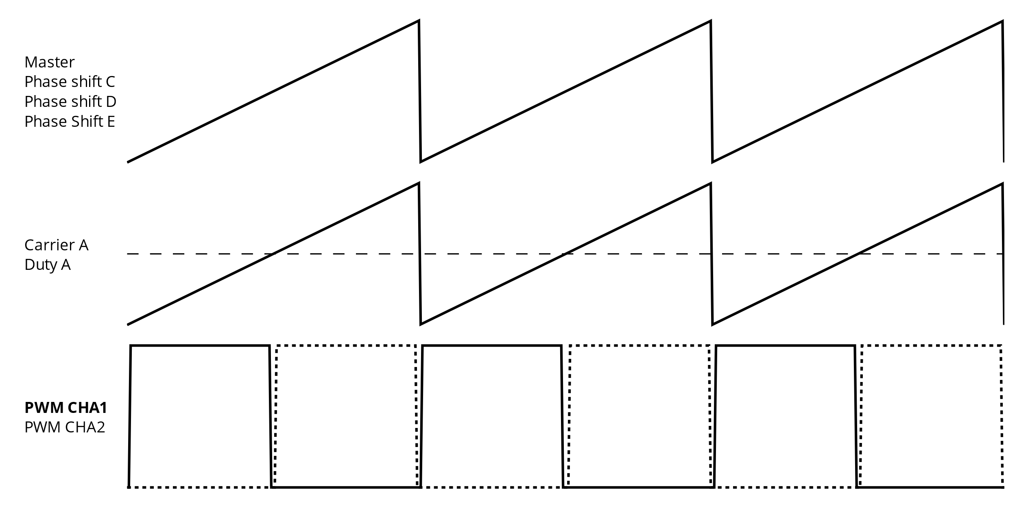

Or it can be set asymmetrically:

spin.pwm.setDeadtime(PWMA, 100, 100);
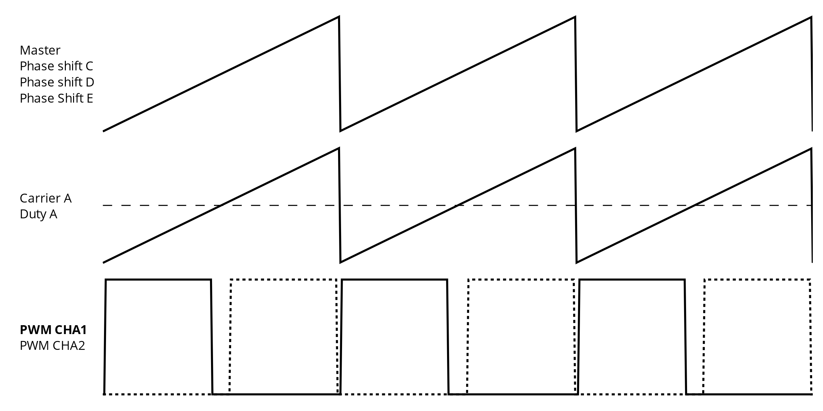

Switch conventions

With the function below, the PWM can be started to HIGH switch (PWMx1) or LOW switch (PWMx2) convention:

spin.pwm.setSwitchConvention(PWMA, PWMx1);
This is automatically set when we initialize the legs as Buck (HIGH convention) or Boost (LOW convention).

Initialization sequences and ADC

Apparently, there is a initialization sequence of the PWM with software or hardware trigger.
Note: I do not understand why it doesn’t appears each time in the OnwTech examples and the use of the ADC trigger.

Software triggered:

spin.pwm.initFixedFrequency(frequency);
spin.pwm.setModulation(PWMA, UpDwn);
spin.pwm.setSwitchConvention(PWMA, PWMx1);
spin.pwm.setMode(PWMA, VOLTAGE_MODE);
spin.pwm.initUnit(PWMA);
spin.pwm.setDeadTime(PWMA, 200,200);
spin.pwm.setDutyCycle(0.5);
spin.pwm.startDualOutput(PWMA);

Hardware triggered:

spin.pwm.initFixedFrequency(frequency);
spin.pwm.setModulation(PWMA, UpDwn);
spin.pwm.setAdcEdgeTrigger(PWMA, EdgeTrigger_up);
spin.pwm.setSwitchConvention(PWMA, PWMx1);
spin.pwm.setAdcDecimation(PWMA, 1);
spin.pwm.setMode(PWMA, VOLTAGE_MODE);
spin.pwm.initUnit(PWMA);
spin.pwm.setDeadTime(PWMA, 200,200);
spin.pwm.setAdcTrigger(PWMA, ADCTRIG_1);
spin.pwm.enableAdcTrigger(PWMA);
spin.pwm.setDutyCycle(0.5);
spin.pwm.startDualOutput(PWMA);

PWM synchronization

In the case of connection of multiple boards with peer to peer control, it will be necessary to
synchronize their PWM. OnwTech already did it using a master-slave PWM configuration. The synchronization is done according to the reference manual RM0440 of the MCU used (STM32G474) in section 28.3.19 Synchronizing the HRTIM with other timers or HRTIM instances.

