eta


Tutorial TWIST MMC

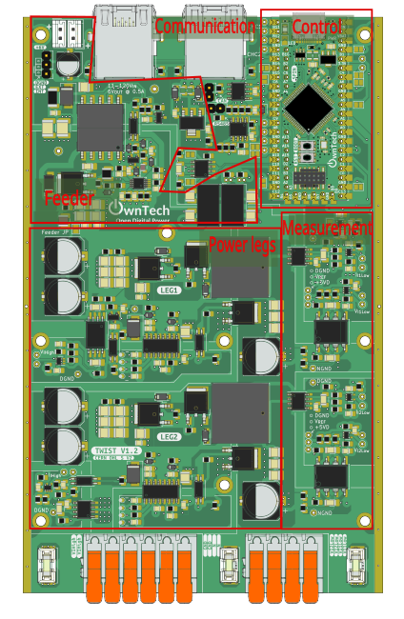

Table of contents
Introduction 4
Additional environment setup 4
Using Scope Mimicry library 4
Blinky MMC stack 6
Objectives 6
Required Hardware 6
Required Software 6
Get tutorial code from VScode 6
Hardware setup 7
Executing the tutorial 8
Expected results during POWER mode 9
Sorting algorithm (CVB) 10
Objectives 10
Required Hardware 11
Required Software 11
Get tutorial code from VScode 11
Hardware setup 12
Executing the tutorial 12
Expected results 13
Individual MMC module test 15
Objectives and context 15
Required Hardware 17
Required Software 17
Get tutorial code from VScode 17
Hardware setup 18
Executing the LF module test 22
Executing the HF module test 22
Expected results 22
MMC stack test in open-loop 26
Objectives and context 26
Required Hardware 28
Required Software 28
Get tutorial code from VScode 28
Modules Hardware setup 29
Module Software setup 30
Stack Hardware setup 30
Executing the tutorial Stack test 34
Expected results 35
Code explanations 37
Code explanation for Blinky MMC 37
Code explanation for CVB algorithm test 43
Code explanation for LF (low frequency) module test 47
Code explanation for HF (high frequency) module test 49
Code explanation for arm test – no CVB 51
Code explanation for arm test – with CVB 51

Introduction
The goal of this tutorial is to use the OnwTech TWIST boards to build an MMC progressively. Please refer to the “Tutorial_Twist_Board” for learning how to use the Twist board before starting this new series of tutorials.

Additional environment setup

After the basic environment setup on “Tutorial_Twist_Board”, you will also need to:
- Install Git graph in VScode.



- Follow this tutorial to create a SSH key and add it to your GitHub account: https://medium.com/@techworldthink/a-beginners-guide-to-adding-ssh-key-to-github-windows-6a5de5396ba6

- If your PC user is not administrator, you will need to modify the file in which you will save the SSH key in Step1:

Enter file in which to save the key (C:\Users\admin/.ssh/id_rsa): C:\Users\your-user-name/.ssh/id_rsa

Then, you will probably have this warning when trying to follow Step 3 in the tutorial:
@@@@@@@@@@@@@@@@@@@@@@@@@@@@@@@@@@@@@@@@@@@@@@@@@@@@@@@@@@@
@ WARNING: UNPROTECTED PRIVATE KEY FILE! @
@@@@@@@@@@@@@@@@@@@@@@@@@@@@@@@@@@@@@@@@@@@@@@@@@@@@@@@@@@@
Permissions for 'C:\\Users\\your-user-name/.ssh/id_rsa' are too open.
It is required that your private key files are NOT accessible by others.

This should concern you if you share your PC with other people, if it is the case, you should get in touch with the IT team of the lab.

Using Scope Mimicry library

The Scope Mimicry library allows to capture live data and variables within the main.cpp code. Its configuration consists of defining its sample length and number of channels with the following line of code:

ScopeMimicry scope(sample_lenght, number_of_channels);

That are:
- Sample length = how many points are acquired (e.g. 512, 1024, 2048)
- Number of channels = how many variables we measuring

The channels are configured by setting the variable we want to track and a string corresponding to the variable legends in the scope with the following line of code:
scope.connectChannel(I1_low_value, "I1_low");

We also use a trigger function that returns a bool value, that will trigger the scope when returning 1. For example:

bool a_trigger()
return (myVariable == 1)

The trigger is set using:
scope.set_trigger(&a_trigger);

We can also set a delay to acquire some data before the trigger moment with:
scope.set_delay(0.0F);

The scope is started with:
scope.start();

But it only launch the acquisition when using:
scope.acquire();

Blinky MMC stack

Objectives
The goal of this tutorial is to do a first MMC stack without using power with the following structure:
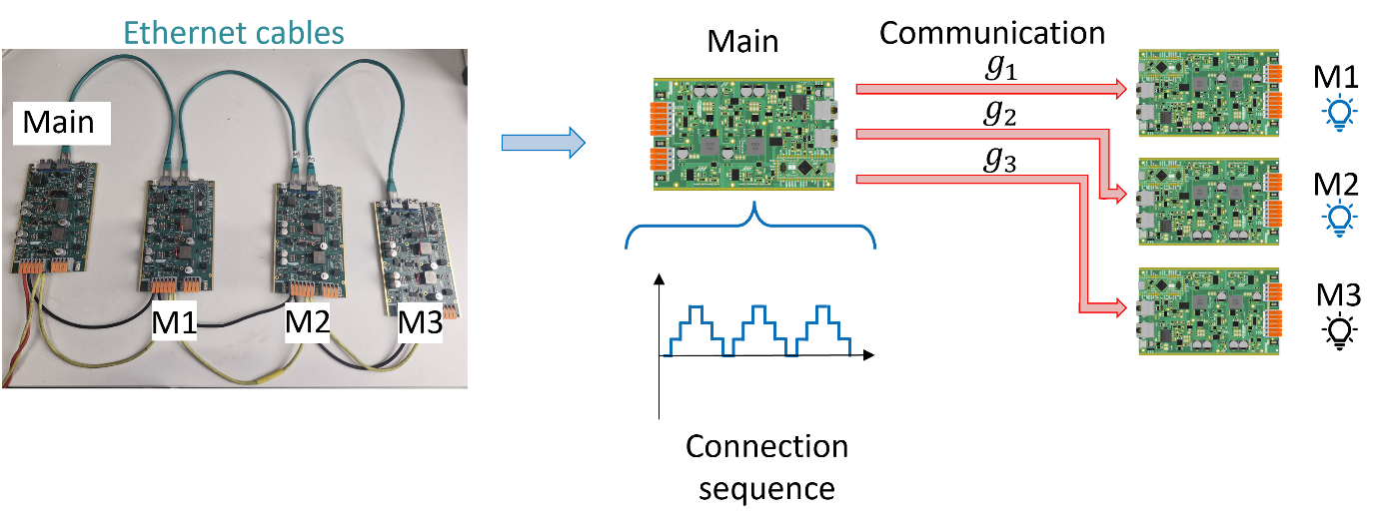
The main board serves as the central controller in the classical structure of the MMC. It will generate a connection sequence going from 0 to 3 that indicates how many modules should be connected. Then, it choses which modules to connect according to the preset preference order M1 → M2 → M3.
Then, the main board sends the connection commands g1, g2 and g3 via the Ethernet cables to the M1, M2 and M3 boards. If the board receives the command to be connected, it turns ON its SPIN board LED. If the board receives the command to be disconnected, it turns OFF its SPIN board LED.

Required Hardware

- 4 TWIST boards with SPIN
- DC Power Supply (48 V, 2 A)
- 3 Ethernet cables (RJ45)
- Cables to connect with the power supply
- PC 64-bits (windows or linux)

Required Software

- Git
- Visual Studio Code with PlatformIO

Get tutorial code from VScode

First, we need to load the Blinky MMC stack code from the OwnTech example repository version in https://github.com/analuhaas/examples
- In VScode, open the folder where you previously cloned OwnTech’s github.
- In platformio.ini file, substitute the owntech_examples variable link by https://github.com/analuhaas/examples.git
- Go to platform.io icon , go to Examples Twist under the Project Tasks tab and click on “Blinky MMC arm”.
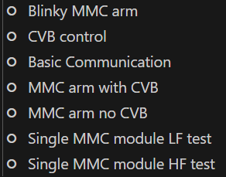
- Now you have the good code to execute the tutorial in your VScode.

Hardware setup
In terms of hardware, you will connect the 4 boards as in the image:
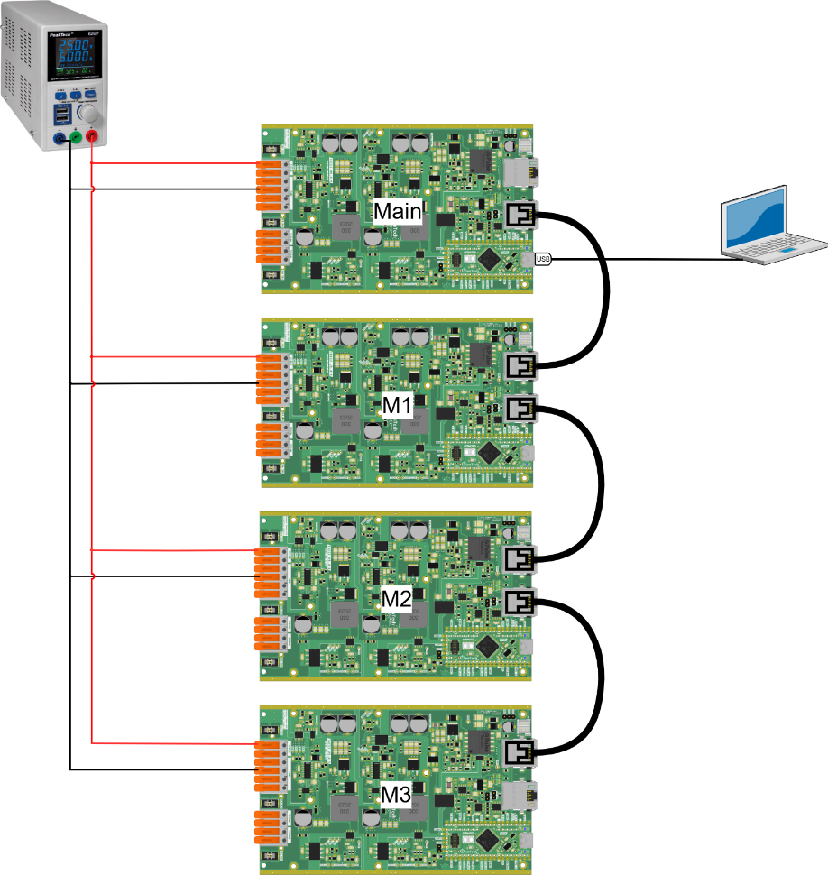

After making the connections and connecting the PC to the main with the USB-C cable, you should have something like this:

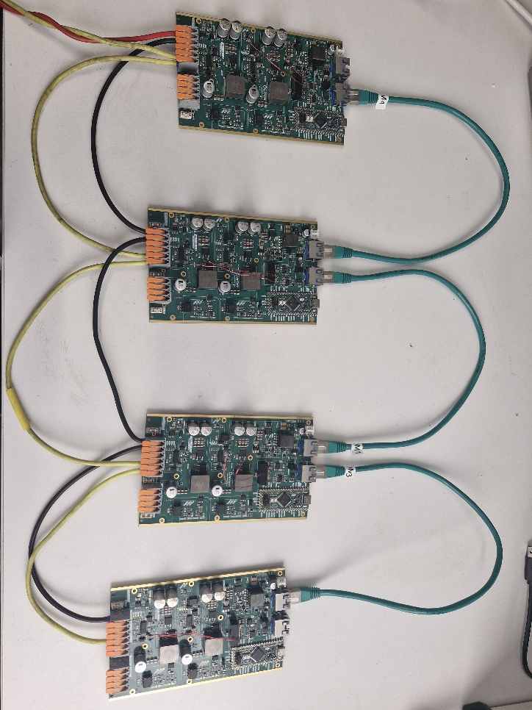
We connect the boards in series and set the power supply to 15 V in order to power the boards Auxiliary Power Supplies (APS). This is necessary cause the APS is used to power the communication devices and the microcontroller of the boards.

Executing the tutorial

- Optional: Change switching frequency using sw_period variable (default 20000 equivalent to 0.5 Hz)
- Build  and Upload 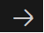 main.ccp code to the board changing the variable module_ID to MMC_LEAD, MMC_SM1, MMC_SM2 or MMC_SM3 according to the board function.
- Repeat step 2 for all 4 boards

/* --------------USER VARIABLES DECLARATIONS------------------- */

/* TODO : Define module_ID depending on the ID of the board */
uint8_t module_ID = MMC_SM1; // The ID of the module, can be set to MMC_LEAD or any other SMx
- Open the serial monitor using the icon with USB-C cable connected with the master, as shown in the hardware setup.
- Press h to display the help menu.
- The main and M1, M2 and M3 boards starts in IDLE mode.
- Turn on the power supply around 15 V to power the 4 SPIN boards.
- Press p to switch to POWER mode and the modules LEDs will start to light up and off according to the connection sequence.
- Press i to switch to IDLE mode and stop the stack operation.
- Turn off the power supply.

Expected results during POWER mode
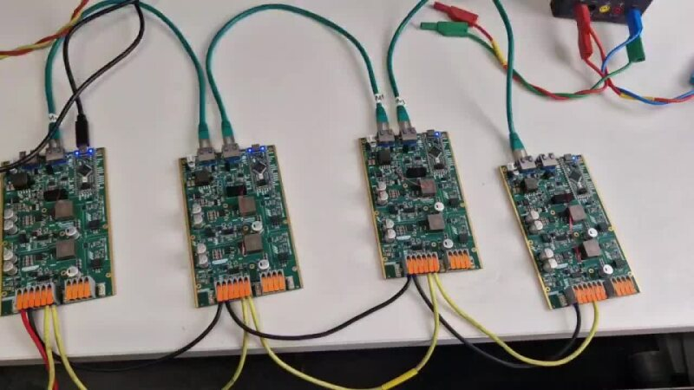

Sorting algorithm (CVB)

Objectives
The goal of this tutorial is test the logic of the Capacitor Voltage Balancing (CVB) algorithm. The CVB algorithm is used in the MMC in order to create a preference order for the connection of modules into the stack.
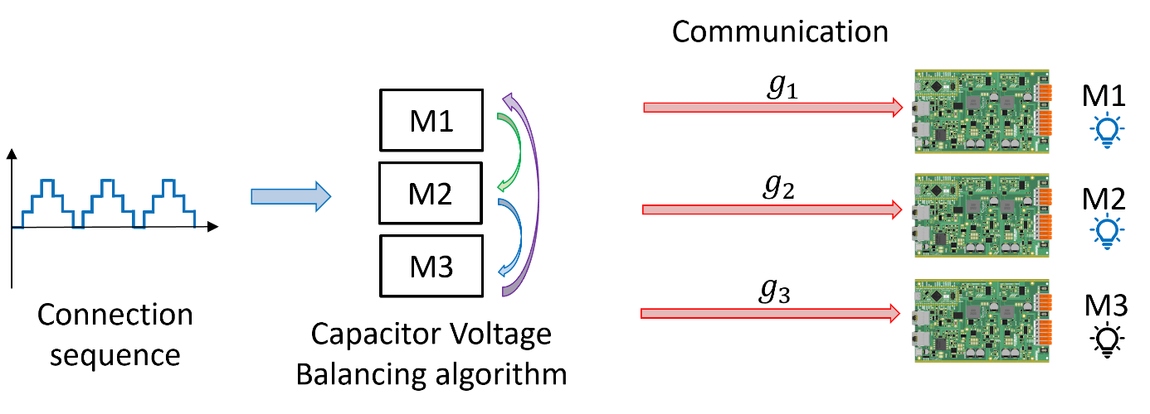
This algorithm is extremely important since the module main element, the capacitor charges and discharges according to the current as seen in the figure:
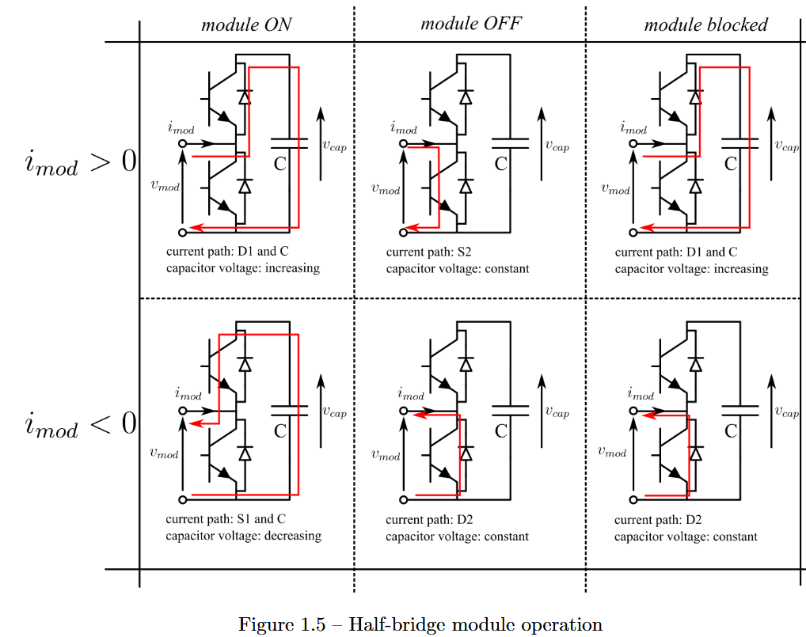
Therefore, if the connection order is random, the voltage of the modules in one stack are going to have different values every time, which is not good for the converter operation. So, we use the CVB algorithm with the objective of maintaining the capacitors voltages of all modules within one stack in the same mean level.
The algorithm works as follows:
- The algorithm receives the number of modules to be connected $N$ from the modulation block.
- It verifies if this number is different from 0.
- If the stack current $i_{arm}$ is positive, the capacitors are going to be charged. Then, the modules with smaller voltage are connected such that their voltage will increase.
- If the stack current $i_{arm}$ is negative, the capacitors are going to be discharged. Then, the modules with higher voltage are connected such that their voltage will decrease.
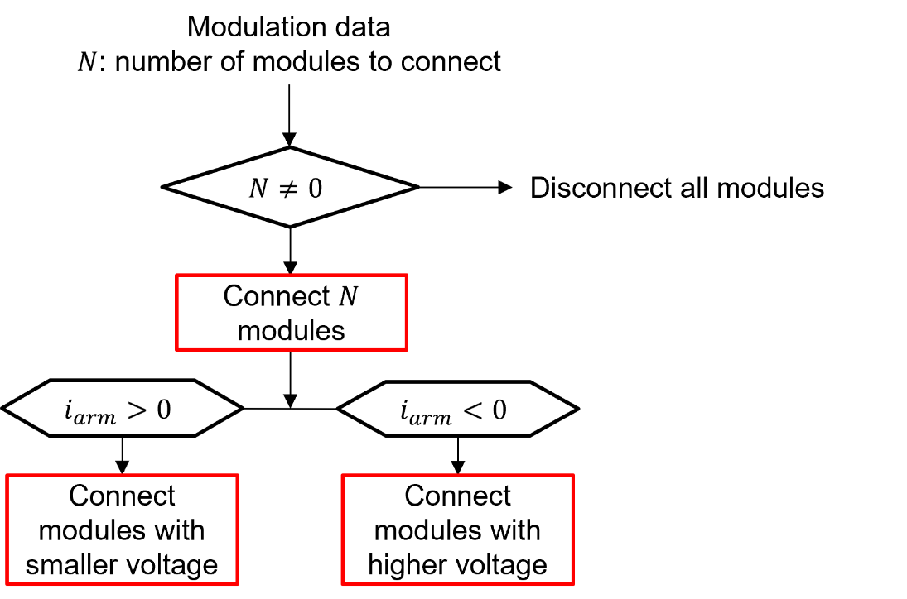
To do this, we need to first sort the modules according to their capacitor voltages and then pass through the algorithm that will generate the switching signals indicating if they are connected or not.

Required Hardware

- 1 TWIST boards with SPIN
- PC 64-bits (windows or linux)

Required Software

- Git
- Visual Studio Code with PlatformIO

Get tutorial code from VScode

First, we need to load the CVB control code from the OwnTech example repository version in https://github.com/analuhaas/examples
- In VScode, open the folder where you previously cloned OwnTech’s github.
- In platformio.ini file, substitute the owntech_examples variable link by https://github.com/analuhaas/examples.git
- Go to platform.io icon , go to Examples Twist under the Project Tasks tab and click on “CVB control”.

- Now you have the good code to execute the tutorial in your VScode.

Hardware setup
Connect the board with the PC using a USB to USB-C cable.
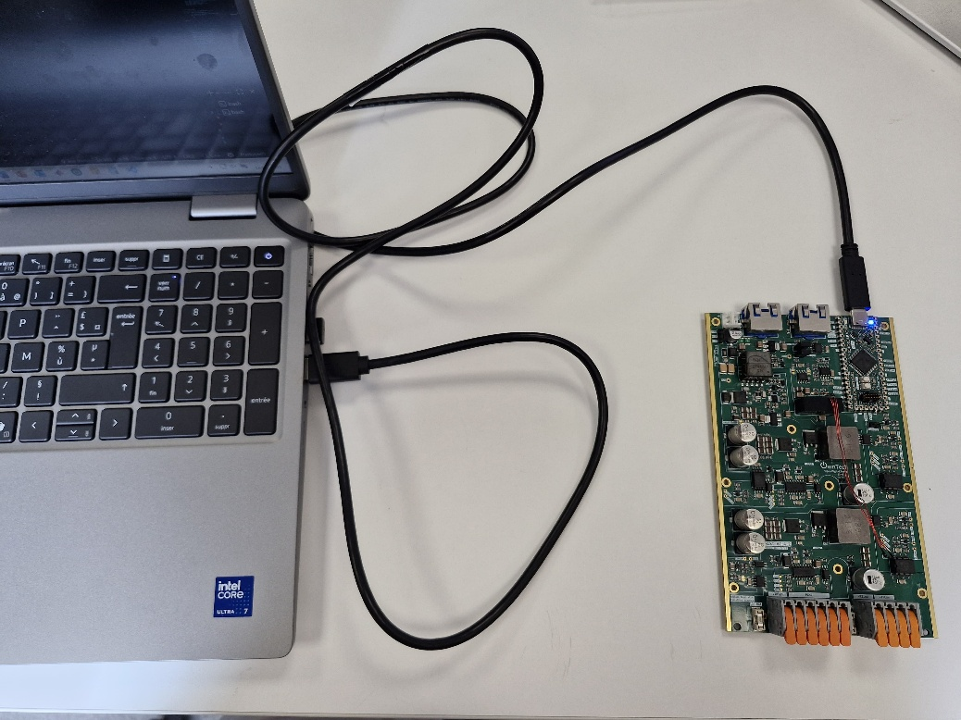

Executing the tutorial
- Optional: Change the parameters to have a more specific test:
  - Switching frequency (variable sw_period - default 10000 equivalent to 1 Hz)
  - Scope configuration
  - Number of modules
  - Current signal (variables i_upper_arm and i_lower_arm)
  - Capacitor voltages (variables modules_capacitor_voltages_upper_arm and modules_capacitor_voltages_lower_arm)
  - Implement and test your own sorting or CVB algorithm!
- Build  and Upload  the code main.cpp into the board
- Open the serial monitor using the icon while the USB-C cable is connected with the board, as shown in the hardware setup.
- Press h to display the help menu.
- The board starts in IDLE mode.
- Press p to switch to POWER mode and the CVB starts to choose the connected modules according to the connection sequence.
- Press a to trigger data acquisition of Scopemimicry scope.
- Press r when you think you have sufficient data to record.
- Press i to switch to IDLE mode and stop the CVB operation.
- Data will be recorded in src>>Data_records folder.

Expected results
By plotting the recorded data using plot_cvb.py, you will have results like these:
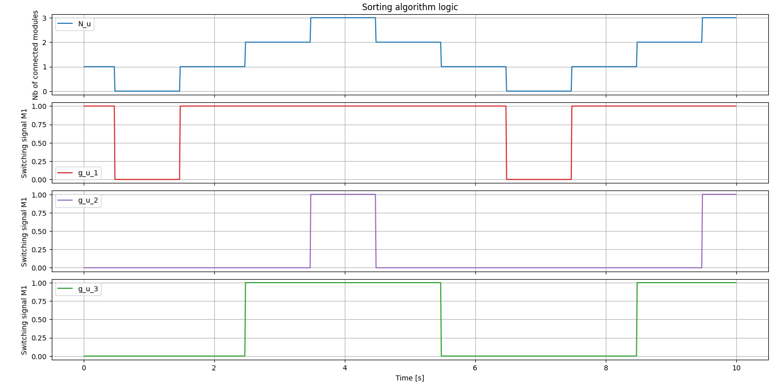
These results were obtained using modules_capacitor_voltages_upper_arm[3] = {3.0,5.0,4.0} and i_upper_arm = 1 ($i≥0$) for the upper stack to test the algorithm, so the preference of connection should be $g_{u1}→g_{u3}→g_{u2}$.
You can plot the same for the lower stack using modules_capacitor_voltages_lower_arm[3] = {3.0,5.0,4.0} and i_lower_arm = -1 ($i<0$), so the preference of connection should be $g_{u2}→g_{u3}→g_{u1}$.
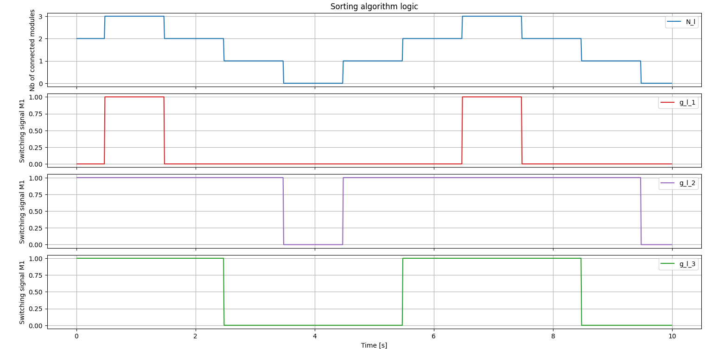
To fully understand the CVB algorithm, you can play with:
- Scope configuration
- Connection sequence steps frequency
- Number of modules
- Current signal
- Capacitor voltages

Individual MMC module test

Objectives and context
The goal of this tutorial is to test a individual MMC module operation in all its states in both low and high frequency. For that, we used the circuit structure below. $R_{dec}$ resistance is connected in parallel to the module in order to emulated negative currents discharging the module capacitor.
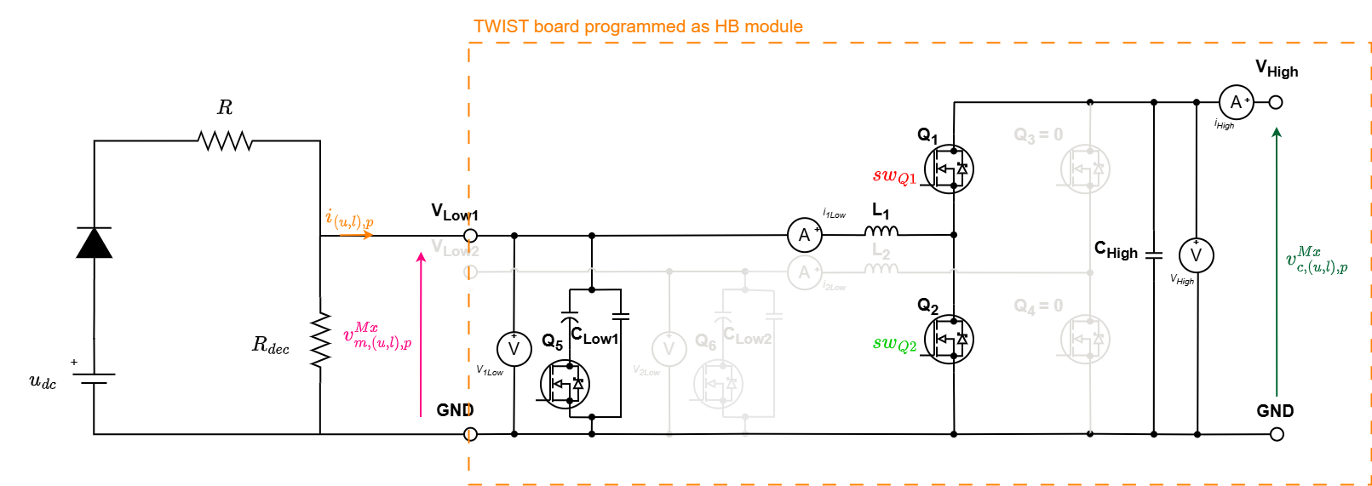
The board serves as a HB module of the MMC by programming its second leg (LEG2) to be deactivated, having the following circuit. Observe that the HIGH terminals are open (Vhigh to GND).
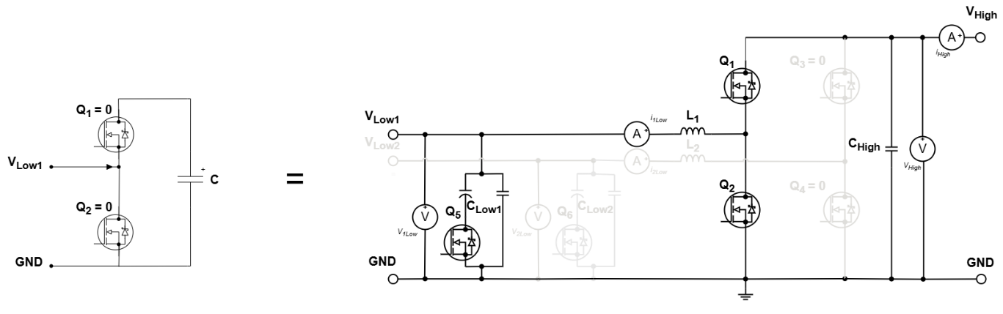
The tutorial will consist of putting the module M1 in Disconnected, Connected and Blocked states according to the correspondence table below:
State | $i_{u,p}^{M1}$ sign | $$sw_{Q1}$$ | $$sw_{Q2}$$ | $$sw_{Q3}$$ | $$sw_{Q4}$$ | $$v_{m,u,p}^{M1}$$
Connected | +/- | 1 | 0 | 0 | 0 | $$+v_{c,u,p}^{M1}$$
Disconnected | +/- | 0 | 1 | 0 | 0 | 0
Blocked | + | 0 | 0 | 0 | 0 | $$+v_{c,u,p}^{M1}$$
 | - | 0 | 0 | 0 | 0 | 0
The module state is controlled using the board first leg (LEG1) switches Q1 and Q2 command ($sw_{Q1}$ and $sw_{Q2}$):
- Connected state:
  - $sw_{Q1}=1$ (close Q1 MOSFET) and $sw_{Q2}=0$ (open Q2 MOSFET)
  - The module is considered to be connected to the circuit, contributing to the stack with its capacitor voltage and the current pass through its capacitor.
- Disconnected state:
  - $sw_{Q1}=0$ (open Q1 MOSFET) and $sw_{Q2}=1$ (close Q2 MOSFET)
  - The module is considered to be bypassed from the circuit having null voltage output and the current does not pass through its capacitor.
- Blocked state:
  - $sw_{Q1}=0$ (open Q1 MOSFET) and $sw_{Q2}=0$ (open Q2 MOSFET)
  - Since both switches gate commands are to be turned off, only the MOSFETs anti-parallel diodes conducts. Which diodes conducts will depend only if current sign is positive or negative.
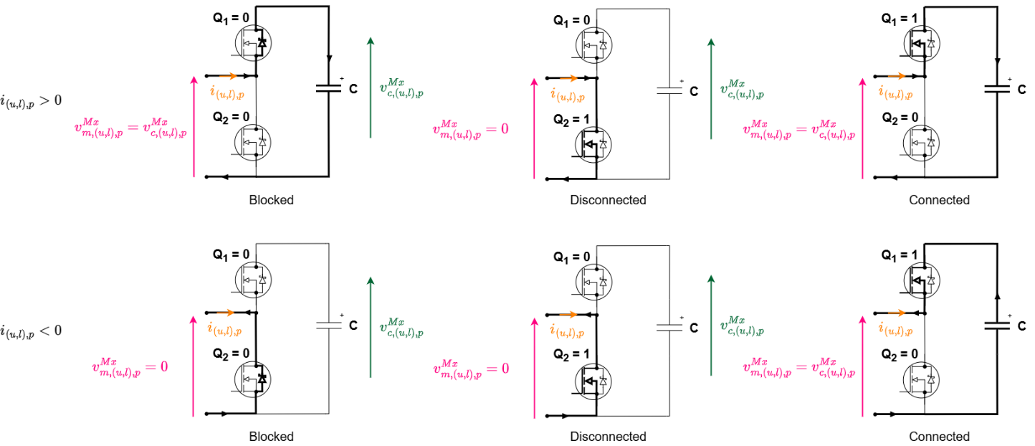
All these different states are illustrated in the figure below according to the current sign:

First, the individual module test is performed in low-frequency and then in high-frequency. The figure below shows the low-frequency test sequence. The user must manually TURN ON the udc power supply to start the sequence first part (positive current) and also TURN OFF udc to start the sequence second part (negative current).
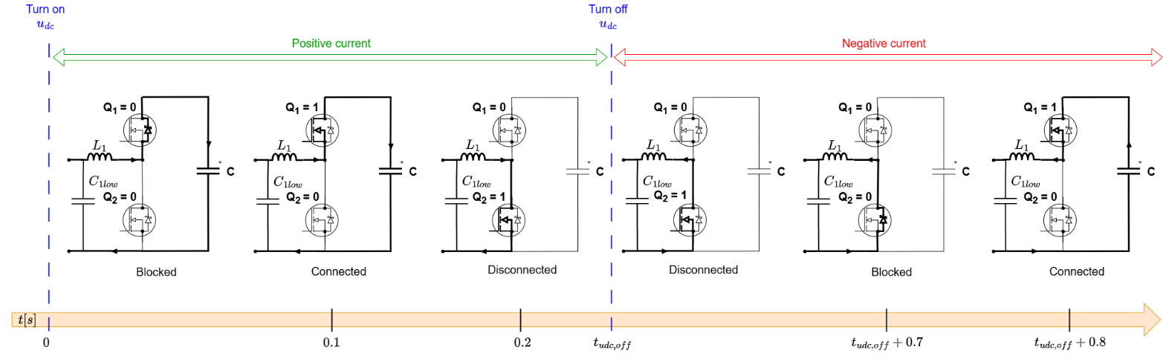
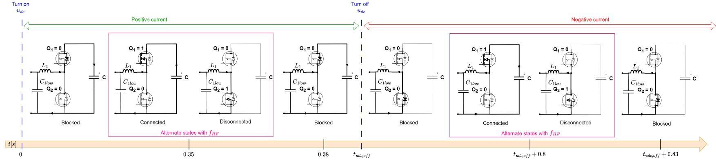
The figure below shows the high-frequency test sequence. The user must manually TURN ON the udc power supply to start the sequence first part (positive current) and also TURN OFF udc to start the sequence second part (negative current).

Required Hardware

- 1 TWIST boards with SPIN
- Programmable DC Power Supply (48 V, 2 A)
- Protection diode (at least 50 V)
- 2 resistors of $15 Ω$
- PC 64-bits (windows or linux)
- Oscilloscope
- Current probe
- 2 BNC adaptors to differential voltage measurement

Required Software

- Git
- Visual Studio Code with PlatformIO

Get tutorial code from VScode

First, we need to load the Single module test code from the OwnTech example repository version in https://github.com/analuhaas/examples
- In VScode, open the folder where you previously cloned OwnTech’s github.
- In platformio.ini file, substitute the owntech_examples variable link by https://github.com/analuhaas/examples.git
- Go to platform.io icon , go to Examples Twist under the Project Tasks tab and click on “Single MMC module – LF test (modified)” or “Single MMC module – HF test (modified)” according to the used test sequence.

- Now you have the good code to execute the tutorial in your VScode.

Hardware setup
- Recommended for MMC use: Configure the board to feed the 6 V auxiliary input externally with feeder completely disconnected from the electrical circuit of the board.
In the TWIST board, it is possible to feed the auxiliary circuit of the board by 3 different ways:
- Using the feeder to provide the 6 V auxiliary input
- Feeding the 6 V auxiliary input externally:
- Feeding the 6 V auxiliary input externally with feeder completely disconnected from the electrical circuit of the board.
The last one is preferable to MMC use cause the board feeder is not yet adapted to MMC charging phase. To do that:
• Connect an External Auxiliary DC Power Supply to the TWIST via the 6 V and DGND PINs. Make sure the External Auxiliary DC Power Supply is configured to deliver 6 V with limiting current above 0.5 A. Make sure this power supply OUTPUT IS OFF.
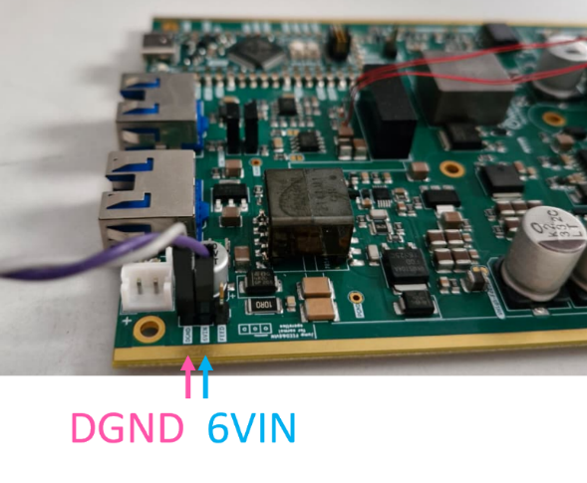
• Open the jumper JP5001 of the board by cutting the jumper connections using a cutter with an appropriate camera to see the area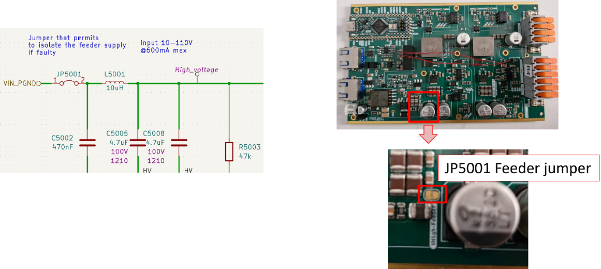
- Recommended for MMC use: Disconnect the electrolytical capacitor of both Low1 and Low2 terminals adding the following code lines in the setup_routine() function
shield.power.disconnectCapacitor(LEG1);
shield.power.disconnectCapacitor(LEG2);

In the TWIST board electrical circuit, we see that Clow1 and Clow2 low-side capacitors are divided in a electrolytical part that is removable by Q5 and Q6 and a ceramic part. It is preferable that these capacitors are disconnected since they are not traditionally present in a Half-Bridge module circuit. 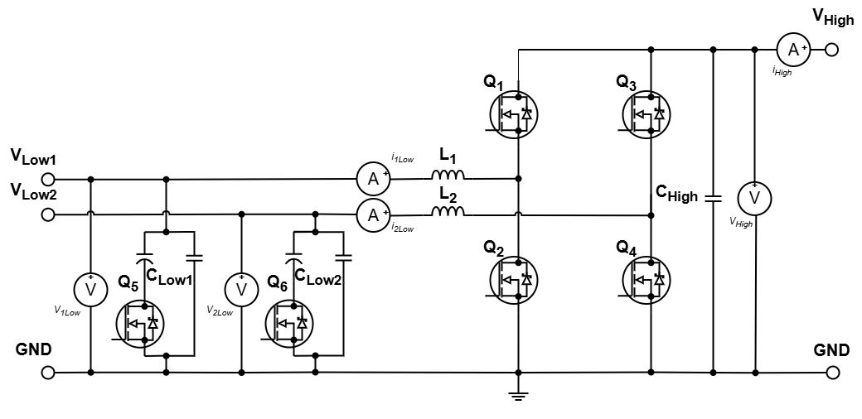
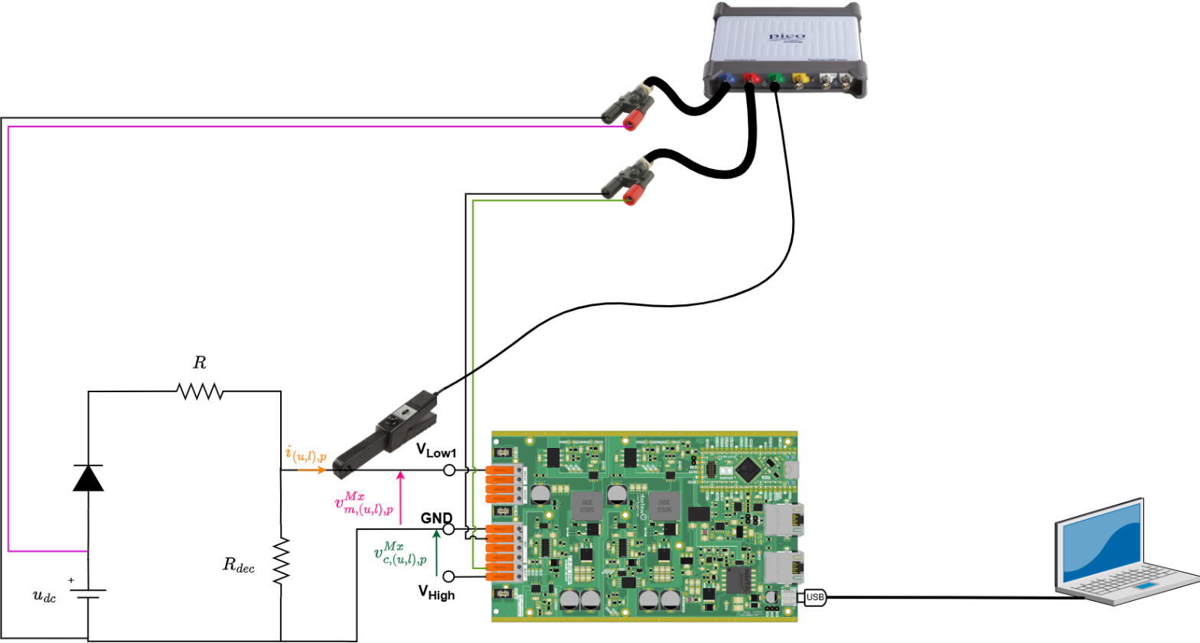
- Connect the board with the power supply, the R and Rdec resistances, oscilloscope and PC as in the image:

After making the connections and connecting the PC to board the USB-C cable, you should have something like this:

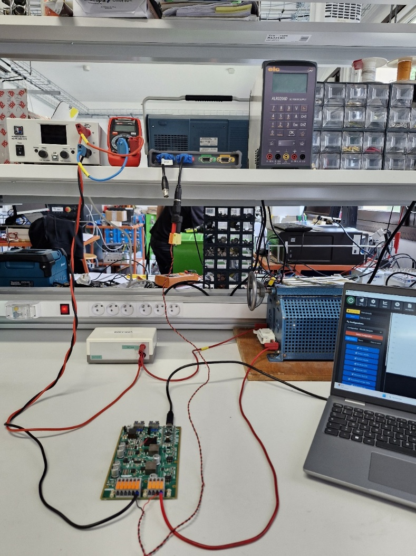
Diode
Power supply
Oscilloscope
Resistor
PC
- Configure your Oscilloscope with PicoScope (tutorial using PicoScope 4444):
  - Make sure it acquires the following measurements:
    - Module capacitor voltage (Vhigh to GND).
    - Module current.
    - DC power supply voltage.

  - Use a 500 ms/div configuration with sampling rate to have 5 µs sampling.
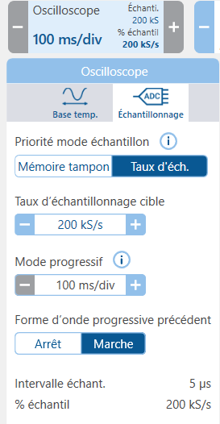

  - Configure it to trigger when the power supply voltage rises up to 2 V.

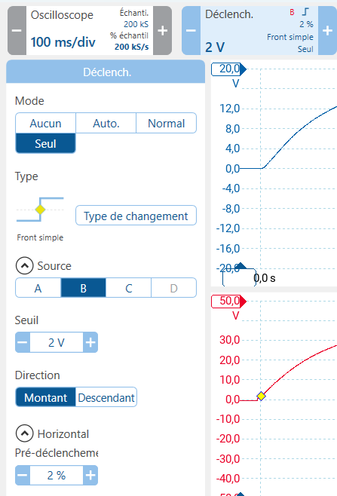

Executing the LF module test
- Get the low-frequency test code using “Single MMC module – LF test” button.
- Build  and Upload  the code main.cpp into the board
- Make sure the External Auxiliary DC Power Supply is configured to deliver 6 V with limiting current above 0.5 A. TURN ON the External Auxiliary DC Power Supply output.
The boards starts in IDLE mode (equal to module blocked state).
- TURN ON the main power supply output. This will start the sequence first part.
- After you verify the first sequence part is finished (after 0.5 s), TURN OFF the main power supply output. This will start the sequence second part.
- TURN OFF the External Auxiliary DC Power Supply output.
- Save your oscilloscope data.

Executing the HF module test
- Get the high-frequency test code using “Single MMC module – HF test” button.
- Change the switching frequency parameter (up to 5 kHz)
- Build  and Upload  the code main.cpp into the board
- Make sure the External Auxiliary DC Power Supply is configured to deliver 6 V with limiting current above 0.5 A. TURN ON the External Auxiliary DC Power Supply output.
The boards starts in IDLE mode (equal to module blocked state).
- TURN ON the main power supply output. This will start the sequence first part.
- After you verify the first sequence part is finished (after 0.5 s), TURN OFF the main power supply output. This will start the sequence second part.
- TURN OFF the External Auxiliary DC Power Supply output.
- Save your oscilloscope data.

Expected results
In the low-frequency sequence, the module expected behavior is as shown in the figure below.
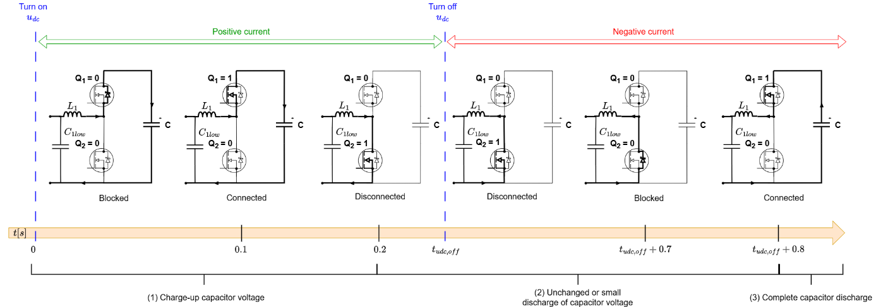
If you perform the low-frequency test with external 6V and feeder disconnected from the circuit, you should expect an experimental result like this:
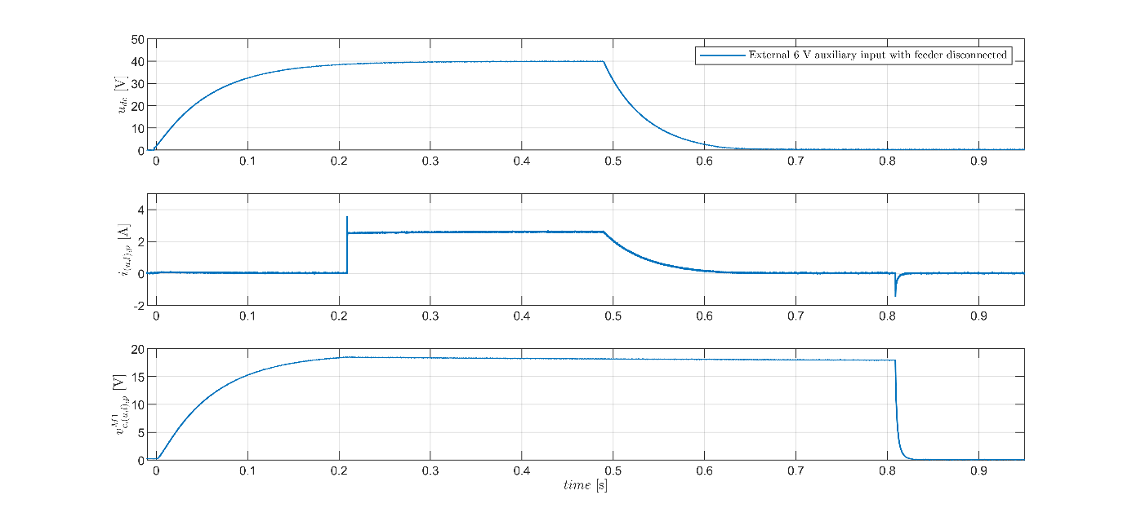
The use of external 6 V auxiliary input changes module discharge behavior while in disconnected state due to feeder behavior:
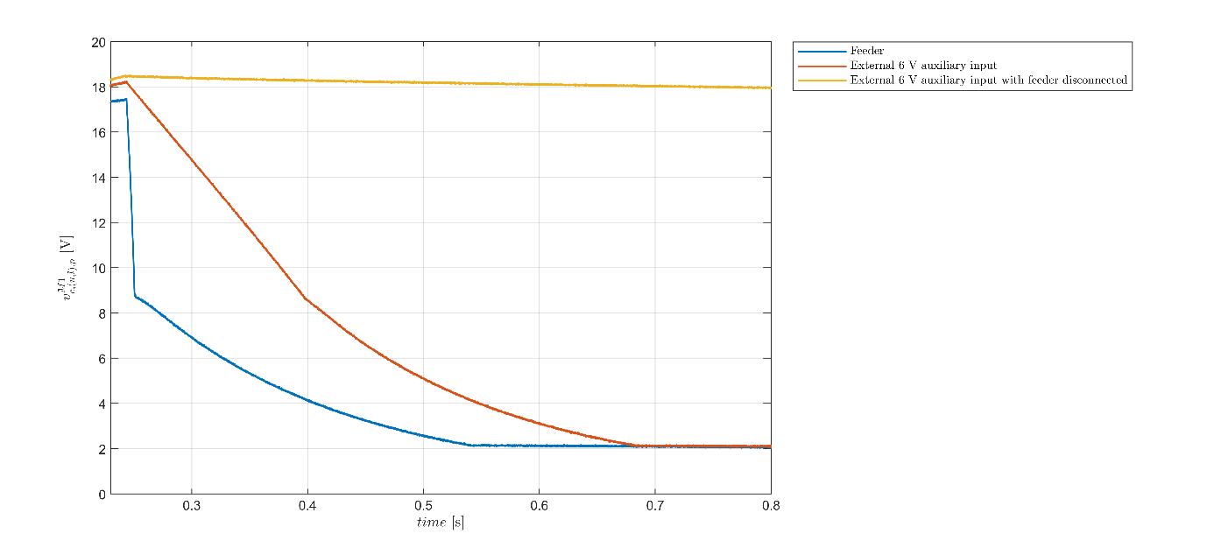
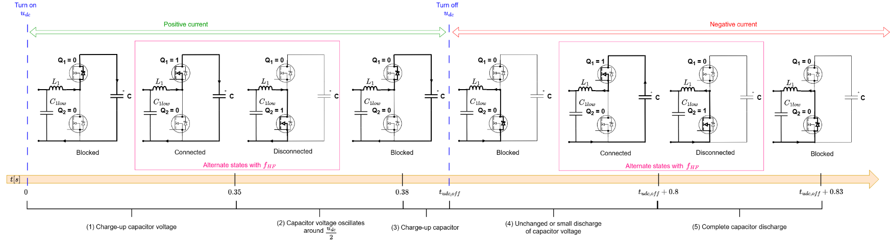
As in the low-frequency test, the high-frequency test module expected behavior is as shown in the figure below.

If you perform the high-frequency test, you should expect an experimental result like in the figure below. You can see that there are two moments where the module is commutated in high frequency:
- Between 0.35 s and 0.38 s with $u_{dc}$ ON
- Between 0.8 s and 0.83 s with $u_{dc}$ OFF
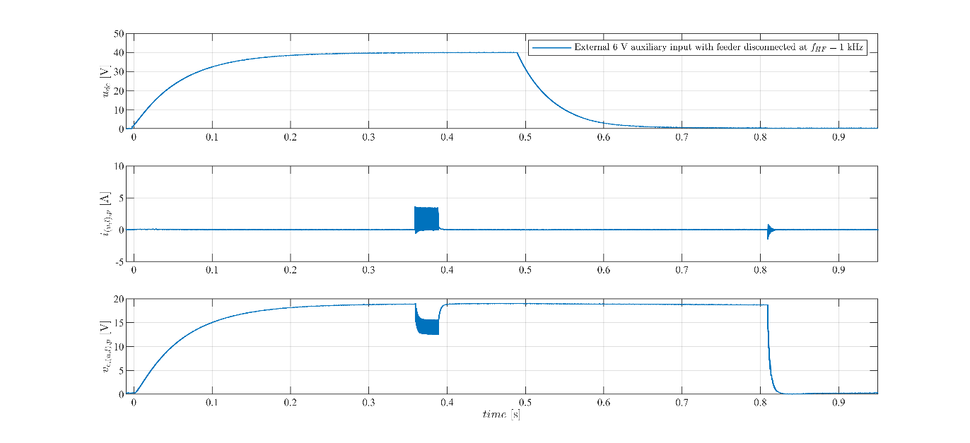
If you zoom between 0.35 s and 0.38 s where the module commutes with $u_{dc}$ ON:
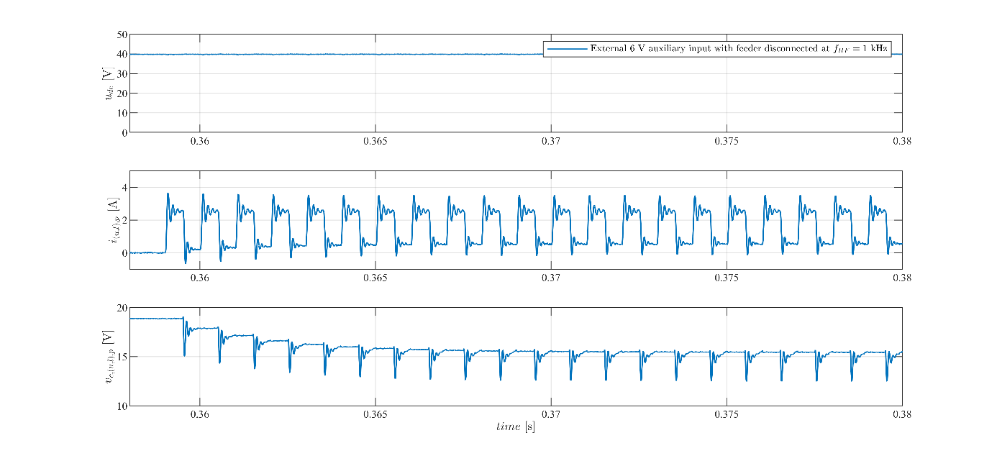
If you zoom between 0.8 s and 0.83 s where the module commutes with $u_{dc}$ OFF:

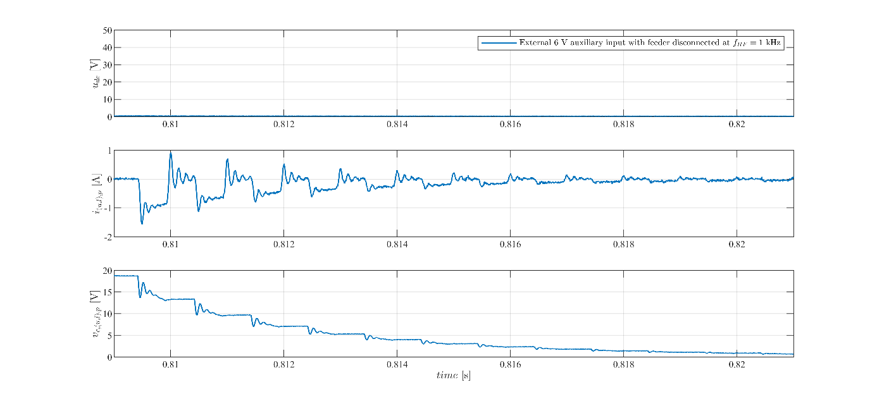

MMC stack test in open-loop

Objectives and context
The goal of this tutorial is to test a MMC stack built with TWIST boards operation with open-loop control using NLM modulation strategy without and with CVB. For that, we use the two circuit structure below. $R_{dec}$ resistance is connected in parallel to the stack for circuit #2 in order to emulate negative currents discharging the modules capacitor.
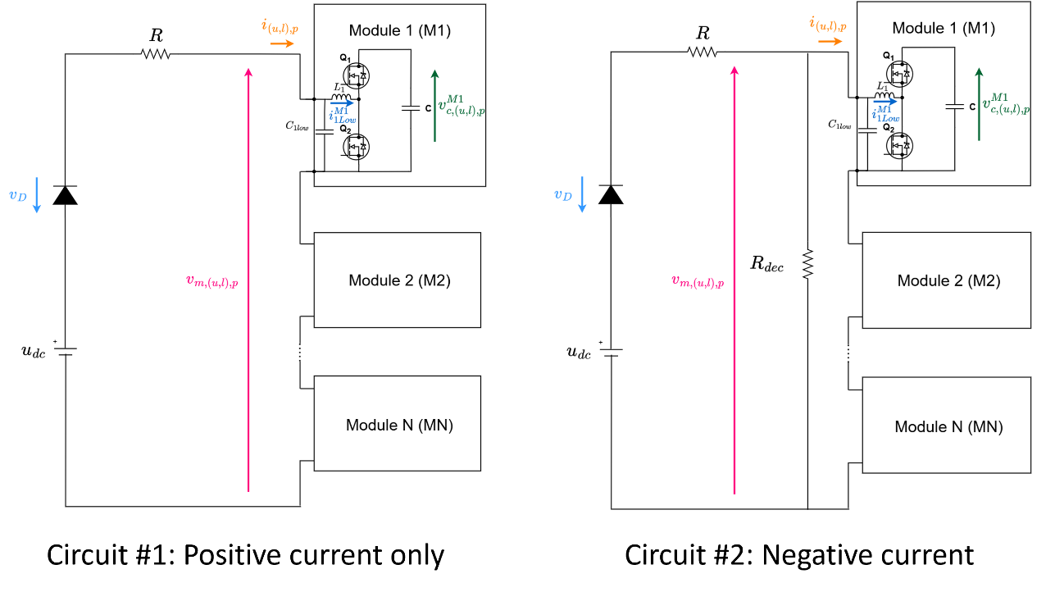
As in the individual module test, the boards serves as a HB module of the MMC by programming its second leg (LEG2) to be deactivated, having the following circuit. Observe that the HIGH terminals are open (Vhigh to GND).

The NLM modulation consists of attributing levels according to the modulation signal amplitude using the function round such that the level attributed to the modulation signal is the nearest integer and its principle is represented here:
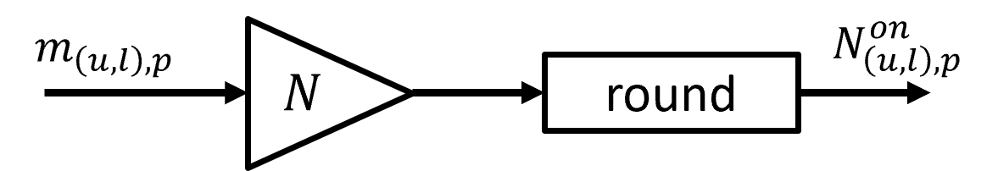
For example, if the modulation signal is 2.6, it is going to be attributed to level 3. For the MMC, the modulation signal is a sinusoidal wave, making that the NLM modulation result is a stepped wave-form as shown:
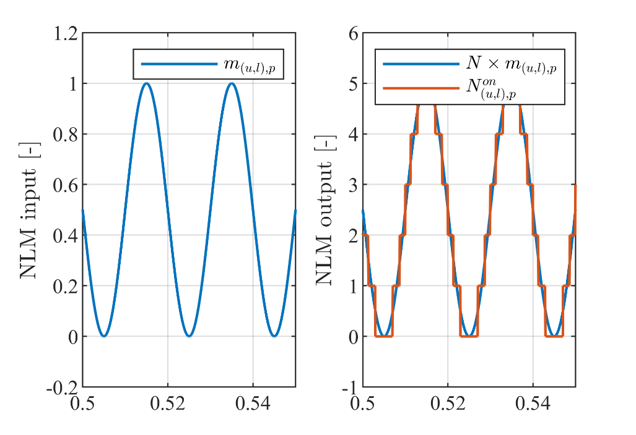
This stepped wave-form output of the NLM indicates how many modules should be connected in the stack $(N_{\left(u,l\right),p}^{on})$ according to time.
The CVB algorithm consists of choosing which modules to connect in order to have equilibrated voltage between all modules. The CVB algorithm makes is choice according to measured capacitor voltages and stack current as described in the algorithm schematic:
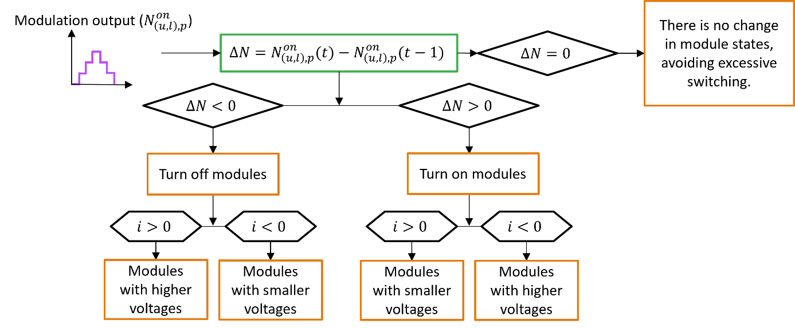
It then generates the command to connect or disconnect the modules by setting the gate command signals ($g_{\left(u,l\right),p}^{M1}$, $g_{\left(u,l\right),p}^{M2}$,..., $g_{\left(u,l\right),p}^{MN}$, to 1 (module connected) or 0 (module disconnected). The complete schematic of the open-loop control implemented:
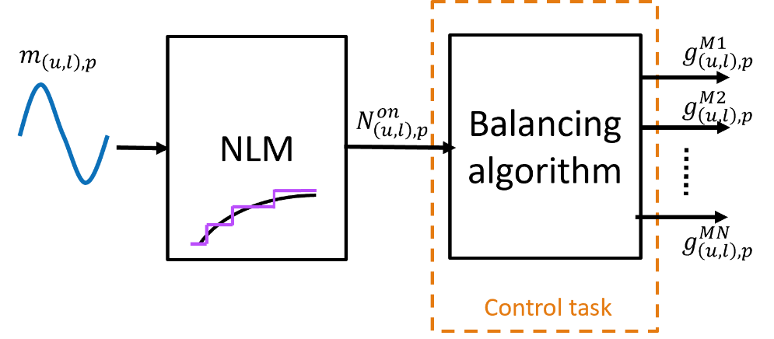

Required Hardware

- 6 TWIST boards with SPIN
- 6 independent DC power supplies of 6 V with minimum 0.5 A
- 1 DC power supply of (48 V, 5 A)
- Protection diode (at least 100 V)
- 2 resistors of $15 Ω$
- 5 ethernet cables
- PC 64-bits (windows or linux)
- Oscilloscope
- Current probe
- 6 BNC adaptors to differential voltage measurement

Required Software

- Git
- Visual Studio Code with PlatformIO

Get tutorial code from VScode

First, we need to load the Single module test code from the OwnTech example repository version in https://github.com/analuhaas/examples
- In VScode, open the folder where you previously cloned OwnTech’s github.
- In platformio.ini file, substitute the owntech_examples variable link by https://github.com/analuhaas/examples.git
- Go to platform.io icon , go to Examples Twist under the Project Tasks tab and click on “MMC arm – no CVB” or “MMC arm – with CVB” according to the used test sequence.

- Now you have the good code to execute the tutorial in your VScode.

Modules Hardware setup

Repeat for the 5 modules boards:
- Recommended for MMC use: Configure all 5 modules boards to feed the 6 V auxiliary input externally with feeder completely disconnected from the electrical circuit of the board.
• Connect an External Auxiliary DC Power Supply to the TWIST via the 6 V and DGND PINs. Make sure the External Auxiliary DC Power Supply is configured to deliver 6 V with limiting current above 0.5 A. Make sure this power supply OUTPUT IS OFF.

• Open the jumper JP5001 of the board by cutting the jumper connections using a cutter with an appropriate camera to see the area
- Recommended for MMC use: Disconnect the electrolytical capacitor of both Low1 and Low2 terminals adding the following code lines in the setup_routine() function
shield.power.disconnectCapacitor(LEG1);
shield.power.disconnectCapacitor(LEG2);

Module Software setup

Repeat for the 5 modules boards:
- Test the module using the low-frequency and high-frequency sequences as explained in Individual MMC module test.

Stack Hardware setup
- Connect the boards in series using VLOW1 and GND terminals to form an MMC stack using banana cables (figure below).
- Connect to each module an External Auxiliary DC Power Supply to the TWIST via the 6 V and DGND PINs. Make sure the External Auxiliary DC Power Supplies are configured to deliver 6 V with limiting current above 0.5 A. Make sure these power supplies OUTPUT IS OFF (figure below).
- Connect the boards using ethernet cables as in the image (figure below).
- Connect the stack to the main DC power supply, R and Rdec resistances and diode (figure below).
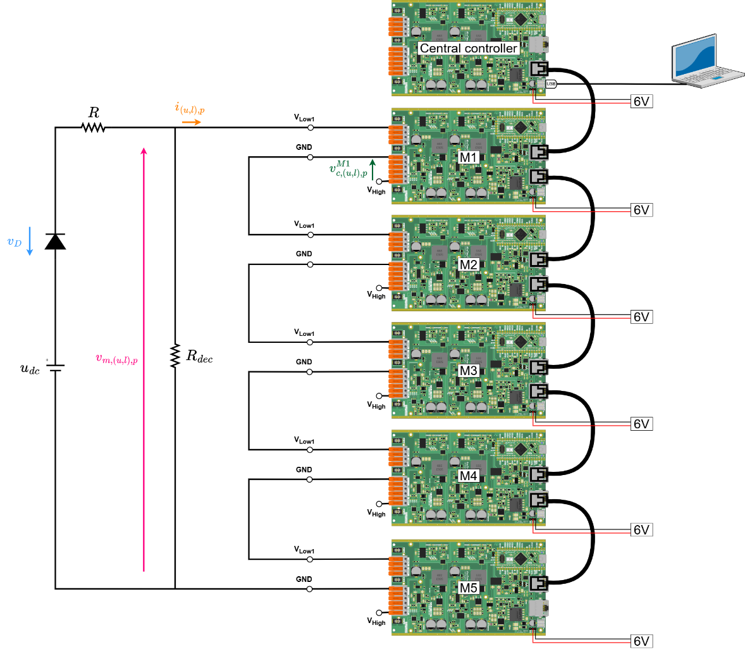
- Connect the voltage and current measurements with the oscilloscope (figure below). 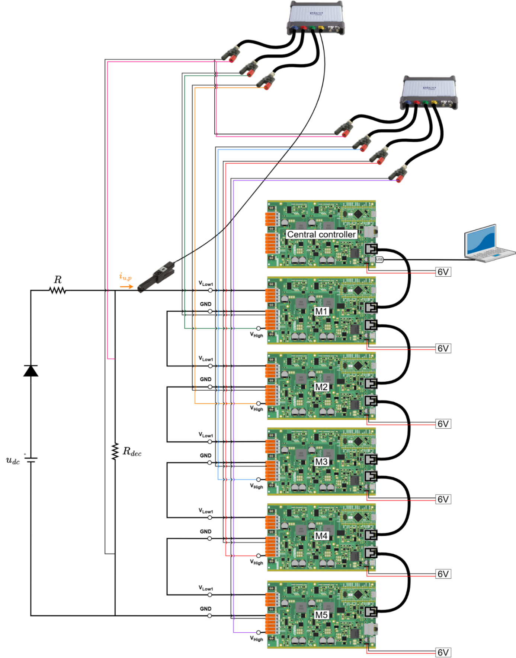
After making the connections and connecting the PC to the central controller board with the USB-C cable, you should have something like this:

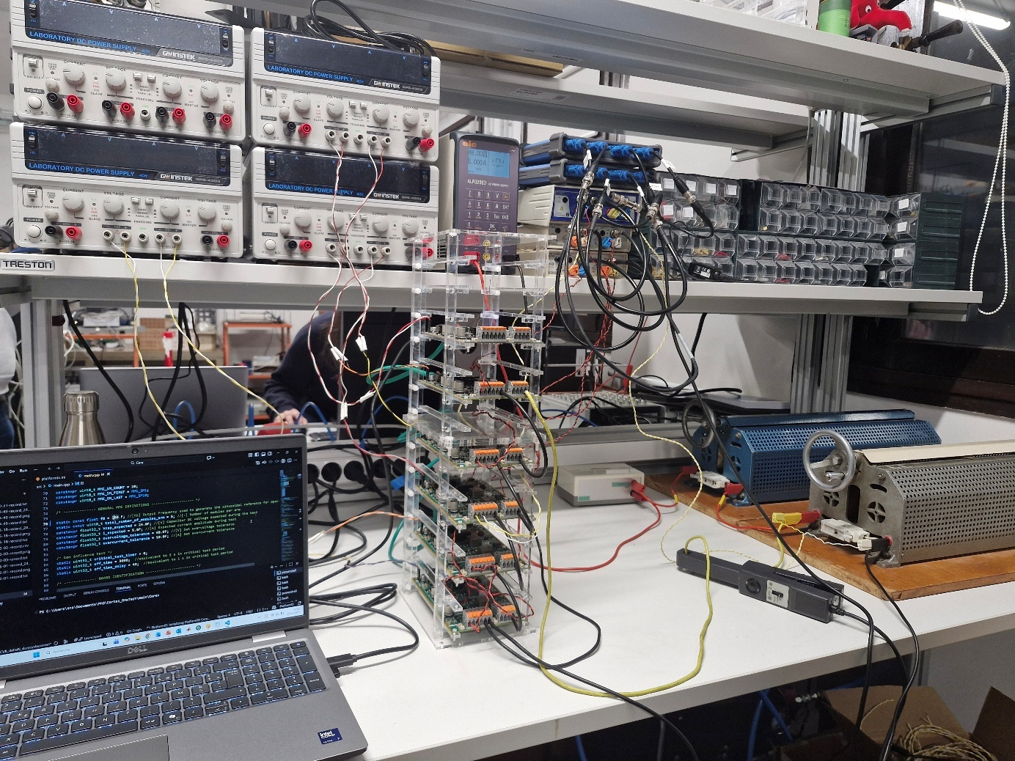
Differential probes
M4
M5
M1
M3
M2
DC supply
Diode
$$R$$
$$R_{dec}$$
Current probe
6 V DC supplies
PicoScope
PC
Leader
- Configure your Oscilloscope with PicoScope (tutorial using PicoScope 4444
  - Make sure it acquires the following measurements:
    - Modules capacitor voltages (Vhigh to GND).
    - Stack current.
    - Stack voltage.
  - Use a 10 s/div configuration with sampling interval around 1 µs (x5 smaller than critical task period)
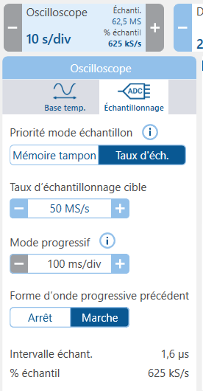
  - Configure it to trigger when the stack voltage rises up to 2 V. 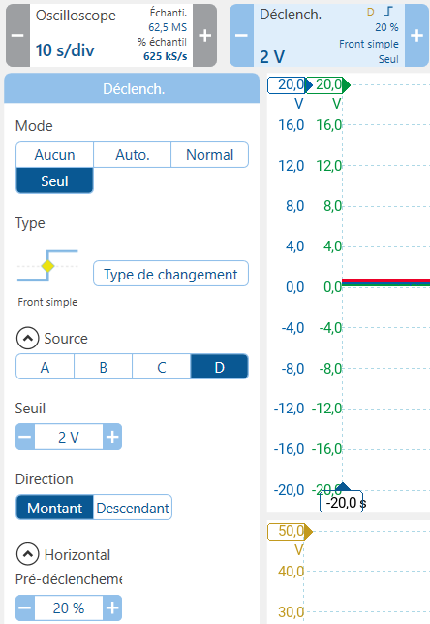

Executing the tutorial Stack test

- Get the correct test code using “MMC arm – with CVB” button.
- Optional: Change the test parameters to have a more specific test:
  - In code: NLM frequency, number of modules.
  - In circuit: Number of modules, resistance values (to reduce or increase current), DC supply voltage.
- Repeat to all 5 module boards M1, M2, M3, M4, M5:
  - Connect the board to the PC via a USB-C cable.
  - Build  and Upload  the code main.cpp into the board
  - Open the serial monitor and copy the board ID to the identification list in the code according to its function in the stack
/* -------------- BOARD IDENTIFICATION ----------------------- */

constexpr uint32_t UID_MMC_LEAD_BOARD = 0x002B002A;
constexpr uint32_t UID_MMC_SM1_BOARD = 0x00330054;
constexpr uint32_t UID_MMC_SM2_BOARD = 0x0033004B;
constexpr uint32_t UID_MMC_SM3_BOARD = 0x00330049;
constexpr uint32_t UID_MMC_SM4_BOARD = 0x0033004C;
constexpr uint32_t UID_MMC_SM5_BOARD = 0x0031001B;
constexpr uint32_t UID_MMC_SM6_BOARD = 0x11118888;
constexpr uint32_t UID_MMC_SM7_BOARD = 0x11119999;
constexpr uint32_t UID_MMC_SM8_BOARD = 0x1111AAA0;
constexpr uint32_t UID_MMC_SM9_BOARD = 0x1111BBB1;
constexpr uint32_t UID_MMC_SM10_BOARD = 0x1111CCC2;

  - Do again: Build  and Upload  the code main.cpp into the board
- Make sure all modules External Auxiliary DC Power Supply are configured to deliver 6 V with limiting current above 0.5 A. TURN ON the External Auxiliary DC Power Supplies output.
- After the capacitor voltages comes back to 0, TURN ON the main power supply $u_{dc}$.
- After the modules are charged with stable voltages more and less at the same level, click “p” to start stack operation with NLM (with or without CVB).
- After 20 s, TURN OFF the main power supply $u_{dc}$.
- Click “i” to stop stack operation and put all boards in IDLE mode (blocked state).
- TURN OFF all 6V External Auxiliary DC Power Supplies.

Expected results
If you perform the stack test without CVB using circuit#1 at 50 Hz, you should expect an experimental result like this:
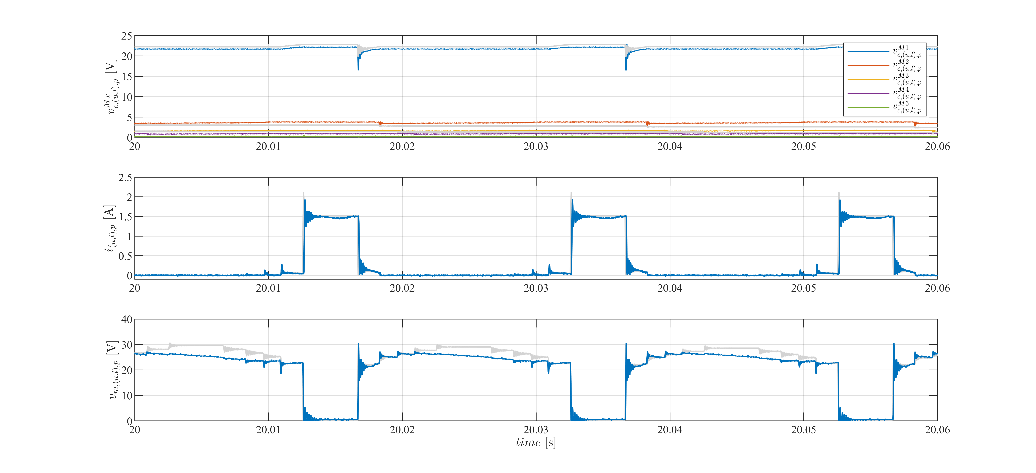
If you perform the stack test with CVB using circuit#1 at 50 Hz, you should expect an experimental result like this:
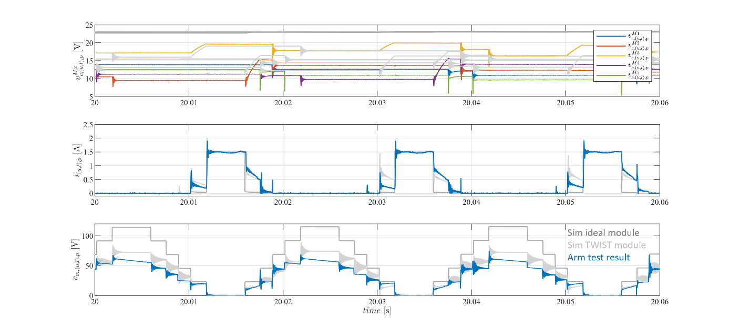
If you perform the stack test without CVB using circuit#2 at 50 Hz, you should expect an experimental result like this:
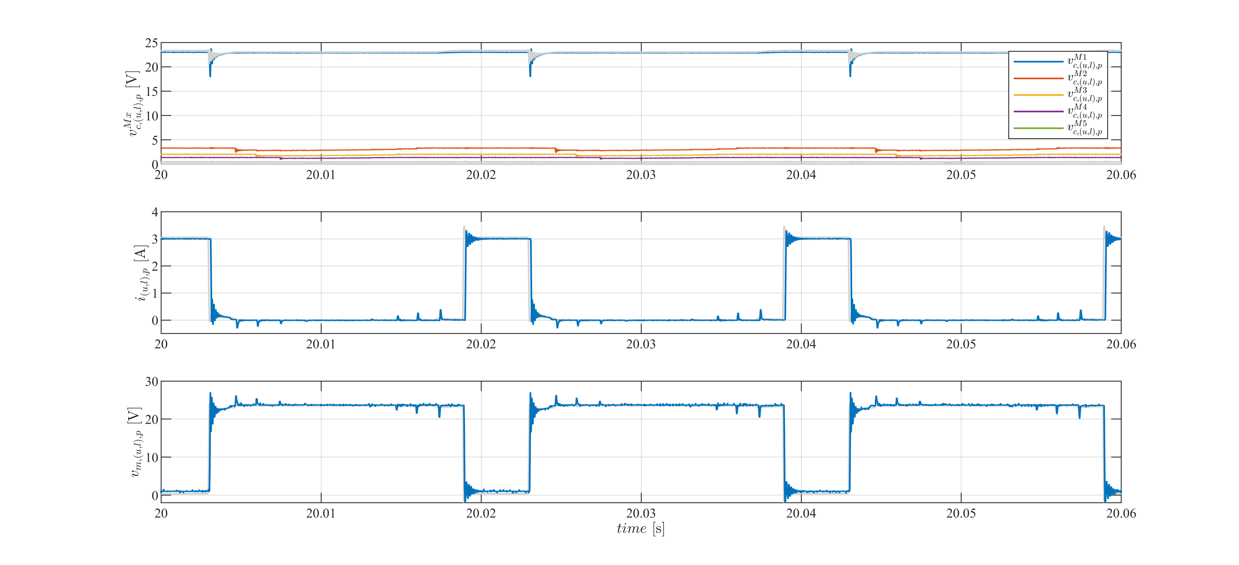
If you perform the stack test with CVB using circuit#2 at 50 Hz, you should expect an experimental result like this:
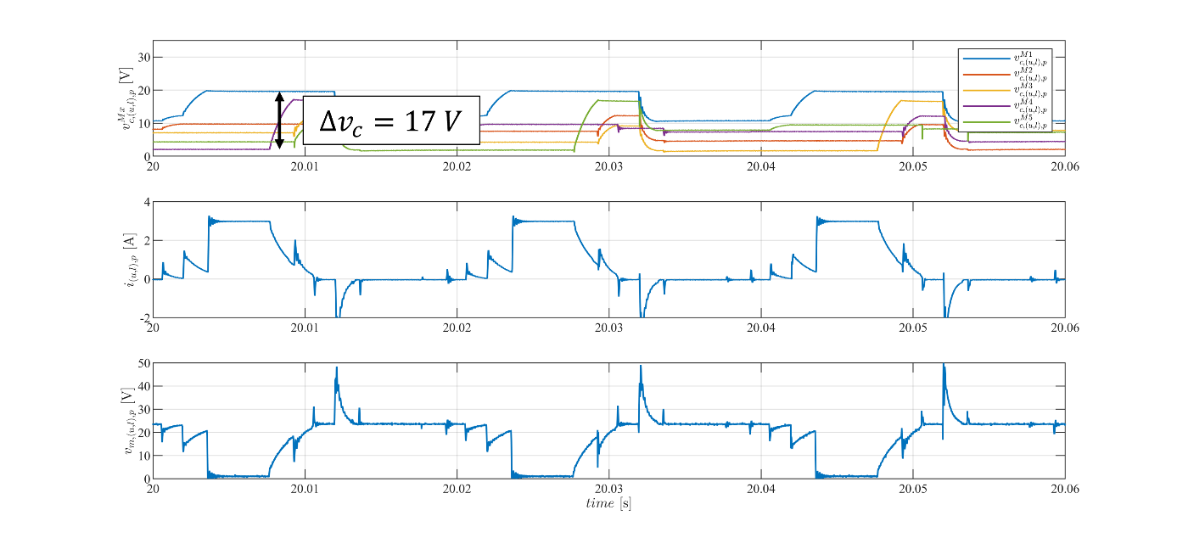
For better results using circuit#2, add extra capacitance in parallel to high-side terminals (Vhigh and GND). You should expect an experimental result like this:
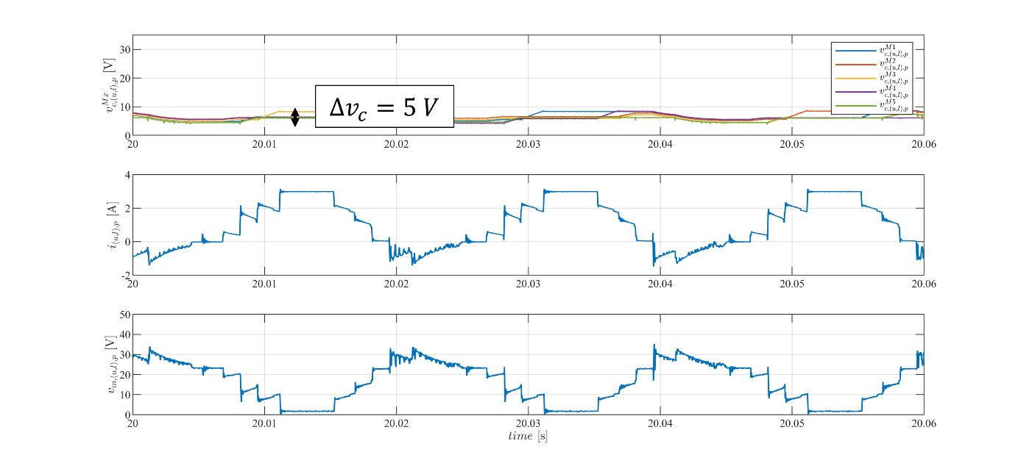

Code explanations

Code explanation for Blinky MMC
- The setup_routine function configures the peripherals and main loop_functions:
It first configures the SPIN LED by using a function coded in Low Level.
config_led_LL(); // Configure the LED pin in Low Level
Then, it sets the TWIST board to Buck mode, declares the background, communication and critical tasks and starts them. The critical task has a frequency of 10 kHz.
After that, it configures the communication protocol used by informing the transmitted and reception buffer variables, the function that gives the actions of the board when it receives a message and the transmission speed.
communication.rs485.configure(buffer_tx, buffer_rx, sizeof(buffer_rx),
reception_function,
SPEED_20M); // custom configuration for RS485
Finally, it configures a some scope channels for the master to acquire the connection sequence generated “N_u” and the connection signal for each module “g1”, “g2” and “g3”.
- Continuing to the loop_communication_task function, it makes the main board change between the IDLE and POWER modes, and enables scope data triggering and recording according to the pressed key in the keyboard.
IDLE mode is equivalent to key “i” and POWER mode is equivalent to key “p”.
Data trigger becomes equal to true when the key ‘a’ is pressed, setting the starting time of data acquisition. It should be pressed during POWER mode.
bool a_trigger()
{
return enable_acq;
}
The data recording function dump_scope_datas stores the acquired data in both csv and text format in the folder “Data_records” within “src” when the key “r” is pressed. It happens only in IDLE mode.
void dump_scope_datas(ScopeMimicry &scope)
{
uint8_t *buffer = scope.get_buffer();
/* We divide by 4 (4 bytes per float data) */
uint16_t buffer_size = scope.get_buffer_size() >> 2;
printk("begin record\n");
printk("#");
for (uint16_t k = 0; k < scope.get_nb_channel(); k++)
{
printk("%s,", scope.get_channel_name(k));
}
printk("\n");
printk("# %d\n", scope.get_final_idx());
for (uint16_t k = 0; k < buffer_size; k++)
{
printk("%08x\n", *((uint32_t *)buffer + k));
task.suspendBackgroundUs(100);
}
printk("end record\n");
}
- Next, the loop_background_task function makes the LED toggle or turn off according if it is in IDLE or POWER mode and it prints some variables values from the control part.
- Finally, the loop_critical_task function contains the whole communication and control logic.
If the board is the Main (module_ID == MMC_LEAD):
In POWER mode, the control part generates the connection sequence using the order of variable seq_u = {1, 2, 3, 2, 1, 0}. The sequence has a certain period sw_period that regulates the width of the staircase step.
if (sw_timer == sw_period)
{
if (counter_seq >= 6)
{
counter_seq = 0;
}
number_of_connected_submodules_upper_arm = (float)seq_u[counter_seq]; // recuperate as float for scope
counter_seq++;
sw_timer = 0;
}
sw_timer++;

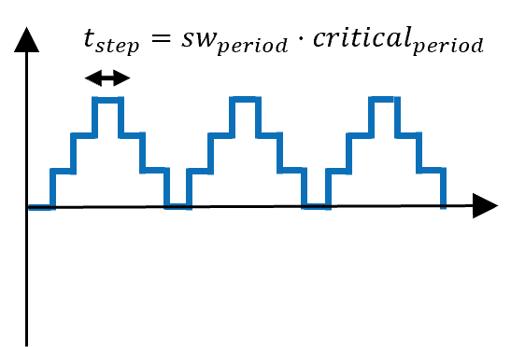
After that, the connection variables are modified to 0 or 1 according to the connection priority M1→M2→M3.
if (number_of_connected_submodules_upper_arm == 0)
{
g[0] = 0; // g[0] -> M1
g[1] = 0; // g[1] -> M2
g[2] = 0; // g[2] -> M3
}
if (number_of_connected_submodules_upper_arm == 1)
{
g[0] = 1;
g[1] = 0;
g[2] = 0;
}
if (number_of_connected_submodules_upper_arm == 2)
{
g[0] = 1;
g[1] = 1;
g[2] = 0;
}
if (number_of_connected_submodules_upper_arm == 3)
{
g[0] = 1;
g[1] = 1;
g[2] = 1;
}

g_u_1 = (float)g[0]; // recuperate as float for scope
g_u_2 = (float)g[1]; // recuperate as float for scope
g_u_3 = (float)g[2]; // recuperate as float for scope

And the scope acquires data according to a certain period equal to $t_{acq}=scope_{period}⋅critical_{period}$.
if (scope_timer == scope_period)
{
scope.acquire();
scope_timer = 0;
}
scope_timer++;
In terms of communication, the main board saves in the structure dataTX_mmc:
- The commands corresponding to each module.
- Its own ID to identify from who the message is coming.
- Status saying if it is in POWER mode = 1 or in IDLE mode = 0.
And then starts the communication to send these information to the modules boards.
SET_SIGNAL(dataTX_mmc.command, MMC_SM1, g[0]);
SET_SIGNAL(dataTX_mmc.command, MMC_SM2, g[1]);
SET_SIGNAL(dataTX_mmc.command, MMC_SM3, g[2]);

dataTX_mmc.ID = module_ID;
memcpy(buffer_tx, &dataTX_mmc, sizeof(dataTX_mmc));
dataTX_mmc.status = 1;
communication.rs485.startTransmission();
We can see that the dataTX_mmc and dataRX_mmc structures have in its definition one more information to store the capacitor voltage of the modules.

struct MMC_frame
{
uint8_t command;
float32_t Capacitor_Voltage;
uint8_t status;
uint8_t ID;
} __packed;

If it enter IDLE mode, the Main sends an IDLE flag to all modules to enter IDLE mode as well via the status information.
else if (mode == IDLEMODE)
{
/* Made to send IDLE flag only once */
if (!send_idle)
{
dataTX_mmc.ID = module_ID;
dataTX_mmc.status = 0;
memcpy(buffer_tx, &dataTX_mmc, sizeof(dataTX_mmc));
communication.rs485.startTransmission();
send_idle = true; // Set the flag to send idle command
}
}
In the reception_function we can see that the main board receives an artificial information of capacitor_voltage from the modules and stores it in a the vector MMC_capacitor_voltage. The capacitor_voltage information will be later substituted by the measure of the capacitor voltage acquired by the board.
If the board is a module (module_ID == MMC_SMx):
Analysing reception_function, it receives the information from the other boards and:
- Verify if the sender is the main if (dataRX_mmc.ID == MMC_LEAD):
  - Stores the command signal in module_comand.
  - Changes to POWER mode or IDLE mode according to the main board status.
- Verify if it is the next one in line to send the next message if ((dataRX_mmc.ID == module_ID - 1)):
  - Updates the transmission data structure for its own values of ID and capacitor voltage.
  - And then starts the communication to send these information to the other boards only if in POWER mode.
if (dataRX_mmc.ID == MMC_LEAD)
{
/* retrievig command from lead message*/
module_comand = GET_SIGNAL(dataRX_mmc.command, module_ID);
/* retrieving status */
if (dataRX_mmc.status == 1)
{
mode = POWERMODE;
}
else
{
mode = IDLEMODE;
}
}

/* The board following the ID of the one who sent will start sending
the next message */
if ((dataRX_mmc.ID == module_ID - 1))
{
dataTX_mmc = dataRX_mmc; // Copy the received data to the transmission data
dataTX_mmc.ID = module_ID;
dataTX_mmc.Capacitor_Voltage = MMC_voltage; /* TODO :uncomment when we get the voltage */
if (mode == POWERMODE)
{
memcpy(buffer_tx, &dataTX_mmc, sizeof(dataTX_mmc));
communication.rs485.startTransmission();
}
}
Observe that the sending order goes as follows:

- Main
- SM3
- SM2
- SM1

This happens since the IDs are defined as:
#define MMC_LEAD 0
#define MMC_SM1 1
#define MMC_SM2 2
#define MMC_SM3 3

In the critical function, while in POWER mode a module board:
- Turns ON its SPIN LED if it is commanded to be connected by the Main (module_command = 1)
- Turns OFF its SPIN LED if it is commanded to be disconnected (module_command =0).
else
{
if (module_comand != module_command_past)
{
change_state_command = true; // Set the flag to change the state
}

if (module_comand)
{
if (change_state_command)
{
Led_turnON_LL();
change_state_command = false; // Reset the flag
}
}
else
{
if (change_state_command)
{
Led_turnOFF_LL();
change_state_command = false; // Reset the flag
}
}
}
module_command_past = module_comand; // Update the past command

Code explanation for CVB algorithm test
- Starting by the setup_routine function, it configures the peripherals and main loop_functions:
It sets the TWIST board legs to Buck mode, declares the background, communication and critical tasks and starts them. The critical task has a frequency of 10 kHz.
Finally, it configures a some scope channels for the master to acquire the connection sequence generated “N_u” and the connection signal for each module “g1”, “g2” and “g3”.
- Continuing to the loop_communication_task function, it makes the main board change between the IDLE and POWER modes, and enables scope data triggering and recording according to the pressed key in the keyboard. If you have already seen it in Blinky MMC arm tutorial, skip directly to step 4 that describes the critical_task function.
IDLE mode is equivalent to key “i” and POWER mode is equivalent to key “p”.
Data trigger becomes equal to true when the key ‘a’ is pressed, setting the starting time of data acquisition. It should be pressed during POWER mode.
bool a_trigger()
{
return enable_acq;
}
The data recording function dump_scope_datas stores the acquired data in both csv and text format in the folder “Data_records” within “src” when the key “r” is pressed. It happens only in IDLE mode.
void dump_scope_datas(ScopeMimicry &scope)
{
uint8_t *buffer = scope.get_buffer();
/* We divide by 4 (4 bytes per float data) */
uint16_t buffer_size = scope.get_buffer_size() >> 2;
printk("begin record\n");
printk("#");
for (uint16_t k = 0; k < scope.get_nb_channel(); k++)
{
printk("%s,", scope.get_channel_name(k));
}
printk("\n");
printk("# %d\n", scope.get_final_idx());
for (uint16_t k = 0; k < buffer_size; k++)
{
printk("%08x\n", *((uint32_t *)buffer + k));
task.suspendBackgroundUs(100);
}
printk("end record\n");
}
- Next, the loop_application_task function makes the LED toggle or turn off according if it is in IDLE or POWER mode and it prints some variables values from the control part in the serial monitor terminal.
- Finally, the loop_critical_task function contains the whole CVB algorithm logic.
In IDLE mode, we ensure that its PWM deactivated.
In POWER mode, the connection sequence logic is generated as in the Blinky MMC arm. But we add an additional sequence for the lower arm that is complementary from the upper arm sequence.
if (sw_timer == sw_period)
{
if (counter_seq >= 6) {
counter_seq = 0;
}
number_of_connected_submodules_upper_arm = (float)seq_u[counter_seq]; // recuperate as float for scope
number_of_connected_submodules_lower_arm = (float)seq_l[counter_seq]; // recuperate as float for scope
counter_seq++;
sw_timer = 0;
}
Then the sorting algorithm function is executed:
It firsts sorts the modules indexes according to capacitor voltage for both arms. This is done in a while loop within 10 times because this was the necessary amount of loops to sort up to 6 modules.
void sorting()
{
uint8_t counter_loops_sorting = 0;
while(counter_loops_sorting < 10){ // Sorts modules indexes according to capacitor voltage
for(uint8_t counter = 0; counter < total_number_of_modules_arm-1; counter++)
{
if(modules_capacitor_voltages_upper_arm[counter] > modules_capacitor_voltages_upper_arm[counter + 1])
{
float32_t temp = modules_capacitor_voltages_upper_arm[counter];
modules_capacitor_voltages_upper_arm[counter] = modules_capacitor_voltages_upper_arm[counter + 1];
modules_capacitor_voltages_upper_arm[counter + 1] = temp;
float32_t temp2 = modules_indexes_upper_arm[counter];
modules_indexes_upper_arm[counter] = modules_indexes_upper_arm[counter + 1];
modules_indexes_upper_arm[counter + 1] = temp2;
}

if(modules_capacitor_voltages_lower_arm[counter] > modules_capacitor_voltages_lower_arm[counter + 1])
{
float32_t temp = modules_capacitor_voltages_lower_arm[counter];
modules_capacitor_voltages_lower_arm[counter] = modules_capacitor_voltages_lower_arm[counter + 1];
modules_capacitor_voltages_lower_arm[counter + 1] = temp;
float32_t temp2 = modules_indexes_lower_arm[counter];
modules_indexes_lower_arm[counter] = modules_indexes_lower_arm[counter + 1];
modules_indexes_lower_arm[counter + 1] = temp2;
}
}

counter_loops_sorting++;
}
Then, a for loop choses the modules to connect according to the input current and generates the connection switching signal for all modules within the upper and lower arms.
if(counter < number_of_connected_submodules_lower_arm)
{
if(i_lower_arm>=0)
{
uint8_t index_smallest_voltage_capacitor_lower_arm = modules_indexes_lower_arm[counter];
g_l[index_smallest_voltage_capacitor_lower_arm] = 1;
}
else{
uint8_t higher_index = total_number_of_modules_arm-1-counter;
uint8_t index_highest_voltage_capacitor_lower_arm = modules_indexes_lower_arm[higher_index];
g_l[index_highest_voltage_capacitor_lower_arm] = 1;
}
}

Returning to the critical function, it retrives the switching signals for the scope and the scope acquires data according to a certain period equal to $t_{acq}=scope_{period}⋅critical_{period}$.
if (scope_timer == scope_period)
{
scope.acquire();
scope_timer = 0;
}
scope_timer++;

Code explanation for LF (low frequency) module test
- Starting by the setup_routine function, it configures the peripherals and main loop_functions:
It sets the TWIST board legs to Buck and Boost mode and changes the duty cycle maximum and minimum limits to 1 and 0, respectively. This is necessary to fully control the module switches.
It declares the background, communication and critical tasks and starts them. The critical task has a frequency of 10 kHz.
Finally, it configures a some scope channels.
- Continuing to the loop_communication_task function, it makes the board do the following functions according to the pressed key in the keyboard:
  - Change between the IDLE (i)
  - Change to SEQUENCE mode (s), that is the mode we are using during the tutorial
- Next, the loop_application_task function makes the LED toggle, turn on or turn off according if it is in IDLE or SEQUENCE mode and it prints the measured currents and voltages Ilow1, Vlow1 and Vhigh in the serial monitor terminal.
- Finally, the loop_critical_task function contains the LF test sequence logic.
First, the measurements from the boards sensors are used to update the measurement variables.
In the different modes:
- If the board is in IDLE mode, we ensure that its PWM deactivated and we verify if the measured V1low voltage is higher than 2 V. When it becomes higher than 2 V, it starts the board sequence by changing to SWITCH mode.
if (mode == IDLEMODE)
{
if (pwm_enable == true)
{
shield.power.stop(ALL);
}
pwm_enable = false;

if (V1_low_value<2) // If VDC is OFF, sequence can be restarted without uploading again
{
Vsource_ON_once_indicator = false;
}

if (V1_low_value>=2 && Vsource_ON_once_indicator == false) // If VDC is ON, starts sequence with small delay
{
mode = SEQUENCEMODE;
Vsource_ON_once_indicator = true;
seq_timer = 0;
}
}
- If the board is in SEQUENCE mode, it will follow the LF sequence defined in the figure from introduction by setting the command variable g:
if(seq_timer >= 0 && seq_timer < decalage_source + 0.1) // BLOCKED
{
g=2;

}
if(seq_timer >= decalage_source + 0.1 && seq_timer < decalage_source + 0.2) // CONNECTED
{
g=1;
}
if(seq_timer >= decalage_source + 0.2 && seq_timer < decalage_source + 0.7) // DISCONNECTED
{
g=0;
}
if(seq_timer >= decalage_source + 0.7 && seq_timer < decalage_source + 0.8) // BLOCKED
{
g=2;
}
if(seq_timer >= decalage_source + 0.8 && seq_timer < decalage_source + 1) // CONNECTED
{
g=1;
}
if(seq_timer >= decalage_source + 1) // BACK TO IDLE
{
mode = IDLEMODE;
}
- The correspondence between the command variable g and the MMC module states configuration in the board are:
  - g=0 (disconnected): as LEG1 is in buck convention, the duty cycle is set to 0 to open Q1 and close Q2 and enables the PWM.
shield.power.setDutyCycle(LEG1,0.0);
if (!pwm_enable)
{
pwm_enable = true;
shield.power.start(LEG1);
}
  - g=1 (connected): as LEG1 is in buck convention, the duty cycle is set to 1 to close Q1 and open Q2 and enables the PWM.
shield.power.setDutyCycle(LEG1,1.0);
if (!pwm_enable)
{
pwm_enable = true;
shield.power.start(LEG1);
}
  - g=2 (blocked): opens both MOSFETS Q1 and Q2 by disabling PWM.
if (pwm_enable == true)
{
shield.power.stop(ALL);
}
pwm_enable = false;
According to documentation, the buck convention uses the PWM channel to control the HIGH switch (Q1) and the boost convention uses the PWM channel to control the LOW switch (Q2).

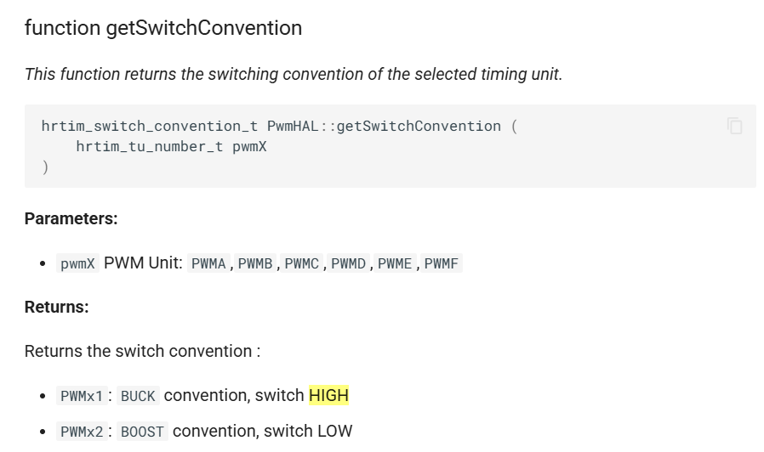

Code explanation for HF (high frequency) module test

The high frequency test code has the same structure of the low frequency test but adds some extra variables to alternate between connected and disconnected states:
- f_sw_HF: Test switching frequency
- HF_period: Test switching period
- counter_ONOFF: Counter that keeps track of when to connect and disconnect module during HF part
- ONOFF_index: Index that indicates if module is connected or disconnected during HF part
If the board is in SEQUENCE mode, it will follow the hF sequence defined in the figure from introduction by setting the command variable g:
if(seq_timer >= decalage_source + 0 && seq_timer < decalage_source + 0.35) // BLOCKED
{
g=2;
}
if(seq_timer >= decalage_source + 0.35 && seq_timer < decalage_source + 0.38) // CONNECTED/DISCONNECTED alternating in high frequency
{
g = seq_ON_OFF[ONOFF_index];
}
if(seq_timer >= decalage_source + 0.38 && seq_timer < decalage_source + 0.8) // BLOCKED
{
g=2;
counter_ONOFF = 0;
}
if(seq_timer >= decalage_source + 0.8 && seq_timer < decalage_source + 0.83) // CONNECTED/DISCONNECTED alternating in high frequency
{
g = seq_ON_OFF[ONOFF_index];
}
if(seq_timer >= decalage_source + 0.83 && seq_timer < decalage_source + 1) // BLOCKED
{
g=2;
}
if(seq_timer >= decalage_source + 1)
{
mode = IDLEMODE;
}
During the HF parts, a pulse is generated in the chosen frequency using the following code:
//Pulse generator at HF frequency
if (counter_ONOFF >= HF_period/2 - Ts)
{
if (ONOFF_index == 1)
{
ONOFF_index = 0;
}
else {
ONOFF_index = 1;
}
counter_ONOFF = 0;
}
counter_ONOFF += Ts;

Code explanation for arm test – no CVB

Code explanation for arm test – with CVB

